

Heritage Statement & Design and Access Statement

SITE ADDRESS: 79 REDINGTON ROAD LONDON LONDON NW3 7RR

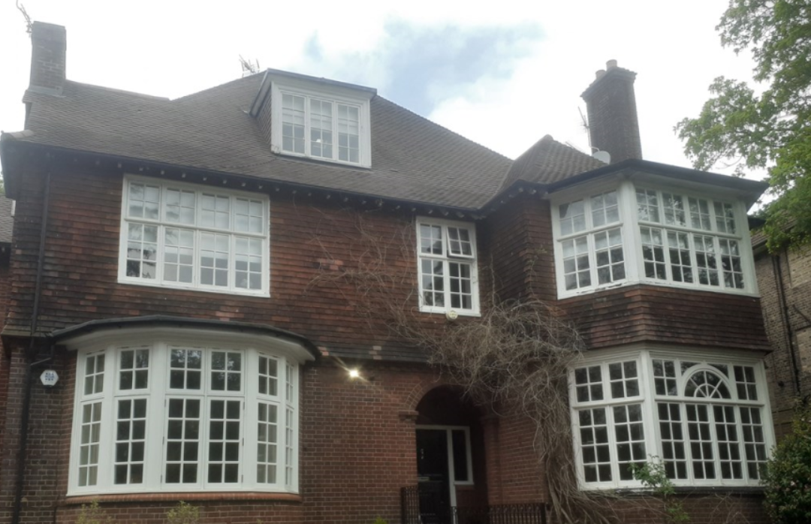

Proposal: Anglian Home Improvements have been contracted to
replace a kitchen window to the rear of the property and replace it
with double doors and full height side window with 3 windows
above.

Surrounding Area:

The local area consists of houses which are predominantly large detached and semi-detached properties and display a variety of formal and free architectural styles typical of the last years of the 19th and early years of the 20th centuries. Generally, these are built in red brick with clay tiled roofs, occasional areas of tile hanging and render and many of them have white painted small paned timber windows.

Heritage/History

The Redington/Frognal Conservation Area was designated in June 1985 and extended in February 1988, June 1992 and January 2003.

The property is an early 20th-century four-storey detached property, including a basement, ground floor, first floor and top floor built into the pitched roof, located on the west side of Redington Road. The existing property is a dwelling containing 4 self-contained flats. The building is neither statutorily listed or locally listed. The area is predominantly residential in character.

Constraints: The property is in the Redington/Frognal Conservation Area for which we have been advised there is an Article 4 Direction in place restricting permitted development hence the requirement of the application.

Design Principles/Justification: The applicant has chosen our white timber french doors and windows with double glazing to replace the existing timber windows to the rear of the property (as indicated on the CAD plans). The overall visual appearance the windows will be replicated in their general formation, with matching glazing bar detailing and will therefore be in keeping within the rest of the property and the conservation. The change of the window to doors will allow the homeowner to enjoy the communal gardens, ease with fire escape and allow additional light to enter the property.

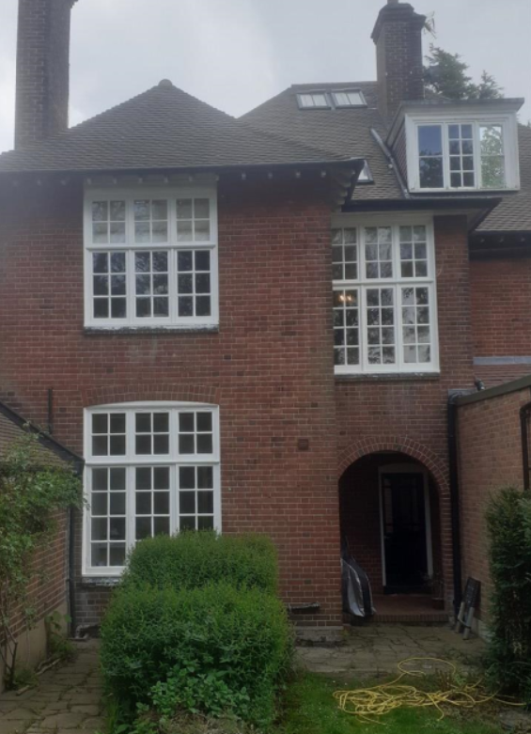

There have been various alterations over the years, with planning approval. The changes are to the rear of the property and would have no impact on the visual aesthetics on the front of the property. There will be no negative impact on the conservation area or the general public from these proposals.

All of our wooden windows are sustainably sourced, then individually designed and manufactured by our skilled joiners to create a window specific to the applicant’s requirements.

Access: No change to the property to the existing access.

Landscaping: N/A

To conclude with the above in mind we trust the proposals will be considered favourably by the council as we do not believe they will have any detrimental impact on the conservation area. We look forward to your reply and positive co-operation.

