REDINGTON FROGNAL ASSOCIATION
Umbrella body for residents’ groups in the Redington Frognal Conservation Area

9 June 2022

Dear Ms Quigley,

2022/1899/P Flat 3, 37 Platt’s Lane - objection

Housing densities are at high levels within much of the Redington Frognal Conservation Area and development can have considerable impacts on neighbours.

The number of objections submitted is indicative of the considerable loss of amenity that would be occasioned by the further enlargement of an existing conservatory (or salami slicing), approved as recently as 2019.

Hampstead Conservation Area Advisory Committee has noted that it would have been helpful if the application had been accompanied by some photographs and a number of views are therefore pasted below.

Existing rear extensions at 37 Platt’s Lane
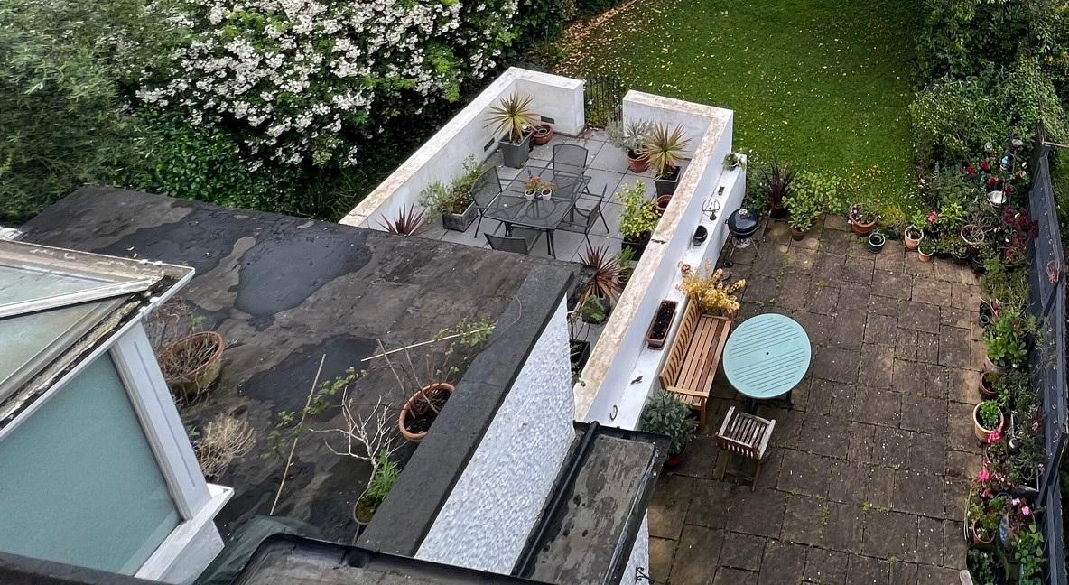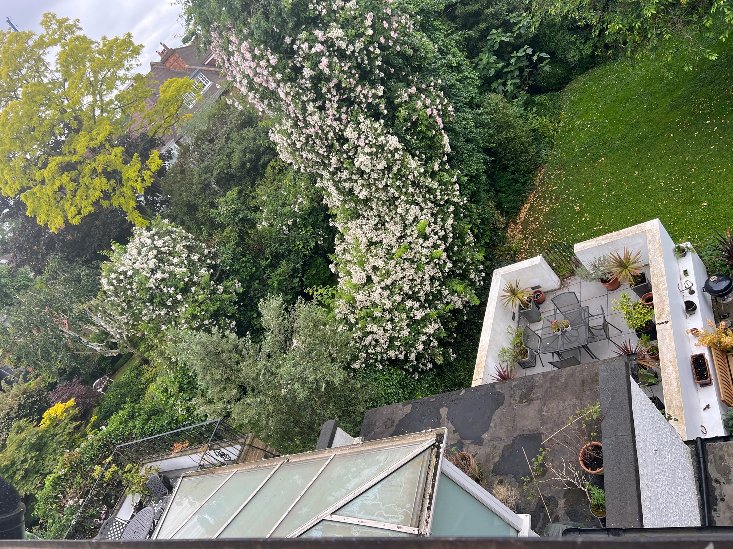

Extensions at first floor level are particularly problematic with considerable repercussions for the amenity of neighbours above and below and neighbours adjoining the proposed extension on either side (numbers 35 and 39). In particular, the proposed further extension would cause overlooking and loss of privacy, as well as loss of daylight to a habitable rooms at Flat 1.

In this case, the extension would additionally be visible from Briardale Gardens, causing harm to the streetscape. It would not provide a public benefit nor preserve or enhance the character or appearance of the Conservation Area (see appeal decision APP/X5210/W/20/3249286, dated 16.11.2020). The harm caused by unsympathetic additions is noted in both the 2003 Conservation Area Statement and Guidelines and by the appeal decision, which notes contributing factors to the harm as,

“including the scale, siting and detailed design of extensions”
and are
“prominent and intrusive”.

Redinton Frognal Association also has concerns about the impact of the lighting on the rear garden tree corridor, where bats commute and forage (see Neighbourhood Plan Evidence Base). This is contrary to Neighbourhood Plan policy BGI 3 ii).

In summary, the proposal would conflict with Local Plan policies A1, D1 and D2 and Redington Frognal Neighbourhood Plan policy BGI 3 ii).

Yours sincerely,

Anne-Marie O’Connor

Chair

Redington Frognal Association

http://www.redfrogassociation.org

