CNWL Live Logo

Camden Neurological & Stroke Service

1st Floor, South Wing

Ms Jane Morris

65 Constantine Road

London

NW3 2LP

St Pancras Hospital

4 St Pancras Way

NW1 0PE

Tel: **020 3317 3309**

Fax: **020 3317 3270**

**25th March 2022**

Dear Ms Jane Morris,

I am writing to support your application to have your front external stairs altered. Having supported you with

your rehabilitation since being discharged from hospital following a brain tumour removal it has become

evident that these stairs are unsafe for you to negotiate due to camber and steep gradient. We have added a

grab bar to the top where the handrail ends but unfortunately it is the steps that are the main issue.

It is important that Jane is able to access the community and currently these stairs are too dangerous for

Jane to manage. This is particularly important as Jane lives alone and has numerous medical appointments

to attend.

Please call me on **020 3317 3309** if you need to discuss this matter further.

Yours sincerely

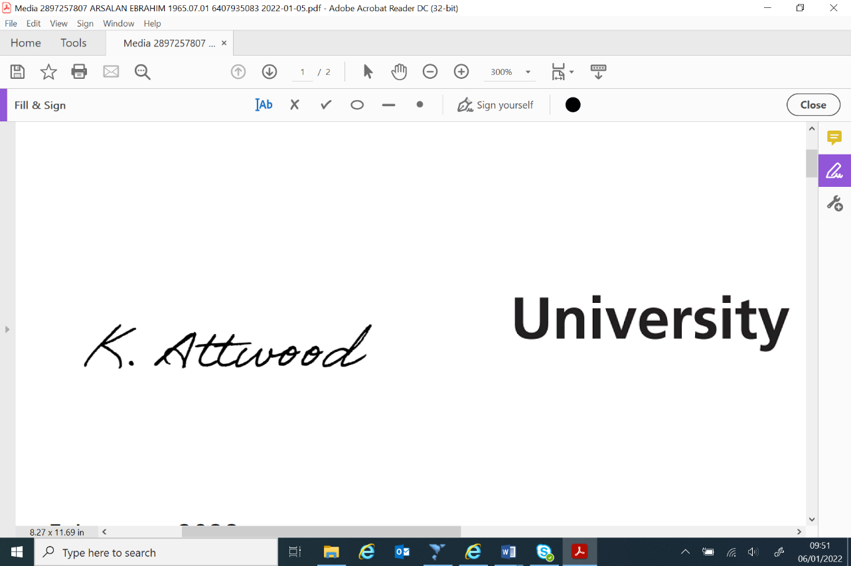Katie Attwood

Physiotherapist

Camden Neurology & Stroke Service