Heathlodge Heathside NW3 1BL

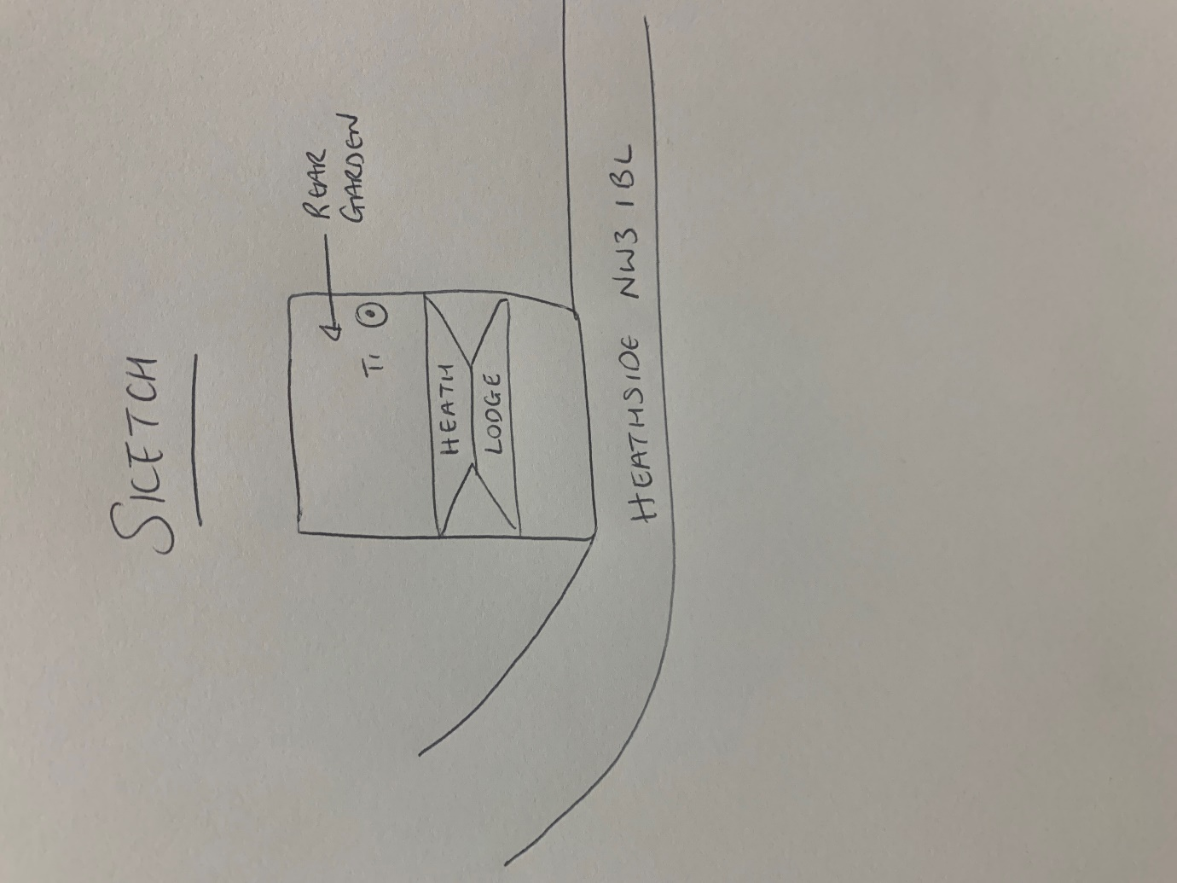

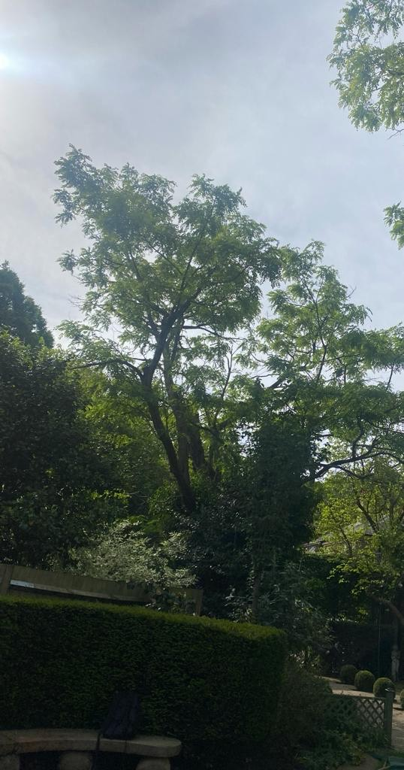

T1: Robinia (8m): Fell to ground level due to dieback in crown