CONSULTATION SUMMARY

Case reference number(s)

2021/5499/P
Case Officer: |  |  |  | Application Address:
Amy Ly |  |  |  | Flat A and Flat Ground Floor  56 Regent's Park Road  London  NW1 7SX

Proposal(s)
Erection of single storey rear extension (to serve Flat A), addition of roof terrace (to serve Flat Ground Floor) and addition of 1 window to rear elevation.

Representations

Consultations: | No. notified | 0 | No. of responses |  | 2 | No. of objections  No of comments  No of support | 2  0  0
Summary of representations  (Officer response(s) in italics) | A site notice was displayed on 24/12/21 and expired on 17/01/2022.  A press notice was displayed on 23/12/2021 and expired on 16/01/2022.  The neighbours at No. 54 and No. 52 Regent’s Park Road have objected to the proposed scheme on the following grounds:  - Proposed terrace privacy screen is too low, design is out of character and creates harmful impact on neighbouring privacy, security and noise  - The height of the proposed privacy screen on the terrace measures 1.8m, which is an acceptable scale and in accordance with CPG Amenity 2021.The privacy screen would be timber, which would preserve the character and appearance of the conservation area. Considering the proposed terrace would be similar in height of the terrace at No.54, it is considered that the privacy screen is a sufficient height in order to minimise privacy, neighbouring amenity and overlooking concerns. The height also matches the projected height of the existing approved planters erected on the neighbour’s terrace, which would further increase security in the immediate area. The terrace replaces an existing balcony, serving as an ancillary purpose to the upper ground flat. Therefore, a privacy screen would be welcomed and would not raise significant additional harmful concerns in terms of noise.  - No requirement for planting to be proposed on the terrace  - Planters at No.54 were recommended and discharged via condition under application ref: 2018/4814/P dated 13/12/2018. The neighbour’s planters screening has already been assessed and considered sufficient in minimising neighbouring amenity, privacy and security concerns. The proposed privacy screen and railings to match the neighbours are considered sufficient to mitigate any additional harmful amenity impacts, in accordance with CPG Amenity 2021. They would reinforce the existing screening measures erected on the terrace at No.54. This is acceptable as it would act as a secondary privacy screen and adds a further measure to protect neighbouring privacy.  - Extension is not set back from boundary and extension at No.54  - The flank wall of the extension at No.54 follows the shared boundary wall with No.56 and does not include a setback. This element has already been assessed and considered appropriate under application ref: 2014/7956/P granted 28/04/2015. Given the context of the semi-detached houses, the approval of the neighbouring extension without a setback and the similar scale and matching projection, the design of the proposed extension flush with the shared boundary is acceptable and would not give rise to adverse overlooking impact.  - 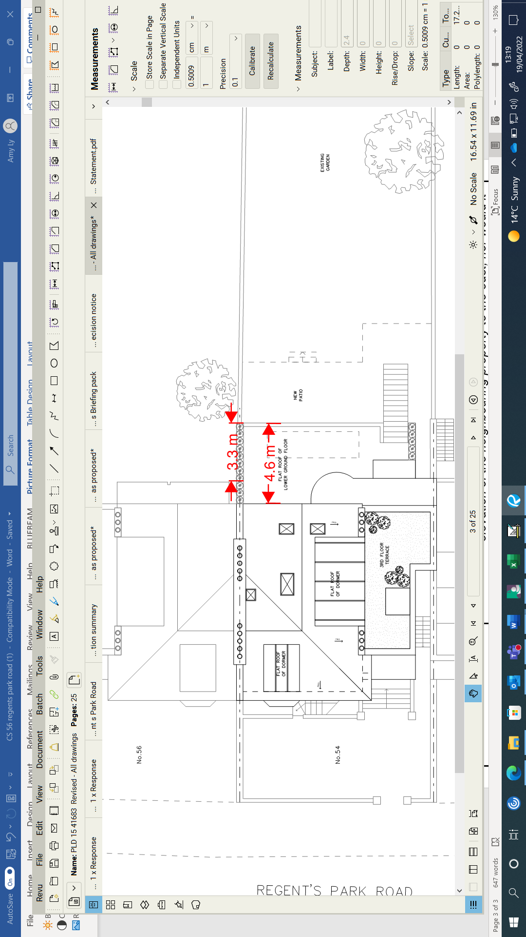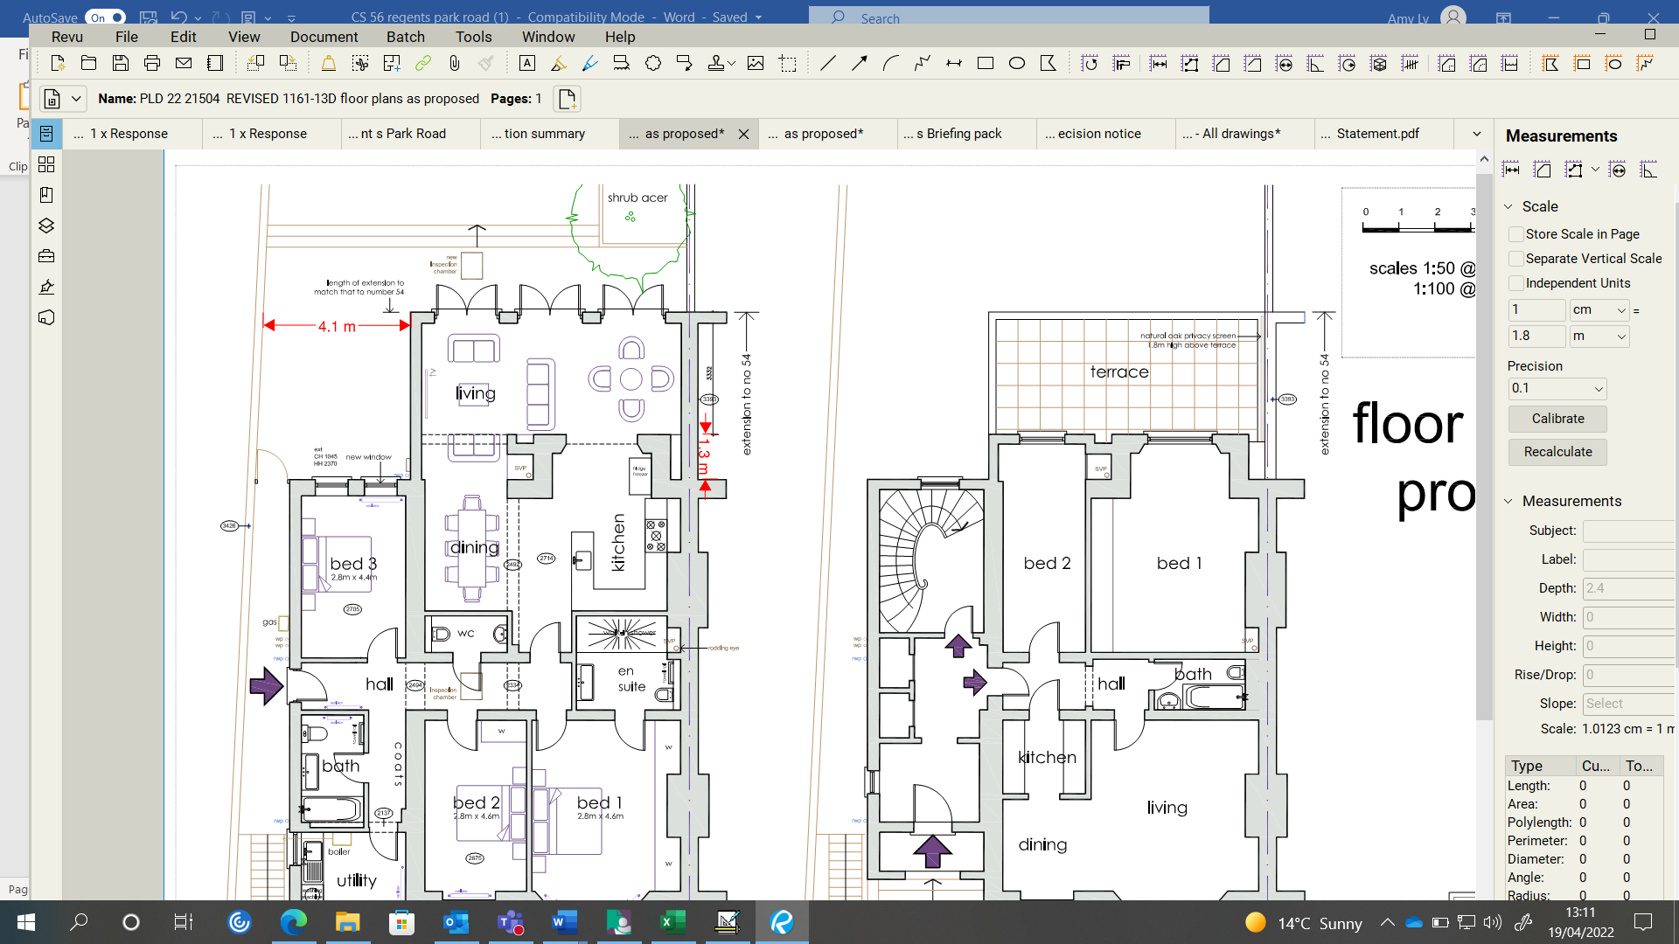Matching depths and shared boundary of proposed extension at No. 56 (top) and existing approved extension at No. 54 (bottom)  - Design and Access Statement is not clear in terms of dimensions of proposed extension.  - The height of the proposed extension would measure 3.6m, which is similar to the height of the neighbouring extension at No.54. It would not project significantly higher than the rear elevation of the neighbouring property to the east, nor would it create a full width addition. It would match the rear projection and would not extend further in depth. The extension is 4.1m set back from the shared boundary with No.38, to the west. This is acceptable and would not create an unacceptable harmful impact on neighbouring occupiers.  - Irresponsible/unsympathetic occupiers of the upper ground flat would worsen neighbouring security/privacy  - The issue of neighbour disputes are not considered a material planning consideration and lies beyond the remit of a Planning Department.

Recommendation:-

Grant conditional planning permission

