Fire statement form
Application information

- Site address line 1 |  |  | 154 Loudoun Road
Site address line 2
Site address line 3
Town |  |  | London
County
Site postcode (optional) |  |  | NW8 0DJ
- Description of proposed development including any change of use (as stated on the application form): |  |  | 154 Loudoun Road is an existing premises. The project is to remediate known external façade defects, including existing timber cladding and phenolic insulation to be removed and replaced with non-combustible cladding and mineral wool insulation.
- Name of person completing the fire statement (as section 15.), relevant qualifications and experience.  Guide: no more than 200 words |  |  | Adam Kiziak – BSc (Hons) Fire Safety, IEng, MIFireE, MIFSM, MSFPE  Adam has over 16 years’ experience in the fire sector, and he uses this knowledge in managing and carrying out Fire Consultancy for a range of different clients, including PFI investors, local authorities, healthcare trusts, universities and housing associations  Adam is an Incorporated Engineer registered with the Engineering Council, a member of the Institution of Fire Engineers (IFE), and a member of the Institute of Fire Safety Managers (IFSM). He also sits on the Council of the IFSM, and on the board of the IFE Fire Risk Assessor Register, of which he is also a member.
- State what, if any, consultation has been undertaken on issues relating to the fire safety of the development; and what account has been taken of this.  Guide: no more than 200 words |  |  | Consultation as required with design team and appointed fire engineer on the project. In general, consultations have largely included configuration of non-combustible façade, as well as replacement of materials with the compliant and safe alternatives that are equal or better in performance. Furthermore, we have considered aspects that are consequentially affected by façade remediation works. All solutions and decisions are subject to compliance with Approved Document B, as well as the appointed fire engineer’s verification and Client Representative’s specification in addition to the Employer’s Requirements’ Scope of Work.
- Site layout plan with block numbering as per building schedule referred to in 6.
(consistent with other plans drawings and information submitted in connection with the application)
Site layout plan is:
provided as a separate plan

The principles, concepts and approach relating to fire safety that have been applied to the development
- Building schedule

Site information |  |  |  |  | Building information |  |  | Resident safety information
a)  block no. as per site layout plan above | b)  - block  height (m)  - number of  storeys excluding those below ground level  - number of  storeys including those below ground level | c)  proposed use (one per line) |  | d)  location of use within block by storey | e)  standards relating to fire safety/ approach applied | f)  balconies | g)  external wall systems | h)  approach to evacuation | i)  automatic suppression | j)  accessible housing provided
One block Only | block height (m) – 21m  number of storeys excluding those below ground level – 8  number of storeys including those below ground level – 8 (from ground level, all above ground storeys) | residential flats, maisonettes, studios |  | All floors are utilised as residential accommodation | Approved document B vol 1 | class A2-s1, d0 or better | worse than class A2-s1, d0 | simultaneous | none | none
 |  | Choose an item. |  |  | Choose an item. | Choose an item. | Choose an item. | Choose an item. | Choose an item. | Choose an item.
 |  | Choose an item. |  |  | Choose an item. | Choose an item. | Choose an item. | Choose an item. | Choose an item. | Choose an item.
 |  | Choose an item. |  |  | Choose an item. | Choose an item. | Choose an item. | Choose an item. | Choose an item. | Choose an item.
 |  | Choose an item. |  |  | Choose an item. | Choose an item. | Choose an item. | Choose an item. | Choose an item. | Choose an item.
- Specific technical complexities
Explain any specific technical complexities in terms of fire safety (for example green walls) and/or departures from information in building schedule above
Guide: no more than 500 words
The project is to remediate known external façade defects, including existing timber cladding and insulation to be removed and replaced with non-combustible cladding.
.
- Issues which might affect the fire safety of the development
Explain how any issues which might affect the fire safety of the development have been addressed.
Guide: no more than 500 words
The remediation project will be subject to regular inspections by the construction team clerk of works, as well as the project fire engineer. Their role will be to ensure the remediation is carried out in line with the design, and cavity barriers are installed where required.
- Local development document policies relating to fire safety
Explain how any policies relating to fire safety in relevant local development documents have been taken into account.
Guide: no more than 500 words
In line with these, we have adhered to Approved Document B, namely the use of material with the minimum European classification - A2-s1, d0 or A1, classified in accordance with BS EN 13501-1:2007+A1:2009; as well as to the requirements listed in the Employer’s Requirements and Client Specification. For example, incorporation of non-combustible cladding and façade system where all new components are covered by a recognised certification and accreditation, such as:

• British Board of Agreement (BBA) Certificate
• European Technical Approval (ETA) Certificate
• Local Authority Building Control (LABC) Approval.
• And similar certification and testing evidence
Emergency road vehicle access and water supplies for firefighting purposes
- Fire service site plan
Explanation of fire service site plan(s) provided in 14. including what guidance documents have informed the proposed arrangements for fire service access and facilities?
Guide: no more than 200 words
Works are being undertaken to an existing building, with no alteration to the fire service access routes or facilities.

- Emergency road vehicle access
Specify emergency road vehicle access to the site entrances indicated on the site plan
Guide: no more than 200 words
Fire service access is available on both Loudoun Road as well as Alexandra Road, to more than 50% of the elevations.

Is the emergency vehicle tracking route within the site to the siting points for appliances clear and unobstructed?
yes
- Siting of fire appliances
Guide: no more than 200 words
All types of fire appliances can be accommodated adjacent to the building.

- Suitability of water supply for the scale of development proposed
Guide: no more than 200 words
Existing fire hydrant available within 90m of the property – working on an existing building

Nature of water supply:
hydrant- public

Does the proposed development rely on existing hydrants and if so are they currently usable / operable?
yes
- Fire service site plan
Fire service site plan is:
inserted in the form
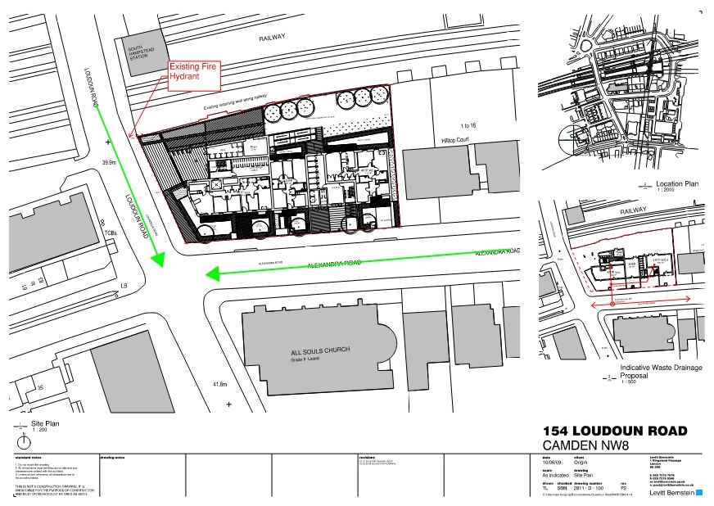

Fire statement completed by
- Signature |  |  | 
- Date |  |  | 24/03/2022

