|  |  |  |  |  |  |  |  |  |  |  |  |
| --- | --- | --- | --- | --- | --- | --- | --- | --- | --- | --- | --- |
| **Delegated Report** | | | **Analysis sheet** | | | |  | | **Expiry Date:** | **03/03/2021** | |
| N/A | | | | | | **Consultation Expiry Date:** | 31/01/2021 | |
| **Officer** | | | | | | **Application Number(s)** | | | | | |
| David Fowler | | | | | | 2020/5623/P | | | | | |
| **Application Address** | | | | | | **Drawing Numbers** | | | | | |
| 5 - 17 Haverstock Hill  London  NW3 2BP | | | | | | See Draft Decision Notice | | | | | |
| **PO 3/4** | **Area Team Signature** | | | **C&UD** | | **Authorised Officer Signature** | | | | | |
|  |  | | |  | |  | | | | | |
| **Proposal(s)** | | | | | | | | | | | |
| Demolition of existing building and erection of a development comprising residential (Use Class C3), Hotel (Use Class C1) and associated commercial, business and service (Use Class E, formerly Use Classes A1 and A3) with associated works. | | | | | | | | | | | |
| **Recommendation(s):** | | **Refuse planning permission** | | | | | | | | | |
| **Application Type:** | | **Full planning permission** | | | | | | | | | |
| **Conditions or Reasons for Refusal:** | | **Refer to Draft Decision Notice** | | | | | | | | | |
| **Informatives:** | |
| **Consultations** | | | | | | | | | | | |
| **Adjoining Occupiers:** | | No. of responses | | | 04 | | | No. of objections | | | 04 |
| **Summary of consultation responses:** | | See below | | | | | | | | | |

**OFFICERS’ REPORT**

1. **SITE**
   1. The site (0.207 hectares) is located directly to the north of Chalk Farm underground station (Grade II listed), at the junction of Chalk Farm Road, Adelaide Road and Haverstock Hill. The site is predominantly occupied by a six-storey brick building, known as ‘Eton Garage’, built up to the boundary of the underground station with street elevations facing onto Adelaide Road and Haverstock Hill. There are 6 ground floor retail units along the Adelaide Road frontage which fall within a designated neighbourhood parade. An element of hard standing is located to the rear of the site, with vehicle entrances provided from Adelaide Road and Haverstock Hill.
   2. The building occupying the site was purpose-built as a private car garage in the 1930’s originally providing a motor showroom and petrol station (now gone) and shops at ground floor level on Adelaide Road. The elevations are designed as though they are in use as flats and are suggestive of residential character rather than a car garage. However, the interior comprises a series of 10 staggered floor levels with spiral ramps provided for independent up and down traffic.
   3. The building (now vacant) was occupied by the British Transport Police from c. 1956, until the summer of 2014, for the storage of vehicles involved in crime. The existing lawful use of the site is as a car garage (Sui Generis) with ancillary office space linked to this operation. It is understood that during the British Transport Police operation (over 50 years) the facility employed approximately 6 employees.
   4. The surrounding townscape is varied with this particular part of Haverstock Hill being residential in character on its western side with a series of 7 storey 1930’s residential mansion blocks known as ‘Eton Place’ and dominated by the 3 storey Haverstock School with a large footprint and set in open space on its eastern side. Adelaide Road offers a short stretch of continued retail parade with residential use beyond.
   5. The site is not located within a conservation area, however, the Eton Conservation Area, Parkhill Conservation Area and Regent’s Canal Conservation Area are located nearby.
2. THE PROPOSAL
   1. The application seeks permission for the following:
      * The demolition of the existing vacant six-storey car parking facility building and ground floor retail units;
      * The erection of a part-six, part-seven storey replacement development comprising a 118-bed hotel (Use Class C1) and 35 residential units (Use Class C3) of which 18 would be affordable housing units (social rented) and 17 market; and
      * The part re-provision of the existing retail floorspace at ground floor level facing onto Adelaide Road. This would include replacing

the 6 existing retail units, currently providing 406sqm of retail floorspace (Use Class A1-A2), with 2 retail units (Use Class A1-A5) providing 134sqm of retail floorspace.

* 1. Two blocks would be constructed – each fronting the two roads, which border the site. The hotel would be located on the eastern side of the site, fronting Haverstock Hill. The residential block would be located on the western side of the site, fronting Adelaide Road. The retail element would be provided fronting Adelaide Road.

1. RELEVANT PLANNING HISTORY
   1. The following planning history is relevant to the application site:

Application Site

2016/3975/P - Planning permission granted on 02/10/2018 for:

*Demolition of existing building and erection of a part-six, part-seven storey development comprising 77 residential units (8 x studio, 18 x 1-Bed, 32 x 2-Bed and 19 x 3-Bed units) (Use Class C3) and retail (Use Class A1-A5) use at ground floor with associated cycle parking, amenity space, refuse and recycling store and associated works.*

2021/3268/P – Application granted on 03/03/2022 for Certificate of Lawfulness for:

*Confirmation that the planning permission dated 02 October 2018 (Ref 2016/3975/P) for ‘Demolition of existing building and erection of a part-six, part-seven storey development comprising 77 residential units (8 x studio, 18 x 1-Bed, 32 x 2-Bed and 19 x 3-Bed units) (Use Class C3) and retail (Use Class A1-A5) use*

*at ground floor with associated cycle parking, amenity space, refuse and recycling store and associated works.’ was lawfully implemented by the carrying out of material operations prior to the expiry of the permission.*

115 Camden High Street

2019/3138/P– Planning permission granted on 29/12/2020 for:

*Demolition of existing two storey building and erection of a part-four, part-five storey building (plus enlargement of existing basement and plant room at roof level) comprising retail (Class A1) at ground floor level fronting Camden High Street, 80-bed hotel (Class C1) and 3 x 2-bed residential units (social rented) (Class C3) fronting Delancey Street.*

155 & 157 Regent’s Park Road

2021/0877/P – Planning permission pending decision, following resolution to grant at the planning committee for:

*Demolition of existing building and redevelopment to provide a part 4 storey/part 7 storey building, with two basement levels, for a 59 bedroom hotel, with new street level public realm works in front (at junction of Regent's Park Road, Adelaide Road and Haverstock Hill).*

7 Bayham Street

2018/3647/P – Planning permission granted 28/08/2018 for:

*Demolition of existing office buildings (B1) and erection of 5 storey (plus two storey basement) building comprising mixed office (B1) and hotel (C1) use.*

1. CONSULTATIONS Statutory Consultees
   1. Thames Water

No objection subject to a condition requesting a piling method statement and informatives relating to storm flows, public sewer crossing, Trade Effluent Consent, main crossing and water pressure being attached to any permission required.

* 1. Historic England

No comments to make on this application which should be determined in accordance with national and local policy guidance, and on the basis of the Council’s specialist conservation advice.

* 1. London Underground

The applicant is in communication with London Underground engineers with regards the development. No comment except that the developer should continue to work with LU engineers throughout the design and construction phase.

* 1. Transport for London (TfL)

**Cycle parking**

10 long stay cycle spaces are proposed for the commercial element, which is in line with policy T5 (Cycling) of the Publication London Plan. However, only 34 commercial short stay cycle spaces are proposed. To comply with policy T5, a further 4 cycle parking spaces should be provided.

It is noted the 34 commercial cycle spaces will be provided around the site on the footway. A minimum clearance of 450mm between any part of the cycle and the carriageway should be retained when a cycle is parked on the stand. The cycle parking should be placed so it is not visually or physically intrusive. Further guidance on the placement of cycle parking can be found within Section 11 (Footway amenities), part 11.5 of our Streetscape Guidance: [http://content.tfl.gov.uk/streetscape-guidance-.pdf](https://protect-eu.mimecast.com/s/JwTyCr8DAU4DgVAc7obBS?domain=content.tfl.gov.uk)

A total of 65 residential cycle spaces will be provided at ground floor. An additional space should be provided to meet the minimum standards of the Publication London Plan, policy T5.

All cycle parking should be designed and laid out in accordance with the guidance contained in the London Cycling Design Standards (LCDS), with a 5% provision for larger cycles, including adapted cycles for disabled persons.

**Car parking**

The proposed development will be car free, which is strongly encouraged by TfL given the sites excellent Public Transport Accessibility Level (PTAL) of 6a. This is also supportive of policy T6 (Car parking) of the Publication London Plan.

TfL welcomes the applicant’s commitment to restrict residents of the development from obtaining a permit to avoid overspill parking. This should be secured by condition.

It is noted disabled parking may be accommodated on Adelaide Road, subject to discussion with the Highways Authority. Developments should provide and design disabled persons parking in line with the standards set out in policy T6.1 (Residential parking), part H and policy T6.5 (Non-residential disabled persons parking).

**Deliveries and servicing**

All servicing, deliveries and refuse activity will take place on-site within the proposed access route to the rear of the development. While servicing off-street is welcomed by TfL in line with policy T7 (Deliveries, servicing and construction), part G of the Publication London Plan, the submitted plans suggest a new egress point will be formed on Haverstock Hill to allow vehicles to exit the proposed route. TfL would encourage the council to request the final design to be subject to a Road Safety Audit (RSA), to demonstrate and ensure compliance with Publication London Plan policy T4 part F, which states new development must not increase road danger. This is essential due to Vision Zero, the Mayor’s goal to eliminate all death and serious injuries from London’s transport networks by 2041. If a RSA is undertaken, this should be approved by the council and TfL requests visibility of the RSA process, including seeing the highway authority response to the RSA.

From plans provided, it appears the egress point will involve vehicles emerging from the site onto the bus lane on Haverstock Hill. The introduction of a new egress point could introduce a new conflict point. Vehicles would now turn over the bus lane, that is also used by cyclists, to egress the site. This impacts bus reliability and creates multiple safety hazards, which contradicts the Mayors Vision Zero approach.

It is understood access to the servicing area will be controlled. Further information should be provided on the actual measures that will be implemented to ensure only delivery, servicing, waste collection and emergency vehicles use this route.

The use of a delivery booking system is supported by TfL, to ensure deliveries are staggered throughout the day. This should be managed so that deliveries can be received outside of peak hours, in line with policy T7, part H of the Publication London Plan.

Additionally, the employment of a concierge for the residential element is supported, as this will likely minimise additional freight trips arising from missed deliveries.

**Construction**

A draft Construction Management Plan (CMP) has been submitted. A Construction Logistics Plan (CLP) should be provided in line with TfL guidance and secured by condition. For guidance on how to best minimise the impact of construction on the road network, please see [https://constructionlogistics.org.uk/construction-logistics-and-planning/](https://protect-eu.mimecast.com/s/lotpCvl0GUryQNWuX9MEQ?domain=constructionlogistics.org.uk/)

The applicant should confirm that they will comply with CLOCS standards. TfL encourages the use of freight operators with FORS silver or gold membership as it is imperative that road safety measures are considered, and preventative measures delivered through the construction and operational phases of the development.

All contractor vehicles should include sidebars, blind spot mirrors and detection equipment to reduce the risk and impact of collisions with cyclists and other road users and pedestrians on the capital’s roads

The proposed construction arrangements of vehicles reversing into the site is far from ideal. Haverstock Hill and Adelaide Road is borough highway and therefore the views of Camden as highway authority ultimately be sought but TfL strongly encourages avoiding reversing where possible. If this arrangement is unavoidable, traffic marshals must be present to oversee the entire process, as pedestrian and cyclist’s safety are paramount and therefore should be protected.

Swept path analysis should be provided to demonstrate how the largest vehicles would enter and egress the construction area.

**Travel Plan**

A draft Travel Plan has been provided. The Council should secure, enforce, monitor, review and ensure the funding of the Travel Plan through the Section 106 agreement to ensure conformity with Publication London Plan Policy T4 (Assessing and mitigating transport impacts).

*Officer’s response: See ‘Transport’ section*

Local Groups

* 1. Eton CAAC

The proposed development falls outside the Eton Conservation Area. However, the site marks what is in effect the southern "gateway" to the Conservation Area in Eton College Road which leads to Provost Road and Eton Villas (South) which form two sides of the "triangle" which surrounds St Saviour's Church. The church and all the houses in Provost Road and Eton Villas (South) are Grade II Listed. It is for this reason that we wish to comment on the proposal.

Object to the proposal for the following reasons:

* + - Loss of potential residential accommodation which is a high priority.
    - Height and massing, as with the approved scheme, the proposals ignore the scale of the area, are a storey too high on both main frontages.
    - Impact on listed Chalk Farm Station.
    - Salmon-pink does not redeem height or massing.
    - Five shops should be replaced.
    - The car pound was a low-intensity use – this is misrepresented in application.
    - Proposals ignore existing uses in area – particularly the residential uses to the north, east and west, proposed ‘mixed use’ is out of character with the surroundings, unnecessary, intrusive.
    - Hotel use unacceptable, there are plenty of hotels in the vicinity, hotel use should be refused:
      * + London Marriott (Swiss Cottage – 304 beds)
        + Premier Inn (Belsize Park – 140 beds)
        + Haverstock Arms (22 beds)
        + Camden Lock Hotel (38 beds)
        + Proposals for 155 Regent’s Park Road (58 beds)
    - Security issues from alleyway running along the back.
    - Impact on amenity of residents in area from overdevelopment.
    - If approved, control over operations of the hotel are required, including events management plan, travel plan, hours, security, noise etc.

*Officer’s response: See sections on ‘Loss of approved housing’, ‘Design, conservation and heritage’, ‘Loss of retail floorspace’, ‘Transport’. The proposed servicing road would be gated and managed by the hotel.*

* 1. New Etons Residents Associations

Object to the proposal for the following reasons:

* + - Air and food vents; these should not face existing residential accommodation, noise, heat, smells.
    - Pest control; demolition work and concern regarding rats.
    - Timing of the proposed works; No demolition works should take place while majority of residents are working from home.
    - Height of the proposed development; Loss of light to neighbouring residential properties.
    - Service road for hotel deliveries; anti-social behaviour.
    - Refuse areas; smells and hygiene.
    - Roof gardens and main exits; noise and light pollution.
    - Trees and planting; should protect existing trees.

*Officer’s response: See sections on ‘Amenity’ and ‘Landscaping’. The proposed servicing road would be gated and managed by the hotel. The demolition would be controlled by a DMP were the application to be granted.*

COUNCILLORS

* 1. Councillor Kelly objects to the proposal because of:
     + Proposed building is far too big for the site, higher than the approved scheme, one block is higher than the other – lack of symmetry.
     + Salmon-pink is inappropriate.
     + No re-provision of local shops.
     + Original application proposed 77 flats, this is reduced to 35 (though welcomes increase of affordable units from 17 to 18), significant loss of potential residential dwellings.
     + Hotel use – the site is outside the commercial area, already a hotel approved next door.
     + If development goes ahead – employment opportunities are targeted at Camden residents.
     + Construction noise and disturbance, controls required to mitigate.

*Officer’s response: See sections on ‘Amenity’, ‘Design, conservation and heritage’, ‘Loss of retail’, ‘Proposed hotel use’ and ‘Transport’.*

* 1. Adjoining Occupiers

|  |  |
| --- | --- |
| *Total number of responses received* | 4 |
| *Number in support* | 0 |
| *Number of objections* | 4 |

* 1. A site notice was displayed on 06/01/2021 and a press notice was displayed in the Ham and High on 07/01/2021. The formal consultation period ended on 31/01/2021.

Representations Summary

* 1. 3 objections have been received raising the following concerns:

Design and heritage

* + - Construction should remain sympathetic to the area, including the Underground Station.
    - Heights listed do not account for mezzanine level.
    - Salmon-pink is unattractive and out of context.

*Officer’s response: See section on ‘Design, conservation and heritage’.*

Amenity

* + - Noise from demolition and construction, local residents will suffer more due to lockdown.
    - Security issues from hotel if not managed properly.

*Officer’s response: See section on ‘Amenity’. A Hotel Management Plan would be secured were planning permission to be granted.*

Land use

* + - Proposed businesses are not needed, introduction of a commercial use into the area would be detrimental to residents
    - Only 35 flats are proposed, only 18 of these are affordable
    - Previous proposal featured 77 flats.

*Officer’s response: See sections on ‘Proposed hotel use’, Loss of approved housing’, ‘Proposed housing’.*

Transport

* + - Building should be converted into cycle parking
    - Servicing impact from large hotel – 10 metre lorries

*Officer’s response: See section on ‘Transport’.*

1. POLICIES
   1. **National Planning Policy Framework 2021 (NPPF)**
   2. **The London Plan 2021**
   3. Mayor’s Supplementary Planning Guidance
   4. **Camden Local Plan 2017**

G1 Delivery and location of growth

H1 Maximising housing supply

H2 Maximising the supply of self-contained housing from mixed-use

schemes

H4 Maximising the supply of affordable housing

H6 Housing choice and mix

H7 Large and small homes

C1 Health and Wellbeing

C5 Safety and security

C6 Access for all

E1 Economic Development

E2 Employment premises and sites

E3 Tourism

A1 Managing the impact of development

A2 Open space

A3 Biodiversity

A4 Noise and Vibration

A5 Basements

D1 Design

D2 Heritage

D3 Shopfronts

CC1 Climate change mitigation

CC2 Adapting to climate change

CC3 Water and flooding

CC4 Air quality

CC5 Waste

TC1 Quantity and location of retail development

TC2 Camden’s centres and other shopping area

TC4 Town centre uses

TC5 Small, independent shops

T1 Prioritising walking, cycling and car-free development

T2 Parking and car-free development

T3 Transport infrastructure

T4 Sustainable movement of goods and materials

DM1 Delivery and monitoring

* 1. Supplementary Planning Documents

CPG Design (2019)

CPG Amenity (2018)

CPG Interim Housing (2019)

CPG 2 Housing (May 2006 Updated March 2019)

CPG Energy efficiency and adaptation (2019)

CPG Transport (2019)

CPG Developer Contributions (2019)

CPG Town centres and retail (2018)

CPG Trees (2019)

CPG Air quality (2019)

CPG Access for all (2019)

CPG Public open space (2018)

Eton Conservation Area Statement (2002)

Park Hill and Upper Park Conservation Area Appraisal and Management Strategy (2011)

Regent’s Canal Conservation Area Appraisal and Management Plan (2008)

London Borough of Camden Housing Delivery Test –Action Plan (August 2021)

This document is an annual measurement of housing delivery, which sets out targets for housing delivery.

1. ASSESSMENT
   1. The principal considerations material to the determination of this application are considered in the following sections of this report:
2. **Principle of land use**
   * Loss of car garage
   * Loss of retail floorspace
   * Proposed hotel use
   * Proposed residential floorspace
   * Loss of approved housing
3. **Design, conservation and heritage** 
   * Introduction
   * Existing site
   * Design proposals
   * Listed buildings
   * Conservation areas
   * Design and townscape
4. **Landscaping and open space**
5. **Impact on neighbouring amenity**
   * Daylight/Sunlight
   * Overlooking and loss of privacy
   * Noise and disturbance
   * Basement excavation
6. **Air quality**
7. **Sustainable design and construction**
8. **Transport**
   * Introduction
   * Trip generation
   * Travel planning
   * Car parking
   * Cycle parking
   * Deliveries and other servicing activities
   * Road Safety Audit
   * Highways works contribution
   * Pedestrian, cycling and environmental improvements
   * Managing and mitigating the impacts of construction
   * Construction Impact Bond
9. **Contamination**
10. **Fire safety**
11. **Flooding and drainage**
12. **Employment and training**
13. **Planning obligation**
14. **Mayor of London’s Crossrail CIL & Camden CIL**
15. **Conclusion**
16. PRINCIPLE OF LAND USE

Loss of car garage

* 1. No objection is raised to the loss of the existing car garage (Sui Generis) use. The site has a low employment density, limited ancillary office space and, as a purpose built car garage, could not easily be converted to modern employment floorspace given the age of the existing building and limited floor to ceiling heights. It is therefore accepted that the building would not fall within the definition of ‘employment floorspace’ as set out in Policy E2. Furthermore, the principle of the loss of the car garage was established under the previous permission 2016/3975/P.

Loss of retail floorspace

* 1. Policy TC4 seeks to maintain the vitality and viability of Town Centres. Whilst the site is just outside the Town Centre, there are existing Class E uses (formerly Class A) at ground floor level, which support the Town Centre.
  2. The Adelaide Road frontage would continue to be occupied by retail, however, within the proposal it is proposed that the quantum would reduce from 406sq.m to 134sq.m (GEA) with just three units being retained. Whilst this would be a fairly significant loss of retail floorspace, given that it is outside the town centre and that there would still be retail provision along this frontage creating ground floor activation it is considered to be acceptable. On the Haverstock Hill frontage, the hotel lobby would provide an active frontage and would include a restaurant open to non-patrons. Whilst this restaurant would be ancillary to the hotel (Class C1), it would not appear dissimilar to a Class E restaurant use and would add to activation of the street frontages. It should also be noted that the existing retail units could be converted to restaurant use without the need for planning permission, using permitted development rights.

Proposed hotel use

* 1. Camden Local Plan policy E3 states that new large-scale tourism development (over 1,000sqm or more) is expected in Central London, particularly the growth areas of King’s Cross, Euston, Tottenham Court Road and Holborn. Smaller-scale visitor accommodation would be supported in the Town Centre of Camden Town.
  2. The application site is far away from the Central London Area, is not in a growth area, and whilst on the boundary with the Town Centre of Camden Town, it is also outside of this area. The location marks the point between the more commercial character of the Town Centre and the more residential character going up Adeleaide Road and Haverstock Hill.
  3. A 118-bed hotel with a floor area of 4,033sqm is considered to provide the type of large-scale tourist accommodation expected in Central London and growth areas, not outside a town centre, and is therefore considered to be contrary to policy E3. Central London and Growth Areas are more suited to accommodating high numbers of visitor movements due to multiple public transport options and taxi / coach pick up points. Whilst the site is outside of the Town Centre of Camden Town, officers recognise that it is only just outside and are not suggesting that a hotel would be unacceptable in principle (were this not to be a site already approved for housing), just that a hotel of this scale is not appropriate. Given the number of bedrooms and the floor area of this hotel, it is clearly not small-scale and would be considered unsuitable, even if it was within the Town Centre of Camden Town.
  4. There have been other recent planning approvals for hotels within or on the edge of the town centre (see ‘History’ section), however, these are much smaller in scale. Furthermore, given these recent permissions, there is clearly an approved supply of hotel bedrooms in the local area and there is no need for a further large-scale hotel, as opposed to housing (see ‘Loss of approved housing’ section below). There have been at least 802 hotel bedrooms approved in the borough since 2016, including in the locality at Regent’s Park Road and Camden High Street (see ‘History’). Officers consider there is no strong need for hotels, compared with the great need for residential use.
  5. A large-scale hotel would be appropriate to Central London. A large-scale hotel is not appropriate to the character of this location, outside of Central London, on the edge of the Town Centre, in a location marking the transition in to a more residential area. The proposed large-scale hotel would attract large numbers of people, introduce a major commercial enterprise to the area and therefore alter the existing quieter, more residential character

Proposed residential use

Introduction

* 1. Camden Local Plan policies H1, H2, H4, H6, H7 and Camden Planning Guidance 2 (Housing) are relevant with regard to the provision of housing, including affordable housing. Residential use is the Council’s priority land use and is welcomed in principle.
  2. The residential block would front Adelaide Road and both the entrances for the social rented and market housing would be located here.

Mixed use policy and tenure

* 1. Given that the proposed hotel use is being justified on the basis that the site is just outside the Town Centre of Camden Town, it is considered that 50% of the uplift in floorspace should be residential, to comply with policy H2 for sites within this Town Centre. There is an uplift of 1,123sqm under the proposals (from 7,665sqm to 8,788sqm). 50% of this calculates to 561.5sqm. 3,705sqm of residential are proposed, and the proposals therefore comply with this policy.
  2. An affordable housing target of 50% applies to developments with capacity for 25 or more additional dwellings, and the guideline mix of affordable housing types is 60% social-affordable rented housing and 40% intermediate housing – based on floorspace.
  3. Under the proposals there would be 35 dwellings, 18 of which would be affordable housing (all social rented). 54% of the residential floorspace would be affordable housing, which therefore complies with policy. The current scheme has the same amount of affordable housing as the approved scheme, but all the floorspace would be social rented instead of a mix of social rented and intermediate. Whilst this breakdown of affordable housing does not comply with the policy requirement of 60% social rented and 40% intermediate, officers recognize that an increased amount of social rented accommodation is positive and is accepted.

Flat sizes and unit mix

* 1. Policy H7 requires homes of different sizes to meet the priorities set out in the Dwelling Size Priorities Table (see below). The proposed unit mix should broadly accord with this table, although the Council will be flexible when assessing development.

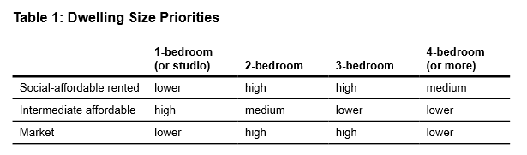

Figure 1: Dwelling Size Priorities

* 1. The proposed unit mix (see below) is broadly compliant with the above. Whilst there is a large amount of 1-bedroom social affordable units, the scheme would still provide a significant amount on 2-bedroom and 3-bedroom units.

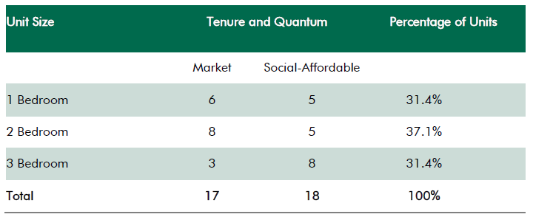

Figure 2: Tenure and quantum

* 1. The proposed residential accommodation is required to meet the National Space Standards which are outlined below.

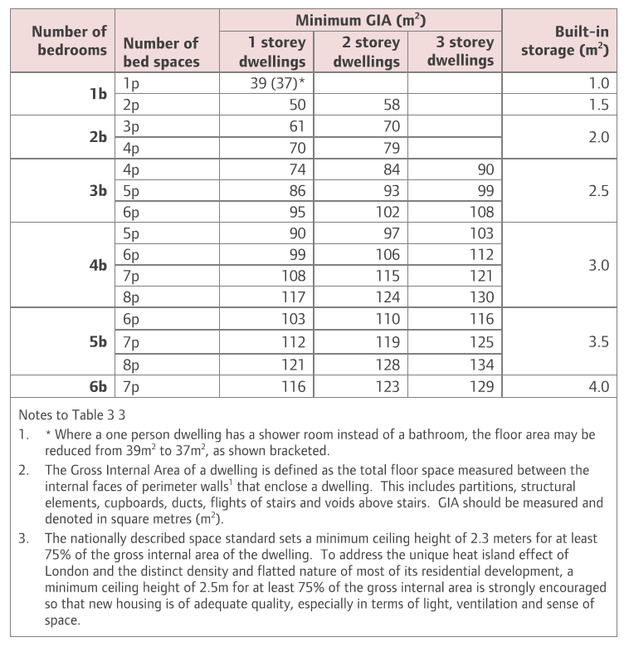

Figure 3: National Space Standards

* 1. The proposed units comply with the standards above.

Accessible accommodation

* 1. Four wheelchair units would be provided, which represents 10%, in line with policy.

Daylight, sunlight, privacy and aspect

* 1. Of the 35 flats proposed, 18 of these would be single aspect. Whilst 8 of these units (social rented) would be north-east facing, none of the flats would be directly north-facing. It should be noted that the approved scheme had 46 units that would be single aspect.
  2. Each flat would have adequate light and ventilation and the proposal would provide a good level of aspect for all future residents with appropriate setbacks from the boundaries of the site and spacing in front of proposed windows being provided. An Internal Daylight and Sunlight Assessment has been provided with the application to assess the quality of daylight and sunlight into the new residential units. The report concludes that the scheme demonstrates good levels of compliance with BRE Guidance in terms of internal daylight amenity. The incidences of derogations from guidance across all the units are marginal across the whole scheme. Many of the rooms below are because of the presence of a balcony.
  3. With respect to the possible implications on amenity by way of overlooking and impact on privacy, this has been addressed through the careful positioning of windows and balconies to minimise the potential for overlooking. In the central courtyard area the layout of the flats has been carefully designed to minimise overlooking and privacy issues. There would be approximately 11m between apartments with the courtyard area with the minimum distance being 7m. However, these views in questions would be oblique.

Loss of approved housing

* 1. Local Plan policy H1 seeks to maximise housing supply. The policy sets out how this will be achieved and states that the council will ‘a) *regard self-contained housing as the priority use of the Local Plan’*; and ‘c) *resist alternative development of sites identified for housing or self-contained housing through a current planning permission or a development plan document unless it is shown the site is no longer developable for housing*’. The supporting text of this policy (para 3.28 and 2.39) set out the reason for this policy. Camden as an inner London borough does not have large swaths of land which are available for housing, smaller development sites make up a significant and important contribution to overall housing delivery and many of those sites would not be identified within a development plan document like the Site Allocations. For this reason the Council seeks to resist alternative development of sites that have an existing consent for self-contained housing (as well as those identified for housing in the site allocation document). If alternative development is proposed on a site with a consent for housing, the Council will consider the viability of the approved residential scheme coming forward as well as if the alternative development might free up another replacement site for housing.
  2. Planning permission was previously granted for redevelopment of this site to provide a solely residential scheme, providing 77 units (including 17 affordable units). A certificate of lawfulness was granted that demonstrated that this permission had been implemented. There is currently an application for a certificate of lawfulness, to prove that this permission has been implemented (see ‘History’ section). Under the current proposals, only 35 flats would be provided (including 18 affordable) which represents a significant drop in the amount of flats provided by 42 – the current scheme would provide just 45% of the amount of flats as the approved scheme. There is a conflict with the requirements of Policy H1. Housing is Camden’s priority land use. Policy H1 of the Camden Local Plan adopted 2017 sets a 15-year housing target for 2016-2031 as 16,800 additional homes – equivalent to an annualised target of 1,120 additional homes. This target has been superseded by the London Plan published in final form in March 2021, which sets a 10-year target for Camden of 10,380 additional homes for 2019-2029 – equivalent to an annual target of 1,038 additional homes if divided equally between years. Policy H1 also indicates that we will seek to exceed the target for additional homes by regarding self-contained housing as the priority land-use of the Local Plan, resisting alternative development of sites identified for housing or self-contained housing through a current planning permission or a development plan document, and expecting the maximum reasonable provision of housing on sites that are underused or vacant.
  3. In 2018, the Government introduced the Housing Delivery Test as a formal measure of whether development is providing the number of homes required. The NPPF indicates that planning decisions should reflect the outcome of the Housing Delivery Test. According to the Government's assessment of the Housing Delivery Test:

• 106% of Camden's requirements were met in the three years to 2018;

• 87% of Camden's requirements were met in the three years to 2019;

• 79% of Camden's requirements were met in the three years to 2020;

• 76% of Camden's requirements were met in the three years to 2021,

* 1. As a consequence of the assessment falling below 95% from 2019, the Council has published Housing Delivery Test Action Plans in 2020 and 2021. As a consequence of the assessment falling below 85% from 2020, the Council must also add a buffer of 20% to the supply specific deliverable sites (the ‘5-year housing land supply’) to improve the prospect of achieving the planned delivery. Consequently, the Council currently needs a 5-year housing land supply sufficient to deliver 6,228 homes (5x 1,038 plus 20%). Officers consider that the Housing Delivery Test assessments and the need to maintain a 5-year housing land supply are material considerations that should be taken into account when making decisions that would have an impact on the supply of land for housing.
  2. The Council published its most recent Authority Monitoring Report in 2019, for the year 2017/18. This indicated that Camden had a 5-year housing land supply. Delivery of 6,308 additional homes was anticipated from 2018/19 to 2023/24, which exceeds the required supply of 6,228 homes by just 80 homes. Delivery of self-contained homes in more recent years has been 827 homes in 2018/19, 985 homes in 2019/20, and 433 homes in 2020/21, falling significantly below the London Plan target in each year.
  3. The Housing Delivery Test Action Plan 2021 set out a number of key actions that the Council should take to overcome barriers to housing delivery. The first of these is to “resist applications for commercial developments outside of the Central Activities Zone, Knowledge Quarter and designated town centres”. This action is consistent with existing Camden Local Plan policies, notably Policy H1.
  4. In the context of the London Plan targets, Local Plan policies, the tightness of the 5-year supply as assessed in 2017/18, and the relatively limited delivery of additional homes from 2018 to 2021, a reduction in the anticipated delivery on this site from 77 to 35 homes would represent a significant reduction.
  5. The applicant argues that the approved residential scheme is not viable and that the significant loss of approved housing in the current mixed-use hotel scheme is therefore justified. The applicant submitted a viability assessment (undertaken by DS2) to compare the two proposals to attempt to prove this position. The viability assessment has been independently audited by BPS, the Council’s independent financial viability assessor. BPS concluded that both schemes were in deficit, but did not agree with DS2 that the extant residential scheme is significantly more in deficit than the mixed-use hotel scheme. BPS found that the extant residential scheme was in fact more viable than the proposed mixed use hotel scheme. BPS’ findings are shown in the table below, compared with the applicant’s findings. BPS have concluded that both schemes remain in deficit but consider the hotel scheme’s deficit to be marginally greater. The Council therefore does not accept the applicant’s viability claims.

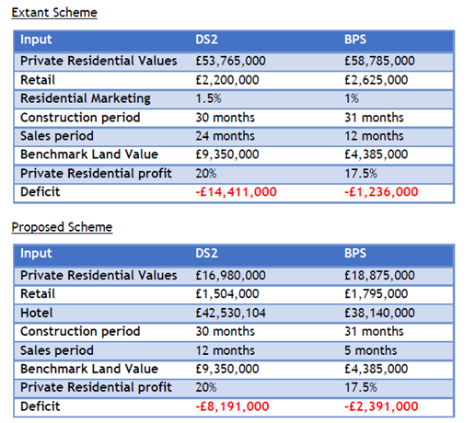

Figure 4: Comparison of applicant’s and BPS’ viability

* 1. Given the clear housing need in the borough and the approved residential scheme for 77 flats, the proposals would result in a significant loss of approved and much-needed housing on the site, contrary to policy H1 on maximizing housing supply.

1. DESIGN, CONSERVATION AND HERITAGE

Introduction

* 1. The NPPF (paragraphs 56 and 57), the London Plan (Policies 7.1 to 7.8), Camden’s Local Plan (Policies D1 and D2) and Camden Planning Guidance (CPG Design), place great emphasis on the importance of good design. The CPG seeks “excellence in design” in Camden. Policy at all levels requires buildings, streets and spaces to respond in a manner which promotes inclusive and sustainable development and contributes positively to the relationship between urban and natural environments and the general character of the location.
  2. The NPPF also states that, in determining planning applications where heritage assets are involved, local planning authorities should take account of the desirability of sustaining and enhancing the significance of heritage assets, as well as the desirability of new development making a positive contribution to local character and distinctiveness. The London Plan also requires, at Policy 7.8, that development affecting heritage assets conserve their significance, by being sympathetic to their form, scale, materials and architectural detail. Camden Policy D2 also seeks to protect other heritage assets including Parks and Gardens of Special Historic Interest and London Squares.
  3. The overarching aim of policies D1 and D2 is to secure high quality design that respects local character and safeguards the heritage of the Borough. CPG (Design) also provides detailed advice on acceptable forms of development.
  4. In considering developments that affect a listed building or its setting, Section 66 of the Planning (Listed Buildings and Conservation Areas) Act 1990 requires that local authorities have special regard to the desirability of preserving the building or its setting or any features of special architectural or historic interest which it possesses.

Existing site

* 1. The existing building is neither statutorily nor locally listed and does not fall within a Conservation Area. The site is, however, near to the Regent’s Canal Conservation Area and the Eton Conservation Area. The site also adjoins the Grade II listed Chalk Farm underground station and is in close proximity to the Grade II listed Roundhouse and listed residential villas on Provost Road.
  2. The building itself is extraordinarily a car park which has been disguised as a mansion block which matches, and appears to have been contemporaneous with the cross-shaped Edwardian mansion blocks of Eton Place, Eton Rise and Eton Hall located to the north of the site. The existing building is considered to be thoughtfully conceived and designed to be viewed from public vantage points as two residential blocks which follow Adelaide Road and Haverstock Hill. Having said that the building is outside a conservation area and is of limited architectural merit. Its demolition is acceptable subject to a suitable replacement being provided. The principle of the loss of the existing building was also established under the previous permission.
  3. The site sits between a variety of character areas namely the commercial area of Camden Town to the south and the largely residential areas of Belsize Park and Primrose Hill to the north and west. These areas also form the conservation areas of Camden Town; Eton Conservation Area and Primrose Hill Conservation Area respectively. The Regent’s Canal is located further to the south.

Design proposals

* 1. The current proposals are similar in terms of bulk, massing and envelope to the previous approval. Creating a U shaped block has a three-fold benefit, which primarily is to allow light and aspect from the south. The space over the top of Chalk Farm tube station allows the listed underground station to be better appreciated and recognised and allows the site to be split – thereby reducing the mass and aligning the blocks with Haverstock Hill and Adelaide Road. In turn the blocks have the correct scale and proportion to be read as mansion blocks.
  2. The proposal is organised into two blocks: one orientated to the north east and the other facing south. A central element, overlooking the landscaped courtyard, stretches between the blocks on the rear boundary of the site. The overall scale of the development is considered to be consistent with the mansion block typology. The block fronting Haverstock Hill rises a storey higher than the block on Adelaide Road, which incorporates a setback upper floor.

Listed buildings

* 1. In this case, the primary issue relates to preserving the setting of the adjoining Grade II listed Chalk Farm Tube Station. The other listed buildings in the area (including the Grade II Roundhouse and Grade II listed villas on Eton College Road and Provost Road) are not considered to be affected by the proposal. The Haverstock Hill block does not obscure the view of The Roundhouse when travelling south and the upper parts respond to the general scale of development on the eastern side of Chalk Farm Road when travelling from the south.
  2. The proposal is not considered to harm the setting of Chalk Farm Underground Station and would not prejudice any potential future development above it coming forward in the future. Similarly, the Roundhouse and Villas to the north are sufficiently distant and surrounded by other diverse building types to not have their setting impacted by the proposal.
  3. The proposed development would preserve if not enhance the setting of the tube station by allowing the apex of the station (seen from the south) to be seen without a building (of similar tone) completely filling the background view of the listed building. This would enhance the appreciation of the station including allowing its form and scale to be more easily recognised as the main focal point for the immediate area.

Conservation areas

* 1. The site is roughly 60m from the Eton Conservation Area; 135m from the Camden Town Conservation Area and 150m from the Primrose Hill Conservation Area. The Regent’s Canal Conservation Area is located 400m to the south-east. Policy D2 does not permit development outside of a conservation area that causes harm to the character and appearance of that conservation area.
  2. The character areas set out above have been fully considered in the proposal which seeks to establish a transitional building that mediates between the adjoining character zones. The site marks the entrance to the north, rather than the exit of Camden Town which is arguably achieved by The Roundhouse and as such respond to the ‘mansion block’ style architectural typologies prevalent to the north along Haverstock Hill. As stated in the accompanying Design and Access Statement, the design of the proposal ‘marries a large scale brickwork facade inspired by the buildings of Camden with more refined, detailed and decorative elements which reference the mansion block typology to the northwest’.
  3. The site also presents an opportunity to re-establish a sense of place within the immediate nodal junction points which co-joins to the northern edge of Camden Town and the southern part of Haverstock Hill. This will be achieved through a contextual high quality response which speaks to the area as well as allows the Grade II listed tube station to remain the prominent building in views from the south.

Design and townscape

* 1. The additional scale of this block compared with the existing building is considered to be relatively inconspicuous from Adelaide Road.
  2. The height of the blocks does not respond to the gradual reduction in height from north to south until you reach The Roundhouse – as you would expect to see because of the gradient of the land. However, the overall scale of the development is considered to be acceptable for the reasons set out above and the proposal would not appear overwhelming or dominant in views from the south. This is a particular benefit of the proposal which has been carefully and successfully moulded to reduce its perception of scale whilst optimising the sites potential for residential accommodation.
  3. The main changes to the design from the previously approved scheme are with regards colour and the fenestration/façade. The design of the proposal reflects a contemporary interpretation of a mansion block. The grouping of windows and use of high quality materials and detailing will allow the overall concept to be successfully achieved. The success of the development is considered to very much depend on the appropriate use of high quality materials, detailed design and finished appearance. In this regard the applicants have provided typical detailing including typical bay; junctions; window and doors and façade details to give the Council confidence that the delicate and restrained facades will work successful and reduce the ability for these architectural elements to be removed or easily engineered out of the scheme at a later date.
  4. The building’s material palette of brick, stone, bronze and glass has been inspired by Camden’s industrial brick buildings and local mansion blocks. Light toned, textured brickwork is employed on the street facades. The distinctive landscape format, combined with raked horizontal joints creates a level of refinement and detail beyond the norm. Salmon pre-cast lintels and salmon tones of brick would be employed in the faced treatment and would very much be in the character of the proposed mansion block typology. Frames to fenestration and balcony balustrades are in a charcoal grey colour and glazed terracotta ‘ox-blood’ to match the faience of Chalk Farm Station. The polished stone of the central courtyard bounces light around this space and links thematically with the reflective faïence tiles of the neighbouring Grade II-listed Chalk Farm Station. Softening this area are sensitively designed areas of planting, trees and hardscape to courtyards and terraces.
  5. For the reasons set out above the proposal is considered to optimise the site’s potential whilst preserving and reinforcing the mixed character of the immediate area. The building successfully enhances the setting of the small scale landmark building (Chalk Farm tube station) which adjoins the site by reconfiguring the building to respond to the typical mansion block typology which is found in the area and allows the blocks to relate the orientation of the Haverstock Hill and Adelaide Road and also reducing the bulk and improving views of the site from the south.
  6. The proposal would not harm the setting of the adjacent listed buildings and would respect the character and appearance of the conservation areas which are nearby. It would respect the character, context and the form and scale of neighbouring buildings and would sit comfortably within the streetscene and surrounding area.
  7. As such, the proposal is considered to be acceptable and in accordance with Section 66 of the Planning (Listed Buildings and Conservation Areas) Act 1990, the NPPF and Council policy.

1. LANDSCAPING AND OPEN SPACE
   1. Policies A2 and A3 require development to consider existing natural features, such as trees, and to provide appropriate hard and soft landscaping. There are no trees on the application site and no trees would be removed under the proposals.
   2. An external courtyard is proposed which would be accessed from Adelaide Road and would provide open space for the public, hotel patrons and residents. This would be a shared space that would be managed by the hotel (as with the previous application). An area of open space is also proposed at 5th floor level for the exclusive use of the occupants of the residential block. The design of the landscaping in the courtyard and in the roof garden and the proposed planting are considered varied and of sufficient quality.
   3. All of the units would be provided with a private balcony.
2. IMPACT ON NEIGHBOURING AMENITY
   1. Camden Local Plan policies A1, A2, A3, A4 and A5 and CPG (Amenity) are relevant with regards to the impact on the amenity of residential properties in the area. Any impact from construction works is considered in the transport section.
   2. The closest residential units to the application site are in Eton Place (Nos. 1-118) on Eton College Road located approximately 20m to the northwest and Bridge House (1-36) on Adelaide Road located approximately 36m to the south.

Daylight/sunlight

* 1. A Daylight and Sunlight Report has been submitted with the application. This provides an assessment of the potential impact of the development on sunlight, daylight and overshadowing to neighbouring residential properties based on the approach set out in the Building Research Establishment’s (BRE) ‘Site Layout Planning for Daylight and Sunlight: A Good Practice Guide’. This includes an assessment of impacts on the site’s residential neighbours. Daylight has been assessed in terms of Vertical Sky Component (VSC) and the No-Sky Line (NSL), sunlight has been assessed in terms of Annual Probable Sunlight Hours (APSH) and overshadowing has been assessed against the above BRE guidelines. The NSL is a measure of the distribution of daylight within a room.
  2. The proposed scheme is broadly similar to the approved scheme in terms of height, bulk, massing and envelope. The images below show the proposed building, a red wire line showing the height and bulk of the approved building and a green wire line showing the bulk and massing of the existing building. The proposed building is slightly bigger than the approval in some places and slightly smaller in others, which balances out to a similar massing (see images below). At the rear, the middle section is a bit higher than the approved scheme, but the buildings fronting the main roads are slimmer/less bulky and there is therefore overall less impact in terms of daylight and sunlight, when comparing the daylight and sunlight reports.

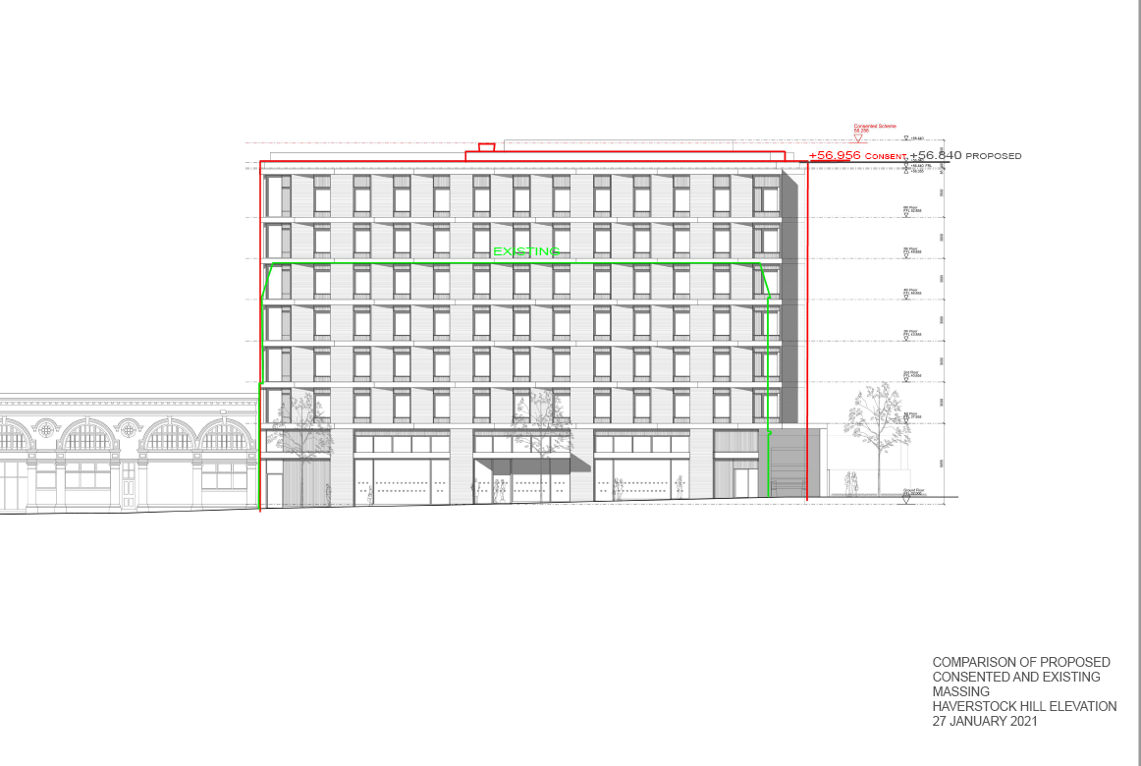

Figure 5: Comparison of existing, approved and proposed massing – Haverstock Hill

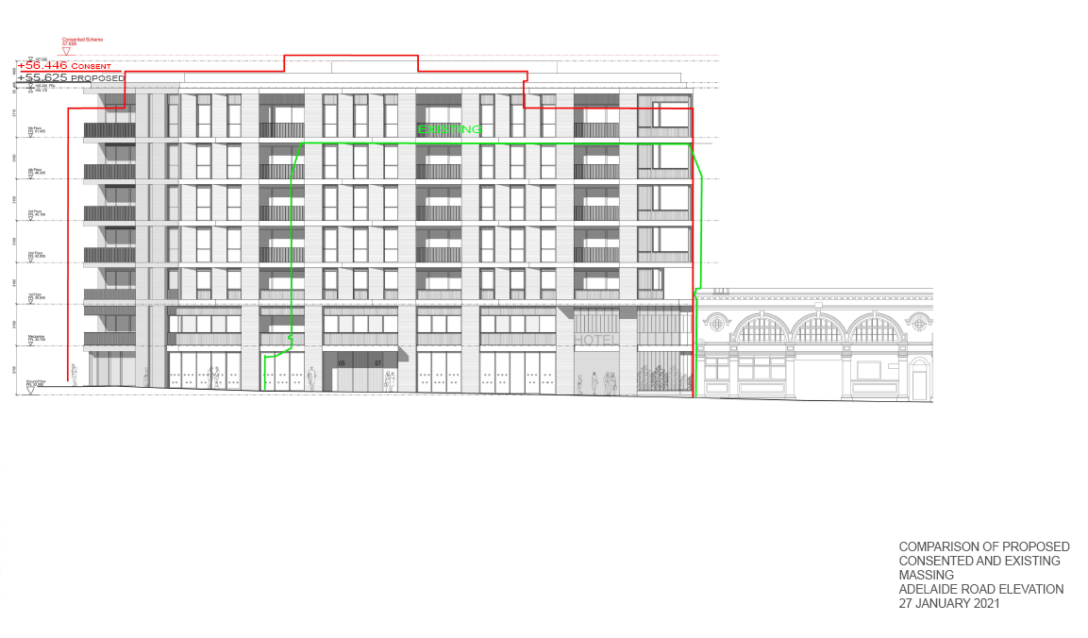

Figure 6: Comparison of existing, approved and proposed massing – Adelaide Road

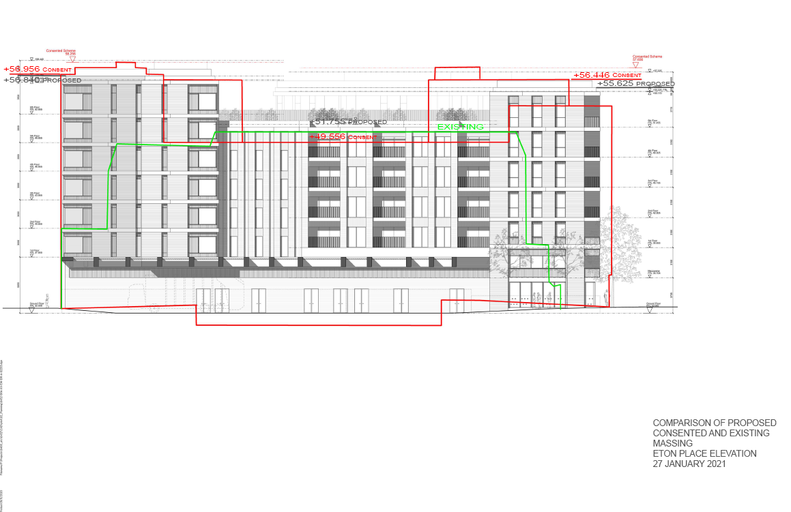

Figure 7: Comparison of existing, approved and proposed massing – rear of site

* 1. There is also a covered colonnaded area at the rear which was not in the approved permission. However, this would not have a daylight impact given its low location at ground/mezzanine level.
  2. Six buildings comprising 300 windows were assessed. Of these six buildings, only Eton Place, which is directly to the north, has windows that would experience a loss of more than 20% of the VSC, as per the BRE guidelines.

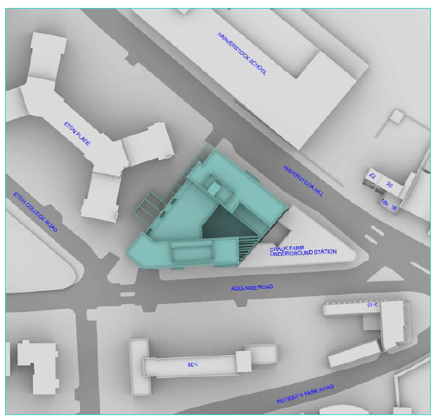

Figure 8: Bird’s eye view showing proposed building and relationship with neighbouring buildings

* 1. 35 windows on this building would experience a loss greater than 20%, 13 of these would experience a loss of between 20% and 30% and one would experience a loss of 43.50%. This worst affected window (W2/10) serves a living room, however this room is served by another window, which would still meet BRE guidelines. Most of the other worst-affected rooms are kitchens or bedrooms which are afforded less protection than living rooms. Many of the living rooms with a window experiencing a loss greater than BRE guidelines, have another window which would remain within the guidelines. There are six living rooms where both windows are affected above the guidelines (R510, R5/11, R5/12, R4/20, R4/21 and R4/22). With some of these windows, the discrepancy above the guidelines is minor. The worst-affected is R5/10, serving flat 7 of Eton Place which would experience reductions of 31.99 and 30.63.
  2. This loss would be above BRE guidelines, but given the orientation of Eton Place to the site, some loss is expected if this site is to be redeveloped. Principally, the urban setting of the site and the Y-shaped configuration of the building means that the rooms and windows facing the site receive light from an oblique view and are sensitive to further change. The development site is, therefore, somewhat constrained by the architecture of the building itself as it is largely dependent on deriving light from this direction. Generally, the effect of the proposed development upon the daylight amenity of Eton Place is, therefore, considered to be acceptable and commensurate with other housing developments in similar urban locations. The proposed scheme has more impact on some windows and less on others, than the approved scheme. Overall, there is marginally less impact. The reductions on VSC and NSL are considered acceptable.

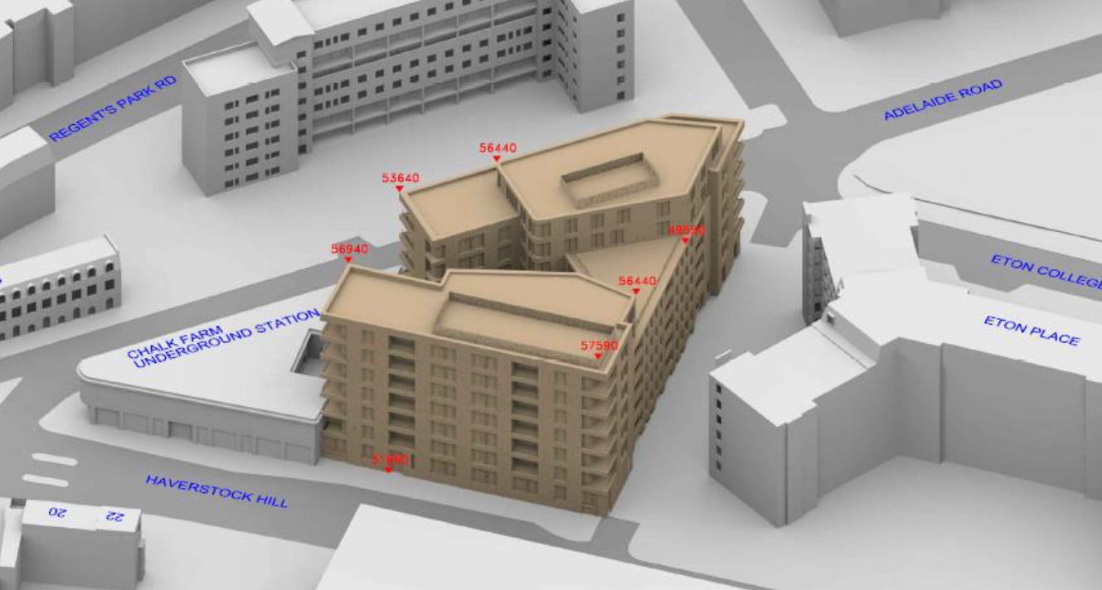

Figure 9: View of approved building (over Haverstock Hill)

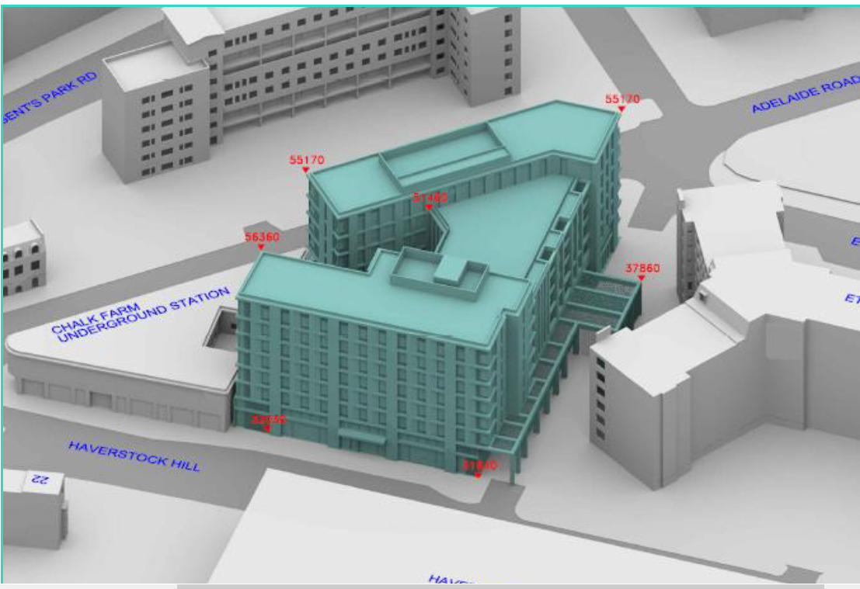

Figure 10: View of proposed building (over Haverstock Hill)

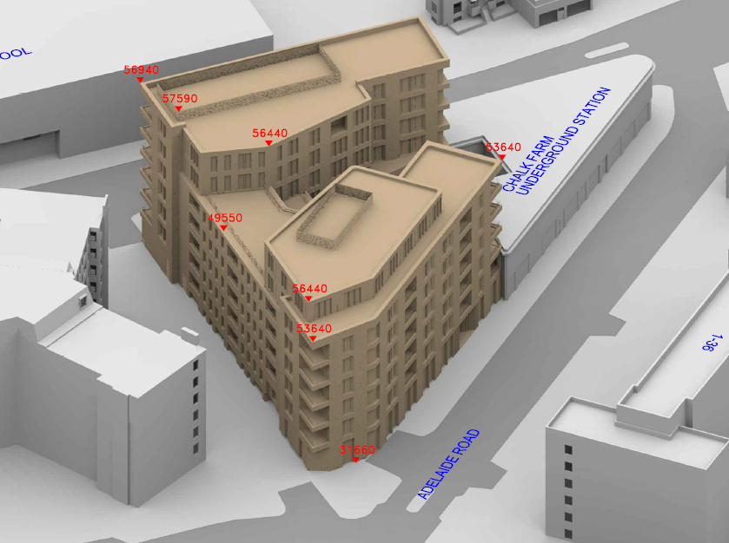

Figure 11: View of approved building (over Adelaide Road)

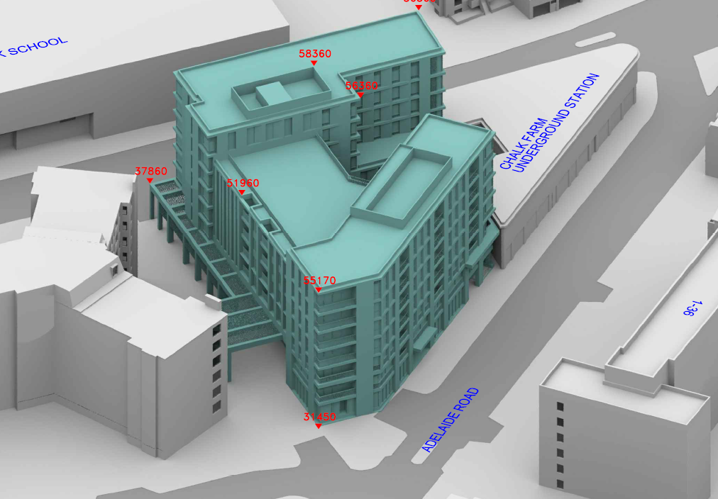

Figure 11: View of approved building (over Adelaide Road)

Outlook, overlooking and loss of privacy

* 1. The residential properties potentially affected by the proposed development in terms of outlook, overlooking and privacy are those located to the northwest and south of the site: nos. 1-118 Eton Place and nos.1-36 Adelaide Road (Bridge House).
  2. As part of the proposals, outlook and privacy has been maintained for the occupants of the adjacent Eton Place, to the north-west boundary of the site. The proposal is 2m closer to the boundary (building edge – not including colonnade) than the existing building and is 14.5m away from the nearest habitable room in Eton Place at its closest point with most overlooking distances exceeding 18m. In addition, the large mature trees situated along the boundary line create a significant level of natural privacy.
  3. The windows to surrounding residential buildings do not directly face the proposed buildings, but are located at an oblique angle from the front and rear windows of these properties. By virtue of the size and scale of the proposed replacement buildings and the distance which they would be set away from neighbouring properties the development is not considered to result in a loss of outlook to neighbouring residential occupiers. Furthermore, the proposed bulk and massing is similar to the approved.
  4. Given the separation distances proposed and positioning of the proposed windows and amenity areas, the proposed buildings would not appear visually overbearing or result in any greater increase in overlooking or loss of privacy to neighbouring properties relative to the existing or approved situation.

Noise and disturbance

Residential use

* 1. The new residential units proposed within the development would not have a detrimental impact on the amenity of surrounding properties in terms of noise or disturbance.

Plant and equipment

* 1. The applicant has submitted a Noise and Vibration Impact Assessment as part of this application. This has been reviewed by the Council’s Environmental Health Officer who raises no objections subject to conditions on anti-vibration and noise limits.
  2. No extract ducts are proposed on the exterior of the building and should the applicant require these in the future separate planning permission would be required. Plant is proposed on the roofs. Where the application to be approved, conditions would be attached ensuring the plant operate within standard noise limits and also anti-vibration measures. Insufficient details have been shown of the extraction from the restaurant and hotel – these would also be conditioned were the application to be approved.

Hotel use

* 1. The site is just outside the Town Centre and marks the start of a more a residential area, north of the busier, commercial area of Camden Town. The introduction of a large-scale hotel use could raise significant noise and disturbance issues through late night movements. The proposed restaurant for the hotel could also create noise and disturbance. This restaurant would be open to the public, as well as hotel patrons. If the application were approved, a Hotel Management Plan would be secured through a section 106 agreement. This would detail hours of use of the restaurant, and how noise from hotel patrons would be dealt with, in particular as they arrive and leave. It should also be noted that the existing retail units could be converted to restaurant use without the need for planning permission, using permitted development rights, which could have an amenity impact. Given the application is refused, this forms a reason for refusal.

1. AIR QUALITY
   1. Camden Local Plan policies CC4 is relevant with regards to air quality. Mitigation measures are expected in developments located in areas of poor air quality.
   2. The proposals are air quality neutral, car free and propose a non-combustion heat pump solution for heating and hot water which is welcomed. The modelling indicates that the nitrogen dioxide and particulate matter pollution levels for the occupants are within the required objective levels. Mechanical ventilation with heat recovery is proposed with intakes to be located as far away from pollution sources as possible which is welcomed. A condition is recommended (in the event permission were granted) to ensure inlet locations are acceptable.
   3. The construction dusk risk is medium and appropriate mitigation has been proposed which should be secured through the CMP. At least two real time dust monitors would be required throughout the development which should be secured through a condition (if permission is granted). The CMP would be secured via section 106 were permission to be granted. Given the application is being refused, this forms a reason for refusal.
2. SUSTAINABLE DESIGN AND CONSTRUCTION
   1. Pursuant to London Plan policies 5.2, 5.3, 5.6m, 5.7, 5.9, 5.10, 5.11, 5.12, 5.13, 5.14, 5.15 and 5.17, Camden Local Plan policies CC1, CC2, CC3, CC4 and CC5, all developments in Camden are required to make the fullest contribution to the mitigation of and adaptation to climate change, to minimise carbon dioxide emissions and contribute to water conservation and sustainable urban drainage.
   2. The London Plan climate change policies collectively require developments to make the fullest contribution to the mitigation of, and adaptation to, climate change, and to minimise carbon dioxide emissions. The London Plan sets out an energy hierarchy (Be Lean, Be Clean, Be Green) within which development proposals should seek to minimise carbon dioxide emissions. The London Plan also sets a target for residential buildings to achieve a 35 per cent carbon reduction target beyond Part L 2013 which is broadly equivalent to the 40 per cent target beyond Part L 2010 is to be achieved.
   3. The London Plan and Camden Local Plan seek to achieve the highest standards of sustainable design and construction and states development proposals should demonstrate that sustainable design standards are integrated into the proposal, including its construction and operation.
   4. The demolition of the existing building is accepted in this instance, given there is an extant permission which also involved the demolition. It is accepted that the building was purpose-built as a garage and could not be easily converted to another use.
   5. The proposals meet the 20% reduction through renewables but not only fail to meet the Be Lean reduction targets but increase on the baseline for the commercial areas and do not meet the -35% minimum on site carbon reduction requirement for either the commercial or residential areas which is unacceptable. SAP 10 is an update on the methodology and testing procedures used to calculate energy use in new residential developments. Whilst the SAP2012 carbon emission information submitted for this application indicates that the proposals would not meet the requirements, the unsubstantiated SAP10 carbon factor submissions indicate that the proposals would be likely to meet the overall minimum 35% carbon reduction and 20% on site renewables requirements. Therefore, in this case a revised Energy Statement, providing verification of these figures and also requiring the other energy efficiency requirements to be met, could be conditioned.
   6. It is noted however that the lack of verification of the SAP10 calculations means that we can only use the SAP2012 figures for the calculation of the carbon offset requirement to ensure that the building meets the requirement to be net zero carbon.  The carbon offset would be secured through the section 106 and would be £1,262,550
   7. Taking into account the fact that there is an extant planning permission for this site which is for the demolition and rebuild of a building of very similar shape and form to this application, then it is considered that whilst officers would usually require a Whole Life Carbon assessment to be completed before approval to ensure that the design takes into account opportunities to reduce the carbon impact. In this case the missing a Whole Life Carbon assessment could be conditioned in these circumstances.
   8. The proposals for heat pumps and solar panels are generally welcomed but further information is required.  There is insufficient information with regards water management, with no mention of grey water or rainwater harvesting which would be expected in a high water use development such as a hotel. The overheating assessment is inadequate as it assumes air conditioning for the private dwellings, although it is not required for the social units. No assessment of overheating is presented for the commercial areas.  Active cooling is not justified.
   9. The BREEAM pre assessment indicates the proposals would meet the requirements with 76% for Energy, 62.5% for water, 78.6% for materials and 84% overall, which is BREEAM Excellent (just below Outstanding at 85%).
   10. Were the proposals to be approved, conditions would be attached to submit an updated energy statement, a Whole Life Carbon Assessment, rainwater/greywater harvesting and construction and demolition waste. The BREEAM overall score of at least 84% (Excellent) and 76% in Energy, 62.5% in Water and 78.6% in Materials would be secured through s106.
3. TRANSPORT

Introduction

* 1. The site is located near the junction of Adelaide Road and Haverstock Hill, in very close proximity to the Chalk Farm Station (underground) and several bus stops, giving the site a Public Transport Accessibility Level (PTAL) score of 6a (Excellent).

Trip generation

* 1. The submitted Transport Assessment (TA) includes details of trip generation analysis from TRICS trip generation software and surveys at similar hotel sites in two London boroughs for the hotel use, and the use of TRICS trip generation software for the residential use. It is likely that the food retail use of the proposed development, which is ancillary to the hotel, will attract mainly users from within the hotel. The non-food retail is of such a size that trips are likely to be generated from passers-by from the adjacent network.

*Hotel*

* 1. The results of the analysis predict the proposed hotel development would generate 55 and 61 additional trips in the morning (8-9am) and evening (5-6pm) peak hours respectively.
  2. The assessment suggests the following modal split:
* 43% walking
* 46% by public transport
* 10% motor vehicles including taxis
* Less than 1% cycling

*Residential*

* 1. The residential element of the proposed development (35 units) is proposed to generate 22 trips in the AM peak and 20 trips in the PM peak, with a modal split of:
* 16% walking
* 73% by public transport
* 3% motor vehicles including taxis
* 8% cycling
  1. The results of the assessment suggest that there will be 77 trips generated in the AM peak and 81 in the PM across both the hotel and residential uses.
  2. The trip analysis suggests that the proposed development will not have a severe impact on the surrounding transport network. However, there is some concern that trips by bicycle have a very low percentage across both uses, and the percentage of trips by taxis/private vehicles are high for the hotel use. The Council anticipates that a higher modal share for cycling and walking, and a lower modal share of taxis/private vehicles can be achieved via a travel plan and the implementation of public realm improvements in the local area to make cycling and walking more attractive to residents, staff and visitors. These would be secured by Section 106 agreement in the event that permission were granted.

Travel planning

* 1. A draft travel plan has been submitted in support of the planning application. This is welcomed as it demonstrates a commitment to encouraging and promoting trips by sustainable modes of transport. A Strategic Level Travel Plan and associated monitoring and measures contribution of £9,762 would be secured as part of the section 106 agreement (for the hotel use) if planning permission were granted. The Travel Plan would be targeted towards staff.

Car parking

* 1. The site is located on the border of two controlled parking zones (CPZ), CA-B and CA-F(nw). Parking controls for CA-B are in place in bays for permit holders, pay to park bays and single yellow lines from 0900 to 1830 on Monday to Friday, 0930 to 1330 on Saturdays, and 0830 to 2300 on Monday to Friday, 0930 to 2330 on Saturdays and 0930 to 2300 on Sundays for CA-F(nw).
  2. The proposed development would involve the use of a servicing road for all vehicles servicing the hotel. This is acceptable from a general parking point of view, as the servicing road will not be used for private parking, and is in accordance with Policy T2 of the Local Plan. The site is easily accessible by public transport and there is not an essential need for residents, staff or visitors to travel to and from the site by private motor vehicle. However, residents, staff and visitors in possession of a blue badge would be able to park on the public highway in the general vicinity of the site, and blue badge bays could be provided on the public highway in the future if required.
  3. A car-free planning obligation would be secured by legal agreement in accordance with Policy T2 if planning permission were granted. This would apply to all proposed uses (Policy T2 requires all new development in the borough to be car-free).

Cycle parking

* 1. In accordance with the London Plan, the proposal is required (as a minimum) to provide the following cycle parking facilities:

|  |  |  |
| --- | --- | --- |
| Land use | Long stay | Short stay |
| C1 Hotel - 118 rooms | 6 | 3 |
| A2-A5 Food & beverage - 562m2 | 3 | 28 |
| A1 Non-food retail -158m2 | 1 | 3 |
| C3 Residential -35 dwellings | 65 | 2 |

* 1. The proposal as indicated on the proposed ground/lower ground floor plan would provide long stay cycle parking facilities as follows:
* 12 long stay spaces for the hotel and restaurant staff
* 61 long stay spaces for residents (27 for the market housing units and 34 for the Social, Affordable or Intermediate Rent units)
  1. The level of provision proposed for the residential does not meets the minimum requirement of the London Plan, and is therefore contrary to requirements of Local Plan Policy T1. A further four spaces are required for the market housing units. In the event that permission were granted it is considered that a condition could be imposed requiring further details of the long stay residential parking to meet the London Plan standard.
  2. Short stay cycle parking spaces are shown on the proposed plans, with 6 in the internal courtyard and a further 28 on the public highway, which would also serve the proposed retail units. The location of these spaces on the public highway are indicative only, and a financial contribution for the short stay provision (28 spaces) would be secured as part of the Pedestrian, Environment and Cycling (PCE) contribution which is discussed below. TfL raised concerns that only 34 short-stay spaces are proposed as opposed to the policy requirement of 38. Given that nearly 90% of short stay spaces are proposed, and the lack of space available on the public highway in the vicinity, the slight shortfall is considered acceptable in this instance.
  3. The provision and ongoing retention of the long stay cycle parking and 8 internal short stay cycle parking spaces would be secured by condition if planning permission is granted.

Deliveries and other servicing activities

* 1. A servicing survey was undertaken by the applicant at a similar site (Holiday Inn) in Kensington – which is of a similar size, to establish the delivery and servicing trips that will be associated with this site. This analysis indicated that there would be approximately four trips by delivery/servicing vehicles associated with the hotel and commercial uses (excluding waste collection). The residential element of the development would also generate four vehicle trips per day. These trips predominantly comprise of courier type deliveries undertaken by light goods vehicle (LGV). The hotel and commercial element of the development will generate three refuse related trips per day, and the residential element will generate up to three refuse trips per week. This equates to an average of 12 vehicle servicing trips per day to the site. The fact that all servicing vehicles will be accommodated off-street, and we will have a servicing management plan, means these trips can be managed.
  2. All delivery and servicing vehicles, including refuse and recycling collections associated with all uses of the site are proposed to be accommodated within the servicing road to the rear of the site. The vehicles will enter the servicing road from Adelaide Road and exit onto Haverstock Hill. Due to the proposed location of cycling facilities in the vicinity of the site, all deliveries to the servicing road would be restricted to take place outside of peak AM and PM commuter periods. Hours of use of the servicing road would be restricted by condition, were the application to be recommended for approval, were the application to be granted.
  3. This increase in servicing related trips should have a negligible impact on the surrounding highway network as long as they are managed effectively and are able to utilise the servicing road to the rear of the site. To ensure that deliveries, refuse and recycling collections and other servicing do not have a severe impact on the area, a servicing management plan will be secured as a section 106 planning obligation if planning permission were granted.

Road Safety Audit

* 1. The introduction of the servicing route through the site would involve large vehicles entering the site via Adelaide Road/Eton College Road and egressing onto Haverstock Hill. There are proposed cycling facilities on both Adelaide Road and Haverstock Hill, with a bus stop in close proximity to the Haverstock Hill end of the service road. These plans for the cycle scheme on Chalk Farm have not been confirmed. The scheme has recently (Dec 2021) been approved to be made permanent. The Council does not unfortunately have plans/proposals as yet for a scheme on Adelaide Road, but still have aspirations to include a cycle/pedestrian scheme there.
  2. The transport assessment submitted by the applicant does include swept path analysis which appears to show that movements by large vehicles can occur safely when entering and leaving the site, however a Road Safety Audit (stage 1 and 2) would flag up any safety issues that can be mitigated with the design of the highway and/or the layout of the entrance to the site. Given the plans progressing/proposed for these cycle routes, a Stage 1 and Stage 2 Road Safety Audit would be required to ensure the proposals do not adversely affect the safety of the users of these areas. This would be required prior to granting planning permission, and therefore forms a reason for refusal.

Highway works contribution

* 1. The carriageway and footway directly adjacent to the site is likely to sustain significant damage as a result of the proposed demolition and construction works. The Council would need to undertake remedial works to repair any such damage following completion of the proposed development.
  2. A highways contribution would need to be secured as a section 106 planning obligation if planning permission is granted. This would allow the Council to repave the carriageway and footway directly adjacent to the site and repair any other damage to the public highway in the general vicinity of the site. The highway works would be implemented by the Council’s highways contractor on completion of the development. A cost estimate for the highway works has been provided by the Council’s Transport Design Team of £37,931.38.

Pedestrian, cycling and environmental improvements

* 1. The development would introduce new residential and hotel associated trips to the area. The Council, through its policies and strategies aims to encourage active travel such as walking and cycling as the primary mode of transport for short journeys within the borough, and is committed to improving cycling and pedestrian routes in the area.
  2. The Council will seek to secure a Pedestrian, Cycling and Environmental (PCE) improvements contribution as a section 106 planning obligation if planning permission is granted. This would be used by the Council alongside contributions secured from other major developments and funding provided by other sources to transform the public realm in the general vicinity of the site for the benefit of cyclists and pedestrians. The contribution would be focused towards improving cycling and walking routes within the vicinity of the site on Adelaide Road and Chalk Farm Road. This could include (subject to feasibility, consultation and detailed design) the provision dedicated cycle facilities, improved crossing points for pedestrians and cyclists. These measure will help to encourage residents, staff and visitors to the site to walk and cycle. The PCE contribution is £37,000 (which includes £7000 for cycle parking)
  3. As discussed in the cycle parking section above, the development will not provide the full required provision of short stay cycle parking spaces on site. The Council will implement short stay spaces on the public highway within the vicinity of the site as part of the works associated with PCE contribution.

Managing and mitigating the impacts of construction

* 1. Construction management plans (CMPs) are used to demonstrate how developments will minimise impacts from the movement of goods and materials during the construction process (including any demolition works). A draft CMP has been submitted in support of the planning application. However, the document lacks detail as a principal contractor has yet to be appointed.
  2. Our primary concern is public safety but we also need to ensure that construction traffic does not create (or add to existing) traffic congestion in the local area. The proposal is also likely to lead to a variety of amenity issues for local people (e.g. noise, vibration, air quality, temporary loss of parking, etc.). The Council needs to ensure that the development can be implemented without being detrimental to amenity or the safe and efficient operation of the highway network in the local area. A far more detailed CMP would therefore be secured via a Section 106 planning obligation if planning permission is granted.
  3. The Council would expect construction vehicle movements to and from the site to be scheduled to avoid peak periods to minimise the impacts of construction on the transport network. The draft CMP states that vehicular movements/deliveries will be restricted to the hours of 9.30am and 3pm on weekdays during term time of Haverstock School. The contractor would need to register the works with the Considerate Constructors’ Scheme. The contractor would also need to adhere to the CLOCS standard.
  4. The development, if approved, would require significant input from council officers. This would relate to the development and assessment of the CMP as well as ongoing monitoring and enforcement of the CMP during demolition and construction. A CMP implementation support contribution of £28,520 would be secured via a Section 106 planning obligation if planning permission were granted.

Construction Impact Bond

* 1. Construction activity can cause disruption to daily activities, however a well-run site that responds to the concerns of residents can greatly improve the situation.  While most sites deal quickly and robustly with complaints from residents, and reinforce the requirements of the CMP with site operatives, there can be situations where this does not occur and officers in the Council are required to take action. Due to the nature of the development and the location of the site, the Council may have to allocate resources to monitor and support the delivery of obligations secured through the CMP. A construction impact bond of £30,000 would need to be secured via a Section 106 planning obligation if planning permission were granted.

1. CONTAMINATION
   1. The NPPF notes that the planning system should contribute to and enhance the local environment by remediating contaminated land, and that the responsibility for ensuring a safe development rests with the developer.
   2. The application site does not fall within the definition of ‘contaminated land’ as described in part 2A of the Environmental Protection Act 1990, and consequently there are no significant contamination risks associated with the proposed development.
   3. An investigation of the site has been undertaken by the applicant. In addition it was found that within the immediate surrounding area there was not a particularly contaminative history and there has been no identification of soil gas. Contamination testing on the site identified elevated levels of some contaminants on the site. However, testing undertaken and recommendations identify that the end users of the site will be isolated from direct contact with the identified contaminant.
   4. Within the proposed soft landscaped areas in the courtyard, some form of remedial measures will be required. Overall there is not considered to be a risk to developing this land from a contaminated land perspective.
   5. No objection is raised to the proposal subject to a condition securing a ground investigation programme prior to the commencement of works, were the application to be approved.
   6. With regard to asbestos, the developer would be required to provide an intrusive pre-demolition and refurbishment asbestos survey in accordance with HSG264 supported by an appropriate mitigation scheme to control risks to future occupiers. The scheme must be written by a suitably qualified person and shall be submitted to the LPA and must be approved prior to commencement of the development. The scheme as submitted would be required to demonstrably identify potential sources of asbestos contamination and detail removal or mitigation appropriate for the proposed end use. Detailed working methods are not required but the scheme of mitigation would be required to be be independently verified to the satisfaction of the LPA prior to implementation. An informative would be attached to any permission granted.
2. FIRE SAFETY
   1. Policy D12 (Fire Safety) of the London Plan requires all major development proposals to be submitted with a Fire Statement. The application includes a Fire Statement.
   2. The submitted statement was developed in line with British Standards and Building Regulations. It addresses the requirements set out in policy D12, relating to the means of escape and safety features. The Fire Statement covers both the residential building and the hotel. Details of means of evacuation and escape, materials and structure have been submitted in the statement. The details would be assessed by Building Control under the Building regulations 2010 Act were this application to be approved.
3. FLOODING AND DRAINAGE
   1. Policies CC1 and CC3 are relevant with regard to flood risk and drainage.
   2. The site falls within Flood Zone 1, which is assessed as having a less than 1 in 1,000 annual probability of river or sea flooding (<0.1%). The Flood Risk Assessment submitted with the application shows that the site is not located within a Local Flood Risk Zone and has low risk of flooding. Surrounding roads were flooded in both 1976 and 2002 but the site itself was not flooded. Implementing SuDS on site should reduce the impact of surface water flooding downstream.
   3. The existing site comprises an impermeable surface over the entirety of the site. The proposals will incorporate sustainable surface water drainage measures including subsurface storage and blue and green roofs. The proposals will provide a robust and sustainable drainage regime and will not increase flooding at the site or elsewhere fully according with policies CC1 and CC3.
   4. A condition requiring full details of the Sustainable Drainage Strategy would be attached if planning permission were to be granted. Such a system should be designed to accommodate all storms up to and including a 1:100 year storm with a 30% provision for climate change, such that flooding does not occur in any part of a building or in any utility plant susceptible to water, and to achieve 50% reduction in run off (targeting a maximum of 14 l/s run-off in all storm events up to and including the 1 in 100 year 6 hour storm). The system shall include: blue/ green roofs (providing 23m3 of storage) and an attenuation tank (providing 47m3 of storage), and shall thereafter be retained and maintained in accordance with the approved maintenance plan.
4. EMPLOYMENT AND TRAINING
   1. The proposed development is large enough to generate significant local economic benefits. In the case of such developments the Council will seek to secure employment and training opportunities for local residents and opportunities for businesses based in the Borough to secure contracts to provide goods and services.
   2. In line with the CPG, a range of training and employment benefits would be secured in order to provide opportunities during and after the construction phase for local residents and businesses, were the application approved. These are as follows:

*Construction phase:*

* The applicant should work to CITB benchmarks for local employment when recruiting for construction-related jobs as per section 68 of the Employment sites and business premises CPG
* The applicant should advertise all construction vacancies and work placement opportunities exclusively with the King’s Cross Construction Skills Centre for a period of 1 week before marketing more widely.
* The applicant should provide a specified number (to be agreed) of construction work placement opportunities of not less than 2 weeks each, to be undertaken over the course of the development, to be recruited through the Council’s King’s Cross Construction Skills Centre, as per section 70 of the Employment sites and business premises CPG
* If the build costs of the scheme exceed £3 million the applicant must recruit 1 construction apprentice paid at least London Living Wage per £3million of build costs, and pay the council a support fee of £1,700 per apprentice as per section 65 of the Employment sites and business premises CPG. Recruitment of construction apprentices should be conducted through the Council’s King’s Cross Construction Skills Centre. Recruitment of non-construction apprentices should be conducted through the Council’s Economic Development team.
* If the value of the scheme exceeds £1 million, the applicant must also sign up to the Camden Local Procurement Code, as per section 71 of the Employment sites and business premises CPG; and
* The applicant provide a local employment, skills and local supply plan setting out their plan for delivering the above requirements in advance of commencing on site, as per section 63 of the Employment sites and business premises CPG.

*End use phase:*

* We would request provision of a rolling programme of 1x end use apprenticeship paying at least London Living Wage. The apprenticeship could be within a range of roles (examples include hospitality, business administration, finance, customer service, IT).
* The applicant should provide a 2 end use work placement opportunities of not less than 2 weeks each, to be recruited through the Council’s Economic Development team
* The applicant should support the Good Work Camden programme, including the following commitments:
* Advertise vacancies in partnership with Good Work Camden and its relevant local employment support providers to create pathways into jobs on the site
* Commitment to providing supported employment opportunities – e.g. supported internships
* The Council would seek to negotiate a Section 106 contribution to be used by the Economic Development service to support employment and training activities and local procurement initiatives. This contribution would be calculated as follows:

No of bedrooms x 0.5 [number of employees per bedroom] = full time jobs created

Full time jobs created x 21% [% of Camden residents who work in Camden] x 35% [% of employees requiring training] x £3,995 [£ per employee requiring training] = employment and training contribution

* 1. Given the application is refused, failure to secure the above forms a reason for refusal.

1. PLANNING OBLIGATIONS
   1. Were the application approved, ‘Heads of Terms’ would be embodied in the S106 legal agreement to mitigate the impacts of the development. Given the application is being refused, these are included as reasons for refusal.
2. MAYOR OF LONDON’S CROSSRAIL CIL AND CAMDEN’S CIL
   1. The proposal would be liable for both the Mayor of London’s CIL and Camden’s CIL given the net increase in floorspace. The Mayor’s CIL would be £122,271.20 and the Camden CIL would be £241,079.90.
3. CONCLUSION
   1. In conclusion, the proposed development is unacceptable, due to:

* the loss of much-needed approved housing,
* being an inappropriate site for a large-scale hotel
* failure to demonstrate the servicing would not impact on road safety.