**62/64 Hampstead Road/144 Drummond Street NW1 2PB LDC application: Plans 1, 2, 3**

**Plan 1: Location Plan**

**Plan 2: Third and Fourth Floors plans and elevations permitted by appeal APP/X5210/A/08/2075312 (January 2009)**

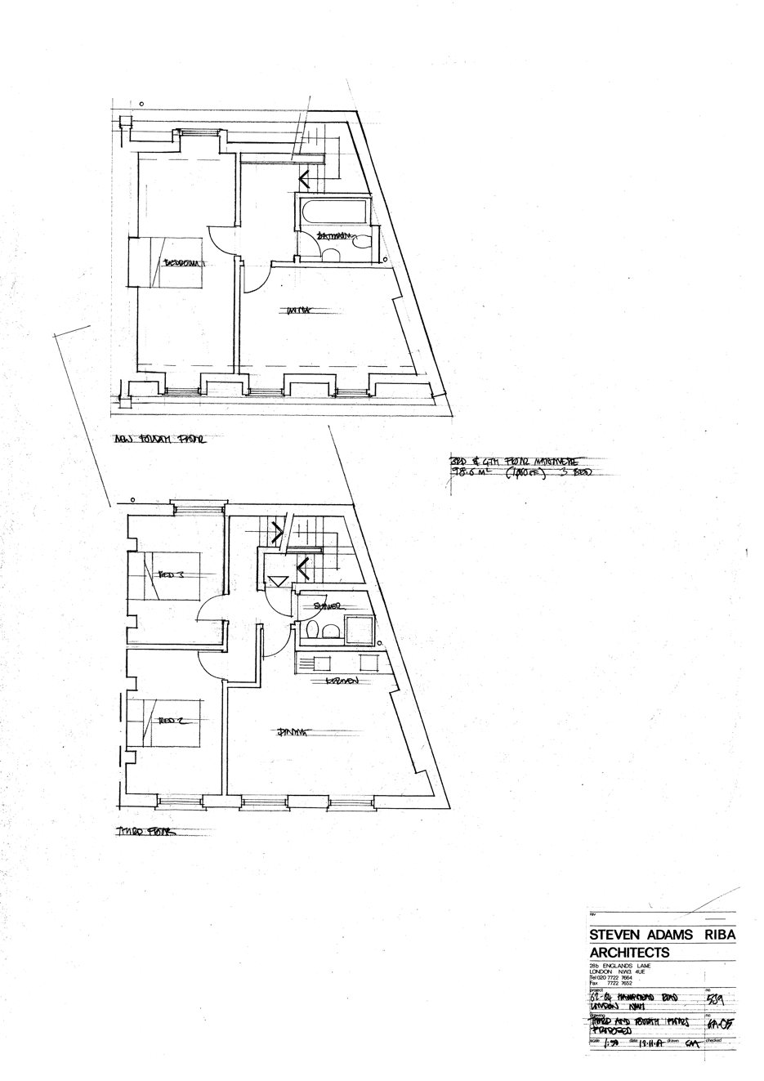

Note: No kitchen on fourth floor

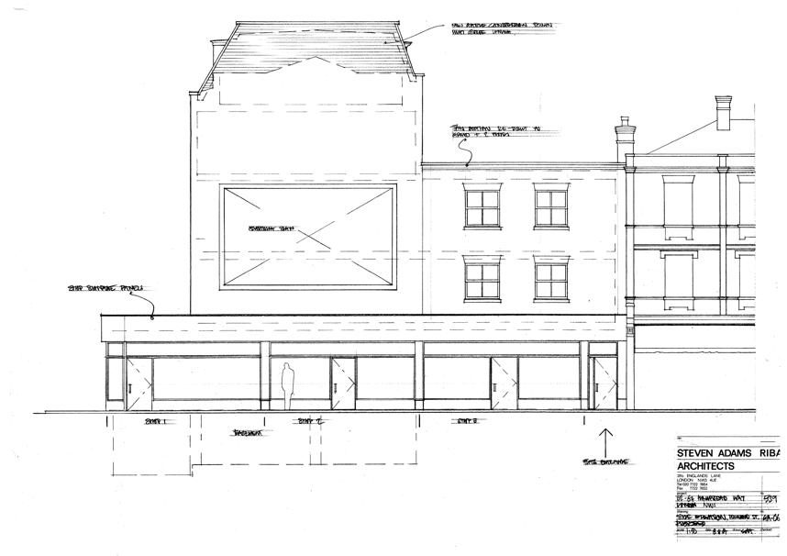

**Plan 3: Flats 5 and 6 in self-contained configuration**

**Flat 6 fourth floor (note kitchen)**

**Flat 5 third floor**