GARDEN SHELTER CONSTRUCTED AT
45 BELSIZE PARK GARDENS, LONDON NW3 4JL

DESIGN STATEMENT

INTRODUCTION

This design statement has been prepared following the guidance and headings set out in the document Design and access statements - How to write, read and use them, published in 2006 by the Commission for Architecture and the Built Environment.
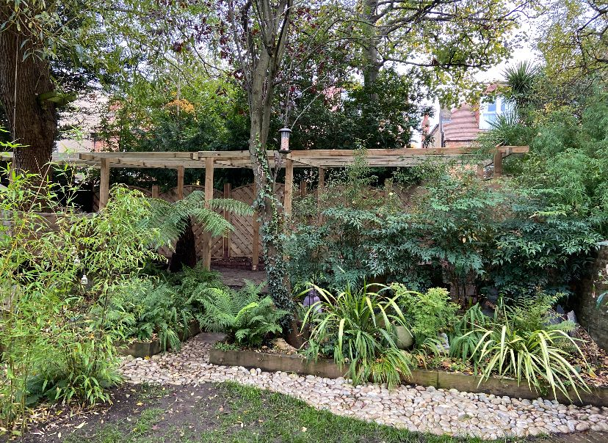
View of Garden Shelter from the garden

DESCRIPTION

An open fronted garden shelter has been constructed in the rear garden of 45 Belsize Park Gardens, without Planning Permission. This retrospective Planning Application seeks to rectify the error by obtaining Planning Permission for the work.

The property at 45 Belsize Park Gardens is owned by Camden Council and contains seven flats that share a rear communal garden, this garden Camden Council has neglected to maintain. The resident of Flat E, Mr. B. McGinlay, has for many years been tending and landscaping the rear garden, transforming it from a wilderness into the pleasant space that it is today.

Page 2

In March 2021 Mr. McGinlay started to construct a garden shelter unaware that the property was within the Camden Conservation Area, and that Planning Permission was required.

Mr. McGinlay received a visit from the Camden Enforcement Officer on 15 June 2021 and was informed that the construction contravened the Planning Act, and that he would be receiving a letter requesting that he submit a Planning Application. However, he never did receive a letter from the Council, although the Council claim that a letter was sent dated 16 September 2021.

Immediately after the visit by the Enforcement Officer, Mr. McGinlay placed Simpson McHugh on notice that he may require their services, but he delayed appointing them awaiting to see if this open lightweight structure, really needed permission. He was therefore surprised after 8 months, to receive an Enforcement Notice on 14 February 2022 and immediately put steps in place to regularize matters.

THE WORKS

The garden shelter is a lightweight structure constructed of 100 x 100 timber posts on steel fence post supports in the ground. There are no foundations so that nearby trees are unaffected.
The shelter is partly enclosed but mainly left open.

The rear wall is in part lined with ply sheets and in part left open.
The front of the shelter is completely left open.
The two end panels are intended to be clad in stained shiplap boarding, although one end has been completed, the other end has not yet been boarded as the work was halted.

The floor of the shelter is partly of timber with the open area paved with York stone, both laid directly on the earth.
The shelter is partly covered with translucent corrugated sheets with the other section being left open with pergola joists over.
The Shelter has no heating and there is no electricity connected.

SIZE

The size of the shelter is as follows:
Length 4.80m
Width 2.20—2.90m
Height at the front 2.30m
Height at the rear 2.50m
The floor area is 12.24sq.m.
Although in this case Permitted Development is not applicable, the size and positioning of the garden shelter conforms to the requirements for Permitted Development for outbuildings that are not within a conservation area.

Page 3

AMENITY SPACE

The rear garden of 45 Belsize Park Gardens provides amenity area for all the seven flats. However, the owners, Camden Council, have not provided any maintenance or upkeep of the garden for many years, so it has fallen on the residents to look after the garden themselves.
When Mr. McGinlay moved into his first floor flat with his family in 2008, the rear garden had been neglected and it was Mr. McGinlay who took it upon himself to transform the area into the pleasant space that it now is today.

Mr McGinlay has landscaped the garden spending a lot of his time and money to create an area that he and his family together with all the other residents can enjoy.

However, there is a real problem for the residents wanting to access the rear garden, for contrary to the Councils Planning guidance, there is no direct access for the flats to the amenity area. The only flat that has direct access is the rear garden flat, which has direct access onto the patio.

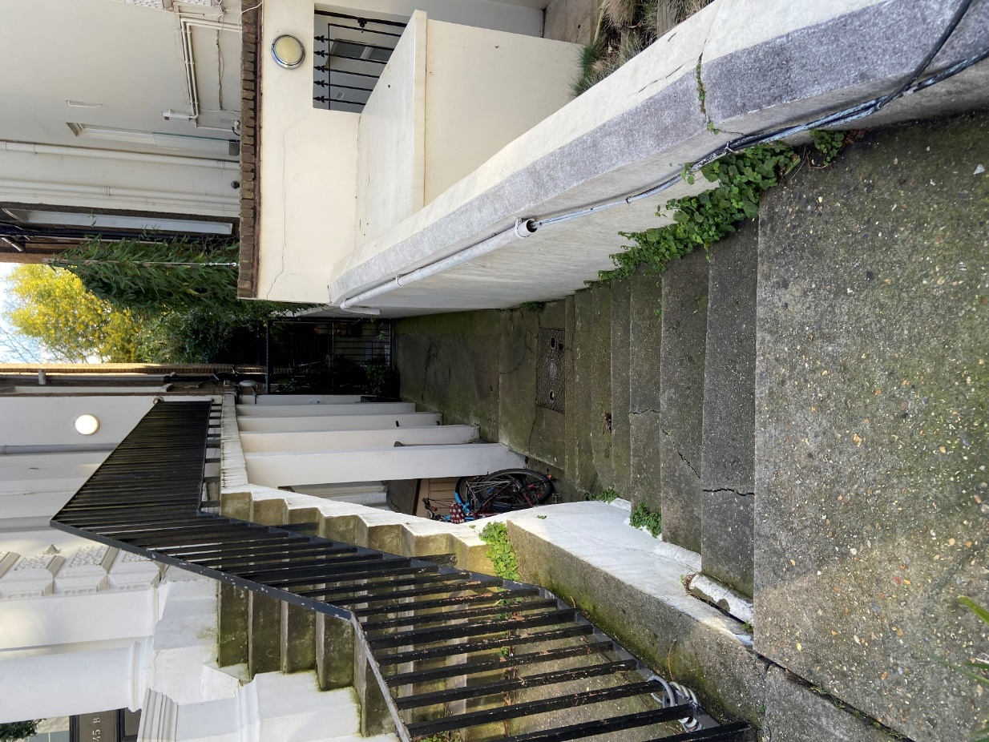
Access to the garden for the upper flats is via flights of stairs to the front door, then along a raised access walkway and down a half flight of stairs to the front of the building, only then to have to turn and descend another half flight of stairs and walk down a side path for the length of the building, opening two sets of gates and finally reaching the garden. The problem is made worse for the residents living on the higher floors having to negotiate several flights of stairs as there is no lift.

View of raised walkway and side path to garden

Page 4

NEED

There is a great need for the residents who use the rear garden to have a shelter that they can use as a temporary place to shelter from a sudden rain showers or when the weather turns colder while in the garden.
At present all items, such as crockery, glasses, games, etc. have to be hurriedly collected up and transported back to the flats along the tortuous route. The garden shelter provides a very useful place to use and prevent excessive journeys.
There are currently four children living in the flats with ages between 7 and 13. The garden allows them to play games and exercise, however this is not used as much as it should be due to the difficulties of access. The garden shelter will help encourage more families to use the garden space.
The open frontage allows the users to sit inside, even in inclement weather and enjoy the garden experience.
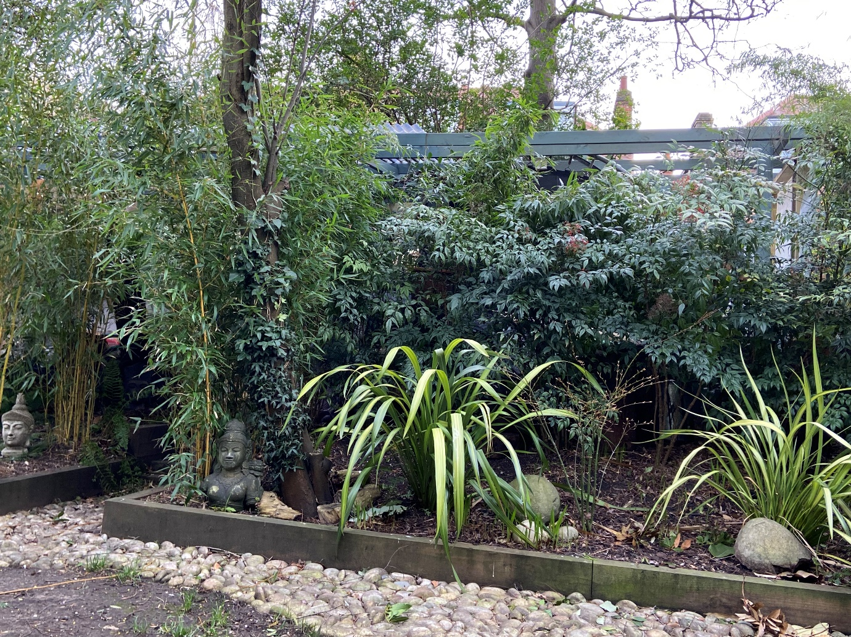

Front of Garden room showing the planting providing screening

Page 5

DESIGN

The design has employed the use of natural materials of timber and York stone.
It has purposely been designed with large areas of open walls and roof, so as to blend in with the environment.
The shelter has no heating and is not equipped with electricity as it is not designed to be used as a room or after dark. The natural materials together with its open frontage allows the shelter to sit comfortably into the garden surroundings.
The landscaping although not complete has created natural screening so that it is barely visible from surrounding properties.
There is no heating so there is no energy loss or damage to the environment.

THE SURROUNDING AREAS

The properties on this side of Belsize Park Gardens are of a similar age and size, with most of the rear gardens being of a similar 10m width to that of 45. Many sheds and outbuildings have been erected in several gardens in the street. Some examples are found in the nearby gardens of the properties on either side of 45 as follows:
49 - A large outbuilding at the rear of the garden with a floor area of approx. 48sqm
47 - A small shed at the rear of the garden with a floor area of approx. 3.6sq.m.
43 - A large triangular garden room measuring 5.3 deep and 7m wide Granted permission in
2016 ref 2015/5803/P It has been positioned some 4m away from the rear fence.
There is also a small shed at the rear of the garden room with a floor area of 18sq.m.
39 – A large outbuilding at the rear of the garden with a floor area of approx.28sq.m.

The garden shelter with a floor area 12.2sq.m is considerably smaller in size than that of the outbuildings at Nos.49 & 39 and the garden room at 43 and is also far less conspicuous than these other outbuildings.

CONCLUSIONS

- Although the garden shelter has been erected in a Conservation Area without the consent of the Council, there are many examples of even larger sized outbuilding being permitted in the street.
- The garden shelter has been designed and built in natural materials to blend in with the surroundings and is well screened by the landscape plantings
- The garden shelter provides a much-needed amenity for all the residents of the flats and so encourages the use of the common garden for all families.

February 2022

