Regeneration and Planning  
London Borough of Camden  
2nd Floor, 5 Pancras Square  
C/o Town Hall, Judd Street  
London  
WC1H 9JE

14th February 2022

Dear Sir / Madam

Full planning application for an office outbuilding at Flat 78a Caversham Road, London, NW5 2DN, planning portal reference: PP-11012717

In addition to the planning application submission we’d like to include the following information to explain the building in more detail.

**Building use**

The building will be used as an office with two desks and office equipment. Currently the desks and equipment is in our spare bedroom and living room. There are no plans to use this for anything else and there will not be space for alternative use due to our office equipment.

**Build**

Access to the site/back garden will be via the front door of flat 78a so there will be no large machinery onsite. Materials like doors, windows and timber will need to be kept to size to fit in through the house. Hence the standard door and smaller windows and not bifold door and windows or large prefabricated components. The area is currently paved and the building will be sited on this area.

Dimensions will be internal 320cm x 400cm = 12.8 m2, external 380cm x 460cm = 17.48 m2. The back garden is 120m2 in total.

The building will be 50cm from the eastern boundary for 80 Caversham Road and 100cm from the north boundary for 59/61 Oseney Crescent.

**Cladding for the external walls**

The building will be covered in a natural hardwood cladding cedar/ larch in a natural finish and for the north and east facing walls cement boards due to access and distance from the fencing.

The larch cladding will be similar to these examples:

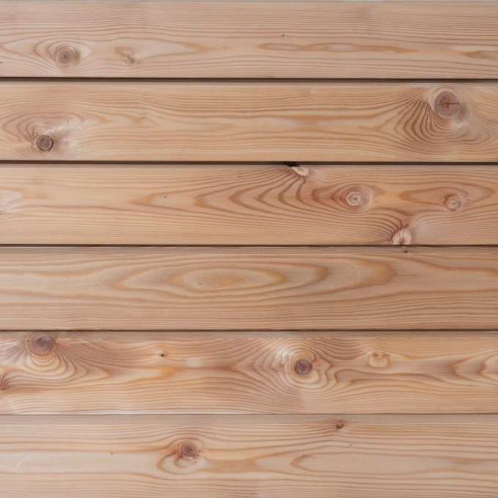

**Door and windows**

Door and window will be A energy rated and made from natural hardwood and finished in a grey colour.

The door will be glazed and open outwards and look like this example:

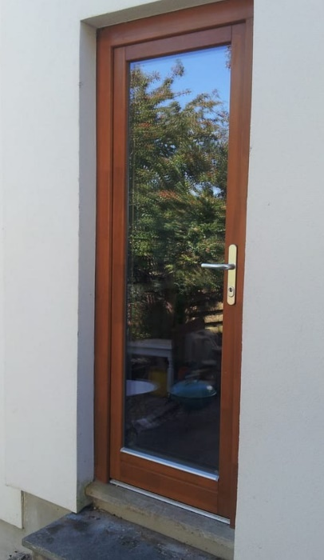

The window will open outwards and will have a similar look to the ones below:

**Window orientation**

The windows will be positioned facing west away from the neighbouring properties and towards Bartholomew road. The windows will be below the height of the neighbour fences for 76 Caversham Road and 61 Oseney Crescent so as not to overlook their properties.

**Site photos:**

This is the back garden where the office will sit: