Spencer Walk 25  
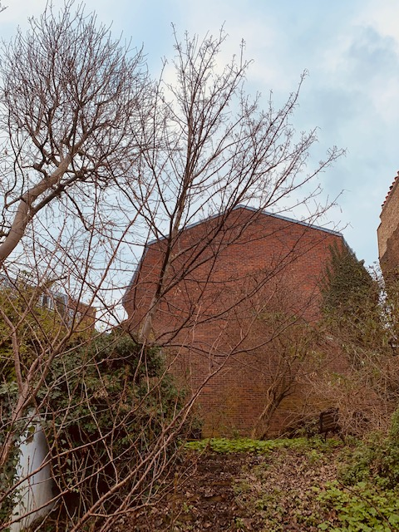

Pushing wall over roots self set sycamore tree   
