

**Construction Management Plan- Addendum no.6**

**Date: 27th January 2021**

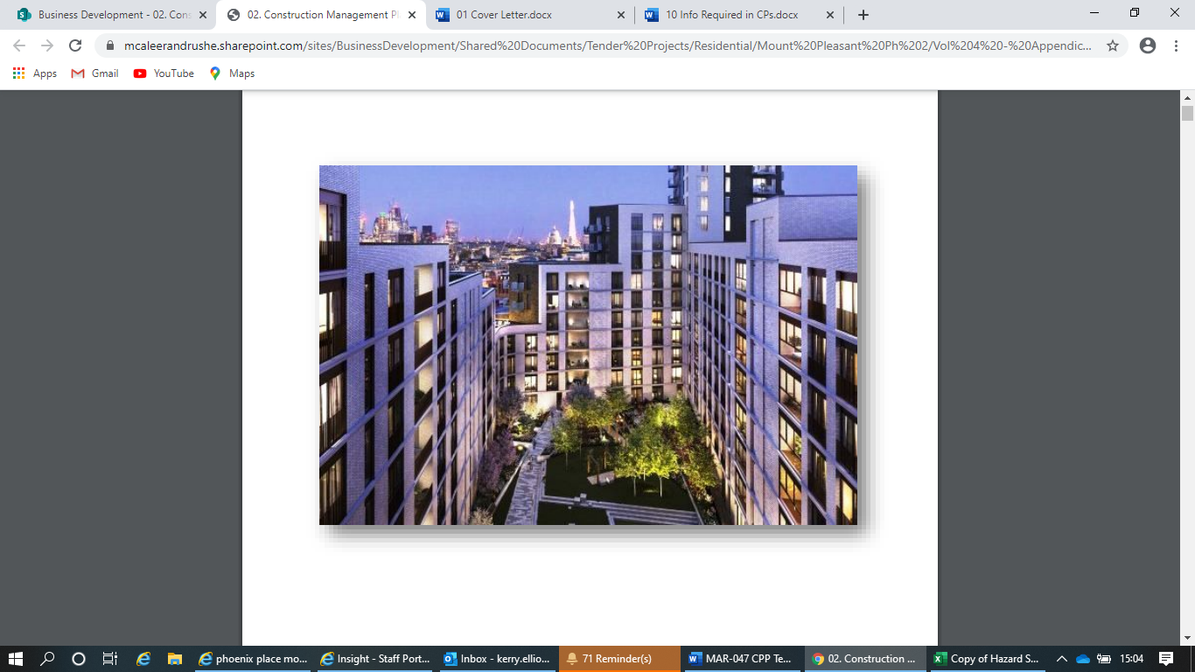

**Contents**

Revisions 2

Introductions 3

Contacts- Update 3-4

Amendments to CMP 5-7

Resident Notification Bulletin 8-10

Signature Page 11

**Revisions**

|  |  |
| --- | --- |
| **Date** | **Produced by** |
| 25th March 2019 | Bouygues UK |
| 4th April 2019 | Bouygues UK |
| 30th March 2020 | Bouygues UK |
| 30th October 2020 | Bouygues UK |
| 13th November 2020 | McAleer & Rushe |

**Introduction**

This addendum is to be read in conjunction with the approved Construction Management Plan (CMP), currently version is 4.1 dated 15th June 2018

The purpose of the addendum is to complement the CMP by providing information on any minor modifications to the proposed works and how the impacts will be mitigated and managed.

**Contacts- Update**

**1.Site Address and CMP approval reference**

Site Address; Mount Pleasant Project, 5 Gough Street, London WC1X0DD

CMP approval: Section 106 discharge notice received on 15/6/2018

**2.Contact details for the person responsible for submitting the CMP addendum**

Name: Eoin Gormley

Address: 100 George Street, London, W1U8NU

Email: [eoin.gormley@mcaleer-rushe.co.uk](mailto:eoin.gormley@mcaleer-rushe.co.uk)

Phone: 07843955249

**3. Contact details of the project manager**

**Phase One- Bouygues UK**

Name: Jean-Marie Perret

Address: Bouygues UK, Mount Pleasant Project, 5 Gough Street, London WC1X0DD

Email: [jean-marie.perret@bouyges-uk.com](mailto:jean-marie.perret@bouyges-uk.com)

Phone:07951633915

**Phase Two- McAleer & Rushe Contracts UK**

Name: Eoin Gormley

Address: McAleer & Rushe HQ- 100 George Street, London, W1U8NU

Email: [eoin.gormley@mcaleer-rushe.co.uk](mailto:eoin.gormley@mcaleer-rushe.co.uk)

Phone: 07843955249

**4.Contact details of the person responsible for community liaison**

Name: Eoin Gormley

Address: McAleer & Rushe HQ- 100 George Street, London, W1U8NU

Email: [eoin.gormley@mcaleer-rushe.co.uk](mailto:eoin.gormley@mcaleer-rushe.co.uk)

Phone: 07843955249

**5.Contact Details for receipt of legal documents for the implementation of the CMP**

Name: Eoin Gormley

Address: McAleer & Rushe HQ- 100 George Street, London, W1U8NU

Email: [eoin.gormley@mcaleer_rushe.co.uk](mailto:eoin.gormley@mcaleer_rushe.co.uk)

Phone: 07843955249

**Amendments to CMP**

**Addendum no.6**- Temporary lane closure on Phoenix Place to accommodate site logistics for construction works on phase two project.

1. **Current**

Approved CEMP- Construction Management Plan (CMP) pro-forma- final v4 approved doc with appendices dated 15th June 2018

Gough Street to have Southern car parking bays suspended and this street used for heavy good and artic-lorry deliveries. Gough Street was proposed as the main logistics route for the phase two project. As per addendum no.5, site welfare containers have been placed on Gough Street and logistics access to this street has been restricted to smaller infrequent van deliveries.

Site vehicles are currently able to access site from Phoenix Place by entering off-street inside the site boundary.

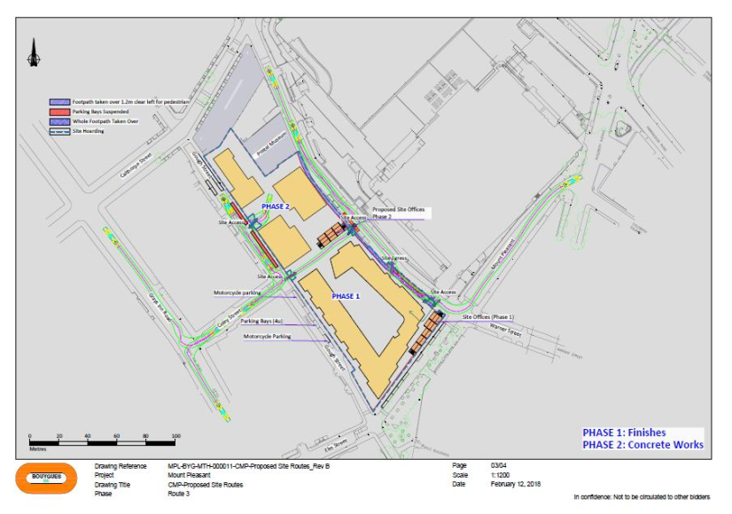

1. **Proposed**

As the superstructure works progress, site vehicles will no longer be able to access off the street into the site boundary from Phoenix Place, at this stage we would propose creating a single lane closure at Phoenix Place, running the length of the building line of phase two (in the North bound lane), this would provide a safe loading/unloading area that is surrounded by ballasted hoarding.

A traffic light system would be in operation to allow the flow of traffic to remain within the open lane. Snapshot of the arrangement has been included below.

To enable the formation of the lane closure, the existing pedestrian crossing outside the British Postal Museum would be suspended from use in its current position, the temporary traffic light system set up by McAleer & Rushe would incorporate the facility for pedestrian crossing within the light signalling.

On completion of the project, the position of the permanent pedestrian crossing will change to move further North along Phoenix Place as per the approved section 278, snapshots of the plans are included below.

The lane closure would have gates at either end to allow vehicles to enter the closure, traffic marshals will be in attendance to ensure that the vehicles can safely enter and exit the closure.

The site logistics operation hours would be in line with the consented site opening hours, 8am to 6pm weekdays, 8am to 1pm on Saturdays). It is proposed that the temporary lane closure would remain in position 24hours per day, 7 days a week. Peak delivery times will be minimised as possible.

McAleer & Rushe is aware of the Christopher Hatton primary school on Mount Pleasant, site deliveries should be limited where possible to avoid school drop off and pick-up times i.e 8.30-9.30am and 3.15- 4.30pm.

McAleer & Rushe is also aware that Phoenix Place is on the TFL’s C6 route, this information will be included in the traffic management plan and traffic marshals will be aware of potential for cyclists

The loading area will be capable to holding a single artic lorry at one time, once loading/unloading is complete, the lorry will leave through the gate and head Northbound on Phoenix Place and exit onto Calthorpe St/Farringdon Road.

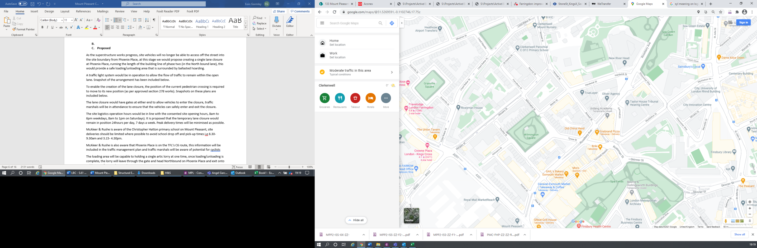McAleer & Rushe use an online booking system for the scheduling of deliveries, all contractors/suppliers have access to the system, with deliveries not being booked in, are refused access to site and will not be unloaded, they will be required to return to site the following day/next available slot. If vehicles are required to wait for a short period of time, they will be directed to predetermined area on Rosebery Avenue, location marked in the below map snapshot.

The lane closure will be in place for the superstructure, façade and fit out works, and will be required from April 2021 till project completion in December 2022.

The estimated frequency of vehicles using the lane closure have been outlined in the below table, the online booking system will be managed to ensure that vehicles are not queued to enter the loading area.

|  |  |  |
| --- | --- | --- |
| **Frequency of Vehicles Movements Using Lane Closure** | | |
| **Construction Vehicle Type** | **Frequency** | **Programme** |
| Van | 2 to 7 per day | Duration of Project construction |
| Concrete Lorry | 1 to 15 per day | Superstructure stage, frequency dependant on pour days |
| Skip Lorry | 1 per day | Throughout fit out stage |
| Flat bed lorry | 1 to 3 per day | Mainly during fit out and façade works |
| Grab lorry | Occasional | Groundworks/landscaping |
| Articulated lorry | Infrequent 1 to 3 per week | Mainly during fit out and façade works |

The proposed lane closure will require the removal of a street lighting column at the site entrance, this is indicated below. McAleer & Rushe have agreed with Camden for the provision of temporary lighting during the operation of the temporary lane closure.

**Drawing Showing Proposed Layout of Lane Closure**

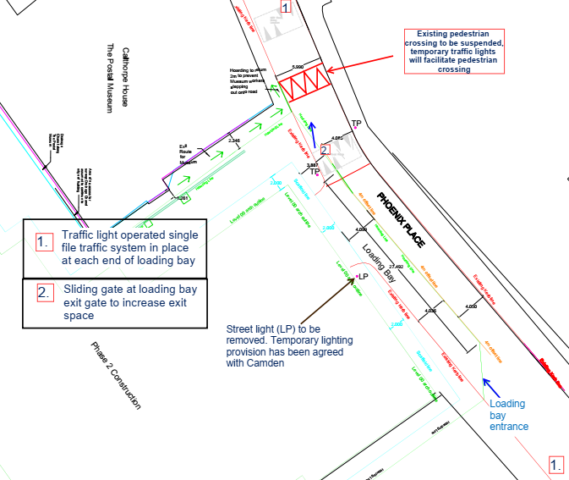

Approved Section. 278 drawings (Drawings 119508-TP-MP-0003-1)

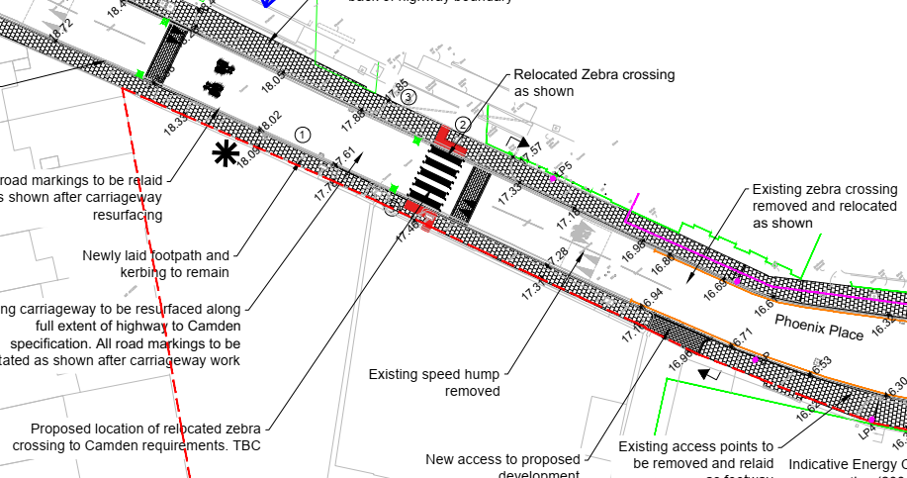

1. **Reasons for Proposal**

The original logistics route for servicing phase one would have meant both phase one and two contractors were using Gough Street as their main logistics route, placing the site containers on Gough Street and using Phoenix Place for logistics created separation between the two contractors for safe logistics.

As the superstructure of the building progresses, vehicles will no longer be able to access inside the site boundary from Phoenix Place, a lane closure will be required to allow site vehicles to enter a safe loading/unloading area.

1. **Consultation**

Notice of the intended lane closure was included in the monthly newsletter issued to the residents on Thursday 21st January. A copy of this newsletter is attached.

The proposal has also been discussed with the operations manager at the British Postal Museum and Archive, his comments have been incorporated into the proposed plan and will factor into the traffic management plan. Email correspondence is attached.

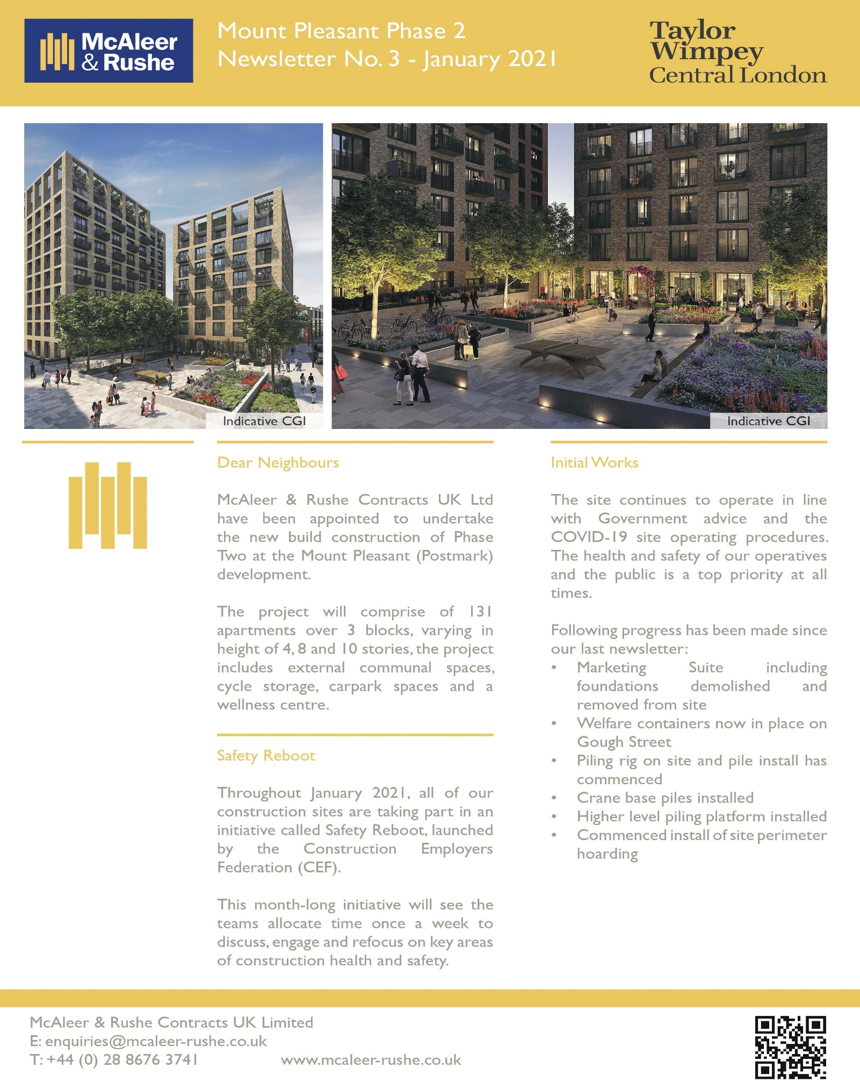**Notification Bulletin to Local Residents/Neighbours**

