**Design and Access Statement**

**For the**

**Proposed Landscaping**

**of**

**12 Gainsborough Gardens NW3 1BJ**

Prepared by

Haine & Co.

6 Lambolle Place

London NW3 4PD

07721398009

[rob@haineco.com](mailto:rob@haineco.com)

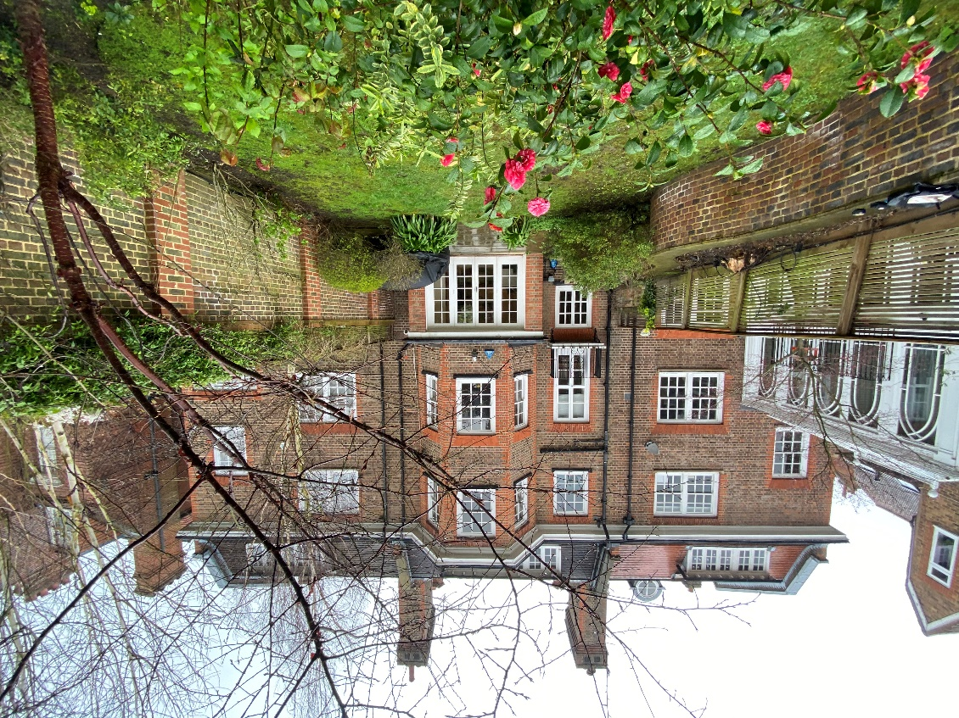

26th July 2021

NOTE: To be read in conjunction with Haine & Co. drawings 20/06/01, 04rev A, 05rev A, 06rev A, 07rev A, 08rev A.

1. **Introduction:**

This Design and Access Statement has been prepared by Haine & Co. on behalf ofIan and Helen Andrews.

This DAS forms part of the planning application for landscaping to the rear garden including demolition of the existing boundary wall between Nos. 12 and 13 Gainsborough Gardens and 12 Gainsborough Gardens and Christchurch Hill.

Note a separate Listed Building Consent application ref. PP10071069 has been submitted, validated on 15th September with a site visit with Colette Hatton on 28th September 2021. Approval for this listed building application has been indicated as being imminent. Please note that both the Listed Building Officer and the Agent were advised by the Planning Department at Camden Council that this proposed work to the garden walls would NOT need planning permission so a Planning Application was not, for this reason, submitted at the same time as the Listed Building Application.

1. **Background:**

12 Gainsborough Gardens is the centre house of a group of three houses, Nos. 11, 12 and 13 Gainsborough Gardens, all of which are Grade 2 listed. The houses were built in the late 19th Century and No. 12 has been in the same ownership for approximately 15 years.

The house is constructed from multi-stocks facing bricks with red rubber quoin embellishments to the window and door openings, the window arched lintols and to the bay’s splayed quoins. Windows are white painted sash windows, the roof covered in natural slates. There are very tall chimneys between the houses.

The house is three storey, plus attic rooms with bay windows to the rear elevation on three floors.

The rear garden is simply landscaped at present with a York stone terrace immediately adjacent to the house as well as a sunken patio area at the bottom of the garden with access gates to Christchurch Hill. There are raised planters approximately 900mm high to the majority of the side of the garden adjacent to No. 13 which return along part of the rear fence line. The remainder of the garden is mainly laid to lawn.

1. **Existing and Proposed Plans:**

The proposals are shown on the scaled drawings attached to the application numbered 20.06.04, 05, 06, 07, 08 all revision A.

1. **Proposals and Planning History:**

The proposals are restricted only to the rear garden. It is proposed to remove the raised planters and infill the sunken patio area to return the garden to a single level for re-landscaping mainly to lawn as well as removing the existing fences along the boundary between Nos. 12 and 13 Gainsborough Gardens and No. 12 Gainsborough Gardens and Christchurch Hill behind.

Demolition of the existing walls will be done carefully in an attempt to salvage as many of the bricks as possible for re-use in the new walls.

The new boundary walls to Nos. 12 and 13 Gainsborough Gardens and No. 12 Gainsborough Gardens and Christchurch Hill will be constructed in multi-stock facings of a similar type to the existing bricks used in the main house and the garden wall between Nos. 11 and 12 Gainsborough Gardens including piers with red rubber quoins, the walls topped with creasing tiles and brick on edge coping with a timber trellis above. The proposal is for the new walls and trellis to match in appearance, colour and height the existing garden wall between 11 and 12 Gainsborough Gardens; the garden of No. 12 Gainsborough Gardens will then have a classic appearance of a walled garden with the addition of a traditional double gate to the rear giving access on to Christchurch Hill (which currently exists).

A similar proposal was carried out at 11 Gainsborough Garden in 2010, see 2010/1640/P.

1. **Design Considerations:**

Design considerations were very straightforward – the new boundary walls to the No. 13 side and facing Christchurch Hill are proposed to mimic the existing boundary wall between Nos. 11 and 12 Gainsborough Gardens.

As many as possible of the demolished bricks will be salvaged for re-use in the construction of the new walls; plus the multi-stock facings are readily available as are the red rubbers and creasing tiles so achieving a similar appearance to the existing walls (and indeed to the rear elevation of the house) is straightforward.

The existing fencing to the two boundaries are in poor condition with extensive work being necessary. Similarly the raised planters are too narrow with inadequate depth and volume of soil to support mature planting. They also impinge unnecessarily on the main body of the garden.

The new walls, once built, will complement the existing wall to the No. 11 side to create a balanced and highly attractive walled garden.

The new design will achieve a conformity and balance that currently the garden lacks; the three existing boundaries are built from a variety of materials with no conformity of height, texture or materiality. The existing boundary to No. 13 Gainsborough Gardens is partially formed by a traditional 9” wide stock brick wall with the majority built from a retaining wall topped by a timber trellis fence.

The new boundary walls will be constructed from multi-stock facing bricks with intermittent piers with red rubber quoins, creasing tile, brick on end coping and a small timber trellis. With the existing wall to No. 11 Gainsborough Gardens currently in this same format, the new garden will achieve a conformity of height and appearance to all three sides.

The new work relates appropriately to the immediate and wider context. Through its high quality, sustainable design and re-use of salvaged materials, plus the scale, form, detailing and materials of the existing structures, scale to the existing building and referencing the original building and structures, every effort has been made to develop a cohesive and relevant design relating to the existing garden and house. The works are sited wholly at the rear of the building, within the existing building line, therefore have no negative impact on the streetscape of Gainsborough Gardens.

The rear elevation of the proposed boundary wall will replace a non original timber fence and a pair of timber gates with a new masonry and timber boundary wall of similar construction to the remainder of the rear garden. The proposed gates are designed to mimic the traditional appearance of the existing gates utilising similar traditional construction techniques with similar framed ledged and braced construction using mortice and tenoned joints.

The outdoor private amenity space will not be reduced, and connection to it from the main living spaces will be enhanced.

Access to the property remains unchanged.

The proposal will not negatively impact the amenity of the surrounding neighbours; indeed it has the support of both immediate neighbours as it improves the appearance and amenity of all three rear gardens.

The proposed re-use of salvaged stock bricks in the construction of the boundary walls where possible compliment with the original structure, and the bulk, form and scale of the new work is sympathetic to the existing buildings.

Overall the works are not believed to be detrimental to the architectural or historic integrity of the buildings.

By respecting the scale, materials, design and grain of the existing area, the character and appearance of the conservation area is not diminished.

1. **Access:**

Access to the residence will not be altered. Pedestrian access is maintained from the street pavement to the front door via one step at the front porch. Internally, access to the four levels will remain as existing via the main staircase. The house will retain access to the garden level via new doors out to the garden with existing exterior levels flush at the threshold of the new extension. All new light switches, door handles etc. will be positioned at appropriate heights.

1. **Flood risk assessment:**

The property does not require a flood risk assessment.

1. **Conclusion:**

We believe the proposal respects the character of the surrounding areas, the character and appearance of the building, and the amenities of the neighbouring properties. The proposed works are similar in scope, scale and materials use as existing adjacent properties.

The proposal is therefore considered to be in accordance with local plan policies and we trust that you will find the scheme to be acceptable.