

**67 – 74 SAFFRON HILL MARKETING PLAN**

**To:** London Borough of Camden

**From:** Planning Insight

**Date:** September 2021

**Re:** 2019/3163/P: 67 – 74 Saffron Hill

### Introduction

#### Overview

* + 1. Planning Insight has been appointed by our client, Nyraff Limited to provide a Marketing Plan to the London Borough of Camden in relation to the Affordable Jewellery workspace that was approved under planning reference 2019/3163/P dated 14 April 2021.

#### Background

* + 1. Planning permission 2019/3163/P granted permission for an additional 3 storeys on the Onslow Street side of the development. In terms of the increase in floorspace the S106 requires that 122.4sqm of this floorspace will provide as ‘Affordable Jewellery Workspace’ in Use Class E(g)(iii) as per the amended Use Class Order. This is in accordance with policy E2 (Employment premises and sites) that requires that 50% of new built workspace is affordable workspace dedicated to the Jewellery sector in Hatton Garden.

### The S106 Agreement

2.1.1 The legal agreement (“The Agreement”) is dated 14 April 21. The below details the relevant aspects of the agreement to this application.

[info@planninginsight.co.uk](mailto:info@planninginsight.co.uk) | 020 7993 4539 | planninginsight.co.uk 31–35 Kirby Street, Farringdon, London EC1N 8TE

Planning Insight Ltd. Registered address 71-75 Shelton Street, London, WC2H 9JQ. Company No. 7020651

#### Definitions

* + 1. The below defines ‘Jewellery Workspace’:

*Jewellery Workspace*

The 122.4 square metres of net internal floor space within the Development as shown on the attached Jewellery Workspace Location Plan which are to be used exclusively for purposes within Class B1 (c) of the Town and Country (Use Classes) Order 1987 or any provision equivalent to that Class in any statutory instrument revoking and re-enacting that Order with or without modification and to be offered for rent (and for all subsequent new leases) for a minimum period of 12 months and to remain at an Affordable Jewellery Workspace Rent for the lifetime of the Development and at all times the Owner must meet the following minimum requirements:-

* + - 1. the provision of the accommodation to be to shell and core level with the following additional specification: -
         1. the provision of durable floor covering over the entire floorspace.
         2. the provision of lighting; heating; energy supply; painted ceilings; broadband sockets and WC's on every floor: and
         3. to ensure the standard is suitable for jewellery manufacturing and/or jewellery workshop space

And should the above criteria at 2.12(a)(i)-(iii) not be provided then a rent-free period must be offered to any jewellery sector tenants in lieu.

* + - 1. to use reasonable endeavours to minimise the amount of any service charge to be charged for the workspace operator through measures to include (but not be restricted to) the following:
         1. separate metering for utilities, and
         2. separate contracts for building services (including security) and
         3. where any part of the service charge is payable as a charge for the Development as a whole that part shall be payable on a pro-rata or direct usage basis in accordance with the provisions of “Service Charges in Commercial Property” (3rd Edition) by the Royal Institute of Chartered Surveyors (or any successor document).
    1. The below definition sets out the requirements in terms of the Marketing Plan.

*Jewellery Workspace Marketing Plan*

A plan setting out a package of measures to be adopted by the Owner in marketing the Jewellery Workspace within a clear 24 month period commencing on the date of approval of the plan by the Council and to include: -

* + - 1. the marketing particulars and specification of the Jewellery Workspace to be offered at the Affordable Jewellery Workspace Rent.
      2. details of how and where the Jewellery Workspace will be marketed.
      3. While the Jewellery Workspace is unoccupied by a tenant or tenants to prepare a report at four month intervals from the date of commencement of the

marketing period (with the Owner to inform the Council of the date in writing) with details of the marketing efforts made by the Owner in accordance with the approved Jewellery Workspace Marketing Plan during the previous four months to market the Jewellery Workspace to secure a suitable tenant AND such details to be submitted to the Council's Planning Monitoring Officer on the six occasions at the 4, 8, 12, 16, 20 and 24 month intervals during the agreed 24 month marketing period OR until such time that a suitable tenant for the Jewellery Workspace is secured by the Owner.

* + 1. Obligation 4.3 sets out further detail in relation to the Jewellery Workspace. This document seeks to confirm that the Owner’s strategy to market the Jewellery Floorspace is supported by the Local Planning Authority.

### Floor Space

#### Location of the Jewellery Floorspace

* + 1. Paragraph 4.3.7 of the S106 provides for any part of the existing building be the Jewellery Workspace on the basis that the area is equivalent floorspace and to be of no less practical amenity than the current Jewellery Floorspace.
    2. Appendix 1 of this Marketing Plan provides a floorplan that demonstrates the amount of floorspace equates to 122.4sqm and provides photos of the internal layout showing the quality of the internal floorspace. The owner will be flexible with how the space is leased, as a whole or in two parts. This approach has been agreed with officers.
    3. The floorspace meets/exceeds the minimum requirements as set out in the Jewellery Workspace definition.

#### Affordable Jewellery Workspace Rent

* + 1. The Jewellery Workspace is required to be offered at 80% of market Jewellery Workspace. Anton Paige is a local agent with significant experience in managing and leasing Jewellery Workspace, they value the rent per sqm as £45psf, this is based on market research carried. Therefore 80% of this equates to £36psf. The proposed rent for the Jewellery Workspace is therefore £36psf per sqm, this has been agreed with officers.

*Service Charge*

* + 1. The S106 sets out expectations that these are calculated on a direct usage basis – the draft particulars set this at £5psf, almost the same as the £5.5psf for the office, and more than the other office example locally (£3.5psf) .
    2. The service charge is universal for all tenants of the building and the space is already discounted. It’s based on common parts cleaning, electricity to common areas, lifts, building insurance for the cost of the building, in this regard it is justified. This has been agreed by officers.

### Marketing Plan

#### Overview

* + 1. This section provides details of the Marketing Plan.

#### Part A – Marketing Particulars

* + 1. Appendix 2 contains a copy of the Marketing Brochure, a similar arrangement will be posted online to the relevant websites.

#### Part B – Details of How the Space will be Marketed

* + 1. The Owner’s agent will carry out a comprehensive campaign in order to effectively market the space to the Jewellery sector. The following actions will be carried out:
       - Will advertise the space through Anton Paige’s and the Owner’s connections in the local and wider area.
       - Will advertise via Anton Paige’s website.
       - Will advertise on relevant websites e.g., Rightmove (commercial).
       - Directly contact relevant organisations as specified in the below paragraphs.
       - Follow up on a regular basis with the identified organisations.
    2. The Local Authority recently discharged the obligation for Jewellery Workspace in relation to the previous applications on the site. The Local Authority provided the following organisations as relevant to the Jewellery Trade in Hatton Garden:
       - Centa.
       - Bench Peg.
       - Mastermelt Group.
       - Primera Corporation.
       - Goldsmiths Centre.
       - Cock Pit Parts.
    3. The Owner’s agents will contact the above organisations on a regular basis in order to advertise the workspace. They will provide the Marketing Brochure as contained in Appendix 2. Should the Local Authority identify other organisations the Owner will contact them and provide the details of the workspace.
    4. The Owner’s agents will retain evidence of attempts to lease the workspace.

#### Part C – Monitoring

* + 1. The Owners or their advisors will contact the council six occasions at the 4th, 8th, 12th, 16th, 20th and 24th month during the agreed 24 month marketing period and provide a report to the Local Authority with an update on the Marketing of the floorspace. The Owner or their advisors will provide updates on the status, should the space be successfully occupied.

### Conclusion

* + 1. The above Marketing Plan in relation to the Affordable Jewellery Space is in accordance with the S106 agreement. We have discussed the particulars with the council, the rent rate, location and arrangement of the space and servicing charge have now been agreed.

## Appendix 1: Floor Plan

**REAR OF BUILDING REAR OF BUILDING**

**{ONSLOW STREET) {ONSLOW STREET)**

**T T**

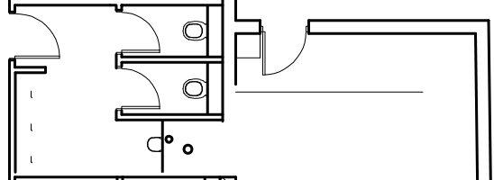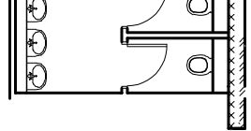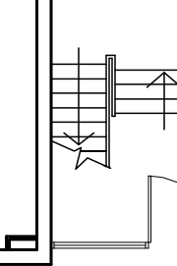

area designated for jewellery workshop lined in red

]

,

-

D

STAIRS DOWN TO REAR

ENTRANCE

D

II

LIFT

dJ

□

0

0

0

I

II

D

0

0

D

D

II

D

YARD

0

D

II

C

=11

0

-

DUCT

LIFT

l )

I

I

*=-='*

BINS

toilet

.

**i**

-

WHEELCHAIR LIFT

Ir---

BINS

SUB STN

□ □

...

LIGHTWELL

# Ground Floor Plan

**FRONT OF BUILDING**

**{SAFFRON HILL)**

# Second Floor Plan

**FRONT OF BUILDING**

**{SAFFRON HILL)**

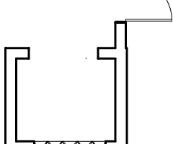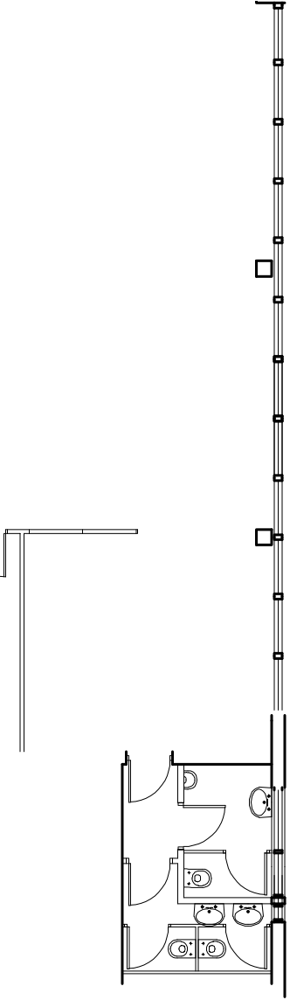

1i

STAIRS DOWN TO REAR

ENTRANCE

-

-

D

50% of new floor area designated for jewellery workshop lined in red

WVVJV _

D

lltl

\_

D

"□

*I*

I I

*I*

I

M

=

F

,

l

LIFT

_

DIS WC

...

|  |
| --- |
|  |
|  |
| NYRAFF LTD. |
|  |
| 67 - 74 SAFFRON HILL LONDON  EC1N 8QX |
| t itl e |
| GROUND & 2nd FLOOR PLANS - JEWELLERY WORKSPACE AREAS |
| dwg no. |

0 1 2 3

4 5 6

7 8 9 10

I-a - **1 :a.;:1** -

SCALE (METRES)

SCALE 1:100

1908/L

MALE

LIFT

FEMALE

sc ale 1:100 @ A1 dole APRIL 2021 1:200 @ A3

THIS DRAWING IS COPYRIGHT & MUST NOT BE REPRODUCED IN WHOLE OR IN PART WITHOUT PRIOR CONSENT FROM GEOFF BEARDSLEY & PARTNERS (UK) LLP



## Appendix 2: Brochure

7



Commercial Work Spaces 398 / 885 / 1,283 sq. ft.

**Ground and first floor jewellery studios**

**TO LET**

**1 Onslow Street, London EC1N 8AS**

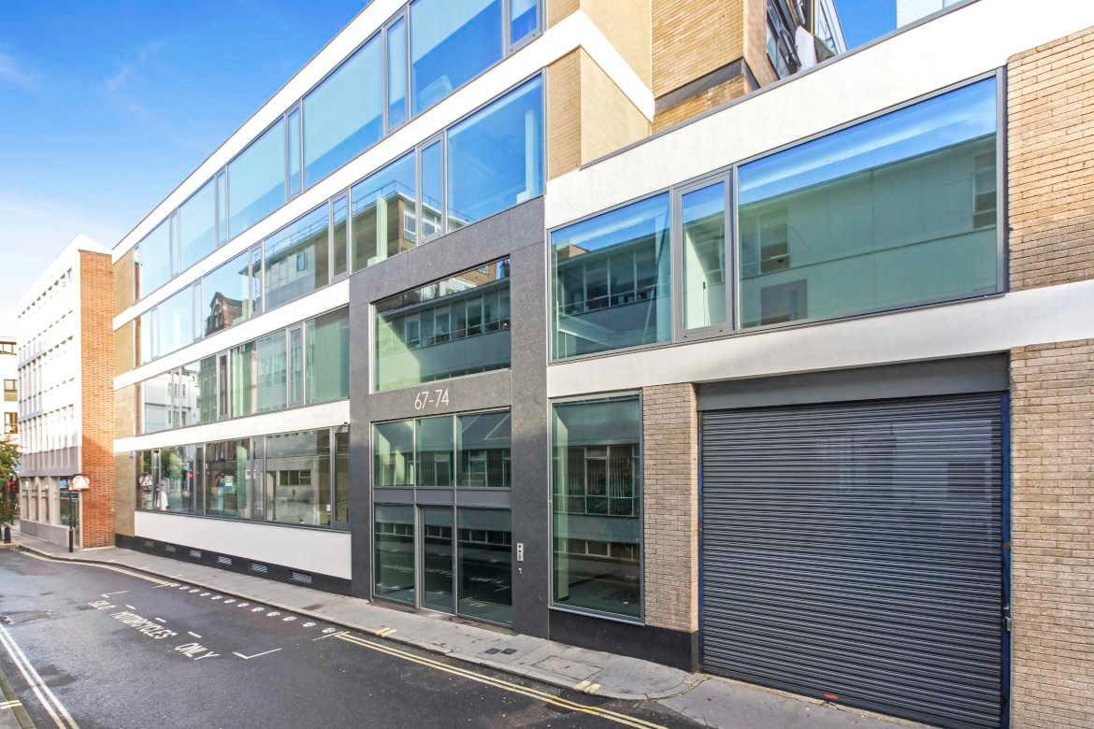

*Building viewed from Saffron Hill

##### LOCATION

The building is located on the western side of Onslow Street, set within to the jewellery district of Hatton Garden. The office is well positioned to provide easy access to the West End and The City, and benefits from close proximity to Farringdon and Chancery Lane.

##### TRANSPORT

Farringdon Station (Metropolitan, Hammersmith & City, Circle Lines and Thameslink) Chancery Lane Station (Central line)

Buses 55, 243 and 63 (Oxford Circus, Waterloo and Kings Cross)



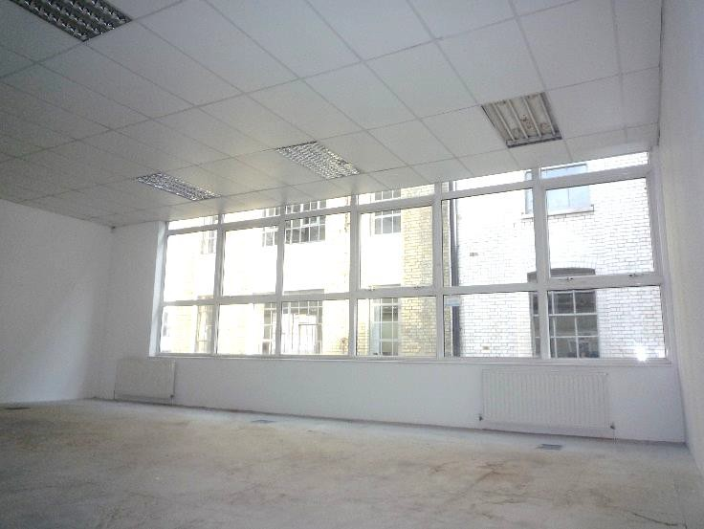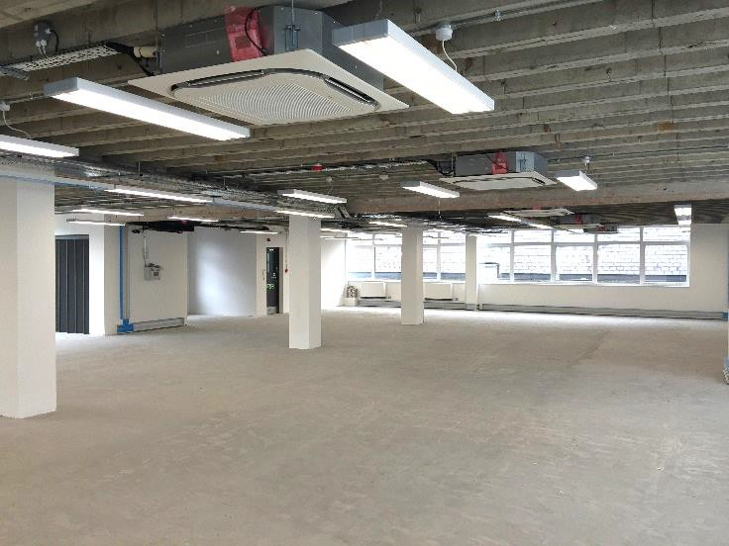

##### DESCRIPTION

The workshops based on the ground and first floors of this industrial style building and provides very bright, open plan studio accommodation for jewellery manufacture based companies.

The workshops are approached either by way of a staircase or industrial style lift.

The workshops are 885 sq. ft. and 398 sq. ft. however all enquires are welcomed.

##### AMENITIES

* + - * Self-contained workspace
      * Newly refurbished
      * Ceiling mounted air conditioning system
      * New lighting
      * Kitchenette
      * WC accommodation
      * Video entry phone
      * Goods lift

##### APPROXIMATE FLOOR AREAS

Ground floor 885 sq. ft. 82.2 sq. m. First floor 398 sq. ft. 37.0 sq. m. **LEASE**

A new flexible lease is available for a term by arrangement.

*Typical floor in the building

##### RENT

£36.00 per sq. ft. plus VAT

##### SERVICE CHARGE

The service charge is fixed at £5.50 per sq. ft. plus VAT

##### RATES

The rates are to be assessed.

Each party must make their own enquiries to The London Borough of Camden.

##### LEGAL COSTS

Each party to be responsible for their own legal costs incurred in the transaction.

##### PLEASE CONTACT

ANTON PAGE 020 7336 1313

Stephen Page [spage@antonpage.com](mailto:spage@antonpage.com)