From: Jane Moses
Sent: 13 September 2021 22:06
To: Obote.Hope@camden.gov.uk; planning@camden.gov.uk
Subject: Planning Application No 2021/3391/P
Importance: High

Planning Application No 2021/3391/P Lower Ground Floor Flat, 39 Priory Road, London NW6 4DG

Dear Sirs

Kindly note my objections to Planning Application No 2021/3391/P.

- The proposed extension will require excavation, increase the hard surfaces and result in the loss of vegetation and grassed areas which could make the property and those adjacent more susceptible to flooding. The extremely heavy rain in July resulted in the basements in nearby Belsize Road being covered in sewage.

- The proposed metal casement windows and sliding doors to the side and rear elevation are not in keeping with the Conservation Area even though the Design and Access Statement says that:

“Appearance
“The materials chosen for the extension are to match that of the existing house in order to remain in-keeping with the appearance and character of the house and local area. High quality double glazing and metal framed sliding doors will be used in the extension and the external walls are to be rendered to match existing.”

As can be seen from the extract of the side and rear elevations below, the windows are crude and not at all in keeping with the existing fenestration or appropriate for a property in the Conservation Area.

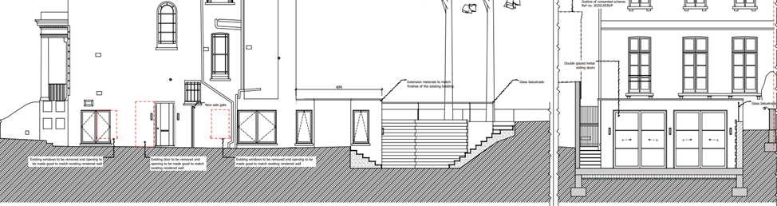

In the circumstances, I hope that this proposal is refused.

Yours faithfully,

Jane Moses

