### Design & Access Statement

**Top flat, 4 Strathray Gardens NW3 4NY**

**On behalf of**

**Humphrey and Nicola Cobbold**

**August 2021**

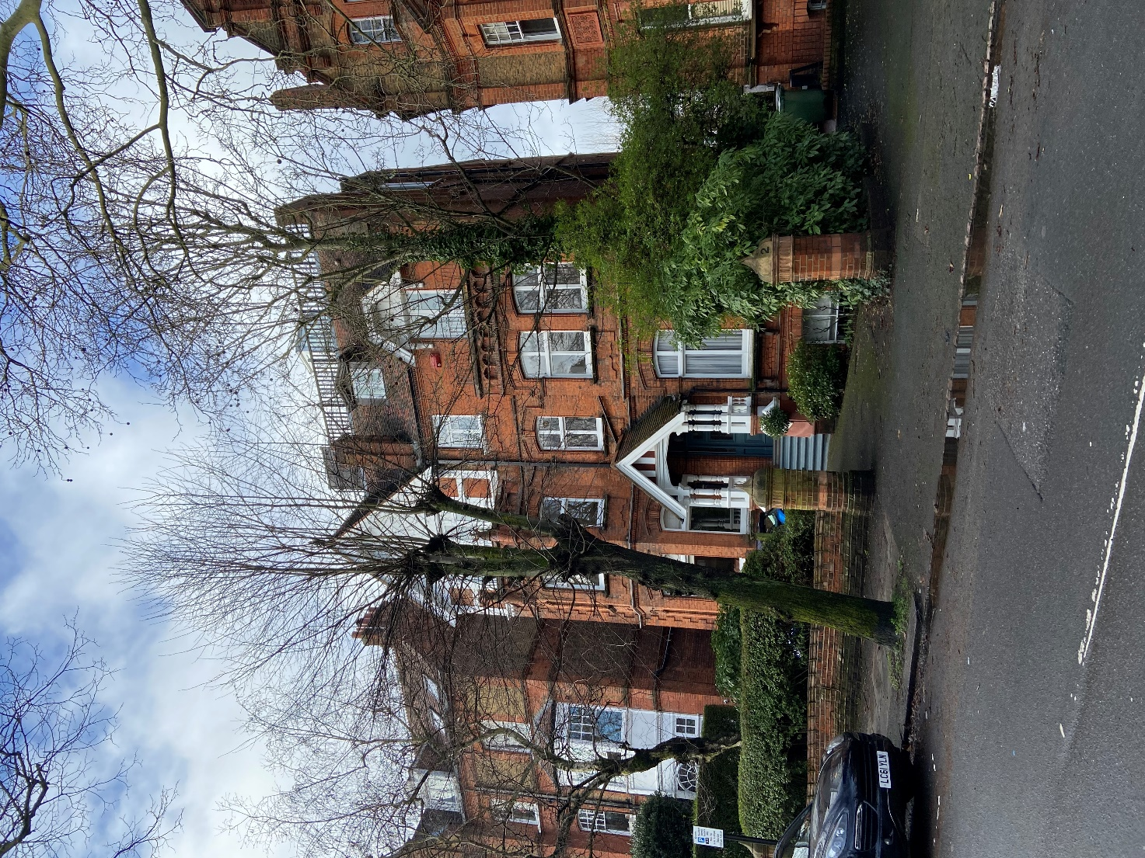

**Haine & Co. Ltd.**

**6 Lambolle Place NW3 4PD**

[**rob@haineco.com**](mailto:rob@haineco.com)

**07721 398009**

1. **Introduction**

This Design and Access Statement has been prepared by Haine & Co. on behalf ofHumphrey and Nicola Cobbold.

This DAS forms part of the planning application for the proposed alteration to the roof terrace access and provision of Air Sourced Heat Pump on the roof terrace.

1. **Background/Description**

The property No. 4 Strathray Gardens is a detached Victorian house dating from the late 19th century. The top flat encompasses the 2nd and 3rd floor and the entire roof terrace. The house is within the Belsize Park Conservation Area.

The house sits towards the end of the street comprising a number of similar detached houses split into apartments. The houses are of similar design with double fronted front elevations, constructed from red stock bricks to the front elevations with moulded terracotta and red brick detailing, cill and arched head embellishments, some painted and stuccoed details, red tile roofs, painted timber sash and casement windows, some dormers, porticos with raised front steps.

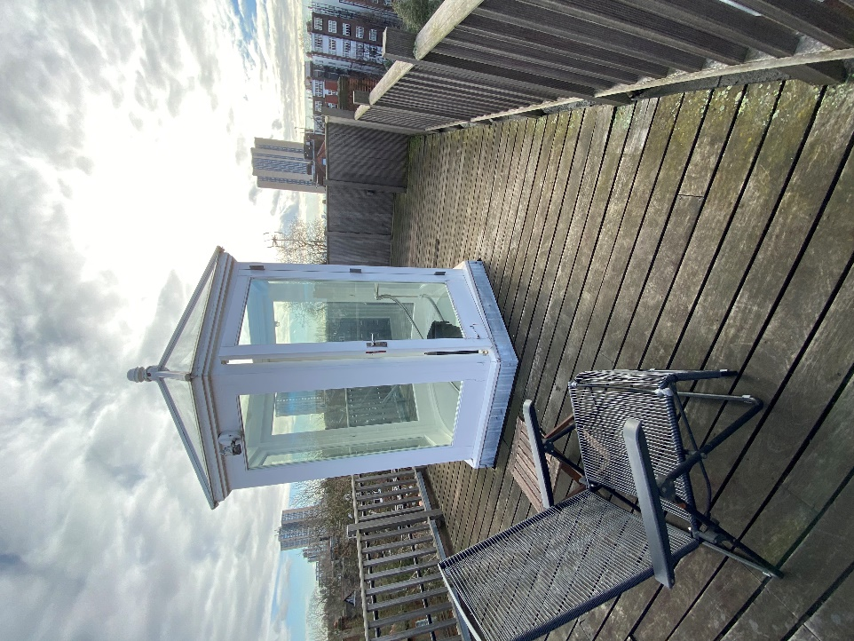

Fig. 1. Rear Elevation 28 Highlever Road

The proposed work is restricted to the roof terrace; the existing terrace is accessed via a glazed white painted timber structure, see Fig. 1.

The roof terrace currently comprises the access structure, 1100mm high timber balustrading (1300mm and solid fence to the west end) and timber decking. The existing access structure is situated centrally on the terrace reducing the practical use of the terrace.

1. **Existing and proposed Plans:**

The proposals are shown on the scaled drawings (1:25) accompanying the submitted planning application:

21/09/01 Existing 2nd floor plan

21/09/02 Existing 3rd floor plan

21/09/03 Existing roof plan

21/09/04 Proposed 2nd floor plan

21/09/05 Proposed 3rd floor plan

21.09/06 Proposed terrace plan

21/09/07 Proposed Plan and Elevations

21/09/08 Sections

21/09/14 Proposed Plan and Elevations

|  |
| --- |
|  |

1. **Design Strategy**
2. Access Structure to roof Terrace:

Our client wishes to reconfigure the roof terrace to make it more user friendly as the current positioning of the access structure, being centrally located within the terrace, effectively renders the remainder of the terrace frustrating to use. The existing structure, being nearly 3m tall casts a shadow over the usable section of the terrace and sits in the centre of the terrace. The spiral staircase that affords access to the roof is also awkward to use (and difficult to access furniture through) and also dominates the 3rd floor hallway, causing awkward routes of passage between the bedrooms and the bathroom.

To achieve a more efficient layout on the 3rd floor and the roof terrace, the proposal seeks to remove the existing approximately 3m high timber and glazed access structure and replace it with a new timber clad (FSC) structure less than 2.50m high in a more sympathetic location that will vastly improve the efficiency of the 3rd floor and the usability of the terrace.

The new access structure has been designed to offer the smallest profile whilst allowing for easy access from the floor below. The structure encompasses a new standard width staircase and a top landing to the minimum allowed dimensions. The overall height of the new structure is less than 2.50m whilst the existing structure is just under 3m tall.

The design of the new structure has taken into account it’s location, effectively within/adjacent to the tree canopy, with street views restricted by the heavy canopy of trees, particularly in summer. Given only occasional glimpses of the structure will be possible from the street, it seemed important to reflect the materiality of the location through the use of natural materials. We have therefore clad the whole structure in FSC registered environmentally friendly softwood cladding, sustainably produced. The timber cladding, when fitted, is a dark brown colour but within a year will fade to a sliver/grey.

The existing balustrade and fencing will be retained; the existing approx. 1300mm high solid fence to the west end (partly returning along the south and north sides as well), will partly conceal the new structure form the street and from neighbouring properties.

The property immediately to the west, No. 6 Strathray Gardens has windows to the top floor facing No. 4 but they are a whole floor below the roof terrace and no view is afforded from these windows of the proposed structure.

The property to the east of No. 4, No. 2 Strathray Gardens, has no windows facing the roof terrace.

The house directly opposite No. 4 is No. 1 Strathray Gardens but this is at least 30m away. Any views from this property of the roof terrace are heavily obscured by the proliferation of trees within the gardens of both houses and along the street on both sides.

The new work relates appropriately to the immediate and wider context. Through its high quality, sustainable design, which responds to the scale, form, detailing, materials of the existing building, and its contemporary, simplified approach, the addition will be secondary in form, materials and scale to the existing building. The works are sited wholly at the top of the building (4th floor), within the existing building line, and therefore will have no negative impact on the streetscape.

Solar and daylight access for the dwelling will be enhanced by introducing more glazing by infilling the existing stair opening with a triple glazed circular walk-on rooflight. Greater indoor/outdoor connection, increased solar and daylight access, will ensure quality living conditions for the occupants. Reductions to the energy requirements of the flat over and above the installation of the Air Sourced Heat Pump will be achieved through considerable remodelling of the existing flat roof forming the terrace via increased floor, wall and roof insulation, solar and daylight access, all of which lead to a reduction in the need for artificial lighting and space heating.

Access to the property remains unchanged.

The proposal will not negatively impact the amenity of the surrounding neighbours. The proposal seeks to build only at roof level with little or no views to or from adjacent properties.

The proposals have no impact on the Belsize Park Conservation Area as the proposed work is confined to the roof of the building. The changes to the fabric of the building affect non original structures.

The proposed terrace decking and new structure is clad wholly with FSC timber.

Overall the works are not believed to be detrimental to the architectural or historic integrity of the building.

By respecting the scale, materials, design and grain of the existing area, the character and appearance of the conservation area is not diminished.

1. Air Sourced Heat Pump:

Current and proposed changes to the Building Regulations are encouraging the use of Heat Pumps and a move away from gas boilers. Haine & Co. and the Client already share these fundamental proposals and intend to remove the existing gas boiler; a specialist Environmental Consultancy has been employed to assist with the design of the replacement energy provision.

Their recommendation is for a 16kW air sourced heat pump; this unit must be situated externally. We have placed it in a location that affords the minimum risk of sound pollution to neighbouring properties. ASHP Planning Assessment calculations (as attached) show the noise level at the assessment position to comply with the standard required (being less than 42dB).

The unit is approx. 1.40m high and will be behind the existing fence and tall brick chimney stack that separates it from the neighbouring property at No. 6 Strathray Gardens.

The unit will not be visible from the street or from No. 1 Strathray Gardens (see elevation drawings).

|  |  |  |
| --- | --- | --- |
|  |  |  |
|  |  |  |

1. **Planning History, Top flat, 4 Strathray Gardens :**

The following permissions have previously been approved for alterations and additions to the top flat at No. 4 Strathray Gardens:

1988 #8804133 Copper barrel vaulted roof extension above roof level; roof terrace balustrading; new windows, new dormers.

1992 #9200334 Erection of glazed enclosure to spiral stairs at roof level and timber balustrading around perimeter of flat roof.

1. **Access**

Street access to the residence will not be altered. Internally, access to the four levels will remain as existing via the main staircase and new stair from 3rd floor to the existing terrace albeit in a slightly altered location.

1. **Flood risk assessment**

The house is in Flood Zone 1 and does not require a flood risk assessment.

1. **Conclusion**

We believe the proposal respects the character of the surrounding areas, the character and appearance of the building, and the amenities of the neighbouring properties. The proposed access structure is of a similar size (but less high) than the existing access structure and of a sympathetic design and use of materials.

The air sourced heat pump meets minimum acoustic regulations and is situated to mitigate impact on neighbouring properties.

The proposal is therefore considered to be in accordance with local plan policies and we trust that you will find the scheme to be acceptable.