Design and Heritage Statement
123 Parkway, London NW1 7PS

Listed Building Consent Submission for Installation of Secondary Glazing for noise attenuation.

Author: KAM

Revision: Rev 01

Date: 13/7/21

Scope
This document relates specifically to 123 Parkway where internal secondary glazing is proposed to be installed. The property is a grade 2 listed Georgian terrace building on Parkway within the Camden town Conservation Area.
This document considers the following proposals which require listed building consent.

Installation of internal secondary glazing to 7 windows over 4 floors (ground to third) on the front façade.
Context
123 Parkway falls within the footprint of the HS2 construction works. It is eligible to receive Noise Attenuation on the rear facade under the current statutory provision. The owner wishes to treat the front façade in the same way.

Note this application is being made part retrospective as installation had commenced on the 1st and 2nd floors when it came to light that the front elevation was not covered by the HS2 application 2020/0420/L. At this point works were suspended pending a decision for this application.

The works which has been carried out are fully reversable and considered to have caused less than substantial harm.

Listing Description
List Entry Number: 1113253

Date of first entry: 2/8/1973

Statutory Address: NUMBERS 119, 121 AND 123 AND ATTACHED RAILINGS, 119,121 AND 123, PARKWAY

National Grid Reference: TQ 28661 83570

Details
TQ2883NE PARKWAY 798-1/76/1288 (South side) 02/08/73 Nos.119, 121 AND 123 and attached railings
GV II
Terrace of 3 houses. Early C19. Yellow stock brick and rusticated stucco ground floors. 4 storeys and basements. 2 windows each. Round-arched ground floor openings. Doorways with fluted quarter columns, cornice-heads, fanlights, No.123 patterned, and paneled doors. Recessed sashes; 1st floor in shallow round-arched recesses with cast-iron balconies. Main stucco cornice at 3rd floor level. Stucco cornice and blocking course above 4th floor. INTERIORS: not inspected. SUBSIDIARY FEATURES: attached cast-iron railings to areas.

Schedule of proposed works
Ground floor (1 opening)

Internal secondary glazing to the front reception room.
The secondary glazing will be fitted into existing timber grounds (which appear to be from a previous secondary glazing treatment) which are fitted into early timber reveals. No new fixings will be added into the early timber reveals.

First floor (2 openings)

Internal secondary glazing to front reception room windows
It is proposed that purpose made joinery subframes are produced and fitted to the face of the early box sash frame using No 8 wood screws. The secondary glazing will be fitted into a purpose made subframe.

Second Floor (2 openings)

Internal secondary glazing to the front bedroom windows.
It is proposed that timber grounds are fitted to the existing plaster reveals using No 8 plugs and screws and to the stub sill using wood screws. The secondary glazing will be fitted to the new timber grounds.

Third Floor (2 openings)

Internal secondary glazing to the front bedroom windows
It is proposed that timber grounds are fitted to the existing plaster reveals using No 8 plugs and screws and to the stub sill using wood screws. The secondary glazing will be fitted to the new timber grounds.

Design Consideration
Noise mitigation. Secondary glazing is widely considered the most effective way to reduce noise ingress though window openings. The addition of secondary glazing will reduce the noise ingress by approximately 12 – 15 dB Rw, bringing the internal of the property in line with World Health Organisation guidelines.

Thermal Insulation: Although not a direct requirement, the addition of secondary glazing will also improve thermal insulation reducing heat loss and reduce the carbon footprint of the building.

Historic England: Secondary glazing is considered an acceptable and beneficial adaptation by Historic England. Reference; Historic England’s publication: Energy Efficiency and Historic Buildings: Secondary Glazing for Windows.

Window design and materials: The secondary glazing windows will be manufactured from aluminium with a polyester powder coating. New timber grounds and subframes will be produced from FSC certified timber finished to match the secondary glazing colour.

Minimising external visual impact on existing windows: Secondary glazing will be installed internally on the proposed windows. The position of the secondary glazing frame will align with the original window frame, sash positions and sightlines to minimise visual impact when viewed externally. The secondary glazing must be set back internally from the original window position to achieve the desired acoustic performance and minimise noise levels from the HS2 works. When viewed externally, the secondary glazing might be seen by a discerning person when viewed obliquely. Some reflection on the secondary glazing may also be evident from the original windows. The external visual impact on the significance of the heritage asset will be low to very low and is an accepted consequence of installing secondary glazing into historic buildings.

Reducing internal visual impact for the residents: The secondary glazing frame section size is minimised to ensure original glazing sightlines are maintained. The secondary glazing frame will be powder coated white to match the existing surrounding joinery.

Maintaining existing window functionality: The secondary glazing is openable for cleaning, maintenance, trickle and purge ventilation as required. All existing windows will remain operable with the secondary glazing installed. Existing sash windows can be cleaned and maintained.

Fixing the secondary glazing: The secondary glazing, timber grounds and subframes will be fitted with minimal discrete fixings to reduce the potential impact on any historic structure. No 8 plugs and screws will be used for fixing to masonry and No 8 wood screws will be used for fixing to timber.
Impact: The secondary glazing treatment is designed in such a way to have minimal impact on the historic features of the property. Apart from fixing holes there will be no damage to existing joinery, architrave, or moldings. The secondary glazing treatment is fully reversible; once removed the fixing holes into the timber reveal and sill can be sympathetically filled and decorate leaving no visible trace of the installation.
Photos
Front Elevation
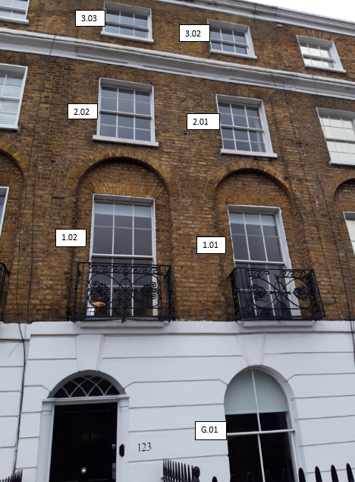
Ground Floor
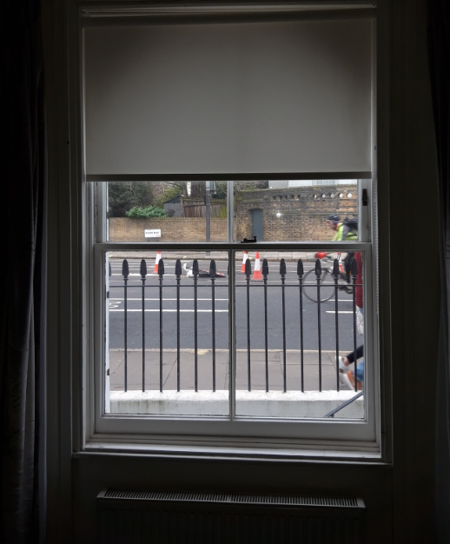
G.01

First Floor
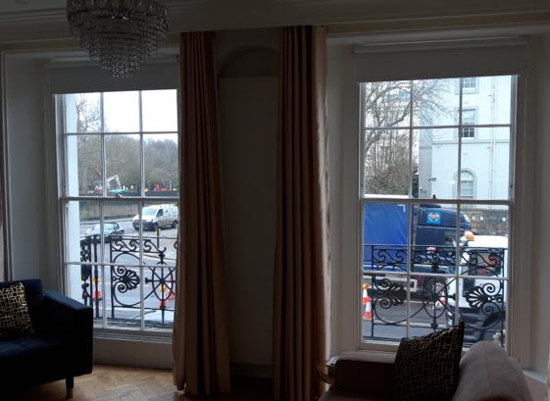
1.02
1.01
Second Floor
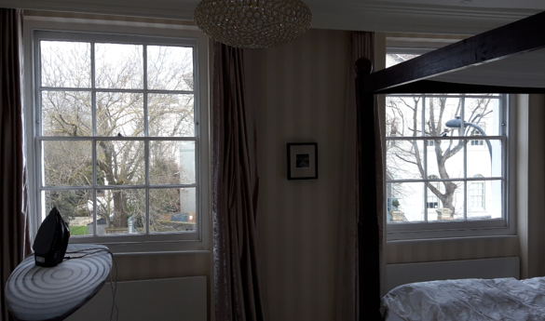
2.02
2.01

3rd Floor
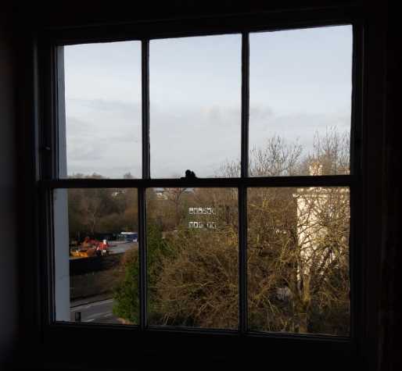
3.02
3rd Floor
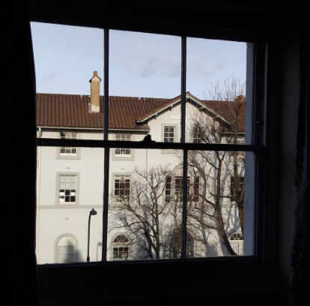
3.03

