Flat 25H
Design and Access Statement

Application for Full Planning
This application is for retrospective planning for alterations made to the partial rear garden of 25H East Heath Road. It was not understood that such works would require planning permission.

Location

The address of the property is Garden Flat, 25H East Heath Road, Hampstead, NW3 6PZ
Located at the north outer edge of Hampstead Heath, at the top of East Heath Road.

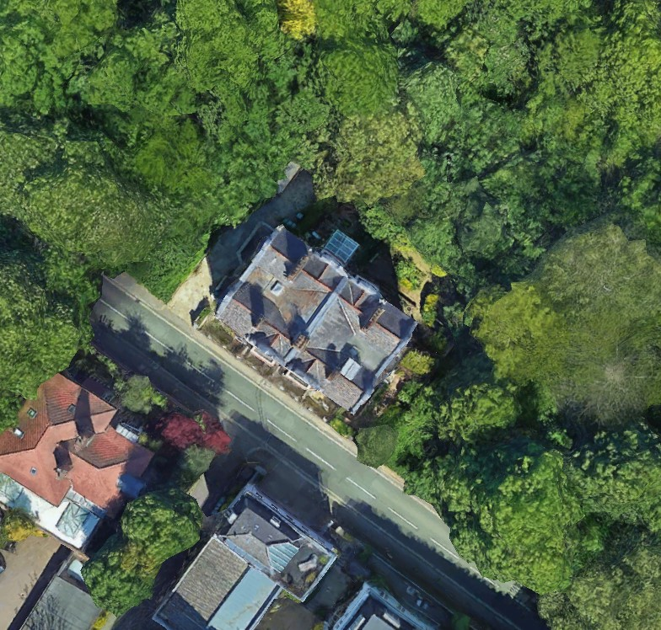

Satellite plan of the property and its surrounds along East Heath Road
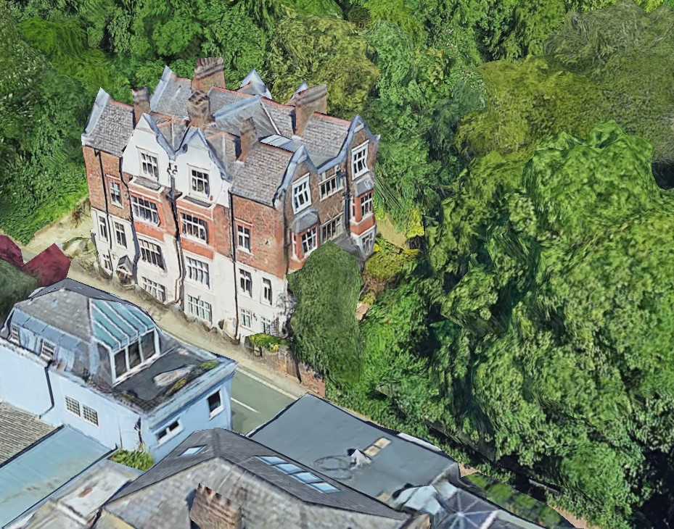

Aerial view of the property from the southeast showing the corner of the building and partial view of the rear garden

Description of existing rear garden

The majority of the garden consists of hard landscaping with soft landscape borders. It is set at varying levels with a solid brick walled perimeter on which a fence sits. In addition to Existing Garden Plan below and attached, see also images of existing garden attached.

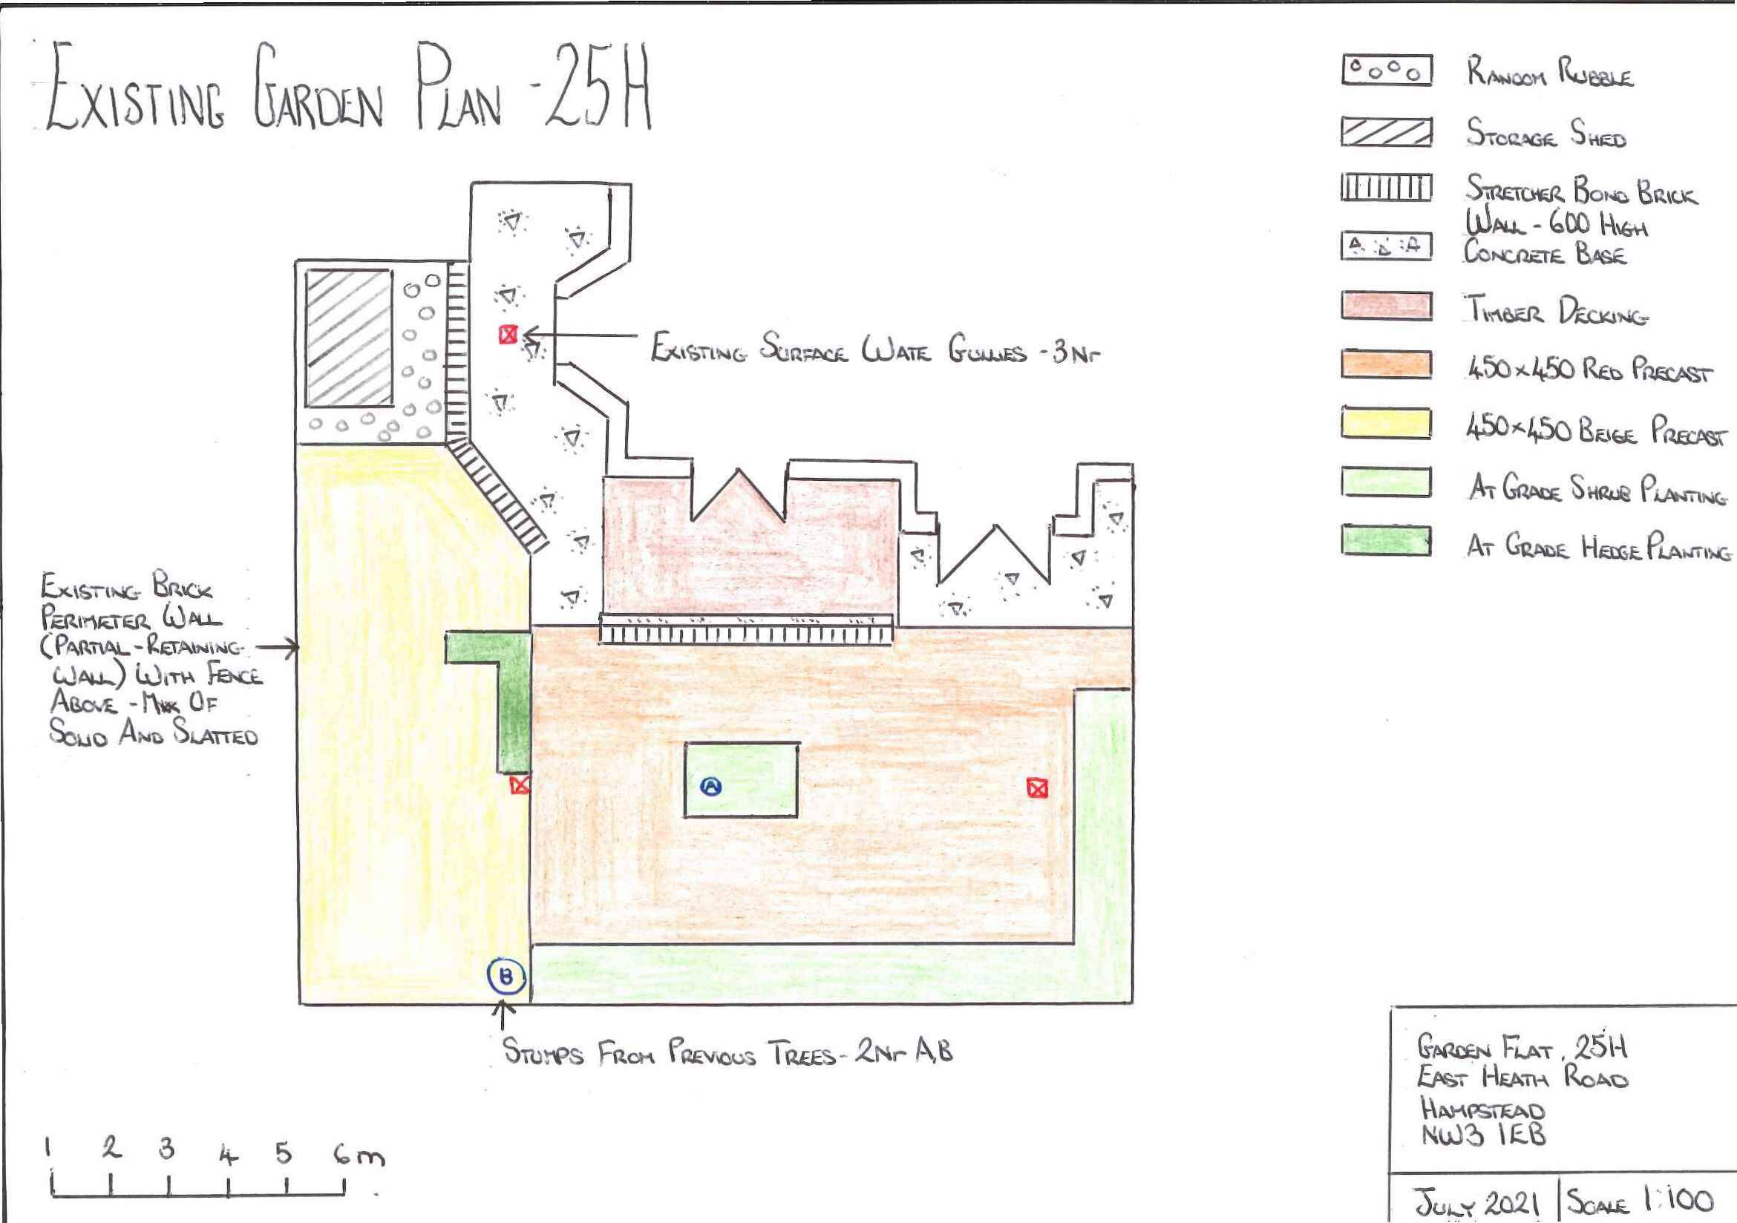

Existing plan

The garden presently is unusable to our family. The reasons for this include:

- Severe cracked and lifted hard landscaping due to tree roots and age of paving. There are no large enough flat areas, due to the damage, to place a table or seating area to enjoy the garden.
- The current soft landscaping is extremely overgrown and has contributed to the lifting of the current paving in addition to minimising the garden space and damaging perimeter wall.
- The current fence is in excess of 40 years old and is damaged beyond repair, in places it is collapsed from weight of trees overhanging from Heath and is unsafe.
- The garden has no direct access from the side of the building which is an issue for maintenance of the building for us and the neighbours, removing garden waste, and as an escape in case of an emergency.
- No outside covered area, whilst working from home and with a family member who suffers with autism, we feel this is a vital area to have for improvement of mental health.
Design brief
In order to enjoy the garden, this brief hopefully makes clear our priorities and preferences.

- Increase the surface area of soft landscaping zones and in turn reduce the area of hard landscaped area.
- Whilst we wish the hard landscaping to reduce in area, our preference would be for a natural product rather than the current precast concrete paving slabs.
- There are four current levels in the garden. Our preference is that the final product respect the existing levels and remain the same.
- The current soft landscaped zones are overgrown and have limited diversity in terms of planting. Diversity of planting to be improved with overall soft landscaping sympathetic to the Heath.
- A family member suffers with autism, given the nature of his condition it is important to have straight lines and symmetry where possible whilst also incorporating an area to sit outside comfortably without feeling closed in.
- Considering the last 18 months and for the general well-being of the family, it is important to have the ability to work outside, so a discrete covered area to allow for external use during times of poor weather conditions is required.
- The only aspect of the very original building and design in the garden is the brick perimeter retaining wall. Over the years this has degraded with bricks spalling, significant jointing damage, and algae and moss has taken over. We would wish this element to be retained, and if possible, brought to its original condition.
- We noticed that previous owners have been dumping garden waste over the existing fence and onto the heath at the rear. Access to be introduced from the communal area to the garden. This will facilitate appropriate garden waste removal and provide safe access and egress for maintenance to the rear of the building without the need to obtain access through the premises, as well as an escape in the event of an emergency.
- The current fence is broken in several areas and rotting. Due to its location where it will generally be exposed to constant moisture, we would wish a recycled product that would stand the test of time, take the load of ivy, climbers, and growth from both garden and Heath over time, and most importantly not require solvent type protection on an annual basis.
- Currently you walk out the rear doors from the living space and are faced with a standard brick wall some 600mm higher. Whilst we are comfortable with a barrier in the same location, we would prefer something softer that would break the garden up.

Design proposals
Replace existing hard landscaping, increase soft landscaping both in size and variety of planting. Replace fence and replace wall outside doors with hedging. Add an outside covered area and create access at side of building. In addition to Proposed Garden Plan below and attached, see also images of proposed garden attached.

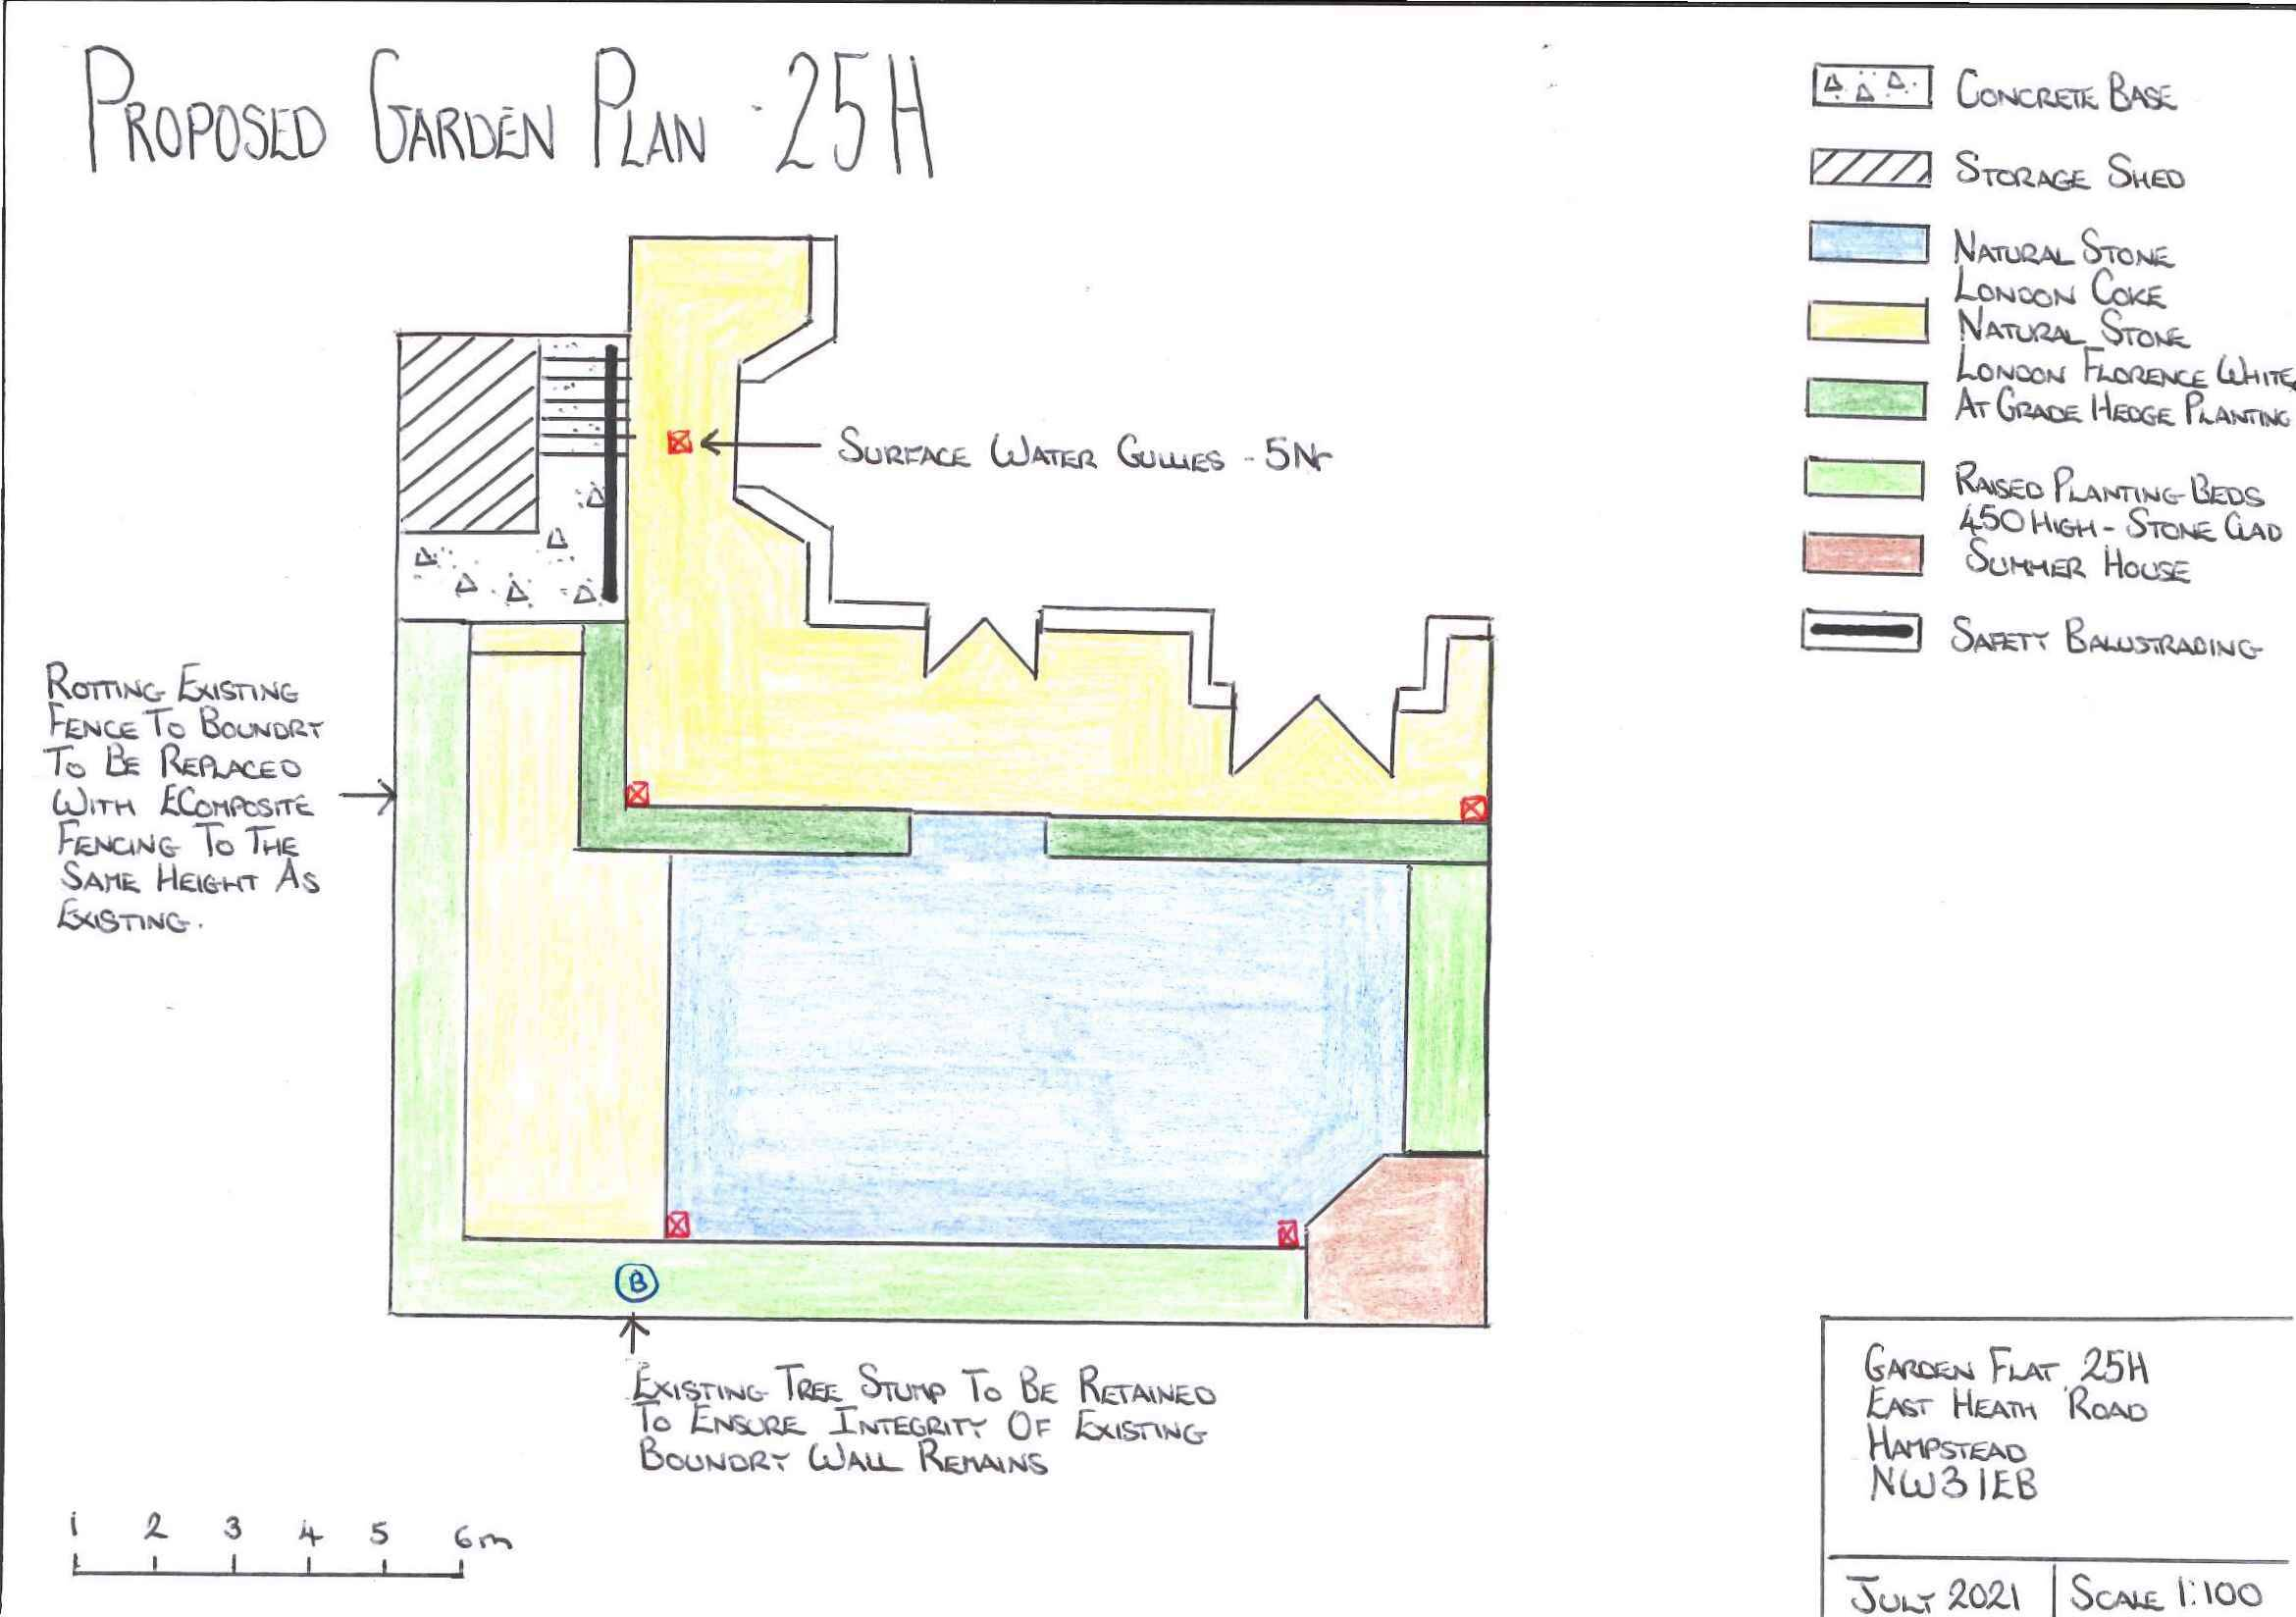
Proposed plan
Benefits of the design

- Whilst the overall garden size will remain the same, the soft landscaping areas will increase from an area of 15.5m2 to 26m2 – giving a 67% increase. This will mainly be achieved by increasing the boundary soft landscaping, but also by replacing the brick wall outside of the rear doors to the property with soft landscape hedging.
- Whilst we will grub up the central tree stump, we will leave the tree stump to the perimeter as its removal could affect the integrity of the boundary wall which we wish to retain and enhance. The stump that remains will be contained within the planting zone. All hard landscaping will be grubbed up and replaced with natural stone all as shown on the drawing.
- All existing levels of the current garden are respected in the proposed scheme.
- Soft landscaping proposal is sympathetic to the Heath with wildflowers, grasses, and shrubs. The owner has an allergy to wasp stings, and this has been respected in the choice of planting.
- In terms of symmetry and straight lines, the proposal has the same lines of those in the existing garden. The border landscaping will allow for more variance in planting for soft landscaping but not to encroach the whole garden.
- We have incorporated a small summer house to allow for covered working space for personal wellbeing as well as replacement of the existing garden shed in the same location as before.
- The proposal includes for a full professional clean to the inside leaf of the existing boundary brick wall. Once complete the jointing will be repaired in full, including the mortar fillet to the top of the existing wall.
- The safest zone to gain an access to the garden is at its highest point which is adjacent to the existing and proposed storage shed location. We have introduced stairs with a safety rail. This will be a lockable access and egress but can allow garden waste removal and safe access and egress in case of emergencies as well as for overall building maintenance and any bulky deliveries.
- The existing fence will be removed and replaced with new. The fence will be to the same height, other than that adjacent to the communal area which will be 300mm higher for privacy both ways (at 1520mm overall height). We appreciate the wish for both the Heath to grow over the fence, and the garden itself to grow up the fence, and as such have addressed the concerns expressed that timber as currently used may buckle, deteriorate rapidly, and as such become unstable adjacent to a public location. There is then the issue of avoiding the use of solvents and substance annually to maintain. With this in mind, we have recommended an Ecomposite product which is composed of 90% recycled materials, the remaining 10% being an eco-friendly bonder. This will need minimal to no maintenance and withstand plants growing on it over time.
- The brick wall barrier from the rear doors is to be removed and replaced with hedging as mentioned earlier. This will give definition to the garden of a softer nature as it matures.

