St Pancras Campus - Sustainable Urban Drainage System

Systems included
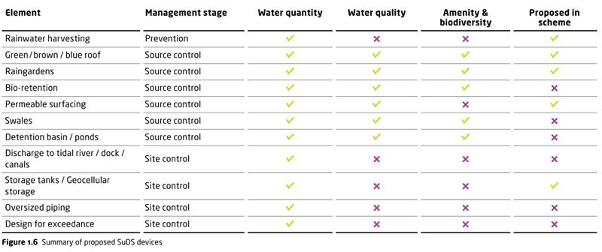

Construction Sequence overview

- The existing buildings are demolished.
- Perimeter piling takes place and the basement is excavated.
- The basement is constructed with connections in to existing sewers, and ground floor slab cast.
- Attenuation tanks are built in the basement plant rooms as shown on the drawings. It will be GRP internally flanged tank built on site
- The superstructure is built.
- The buildings roofs are formed and the blue roofs are constructed.
- The blue roofs are linked to the attenuation tank and this all discharges as described in the planning documents and numerous AKT II submissions

Note: For the Rainwater Harvesting, part of the surface water collected within the attenuation tank will be pumped to the planting areas located at the ground ﬂoor and terraces level for planting irrigation which will be undertaken towards the latter end of the programme once planting is complete.

Temporary management of water throughout construction

- BAM will manage water throughout the basement excavation via sumps and pumps and a temporary discharge license.

- A settlement tank will be used on site to ensure silts and solids are not discharged back into the watercourse

- During the structural frame construction and as we start to enclose the building temporary rain water down pipes will be installed at regular intervals and connected to a temporary attenuation tank or soakway to ensure slow discharge via the new heading constructed on site

- Any rainwater that can be harvested on site for use during construction will be done so by use of water butts.

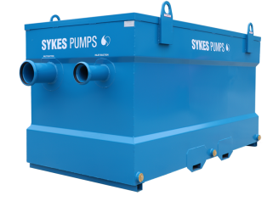
Settlement tank example

