REDINGTON FROGNAL
NEIGHBOURHOOD FORUM

12 August 2021
Dear Ms Fieldsend,

Application 2021/2002/P: 12 Platt’s Lane

Thank you very much for the clarification in your email of 11 August.

We are delighted with the revisions 2, 3 and 4. The scheme would be an exemplar if the front boundary selected were to be the traditional boundary treatment for sub area 1 (and all other sub areas) of the Conservation Area.

Metal railings are not a characteristic feature and it is unfortunate that so many are being consented. The traditional front boundary treatment is a low brick wall with a hedge. Relatively few remain in Platt's Lane, but some photos of low brick walls and hedges, which contribute positively to the Platt's Lane streetscape, are copied below.

Low brick walls and hedges at 43-47 Platt’s Lane
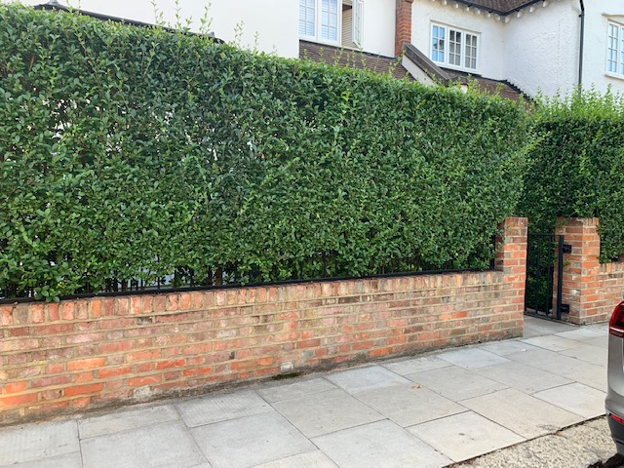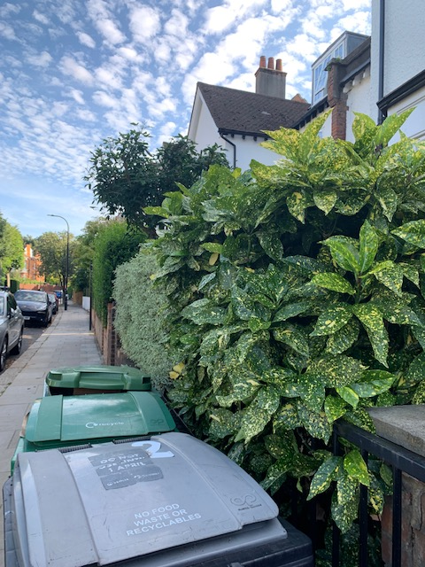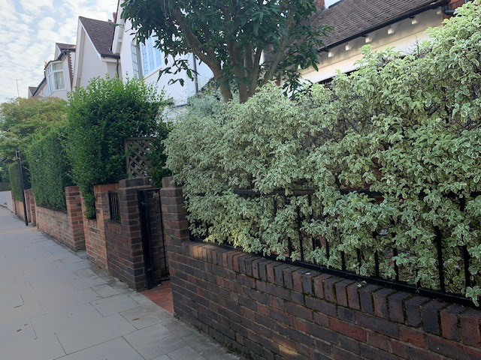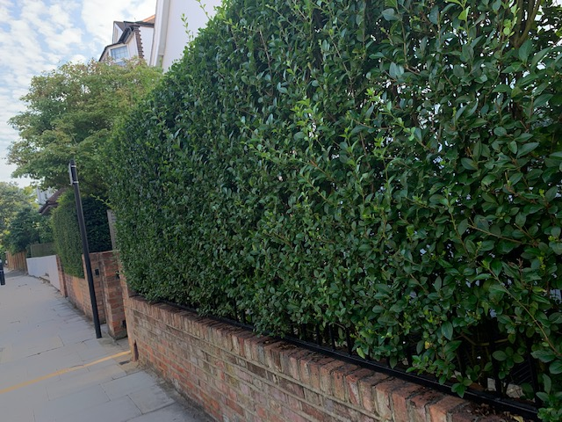

Low brick walls and hedges at 27, 29 and 17-18 Platt’s Lane
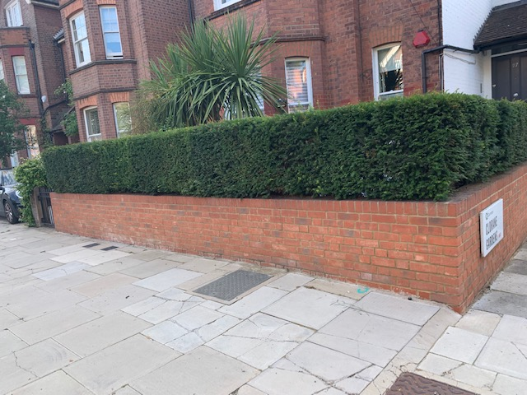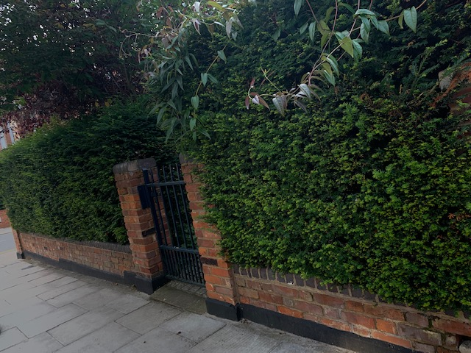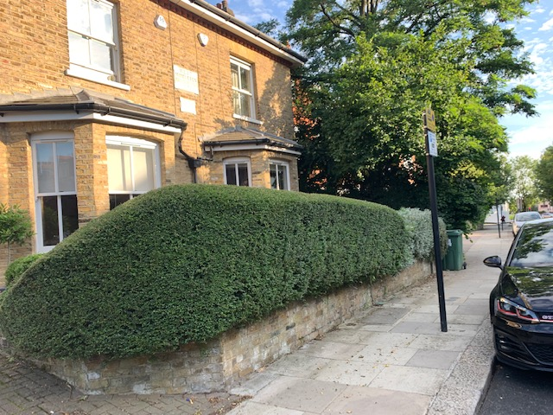

If such a treatment could be substituted for the proposed metal railings, the Forum would be most grateful and would happily withdraw its objection. A low boundary wall and hedge would make a tremendous contribution and would additionally enable the scheme to comply with policies SD 1 iii, vi, vii and BGI 1 v.

Yours sincerely,

Nancy Mayo
Secretary
Redington Frognal Neighbourhood Forum
https://www.redfrogforum.org
REDINGTON FROGNAL
NEIGHBOURHOOD FORUM

