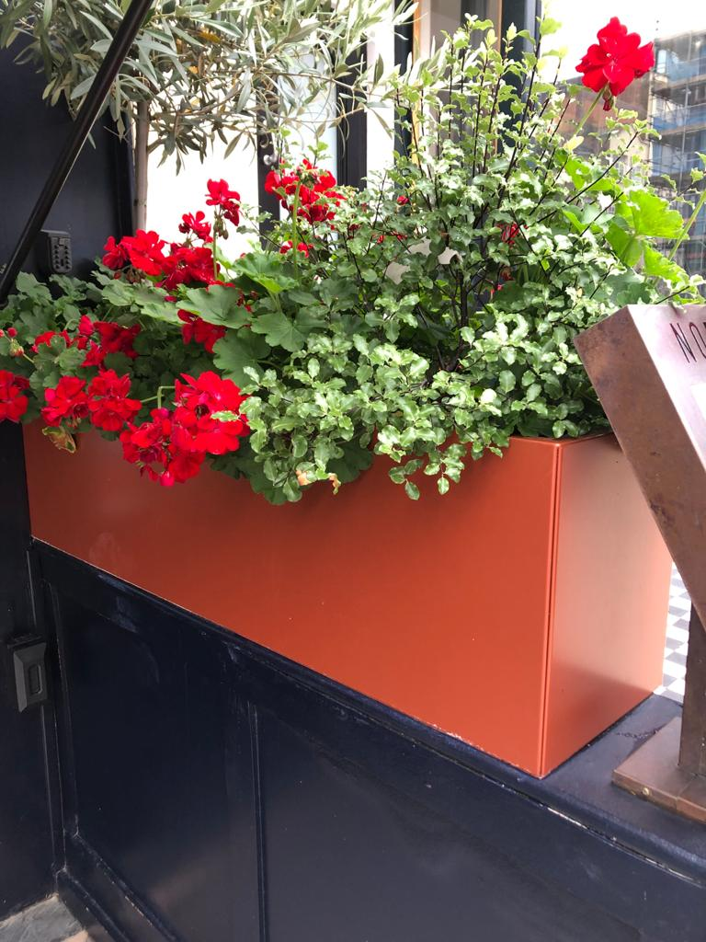

**PLANTER WILL BE ON WHEELS IT IS ONLY MADE FROM LIGHT STAINLESS STEEL.**

Navy blue parasols, set in 25 kilo stands. All returned into the restaurant during the evening

