FOOD LORD PREMISES PLAN FOR CAMDEN COUNCIL

* **Activities aim – Page 2**
* **Premises location – Page 3**
* **Premises location [Replacing the old newsstand] - Page 4**
* **Measurements of food kiosk – Page 5**

**Name of business: Food Lord Ltd**

**AIM: I AIM TO FOLLOW ALL GUIDELINES / RULES SET OUT BY CAMDEM COUNCIL. I PLAN TO OPERATE OUTSIDE CAMBRIDGE CIRCUS WC2H 8AA, SERVING HOT FOOD AND DRINKS FROM A FOOD KIOSK.**

My Activities:

Morning - Late night hot Caribbean food

Sale by retail of soft drinks/ normal juice

**Opening hours of the premises/ Times I plan to carry out activities**:

Late night food: 10:00 – 23;00

Soft drinks/normal juice: 10:00 – 23:00

Name of business: Food Lord Ltd

**Children Access:**

This premises is safe for Children to access this premises when accompanied by an adult.

**Pedestrians:**

This premises is safe for Pedestrians to access this premises.

**Below is the premises pitch I would like to propose putting my food kiosk.**

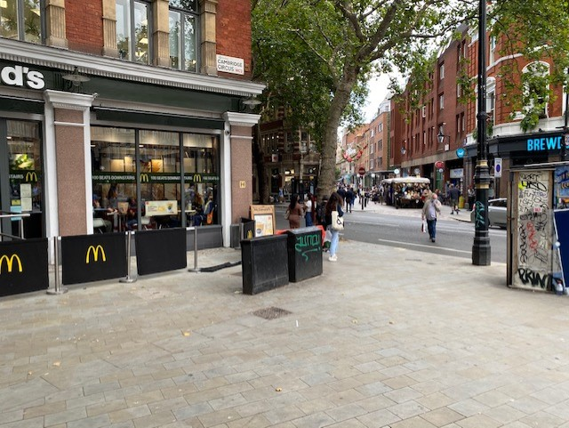

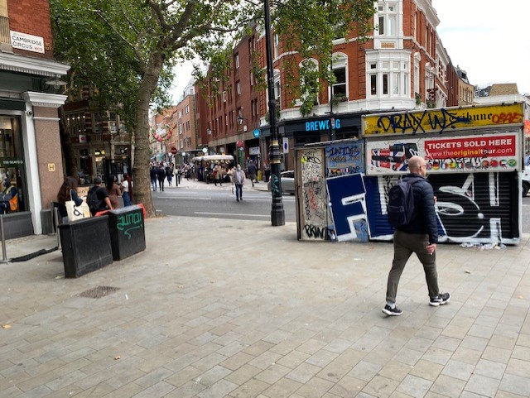Replacing the newspaper stand as it hasn’t been in use for a few years.

Measurements of my food kiosk:

Width: 3.7m

Length; 2.5

