24C LAMBOLLE ROAD, NW3 4HP

DESIGN AND ACCESS STATEMENT

JULY 2021

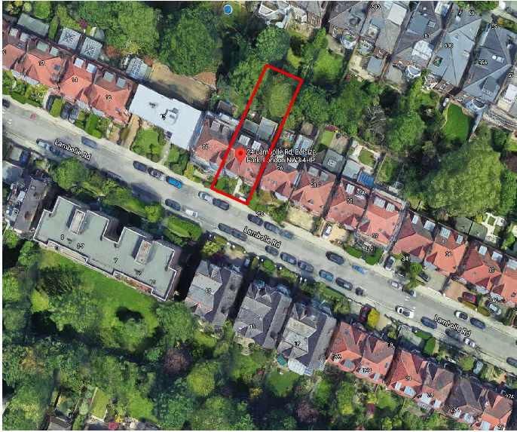

1. **Introduction**

A This Design and access statement is prepared to support the Planning application at 24C Lambolle Road for two inset balconies on the rear façade, and installation of conservation style Velux windows. Also, internal layout update to improve the existing living conditions.

1. **Application Site and Context**

24 Lambolle Road is not a listed building but it does sit in the Belsize Park Conservation Zone. The application site is on the north side of Lambolle Road. The house is a period conversion into 3 flats and 24C is the top floor flat which has direct and its own entrance from the 1st floor landing level as shown on the SK-02, 1st Floor Plan.

The existing flat has two bedrooms, a large bathroom and kitchen and lounge/ dining area with attic space above.

1. **Proposal**
2. An addition of six (6) new conservation style Velux windows, which will give more daylight and air into the existing living condition.
3. Internal layout changes to the existing flat to improve quality living spaces.
4. Two new inset balconies with bi-folding doors to Bedroom 2 and Lounge area. The proposed two inset balconies will allow air and light into the living spaces to improve living conditions. New low height tile (to match existing) cladded upstand to the proposed inset balconies. The line and position of existing dormers will remain as existing. The Lounge inset balcony will have three doors to match the existing three windows of the dormer and Proposed bedroom will have two bi-fold doors to match with existing dormer window.

The proposed inset balconies are designed to minimise additional overlooking to the neighbouring properties.

Also, as the existing flat has no amenity space, the proposed inset balcony will provide improved living spaces.

***Rear of property***

Two new conservation style skylights are also proposed at the rear of the property. This will allow more daylight and air into the living room space and Bedroom.

***Front of property***

Two new conservation style skylights are proposed at the front of the property. This will allow more daylight and air into the kitchen/dining space.

***Side of property***

Two new skylights are proposed at the side of the property. New glazing over the stairwell will allow more daylight into the entrance of the application accommodation.

1. **Relevant Planning History**

**26D Lambolle Road NW3 4HP**

***The local planning office have recently approved a similar planning application ref. 2020/2916/P on 26th Oct. 2020 at 2******6D Lambolle Road, London NW3 4HP.***

***Application Ref. 2020/2916/P approved on 26th Oct. 2020, Alteration to the rear dormer roof extensions associated with creation of a terrace with upstand following the replacement of the existing windows with doors and installation of a conservation skylight to the flank elevation.***

The internal spaces are proposed in a way that the existing space and volume can be used at its best. Our proposal is similar to this approved application.

Application Ref. 2020/3292/P approved on 27th May 2021, Erection of single storey outbuilding and installation of associated air source heat pump in rear garden to replace existing play equipment, for use ancillary to lower ground floor flat.

Application Ref. 2018/5492/P approved on 22nd January 2019, Erection of single storey rear extensions and side fenestration alterations.

Application Ref. 2018/2899/P approved on 29th August 2018, Installation of raised balcony to the rear at upper ground floor level with associated spiral staircase.