BT_mark_4col_pos

BTW&V Small Cells

Site Type Design for

Small Cells in BT KX100 series Payphone Kiosk

Issue: 1

© 2019 British Telecommunications plc

The information in this document is the property of British Telecommunications plc and may not be copied or communicated to a third party, or used for any purpose other than that for which it is supplied without the express written consent of British Telecommunications plc.

This information is given in good faith based upon the latest information available to British Telecommunications plc, no warranty or representation is given concerning such information, which must not be taken as establishing any contractual or other commitment binding upon British Telecommunications plc or any of its subsidiaries or associated companies.

1 – Contents

**1 – KX100 & KX100+**

**2– Structure changes**

2.1 New Dome

2.2 Service Pannel

2.3 Dome Antenna

2.4 Ventilation

2.5 Warning labels

# KX100 & KX100+

The KX100 payphone was introduced by BT in the mid 1980s with a revised KX100+ deployed from 1996. The main format of both payphone types are very similar with the only significant difference being the domed plastic roof introduced with the KX100+. Example pictures of both types of payphones is shown below:-



1. KX100 and KX100+ kiosks

The KX100 payphone structure has a flat roof which is unsuitable for the installation of small cell eNodeB equipment. It can however be modified by removing the existing stainless steel external roof panel and replacing with a plastic dome so that it resembles a KX100+ structure. This is a technically viable option and means that the KX100 estate can be considered for small cell installation. The KX100+ requires no physical modification to basic structure to introduce additional space to support the small cell installation.

Both payphone types have minimal services deployed to support the plain old telephony service it offers to the public. These are:-

* Single PSTN line to support the payphone itself
* 240V mains supply to power the light in the payphone roofing.

Both services enter the payphone structure from the bottom and is terminated within a service panel.

Distribution within the payphone structure itself is behind a stainless steel back panel onto which the payphone itself is installed. Although there is minor differences between the two models, general distribution within the structure for cabling exists, particularly for the existing power for lighting. The diagram below illustrates how the power distribution is achieved within a KX100+ structure:-



1. KX100 Existing Services Distribution

The 240V mains supply terminates behind the service panel at the right side at the base of the payphone. Internal 240V cable distribution to the light itself is via plastic flexible conduit routed behind the stainless steel back panel into the ceiling space, with entry into the ceiling from the top right corner of the stainless steel back panel. Access to the ceiling space itself is via a small drop down panel which is secured with M5 pin torx button security screws. The existing KX100+ (and modified KX100) ceiling layout is shown below:-

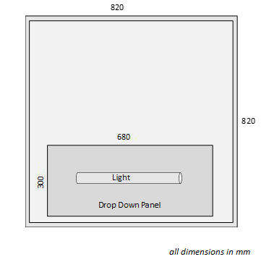

1. KX100+ Existing Ceiling and drop down panel

# Structure Changes

The most viable solution is to re-purpose the structure to a cell site. This will involve

1. New Dome;
2. Service panel replacement;
3. Adding antenna;
4. Ventilation;
5. Warning Labels.

## New Dome

A new IP rated dome will be fitted which contains fans and outlets. Where a KX100+ has an existing dome. This will be replaced entirely.

The dome is attached to inside of ceiling rim by four hand tightened clamps as shown below.

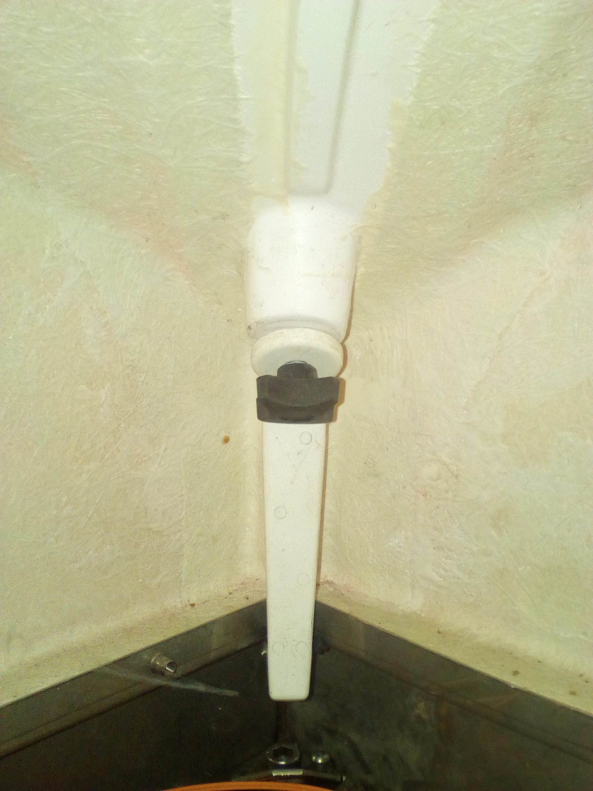 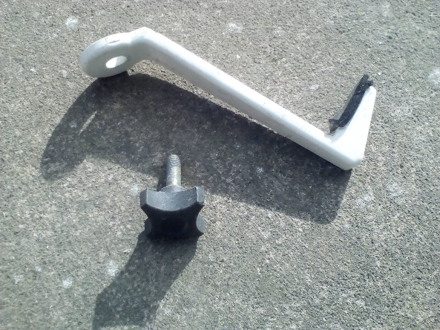

1. Dome clamp

A M8 Spring washers should be fitted to each of the clamp bolts before fitting to prevent bolts lessening due to vibration and the clamps firmly tightened.

## Service Panel

The existing service panel will be removed and new service panel installed.

Space available for Service Panel this is 650 x 600 x 200 mm (h x w x d)

**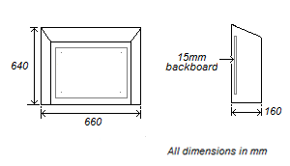**

1. Service Panel

This is a repurposed existing service panel design that has previously been used on some K6 kiosks.

This will be attached to the metal frame using 6 x M6 screws into attachment lugs on the frame. These are accessible when the door is removed.

The wooden backboards will be replaced with 18 mm plywood.

## Dome Antenna

Typically one antenna radome will be fitted to centre of dome.

|  |  |
| --- | --- |
| Model | Laird VLQ69273x21G |
| Size | 132 x 75 mm (diameter x height) |
| Mounting | ¾ inch hole  ¾ inch long zinc stud with dual jam nuts |
| Colour | as supplied Black |

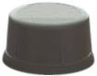

1. Laird Antenna

Antenna position shown below

**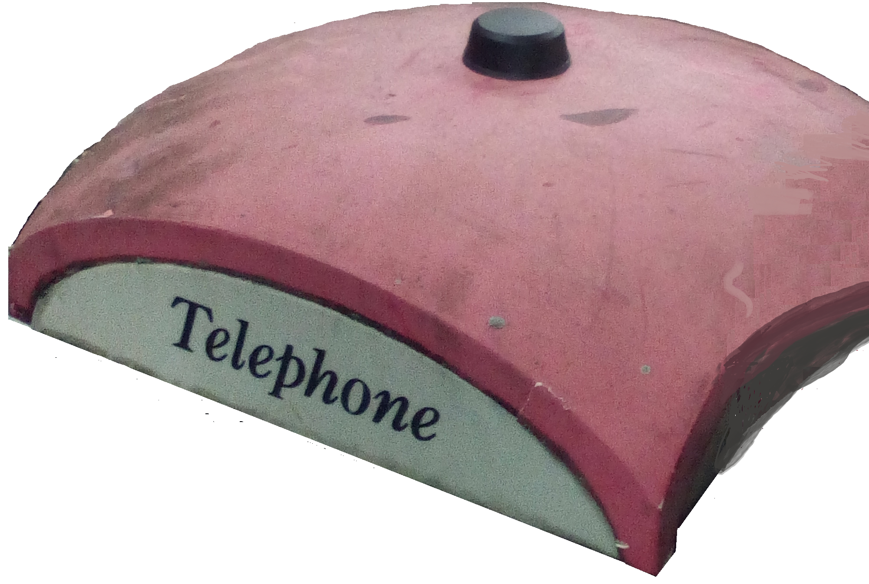**

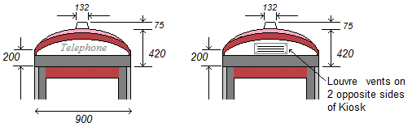

1. Dome with single antenna

Once the antenna dual jam nuts are spanner tightened, the roof will resist any water ingress from above.

## Ventilation

The design will place equipment in the roof space and behind service panel

The combined power consumption of the devices is

|  |  |
| --- | --- |
|  | Power consumed W |
| Roof space | 360 |
| Service Panel | ~40 |

For Service Panel, no change is needed to improve ventilation.

For Roof space, to disperse the heat generated to the atmosphere will require adding inlet vents with fans on one side of the dome and vents on the opposite side to allow forced warm air to exhaust.

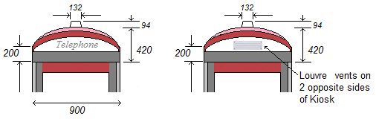

1. Vents on dome side

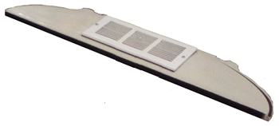

1. Picture of Vent of side panel

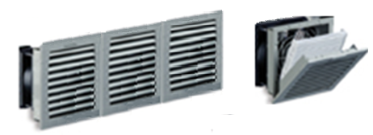

1. Fans and Filters

Each mains powered Fan will draw **in** air through an IP55 filter at 64 m3/h, giving 0.035 m3/second in total.

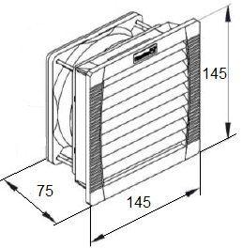

1. Fan size (Hole 125 x 125 mm)

|  |  |
| --- | --- |
| Model | PF22.000 |
| Manufacturer | Pfannenberg |
| IP Rating | IP55 |
| Power | 230V AC |
| Throughput | 56 m3/h |

An IP55 filter will be fitted across the outlet vent on the opposite side. (Same assembly but without fan,)

The fans are controlled by thermostat in roof space at outlet vent.

|  |  |  |  |  |  |  |  |  |  |  |  |  |  |  |  |  |  |  |  |
| --- | --- | --- | --- | --- | --- | --- | --- | --- | --- | --- | --- | --- | --- | --- | --- | --- | --- | --- | --- |
|  | |  |  | | --- | --- | | Manufacturer | Vostermans | | Model | T15-WD | | Switching range | 0 to 40 deg Celsius | | Contacts | normally open | | Size | 10 x 15.5 x 6 mm | | Max voltage | 380 | | Max current | 16 A | | Max load | 120 VA | | Housing | IP55 plastic | |

1. TD15-WD thermostat

## Warning Labels

Following labels should be attached

|  |  |  |
| --- | --- | --- |
| Label | Appearance | Size mm |
| 1 |  | 60 x 80 |
| 2 |  | 49 x 79 |
| 3 |  | 70 x 120 |

|  |  |
| --- | --- |
| Label | Position |
| 1 | on dome near antenna |
| 2 | on the outside of Service Panel |
| 3 | on inside of Service Panel facing outwards |

--- end of document ---