**12 Gainsborough Gardens NW3 1BJ**

**Schedule of Photos**

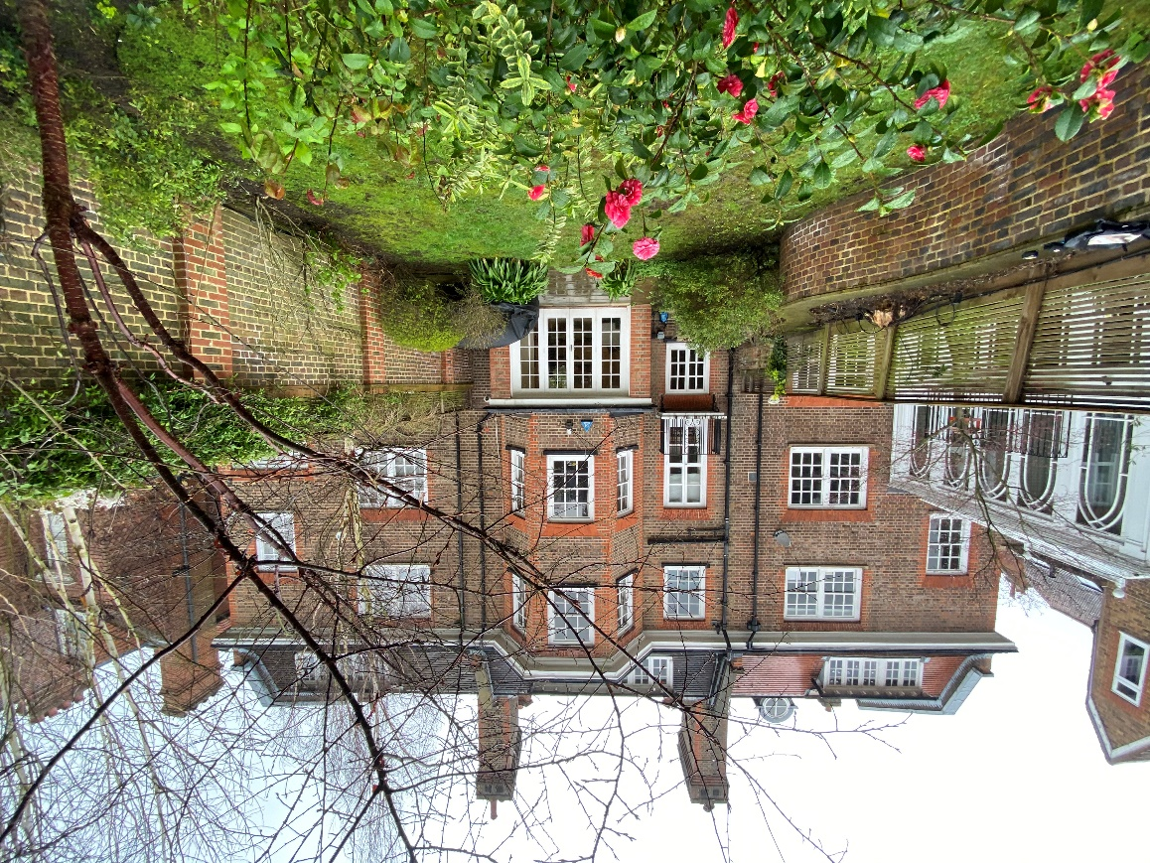

Photo. 1 12 Gainsborough Gardens; No. 13 on the left.

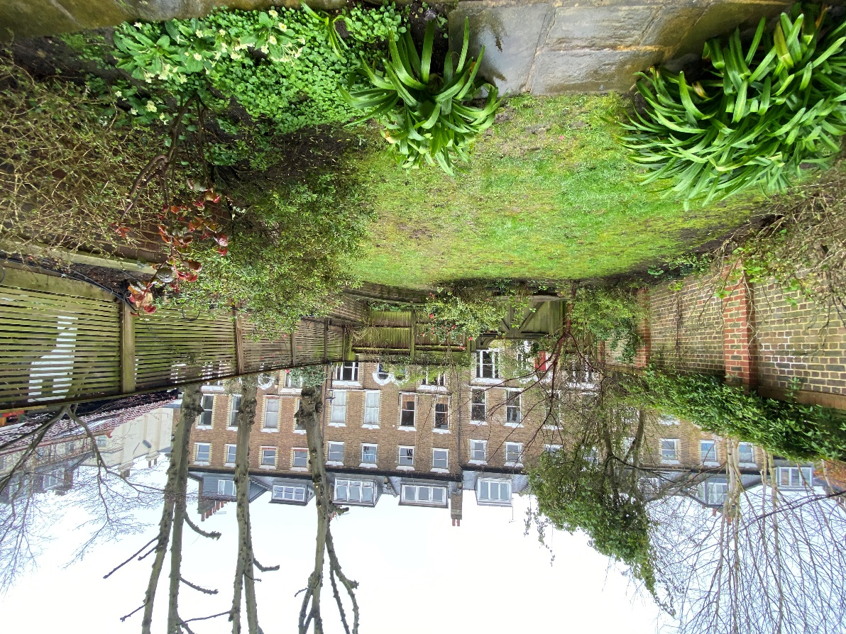

Photo 2: 12 Gainsborough Gardens towards Christchurch Hill

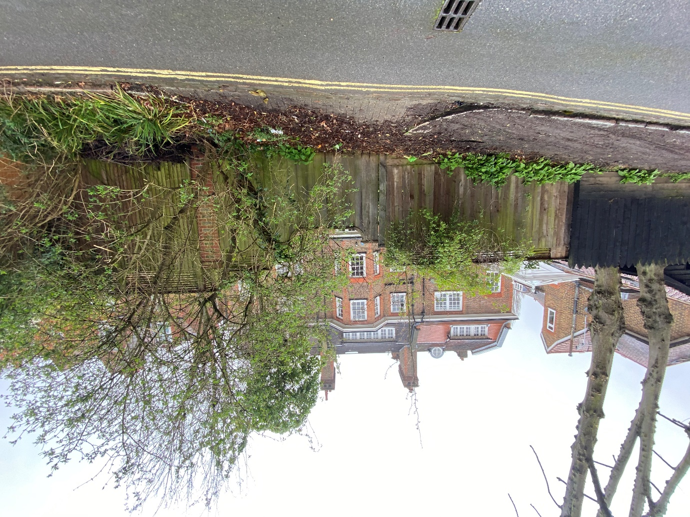

Photo 3: 12 Gainsborough Gardens from Christchurch Hill