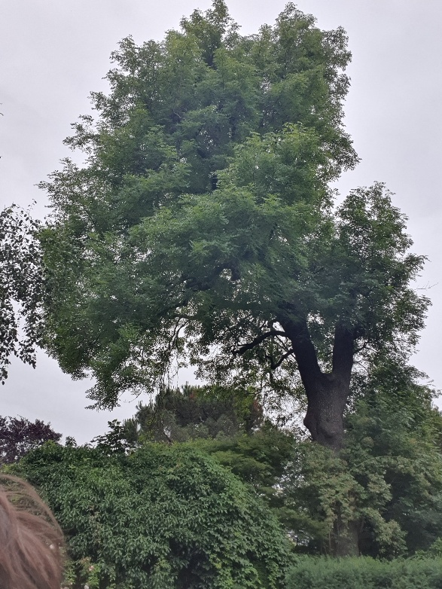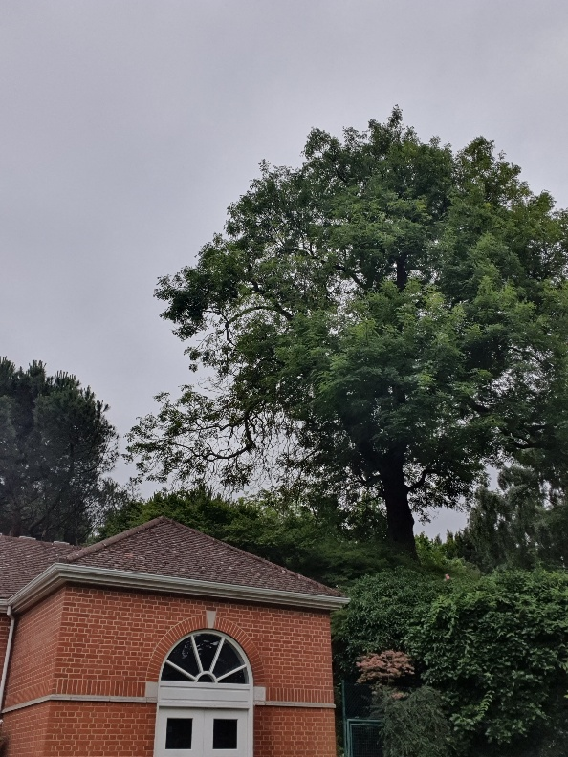42 Frognal Lane Ash Tree with TPO. Urgent request for work. Tree has Ganoderma bracket at base and suspected Inonotus hispidus higher in canopy. This isn’t very clear in the photo, but you can make out that there is a bracket growing from the cavity on that limb. The trunk bipartites at 25 feet, one of those has previously failed and the tree is very one sided. If the trunk were to fail or a major limb were to fall, it would almost certainly strike one of the property buildings. The tree will have two tomographic scans as a part of the condition survey. Please see images.

Building below Tree. Trunk split.

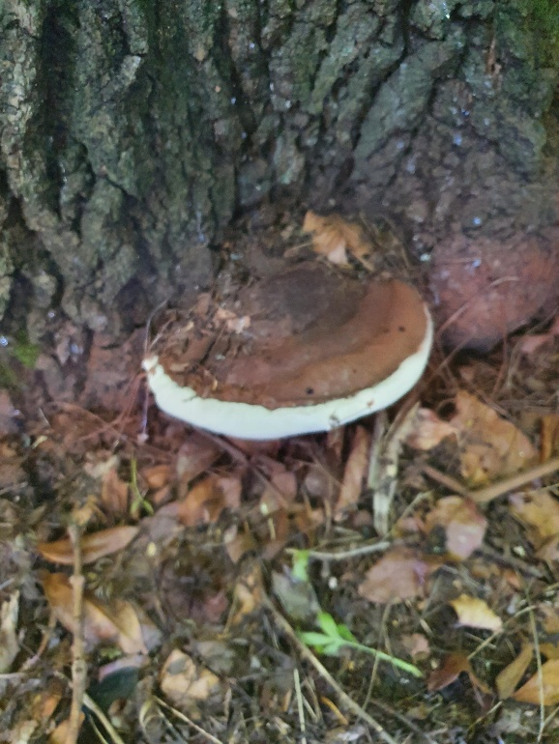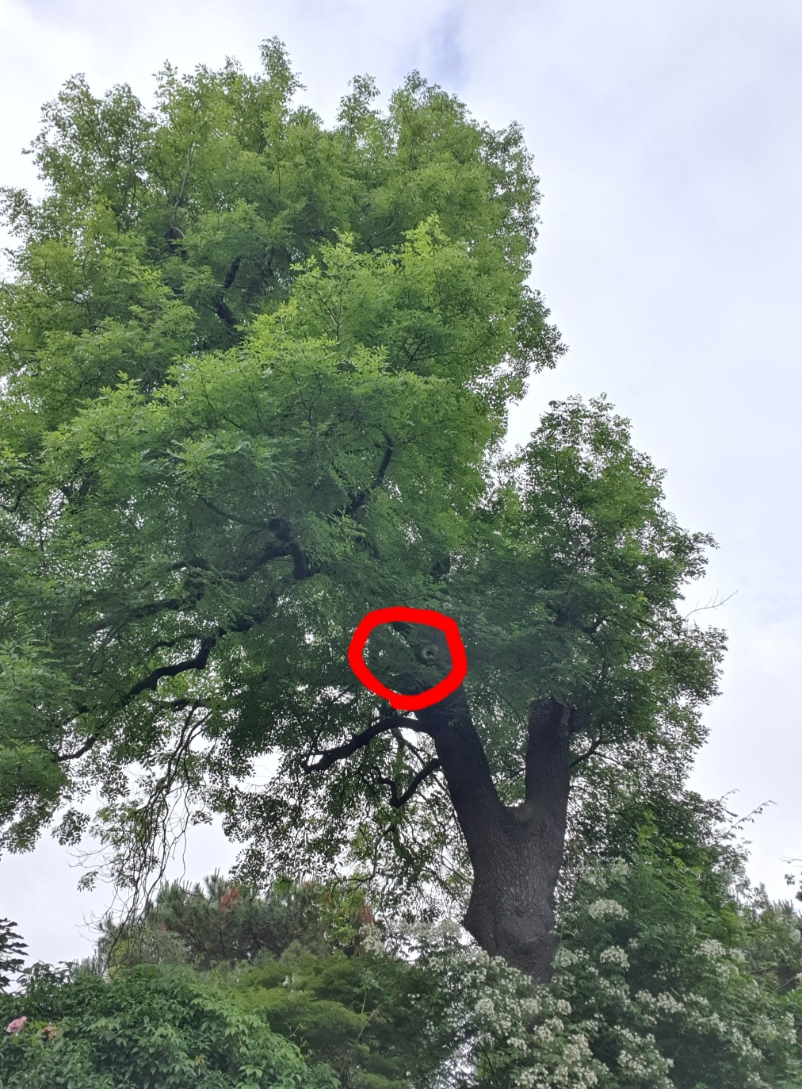Suspected Inonotus hispidus in cavity. Ganoderma at base.