DECISION

Town and Country Planning Act 1990

Certificate of Lawfulness (Existing) Granted

The Council hereby certifies that on the 11 June 2021 the use described in the First Schedule below in respect of the land specified in the Second Schedule below, was lawful within the meaning of Section 191 of the Town and Country Planning Act 1990 as amended.

First Schedule: Use of roof of ground floor rear extension as a terrace.
Drawing Nos: Location plan, Plan of existing terrace, Plan of first floor

Second Schedule:
Flat 2
37 Ulysses Road
London
NW6 1ED

Reason for the Decision:

1 | The use of the roof of ground floor rear extension is considered to be incidental to the use of the dwelling house and not to amount to a material change requiring planning permission.
2 | The works are not considered to fall within the "meaning of development" requiring planning permission as defined by the Town and Country Planning Act 1990.

Informative(s):

The grant of certificate only applies in as far as the use described does not constitute development requiring planning permission. You may require permission from other owners of the part of the building in question. Further any formalised use as a roof terrace may require works to facilitate access and means of enclosure to satisfy Building Regulations. Such works are likely to require an application for planning permission which may or may not be granted.

In dealing with the application, the Council has sought to work with the applicant in a positive and proactive way in accordance with paragraph 38 of the National Planning Policy Framework 2019.

You can find advice about your rights of appeal at:

http://www.planningportal.gov.uk/planning/appeals/guidance/guidancecontent

Yours faithfully

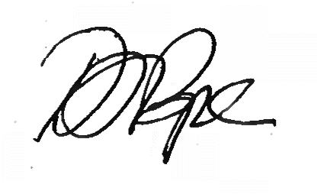
Daniel Pope
Chief Planning Officer

Notes

- This certificate is issued solely for the purpose of Section 191 of the Town and Country Planning Act 1990 (as amended).

- It certifies that the use*/operations*/matter* specified in the First Schedule taking place on the land described in the Second Schedule was*/would have been* lawful on the specified date and thus, was not*/would not have been* liable to enforcement action under Section 172 of the 1990 Act on that date.

- This Certificate applies only to the extent of the use*/operations*/matter* described in the First Schedule and to the land specified in the Second Schedule and identified on the attached plan. Any use*/operations*/matter* which is materially different from that described or which relates to other land may render the owner or occupier liable to enforcement action.

- The effect of the Certificate is also qualified by the provision in Section 192(4) of the 1990 Act, as amended, which states that the lawfulness of a described use or operation is only conclusively presumed where there has been no material change, before the use is instituted or the operations begun, in any of the matters relevant to determining such lawfulness.

