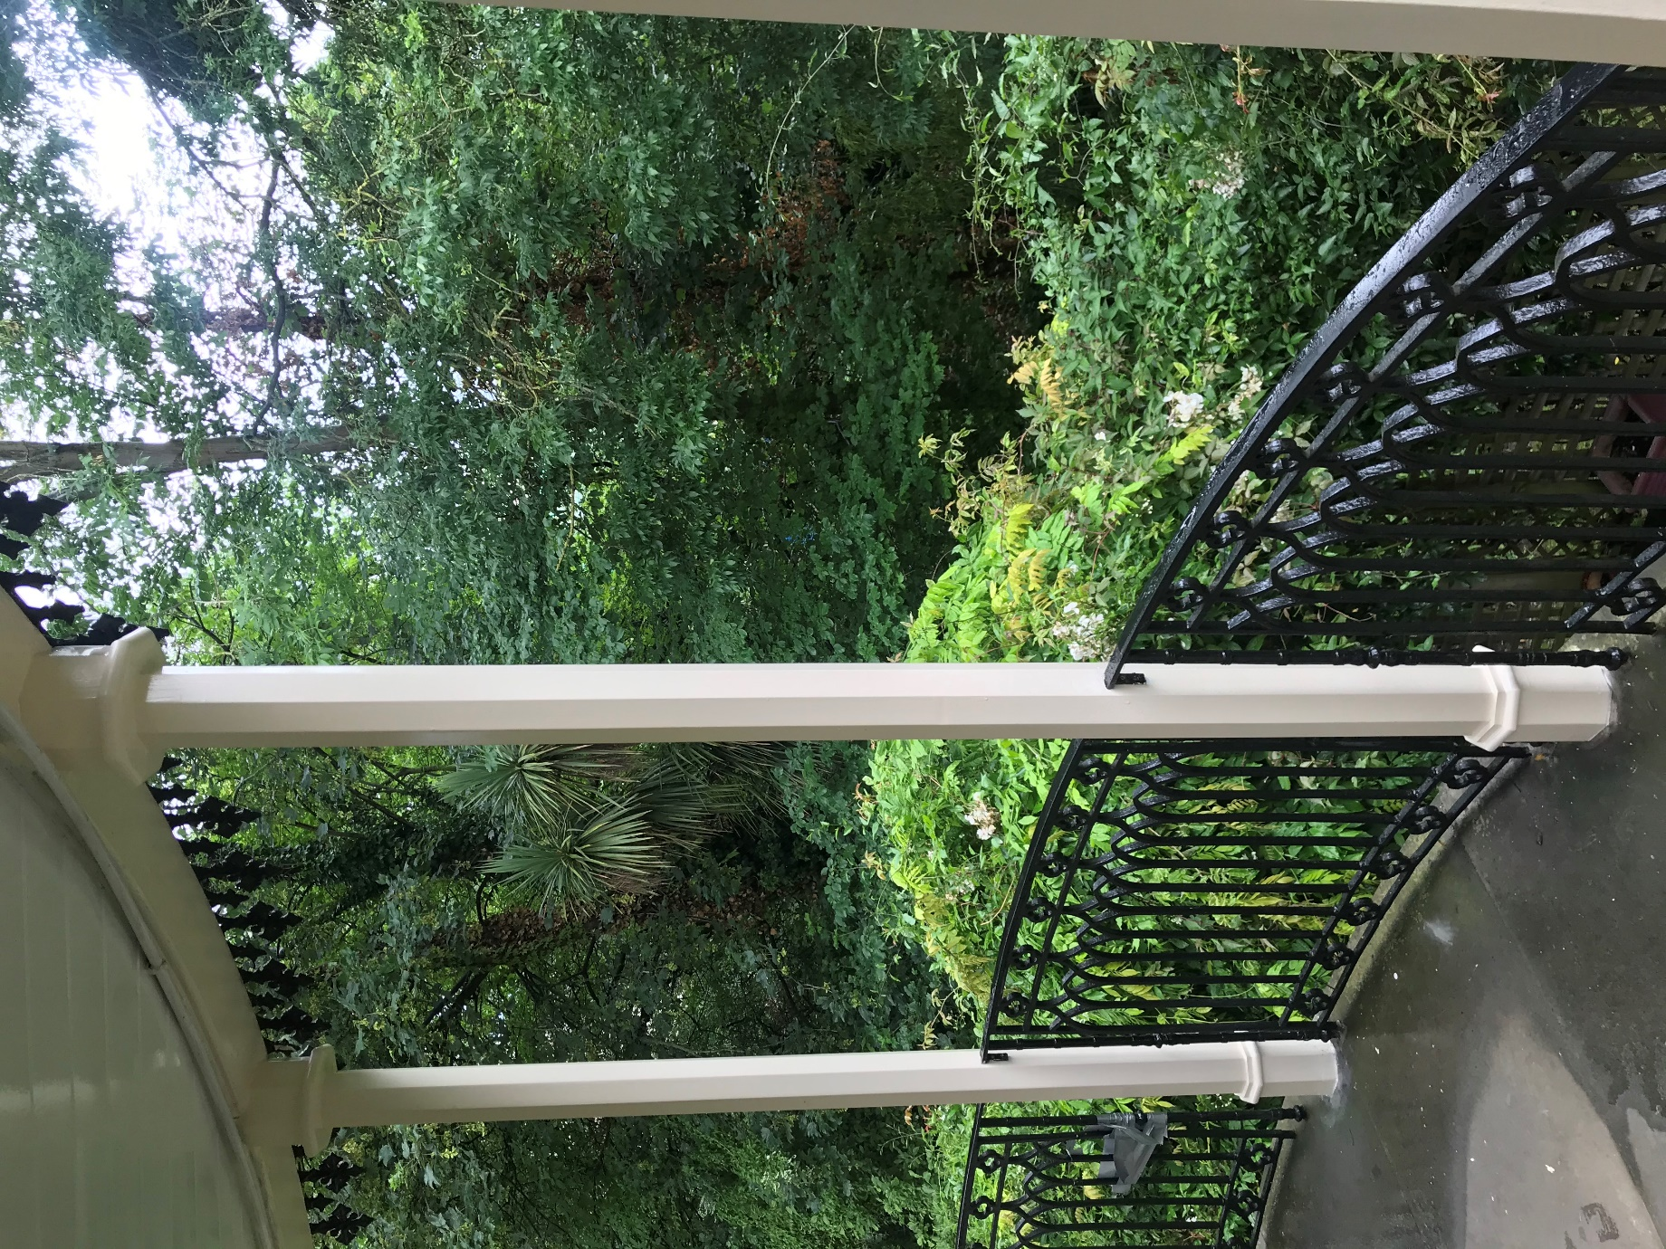
Figure 1. Photograph showing the replaced pillars, viewed from the balcony

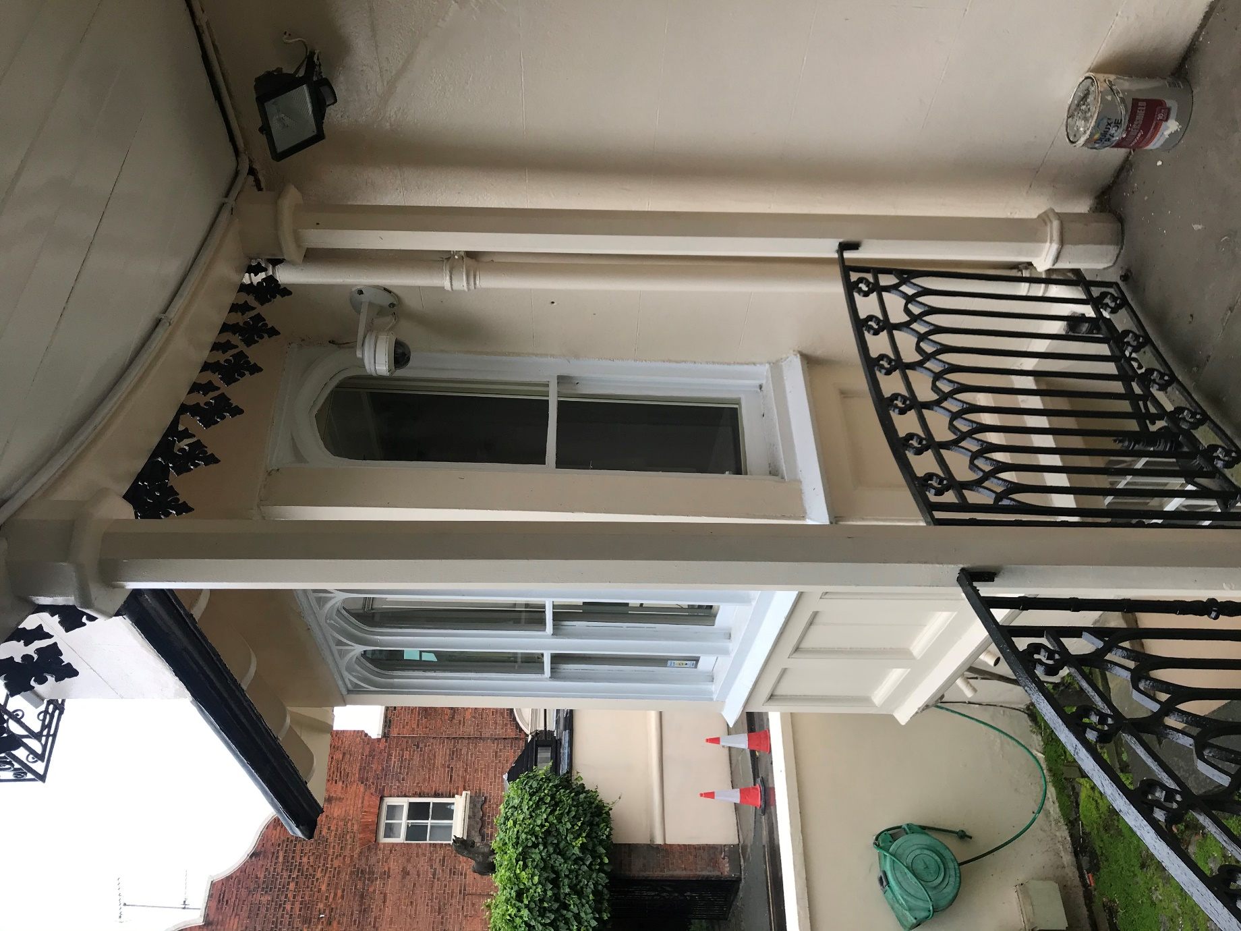
Figure 2. Photograph showing the existing ‘original’ pillars, viewed from the balcony

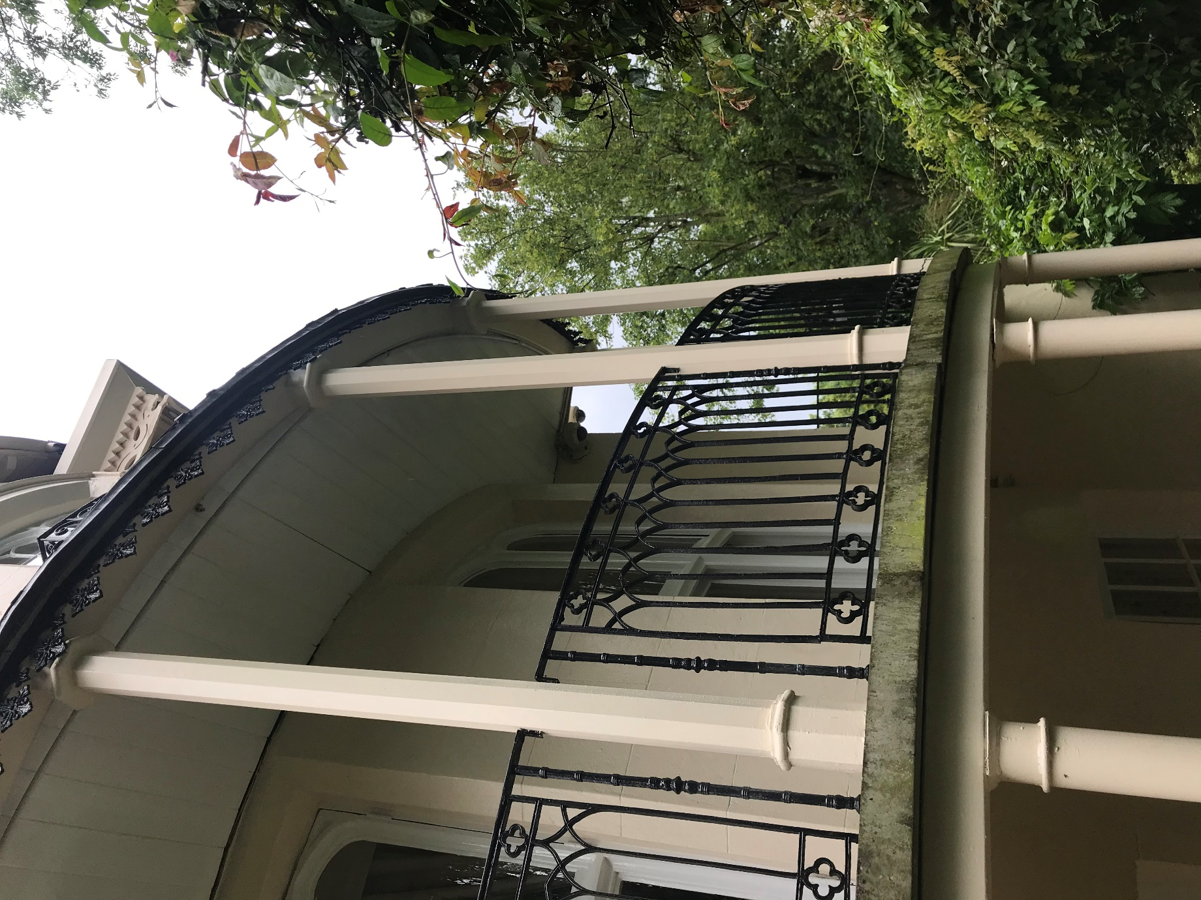
Figure 3. Photograph showing the existing ‘original’ pillar on the left and the 2 of the 3 replacements on the right, viewed from the area of hardstanding in the garden.

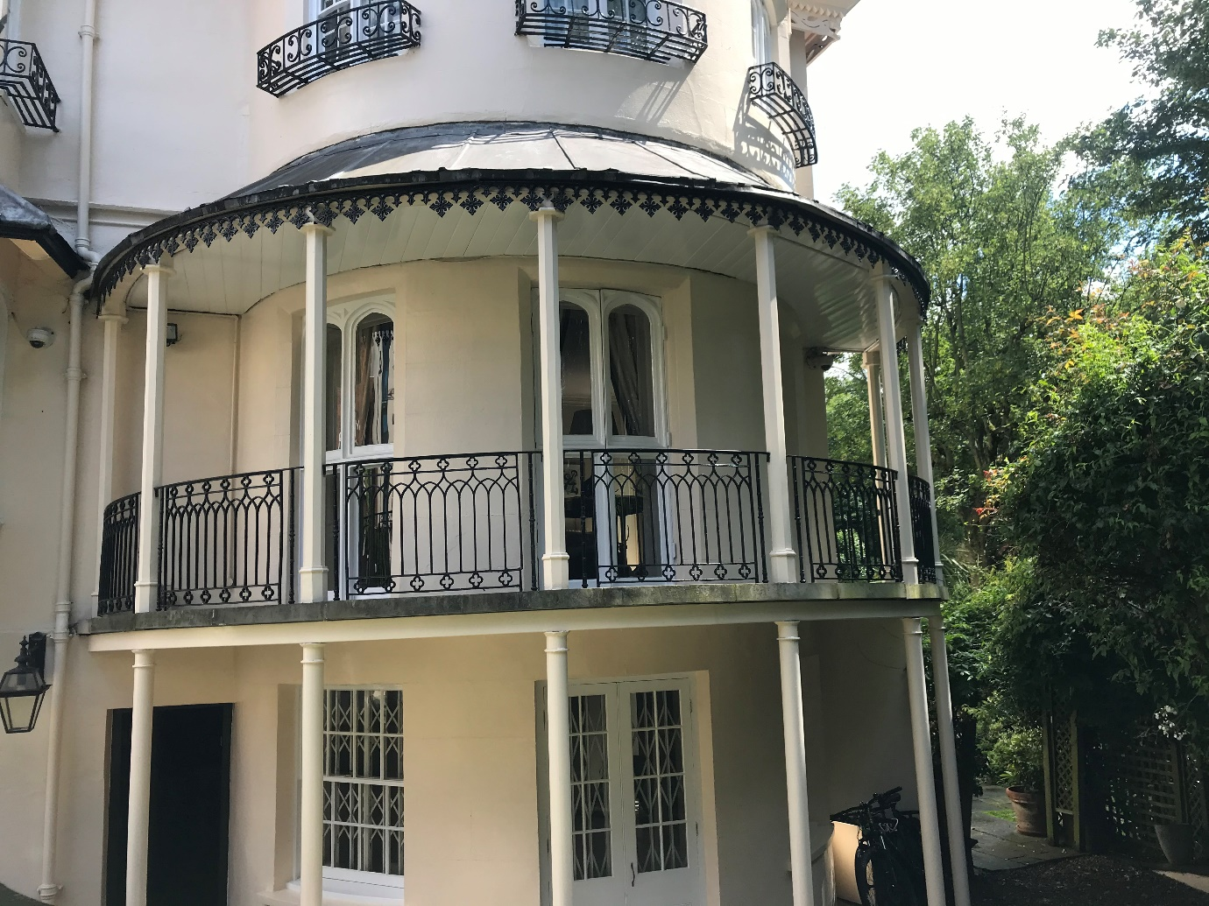
Figure 4. Photograph showing the existing ‘original’ pillars 1-4 on the left, and the 3 replaced on the right (at 1st floor level) viewed from the area of hardstanding in the garden.

