**Performance Officer - Job Profile**

**Job Title: Performance Officer**

**Job Grade: Level 3 Zone 2**

**About Camden**

Camden is building somewhere everyone can thrive, by making our borough the best place to live, work, study and visit. Because, we’re not just home to UK’s fast-growing economy; we are home to the most important conversations happening today. And we’re making radical social change a reality, so that nobody gets left behind. Contact Camden plays a critical role in supporting our citizens being the first point of contact and front door for a range of services.

**About the role**

The Performance officer plays a crucial role in ensuring Camden citizens receive an exceptional service when contacting Camden Council. The role helps to achieve this aim by analysing our customer demand and the overall customer experience making recommendations to improving processes taking into consideration the entire journey from the Interactive voice response (IVR) to managing our relationships within the customer insight team to make improvements to our web offer, all of which will enable us to deliver excellence with every customer contact. We have over 100 Customer Service Officers (CSO’s) in Contact Camden who between them have over one million customer conversations every year. Therefore, by identifying knowledge gaps, creating a seamless journey for our citizen’s and developing the CSO’s, the Performance officer will have a direct impact on the service received by our customers.

In this role, the ability to analyse our customer demand and understand the services we are delivering, and to develop support tools (online learning modules) and to identify skills gaps and know how to provide the most effective coaching for the CSO’s is essential. The post holder will be required to liaise with a range of stakeholders and act as the voice of customer, to support not only Contact Camden but the wider organisation in designing their services around our customer needs, focusing resource where required. You’ll be part of the Performance team, who will work together on developing capabilities, skills and knowledge throughout Contact Camden, and enable CSO’s to become the best they can be by delivering the highest level of customer service to our citizens with an aim to getting the issue resolved first time round. This role will constantly look for ways to improve customer service through coaching CSO’s to have better customer conversations, fixing broken processes, surfacing customer/CSO obstacles and support re-designing how we deliver services to citizens.

Our customers do not see us as Contact Camden but as one “Camden Council” therefore it is imperative we leave a lasting impression, as this will how the customer views us as an organisation.

**Example outcomes or objectives that this role will deliver:**

**Improving performance through people**

* You will improve CSO’s call quality and technical competency by side by side coaching and support co-creating CSO personal development plans
* Strategically plan, prioritise and deliver coaching interventions with the Contact Camden management team
* Plan and deliver coaching and subject matter expert training one to one, in small groups and team events
* Design and deliver a new Contact Camden induction and on-boarding programme
* Report the call quality score across Contact Camden; on a department, team and individual level

**Improving performance through process**

* Drive continuous improvement within Contact Camden by identifying improvements and working with Team Managers & CSO’s to deliver quick wins
* Understand our customer demand, analyse the customer journey from the start IVR to our online offer, understand the process and making recommendations for improvement to the entire journey.
* Support the implementation and embedding of new processes and ways of working
* Identify and implement process improvements, using root-cause analysis and engaging CSO’s
* Work closely with service areas to fix broken processes and to collaborate on process improvements – ensuring the customer journey is at the forefront of all changes
* Engage with back office partners sharing our “voice of the citizen” insight to support redesigning services to meet our citizen needs.

**Own frameworks, templates and learning tools**

* Design and own the personal development plan template
* Create and implement a new call quality and scoring framework
* Create and design new learning tools and training content; including enhancing our online offer and the induction programme for new starters within Contact Camden
* Own the Contact Camden knowledge base – ensuring the most up-to-date information and processes are available for CSO’s
* Identify training needs through the quality framework and skills matrix

**People Management Responsibilities:**

Line management of 1 direct report

**Key relationships.**

* Customer Service Manager, Performance Manager, Performance Coaches, Performance Analysts, Senior CSO’s, Team Managers, Improvement Manager, Head of Customer & Registration Services and key stakeholders in wider organisation

**Work Environment:**

You’ll split your time between the Contact Camden Hub in Mornington Crescent and Camden Council’s main office in Kings Cross.

**Technical Knowledge and Experience:**

**Strong experience in training and coaching**

You’ll have strong experience and ability in coaching with a toolbox of techniques to improve performance in Contact Camden. Ideally, you’ll have a customer service background with experience in delivering inductions and on-going coaching development

**Experience in process re-engineering, root cause analysis**

You’ll have experience in improving processes and re-designing how things work; showing innovation and tenacity in approaching things differently

You will have experience in designing support tools and creating online leaning modules

**Engaging and a clear communicator**

You’ll be a people person who is respected by teams due to your clear and personable communication, knowledge and skills

**Deliver high performance results**

You’ll have proven experience in delivering multiple priorities at the same time and proven at delivering high performance

**Collaborator**

You’ll be someone who is able to work alone, and more importantly as part of a team. This role requires someone who is great at and enjoys building relationships with a range of people and roles

**Over to you**

We’re ready to welcome your ideas, your views, and your ambitious spirit. Help us redefine how we’re supporting people, and we’ll redefine what a career can be. If that sounds good to you, we’d love to talk

**Is this role Politically Restricted?**

Some posts at Camden are politically restricted, which means individuals holding these posts cannot have active political role. For a list of all politically restricted roles at Camden [click here](http://camdocs.camden.gov.uk/HPRMWebDrawer/Record/8081811/file/document?inline).

**Diversity & Inclusion**

At Camden, we value and celebrate difference and encourage diversity in all respects. Our diverse workforce ensures we represent our communities to the best of our ability and enables us to make better decisions. Because of this, we particularly welcome applications from Black, Asian and those of other non-white ethnicities those who identify as LGBT+, neurodiverse and disabled people.

**Agile working**

At Camden we view work as an activity, not a place. We focus on performance, not presenteeism. We create trusting relationships, we embrace innovation rather than bureaucracy and we value people. Collaboration is the Camden way, silo working isn’t.

At Camden we are proud to be one of Hire Me My Way’s inaugural campaign supporters. Hire Me My Way is a national campaign led by Timewise, designed to increase the volume of good quality jobs that can be worked flexibly in the UK (www.HireMeMyWay.org.uk). Hire Me My Way aims to treble the number of available good quality flexible jobs to 1 million by 2020.

**Asking for Adjustments**

Camden is committed to making our recruitment practices barrier-free and as accessible as possible for everyone. This includes making adjustments or changes for disabled people, neurodiverse people or people with long-term health conditions. If you would like us to do anything differently during the application, interview or assessment process, including providing information in an alternative format, please contact us on 020 7974 6655, at resourcing@camden.gov.uk or post to 5 Pancras Square, London, N1C 4AG,

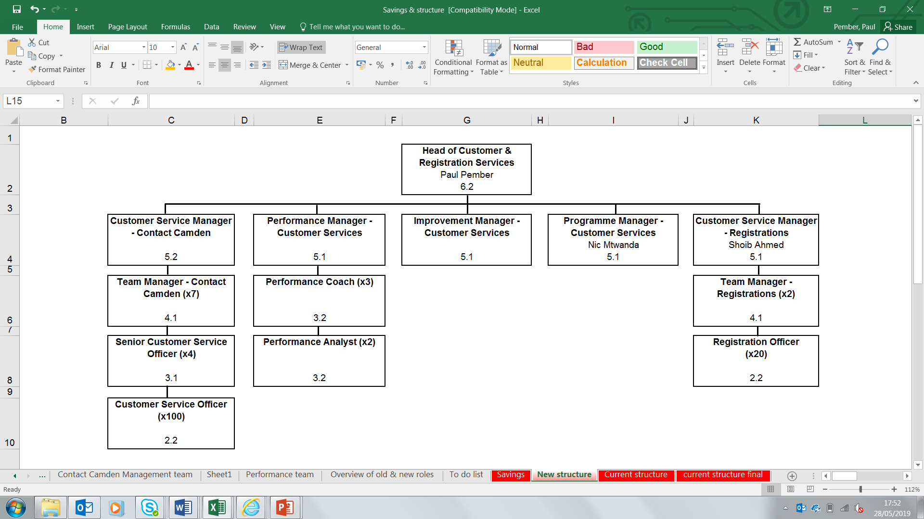

Performance Assistant

Kickstart

Performance Officer

3.2