

**DESIGN, ACCESS AND HERITAGE STATEMENT**

**SITE ADDRESS: FLAT 4, 109 BROADHURST GARDENS, LONDON, NW6 3BJ.**

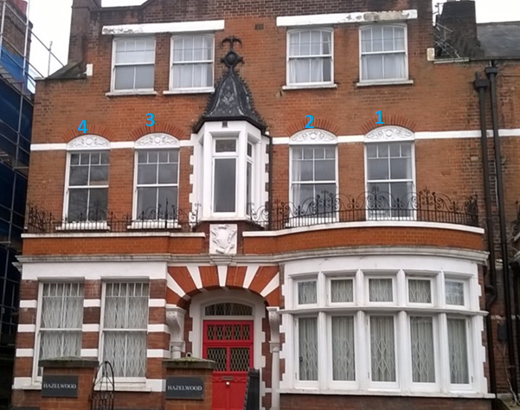

**CONTEXT AND STATEMENT OF HISTORIC SIGNIFICANCE**

Anglian Home Improvements have been contracted to replace 4 windows to the front of the property as shown above. The property is a large Semi-detached house that has been split into flats.

The property falls within the South Hampstead Conservation area and benefits from tree lined streets with distinct properties and ornate building work. The windows and doors have decorative surrounds. In the guide it mentions that the replacement of windows and doors must be undertaken in traditional materials and be sympathetic to the original property. The detailing wherever possible should match the existing.

The new windows must fit in with the surrounding area to respect the history and appearance of the property.

**SURROUNDING AREA:** The surrounding properties are all very similar with 1st floor iron balcony railing and a prominent decorative 1st floor bay window. The windows to the properties are predominantly white timber with decorative bars. The properties opposite are more modern in design and have smaller casement style windows.

**AMOUNT:** There will be 4 new windows to the front of the property.

**LAYOUT**: The new windows will replace the ones in situ and there will be no change in the aperture sizes or the decorative surrounds.

**SCALE**: The windows will be in proportion to the house as they will be in the original openings. The windows will match in style and design as closely as possible.

**LANDSCAPING**: Our proposal will not require any landscaping as these are replacement windows only.

**ACCESS:** Access will be gained by entering the property via the main entrance. If any special measures needed are with highways or any other property owners to install the windows or bring materials to site these will be discussed and arranged as necessary.

**APPEARANCE:** We appreciate the importance of retaining the properties history and the importance of maintaining its unique features however we would ask that a fair balance is struck between the visual aesthetics of the property and the wellbeing and standard of living for the occupants.

The benefits to the homeowner to use Anglian’s Timber windows are that they are minimal maintenance and as such the aesthetics of the property will be maintained without the reliance of too much future upkeep. This being especially important at above ground floor level.

The Anglian Timber sash has been specifically designed to be used on properties where aesthetics are important. A fair balance needs to be struck between the ideals of historical preservation versus the human rights of individual home owners.

Our proposed window is to be a white Timber sliding sash with cottage bars to the frames as per the current designs.

In addition draught proofing, sound insulation and security measures will all be improved upon to the benefit of the quality of the life of the homeowners.

The photograph below shows part of our Timber Sash window range.

The bars and frame details will be as per the submitted plans that accompany the application.

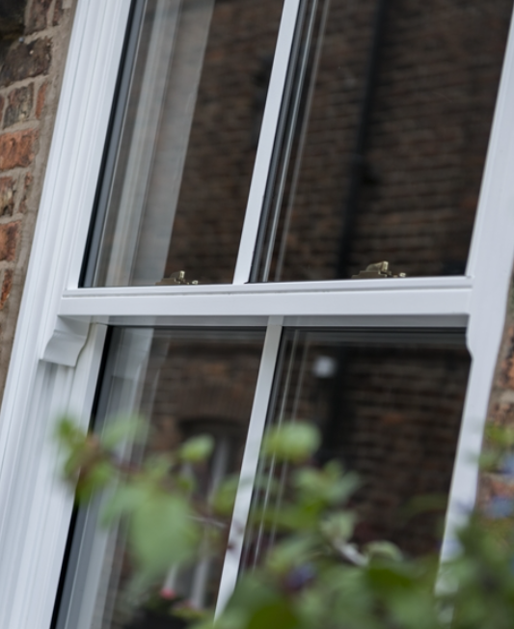[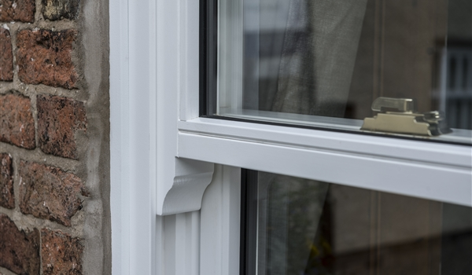](https://astar.anglian-windows.com/sorce/beacon/singlepageview.aspx?contentType=Images&row=8725&SPVPrimaryMenu=2294&SPVReferrer=portal_product_gallery_windows)

Furthermore Anglian are a Green Deal provider and are environmentally responsible. We work with local authorities across the country and understand the importance of conservation areas. We regularly gain approval for our specialist windows in conservation areas and our products are now being recognised for their improvements in design.

We have tried to produce a range of windows which specifically address the design concerns commonly raised in connection with conservation areas or listed buildings.

**DEVELOPMENTS WITHIN OR AFFECTING CONSERVATION AREA, LISTED BUILDING OR ITS SETTING.** We have considered carefully the proposed changes to the property and feel that the new Timber windows should not have a detrimental effect on the property as a whole and its surrounding area or setting as the products are to replicate the original designs and materials. The property is above ground floor and set back from the road and the aesthetics of these new windows will not be under such scrutiny as those at ground floor level therefore will not cause harm to the fabric of the building or surrounding area.

