**A Planning Application for an extension to Flat 1, 5 Denning Road Hampstead**

# for mr. ISAAC JEBREEL

Design and Access Statement

INTRODUCTION

Flat 1, 5 Denning Road is a self-contained two-bedroom, ground floor flat, independent of the main property, No.5 Denning Road. It consists of two bedrooms, a living room/dining area facing the rear garden, a small kitchen, an en-suite to the principle bedroom and a shared bathroom.

HISTORICAL CONTEXT

Denning Road was laid out by 1878, alongside Willoughby Road, Kemplay Road, Carlingford Road, and Rudall Cresent, all located to the North of Pond Street on an estate owned by George Crispin, on which Hampstead Hill Gardens had also been built a few years prior (in 1873). The houses on these roads and on the Willow Road frontage were complete by 1866. Among the last to be built, in 1890, were nos. 54-66 Rosslyn Hill.

ACCESS STATEMENT

Denning Road is located within the London Borough of Camden, 0.4 miles from the Hampstead underground station. The area is served by the nos. 46, 268, 168, C11, 603 daytime bus service and N5 night buses. Limited street parking is available in front of the property. Disabled access is limited being a lower ground floor property, accessed from an external stairway.

DESIGN STATEMENT

This Planning Application is proposing a side extension to the existing living room. It will incorporate a narrow, dark, unusable dead passage, less than a meter wide, between Flat 1 and the boundary wall with 7A Denning Road.

The extension comprises two sections, the majority of the space providing additional width to the living area, with the rear partitioned portion creating an addition to bedroom 2. The existing brick wall and four windows are to be removed to open the space between the existing and proposed.

Stephen Arnold Architects|Flat3 128 Lion Lane Haslemere Surrey GU27 1JH|mobile: 07884 157009

email: [stephenarnoldarc@btinternet.com](mailto:stephenarnoldarc@btinternet.com)

The extension is to be connected from the single storey living room to the boundary wall of the single storey section of 7A Denning Road with a lightweight, open and transparent infill to minimize intrusion into the space, using narrow section, self-supporting, sloped patent glazing. The rooflights over the living room will be fixed, while an opening light will provide daylight and ventilation to the bedroom. The height of the top of the rooflight is 2770mm above patio deck level, the same as the adjacent neighbouring rooflights, while the bottom of the slope is at 2540mm. It will allow indirect light to illuminate the eastern area of the living room and bring daylight into the interior.

The end of the sloped glazing at the rear (North) elevation is closed by a brick wall, the width of the side extension space and the height 2930mm, extending to the bottom of the cap to the existing single storey flat roof over the living room. The brick is to match the existing. This brick panel is set back 300mm from the face of the existing elevation, to create an articulated façade and to allow the existing to be read separately from the extension, while integrating both. The location of the extension is considerably set back from the face of the single storey addition next door and designed to harmonize with it in feeling and detail. The existing, unsightly, hopper and downpipe draining the flat roof will be removed and drainage redirected via a gutter to discharge into a hopper set within a niche at the boundary edge where it will be integrated into the overall elevation.

The gutter to the sloped glazing will be supported by a steel beam, independent of the abutting wall of the neighbouring property at 7A Denning Road. A party wall agreement will be needed for the footings to the proposed brick wall & for waterproof flashing & capping.

The interior layout of Flat 1, and the decking and garden will be unchanged by this addition.

The existing flat roof covering, black mineralized asphalt, is to be replaced with a lead coloured, membrane roofing finish. The damaged and failing upstand flashing will be repaired or replaced as necessary.

EXTENT

1. The width of the side passage is 995mm, the length 6820mm. The front of the wall of the extension is to be set back 300mm (dimensions based on onsite measurements)
2. The existing area of Flat 1 is **86.75 sq m** (NIA). The area of the proposed extension is **7.54 sq** m which gives a total area of the proposed Flat 1 of **94.29 sq m** (NIA).

CONCLUSION

The proposed extension, making a transparent connection across a passageway between the two properties will minimally affect the existing, while improving the elevation of Flat 1 facing the garden, which also allows the rainwater drainage to be fully integrated into the design, instead of the existing unsightly arrangement. This small addition will considerably enhance the interior area, providing an improved quality of light and will add valuable usable space. We feel the extension will have negligent impact on the adjacent buildings, neighbourhood or Conservation Area.

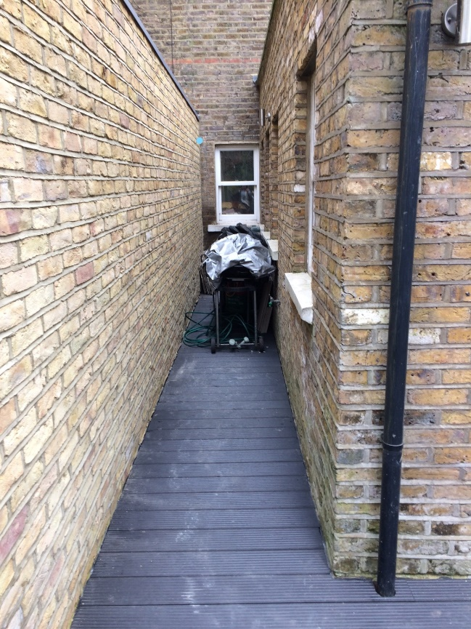

Passage – area of proposed side extension

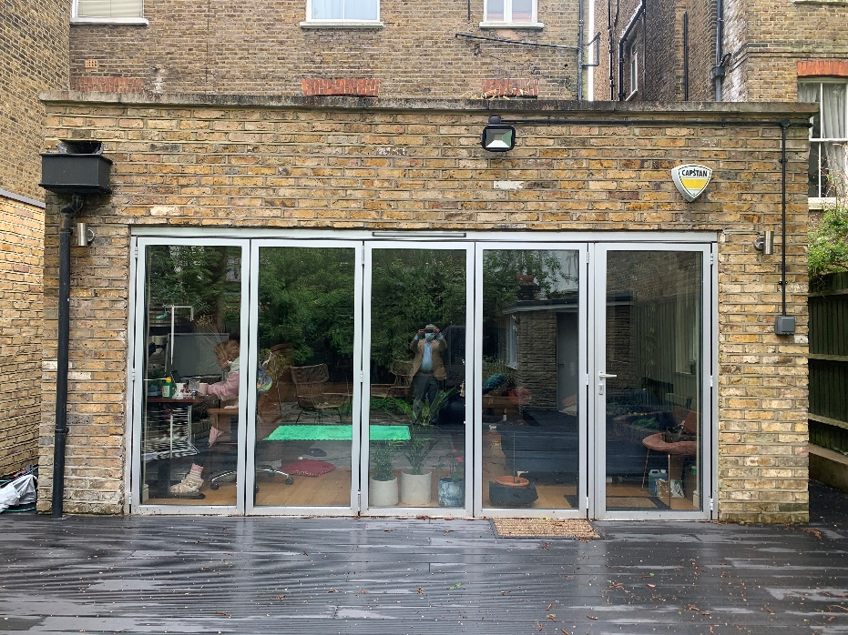

Existing flat roof, single storey living room