|  |
| --- |
| Technical Note |
| |  |  | | --- | --- | | Project name | The Hall School | | Project no. | 1620007106 | | Memo no. | AQ001_03 | | To | Mark Perkins (mperkins@ainsleys.net) | | From | Catherine Gould, Ana Gomes | | Copy to | Billy Pattison (BillyPattison@boyerplanning.co.uk) | |  |  | | Prepared by | Catherine Gould, Air Quality Consultant | | Checked by | Ana Gomes, Senior Air Quality Consultant | | Approved by | Alice McLean, Associate Air Quality Consultant | |

The Hall School - AIR QUALITY Assessment

# Introduction

Ramboll UK Ltd has been retained by The Hall School to assist in the clarifications regarding air quality relating to the refurbishment of The Hall Senior School, planning reference 2019/1325/P. The redevelopment work is to update facilities at the Hall School and will include partial demolition of some of the existing buildings, construction of new buildings and the refurbishment of other areas. The number of pupils and staff accommodated by the school will not be increased as a result of the development.

This technical note (TN) has been prepared to inform the design stage and advise if mitigation against potential poor local air quality is required. It summarises previous air quality work undertaken as part of the planning application, reviews London Borough of Camden (LBC) policy regarding WHO guidelines for particulate matter and assesses the suitability of the application site for the proposed development.

# Background

An air quality assessment[1] and a letter[2] have been prepared by Ramboll UK Ltd and submitted as part of the planning application. Both documents, reviewed existing monitoring data and projected air quality from London Atmospheric Emissions Inventory (LAEI) in the vicinity of the site and concluded that air quality would be expected to meet all relevant objectives at the application site and the need for a mechanical ventilation system to protect staff and pupils from poor air quality was not required.

However, further information on air quality to determine the need for mechanical ventilation has been requested from the LBC in the form of a planning condition and a detailed modelling assessment has been carried out[3],[4]. The modelling has demonstrated that air quality across the school site would comfortably meet relevant air quality objectives (AQOs) with annual mean nitrogen dioxide (NO2) concentrations comfortably below 38 µg/m3 and air quality was also predicted to meet the more stringent WHO guidelines for particulate matter (PM10 and PM2.5) in 2019. As a result, it was concluded that a mechanical ventilation system with pollution filters to protect staff and pupils from poor air quality was not required.

Further to the air quality assessments, the EHO acknowledged that “the site shows to be below UK national air quality objectives, however Particulate Matter exceed the WHO guidelines” and requested additional design solutions to address the WHO exceedance.

This TN AQ01 provides an up to date modelling exercise for the year 2021, following the methodology and verification process presented in the December 2020 air quality assessment[5], with particular focus on particles (PM10 and PM2.5) concentrations.

# Legislation and Policy

**London Environment Strategy**

The London Environment Strategy[6] sets vision for improving London’s environment. Policy 4.3.1.a states that “*The Mayor will set new concentration targets for PM2.5, with the aim of meeting World Health Organization guidelines by 2030”*. The WHO guidelines relevant for this assessment are presented in Table 1.

Table 1: WHO guidelines

|  |  |  |  |
| --- | --- | --- | --- |
| Pollutant | Time Period | National AQOs | WHO Guidelines |
| NO2 | Annual Mean | 40 µg/m3 | 40 µg/m3 |
| PM10 | 40 µg/m3 | 20 µg/m3 |
| PM2.5 | 25 µg/m3 | 10 µg/m3 |

**London Plan**

The London Plan 2021[7] is the Spatial Development Strategy for Greater London. It is stated that the Mayor is committed to complying legal limits not only for NO2 butalso to achieve the WHO guidelines for particulate matter.

**Camden’s Clean Air Action Plan 2019-2022**

Camden’s Clean Air Action Plan (CAAP)[8] outlines the actions of the LBC that will take place between 2019 and 2022 to reduce pollution concentrations and exposure to pollution. It states that LBC is meeting all of the national AQOs, other than NO2. It recognises that Camden is meeting the current objectives for PM10 and PM2.5 but, as this pollutant is damaging to health at any level, this remains a pollutant of concern and therefore Camden committed to target compliance with World Health Organization Guidelines for PM10 and PM2.5 by 2030.

LBC have implemented interim targets to understand if the actions of the Council would be effective in meeting the WHO guideline for years 2022, 2026 and 2030. The targets were set against a 2017 baseline for two monitored sites in Camden which experience the worst air quality for particulate matter and NO2 (Swiss Cottage and Euston Road). Achieving WHO guideline compliance at these two worst performing sites by 2030 will mean that all other sites in Camden are also highly likely to be compliant with WHO guidelines. The targets for Swiss Cottage automatic site located approximately 300 metres west of the site are presented in Table 2.

Table 2: LBC Swiss Cottage Monitoring Site Annual Average Interim Targets (µg/m3)

|  |  |  |  |
| --- | --- | --- | --- |
| Pollutant | 2022 | 2026 | 2030 (WHO Compliance) |
| PM10 | 17.1 | 14.8 | 12.5 |
| PM2.5 | 13.7 | 11.8 | 10 |

Measured PM2.5 concentrations at Swiss Cottage in 2019 (pre Covid-19 pandemic)[9] were 11 µg/m3, i.e. below the interim target for 2022.

**Camden Planning Guidance on Air Quality**

Camden Planning Guidance (CPG)[10] on Air Quality, published in January 2021, provides information on key air quality issues within the borough and supports Local Plan Policy CC4 Air quality. It states that ”*Camden’s overarching objective is to achieve WHO limits by 2030 and this will be steered by the Council’s Clean Air Action Plan*”.

The guidance key messages require, among others that “*all developments are to protect future occupants from exposure to poor air quality*”; defining areas of poor air quality as “*an area with NO2 or PM10 concentrations within 5% below the air quality objective, 38 µg/m3 (micrograms per cubic metre)*”.

**Supporting Studies**

King’s College produced a study[11] to support Camden’s Clean Air Action Plan 2019 – 2022 and Camden Transport Strategy (CTS)[12] to provide an estimate as to whether the existing and proposed air quality policies would lead to the air quality in Camden meeting the Councils WHO targets for NO2 and particulate matter. The study was based on 2013 London Atmospheric Emissions Inventory (LAEI) dataset to model and predict annual mean concentrations of nitrogen oxide (NOx), NO2, PM10 and PM2.5 for 2030, which was the most recent at the time of the study. The study suggested that PM10 and PM2.5 WHO guideline objectives would not be achieved by 2030. However, since completing this modelling study for Camden, King’s has undertaken a new research project which uses current particulate matter (PM) data from monitoring sites within London and surrounding areas to produce amended forecast assumptions for the updated LAEI 2016 dataset[13]. This research found that measured PM concentrations are lower than had previously been predicted, and suggests that reaching the WHO guideline objectives for PM10 and PM2.5 in London by 2030 is now within a range of possible outcomes.

Air quality at background and roadside locations is expected to improve in future years due to the gradual renewal of the vehicle fleet with less polluting and more efficient models. National policies and London specific policies, such as London’s Ultra Low Emission Zone (ULEZ) expansion due in October 2021, would further encourage vehicle fleet renewal in London and would hasten and enforce this process. Evidence has suggested that since the introduction of the ULEZ in February 2017, there has been an overall reduction of 44 % in NO2 concentrations at roadside sites in the central zone[14].

# Assessment Methodology

**Road Traffic Impacts**

To assess the site suitability, this assessment followed the methodology outlined in Ramboll’s Air Quality Assessment undertaken in 2020[15].

The model has been rerun to estimate NO2, PM10 and PM2.5 concentrations for the year 2021. Themodel was based on 2021 background data and emission factors combined with 2019 LAEI traffic data.

**Backgrounds**

The 2021 Defra background concentrations[16] used in this assessment are presented in Table 3 below. The backgrounds have been compared against concentrations measured at North Kensington and Bloomsbury AURN[17] automatic urban background station in 2019 to produce a calibration factor, which then has been applied to background concentrations across the study area which were used in the initial assessment[18].

Table 3: Adjusted background concentrations

|  |  |  |  |  |
| --- | --- | --- | --- | --- |
| **Year** | **Grid Square** | **Annual Mean (µg/m3)** | | |
| **NO2** | **PM10** | **PM2.5** |
| 2019 | 526500, 184500 | 24.4 | 15.2 | 9.7 |
| 2021 | 22.2 | 14.6 | 9.3 |
| **Objective** | | **40** | **40, 20\*\*** | **25*, 10\*\*** |
| * UK national air quality exposure reduction objective to be achieved by 2020.  ** WHO recommended guideline. | | | | |

The adjusted backgrounds for both 2019 and 2021 are below the UK air quality objective and the WHO guidelines.

# Site Suitability

**Assessment of Impacts**

As in the 2020 Air Quality Assessment the front façade of the school has been chosen to represent the location where impacts from existing road traffic are likely to be the greatest, i.e. on the site façade close to the road network. Concentrations have been predicted at a grid of receptors (contours) across the proposed development site to assess the suitability of the site for the proposed redevelopment and determine the need for mitigation. Contours were modelled at 1.5 metres height to represent exposure at ground floor level. As air quality is expected to improve with height[19], ground floor exposure is considered the worst case exposure location.

The predicted NO2 concentration in 2021 is shown in Figure 1. The predicted annual mean NO2 concentration at the school building façade is predicted to be approximately 25.6 µg/m3 therefore well below (below 5%) the national AQO and WHO guideline. The predicted annual mean NO2 concentrations do not exceed 60 µg/m3 and therefore exceedance of the 1-hour mean NO2 objective is unlikely.

# 

Figure 1: 2021 Model Predicted NO2 Concentrations Contour at the School Site

The predicted PM10 concentration in 2021 is shown in Figure 2. The predicted annual mean PM10 concentration for 2021 at the school building façade is approximately 15.0 µg/m3 and therefore well below (below 5%) the national AQO and the WHO guideline. The predicted annual mean PM10 concentrations do not exceed 32 µg/m3 and therefore the 24-hour mean PM10 objective is not predicted to be exceeded.

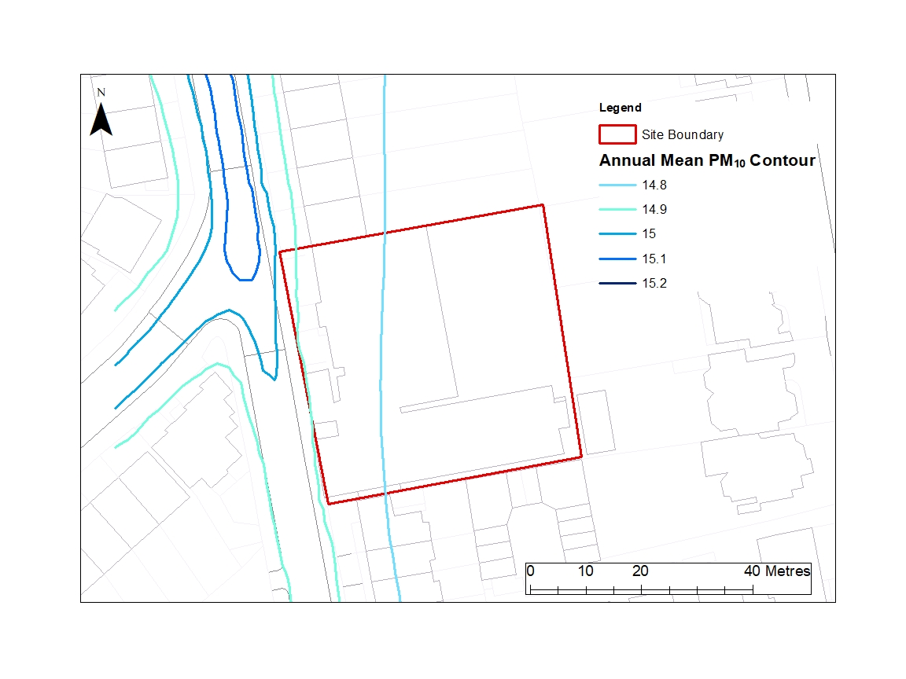

Figure 2: 2021 Model Predicted PM10 Concentrations Contour at the School Site

The predicted PM2.5 concentration in 2021 is shown in Figure 3. The predicted annual mean PM2.5 predicted modelled concentration at the school building façade is approximately 9.5 µg/m3, and therefore well below the national AQO (below 5%). The PM2.5 concentration at the site is also below the WHO limit objective of 10 µg/m3 andbelow 5% of the guideline.

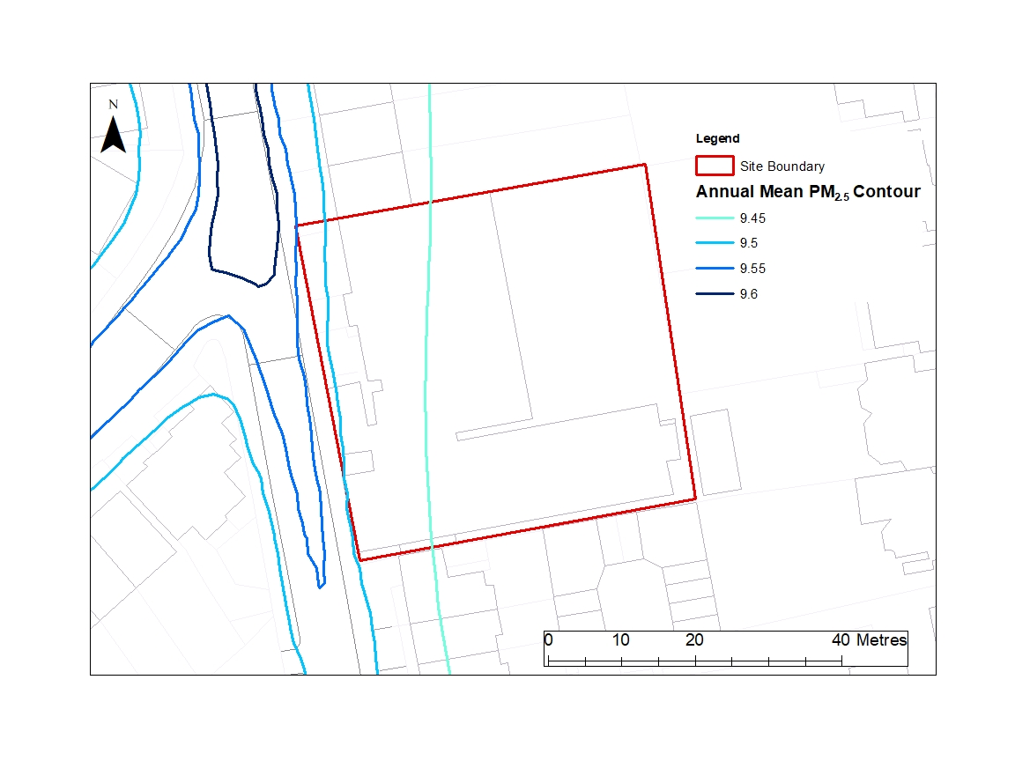

Figure 3: 2021 Model Predicted PM2.5 Concentrations Contour at the School Site

The above results show an improvement from the 2020 Air Quality Assessment15, which presented the predicted annual average for the year 2019 at the site. Table 4 presents a comparison of the air dispersion model predicted concentrations in 2019 and 2021.

Table 4: Ramboll’s Air Quality Dispersion Model Predicted Concentrations at the Proposed Development Façade (µg/m3)

|  |  |  |  |
| --- | --- | --- | --- |
| **Year** | **Annual Mean (µg/m3)** | | |
| **NO2** | **PM10** | **PM2.5** |
| 201915 | 28.0 | 15.5 | 9.9 |
| 2021 | 25.6 | 15.0 | 9.5 |
| **Objective** | **40** | **40, 20\*\*** | **25*, 10\*\*** |
| * UK national air quality exposure reduction objective to be achieved by 2020.  ** WHO recommended guideline. | | | |

As per the supporting studies section above, air quality at background and roadside locations is expected to improve in future years due to the gradual renewal of the vehicle fleet with less polluting and more efficient models and policies such as the ULEZ expansion. With construction stage expected to start in summer 2022, the proposed development would not be expected to be operational before April 2024, and therefore air quality at the site would be expected to improve in comparison with the predicted concentrations in 2021 and therefore be below the national AQOs and the WHO guidelines (only required to be met by 2030).

**Mitigation and Ventilation**

The 2021 modelling results show that the assessed pollutant concentrations are predicted to below 5% the national AQOs and WHO guideline at the school façade and within the site. On this basis, the proposed development would not introduce sensitive receptors into an area of poor air quality[20] and mitigation to reduce exposure of pupils and staff to poor air quality is not required.

However, to further reduce exposure and building emissions several mitigation measures have been considered during the design of the proposed development, namely:

* Mechanical ventilation with heat recovery (MVHR) within the teaching spaces to provide a controlled supply of outside air. The units will intake and exhaust air from the façade that the room is located on. The intake and exhaust (typically 4 metres apart) facing Crossfield Road would be located above the windows at every level for the teaching spaces[21];
* The building will be ventilated with mixed mode, mechanical ventilation operates for most of the year to guarantee ventilation rates, but openable windows, louvers and skylights are provided for natural ventilation when external air temperature permits[22];
* Reduction of buildings emissions over the existing situation by replacing the two existing boilers with ultra low NOx modern condensing boilers with higher efficiency. A Hoval Modu-max with a NOx emissions rate of 39.8 mg/kWh and an energy efficiency of approximately 95% is being proposed. The proposed boiler complies with the emission rate <40 mg/kWh and the energy efficiency >90% required by with LBC Local Plan[23] (section 8.85) and the LBC CPG on Air Quality[24];
* Air source heat pumps (ASHP) serving the space heating and cooling for the school as well as the domestic hot water; and
* Use of photovoltaic panels on the roof to provide onsite energy generation equivalent to approximately 33% of the annual energy load.

# Conclusions and Recommendations

London and LBC policy recognise that PM10 and PM2.5 remains pollutants of concern and the LBC is committed to target compliance with World Health Organization Guideline by 2030.

The updated modelling has demonstrated that the current (2021) air quality at the proposed development ground floor façade would be 5% below the relevant objectives and meet the national air quality objectives and the WHO guidelines. As air quality is expected to improve with distance from the road traffic emissions and with height, the overall site site would be expected to confortably meet the relevant national air quality objectives and the WHO guidelines.

Air quality at background and roadside locations is expected to improve in future years due to the gradual renewal of the vehicle fleet with less polluting and more efficient models and inforcement of air quality policies, such as the expansion of the Ultra Low Emissions Zone. At the time of the expected opening of the proposed development in 2024, air quality at the site would be expected to improve when compared with 2021 predicted concentrations therefore be well below the national AQOs and below the WHO guidelines (only required to be met by 2030). On this basis mitigation to reduce exposure of pupils and staff to poor air quality is not required.

1. Ramboll, 2019. The Hall School Air Quality Assessment. Project No. 1620007106. Issue No.2. June 2019.
2. Ramboll, 2019. THE HALL SENIOR SCHOOL – Planning reference 2019/1325/P. Ref L1620007106_200819. August 2019.
3. Ramboll, 2019. THE HALL SENIOR SCHOOL – Planning reference 2019/1325/P Discharge of Planning Condition 6. Ref L1620007106_200819. August 2019.
4. Ramboll, 2020. The Hall School Air Quality Assessment. Project No. 1620007106. Issue No.1. December 2020.
5. Ramboll, 2020. The Hall School Air Quality Assessment. Project No. 1620007106. Issue No.1. December 2020.
6. Mayor of London. London Environment Strategy, May 2018.
7. Greater London Authority, 2021. The London Plan. March 2021. London.
8. London Borough of Camden, 2019. Camden Clean Air Action Plan 2019-2022.
9. London Borough of Camden, 2020. London Borough of Camden Air Quality Annual Status Report for 2019 Date of publication: July 2020.
10. London Borough of Camden, 2021. Camden Planning Guidance Air Quality. January 2021.
11. King’s College London. World Health Organisation guideline study: Technical report.
12. London Borough of Camden, 2019. Healthy Streets, Healthy Travel, Healthy Lives: Camden Transport Strategy 2019-2041. April 2019.
13. LAEI 2016 data can be viewed on the London Datastore: https://data.london.gov.uk/dataset/london-

    atmospheric-emissions-inventory--laei--2016.
14. https://www.london.gov.uk/WHAT-WE-DO/environment/environment-publications/central-london-ulez-ten-month-report
15. Ramboll, 2020. The Hall School Air Quality Assessment. Project No. 1620007106. Issue No.1. December 2020.
16. Defra. Available at: https://uk-air.defra.gov.uk/data/laqm-background-maps?year=2018
17. https://uk-air.defra.gov.uk/networks/site-info?uka_id=UKA00253
18. Ramboll, 2020. The Hall School Air Quality Assessment. Project No. 1620007106. Issue No.1. December 2020.
19. WSP Parsons Brinckerhoff, 2017. City Air Quality at Height – Lessons for Developers and Planners. Available at: https://www.camden.gov.uk/documents/20142/18667687/8-1+City+Air+Quality+at+Height.pdf/5cfb1877-c72c-869b-23e1-32f06a3cd642#:~:text=The%20results%20show%20that%20air,(typically%20in%20background%20locations).
20. London Borough of Camden, 2021. Camden Planning Guidance Air Quality. January 2021.
21. Elementa, 2020. The Hall School. Energy Strategy Report. December 2020. V06.
22. Elementa, 2021. Hall School. Overheating Analysis Report. June 2021. 515208-ELE-XX-XX-RP-YE-51003.
23. London Borough Camden, 2017. Camden Local Plan 2017.
24. London Borough of Camden, 2021. Camden Planning Guidance Air Quality. January 2021.