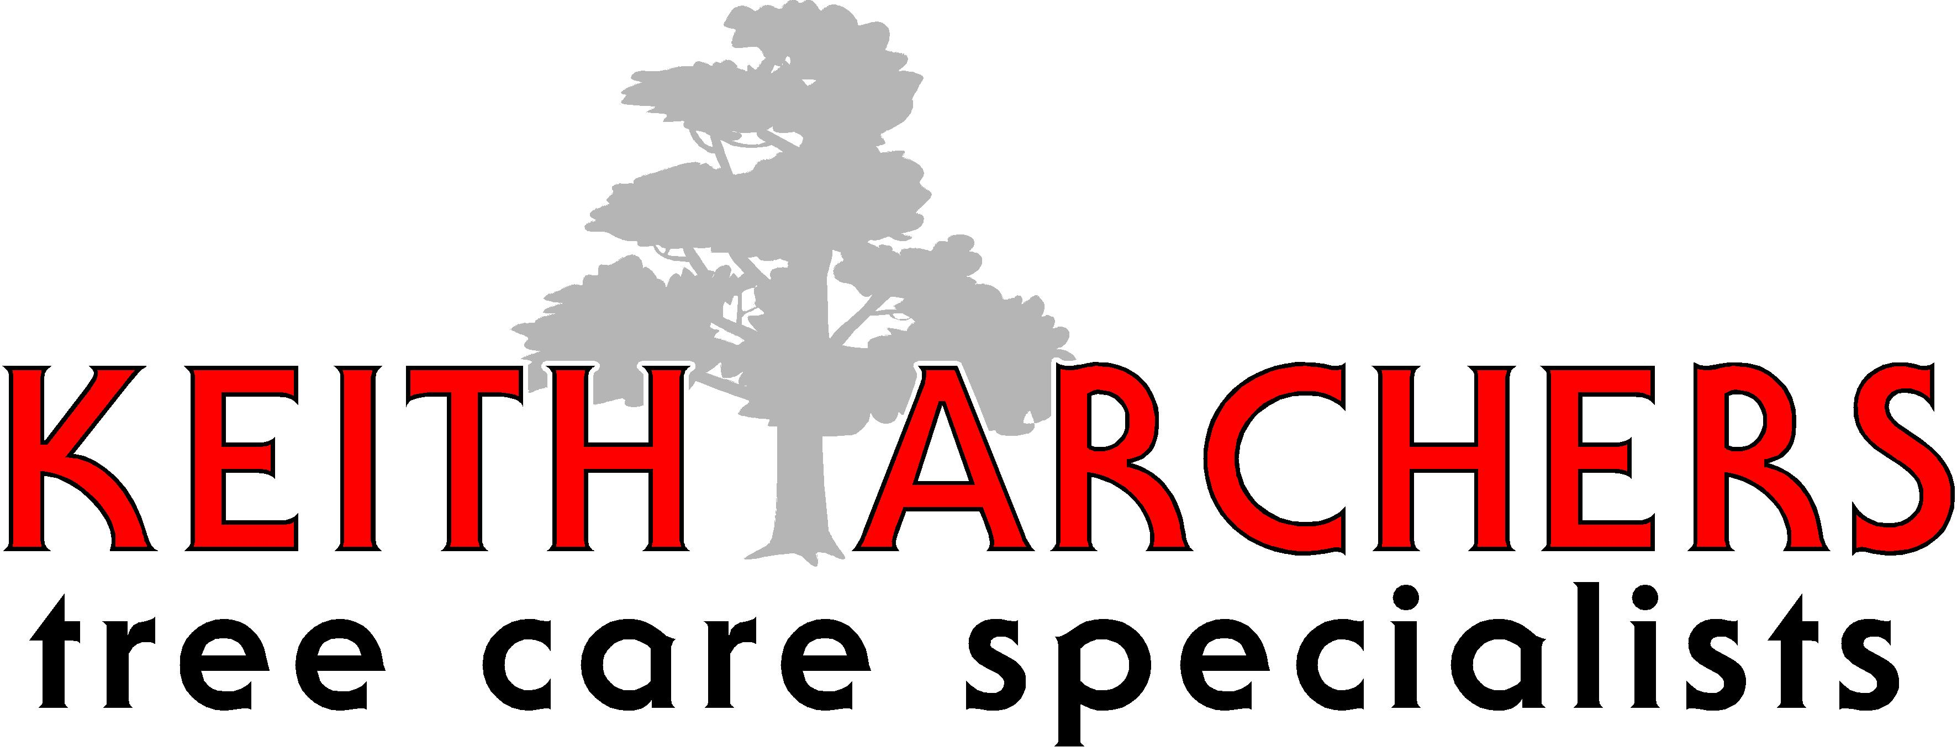  Free Estimates  Tel 01708 223332  Fax 01375 385 542  154 Lodge Lane  Grays  Essex  RM16 2TS  All correspondence to above  Inspection-Spraying  Pruning-Felling  Emergency Service  £5,000,000  Public Liability Insurance  Registration Number  3842184  Vat No752472821  Registered Office  Lakeview House  4 Lake Meadows Office Park  Woodbrook Crescent  Billericay, Essex  CM12 0EQ  Director  K.B. Archer | Date; 16.06.21  Re:  47 Kingstown Street  London  NW1 8JP  Reasons for tree works;  T1 = To Reduce 1 X Silver Birch Tree by 1.5/2.0Mts & Lift to Crown Union & Clean Crown  T2 = To Reduce 1 X Bay Tree to Old Pruning Points 1.5/2.0Mtrs  T3 = To Reduce 1 X Smaller Bay Tree by 0.5/1.0Mtr & Shape  T4 = To Reduce 1 X Hawthorn Tree by 1.5/2.0Mtrs in Height & Remove Deadwood

