**DESIGN AND ACCESS STATEMENT**

**PRINCESS LOUISE 208 HIGH HOLBORN, HOLBORN, LONDON WC1V 7EP**

**HISTORY**

Built in 1872, it is best known for its well-preserved 1891 [Victorian](https://en.wikipedia.org/wiki/Victorian_decorative_arts) interior. It is now owned by the [Samuel Smith Brewery](https://en.wikipedia.org/wiki/Samuel_Smith_Brewery) of [Tadcaster](https://en.wikipedia.org/wiki/Tadcaster" \o "Tadcaster), [Yorkshire](https://en.wikipedia.org/wiki/Yorkshire)

Grade II listing:- Public house. Mid C19. Interior 1891 by William B Simpson and Sons who contracted out the work. Yellow brick with stone and terracotta dressings. EXTERIOR: 4 storeys 4 windows. Double-fronted public house ground floor facade of red granite columns and pilasters (with masks on the capitals), carrying entablature flanked by modified consoles. Central bow window with arched and lozenge lights flanked by wide entrances. Recessed sash windows with moulded stone heads, enriched impost bands, bracketed sills with cast-iron window guards to 2nd and 3rd floors. Entablature with dentil cornice and rosettes in frieze. Parapet. INTERIOR: good interior with decorative, polychrome tile work, gold embossed glass by R Morris & Son, stained glass and original mahogany bar fittings by WH Lascelles and Co. In centre of bar, 4 cast-iron Corinthian columns carrying patterned ceiling with moulded cornice and polychrome tile frieze decorated with urns and swags. Staircase with elaborate wrought-iron balustrade between ground and 1st floor. 1st floor bar with good fittings and Art Nouveau dado. Included II* as a rich example of a Victorian public house interior

A splendidly preserved pub displaying some of the finest examples of the Victorian art of public house building. Built in 1872 the interior includes marble, etched windows, enormous engraved and gilt mirrors, Portland stone columns, an ornate crimson and gold ceiling and a huge central island bar. During 2007 the pub went through a comprehensive restoration which saw the reinstatement of the original multi-roomed layout with wood and etched glass dividing walls. This has completely changed its appearance and Sam Smith’s are to be commended for their attention to detail. A CAMRA Heritage Pub and winner of Refurbished Pub of the Year, 2008

**THE WORKS**

The two flues in question serve the open fires situated to rear of the public house -one on the ground floor, one of the first floor. The open fires, which are an essential part of the ambience and atmosphere of this historic Victorian pub, have been in daily use throughout each autumn and winter since the major restoration of the premises in 2007. I can confirm that our Managers of the premises are under strict instruction to burn only smokeless fuel. the new flues cannot be seen from the street level. Access is required through the public house, via the loft and on to the rear roof.

**LOCATION**

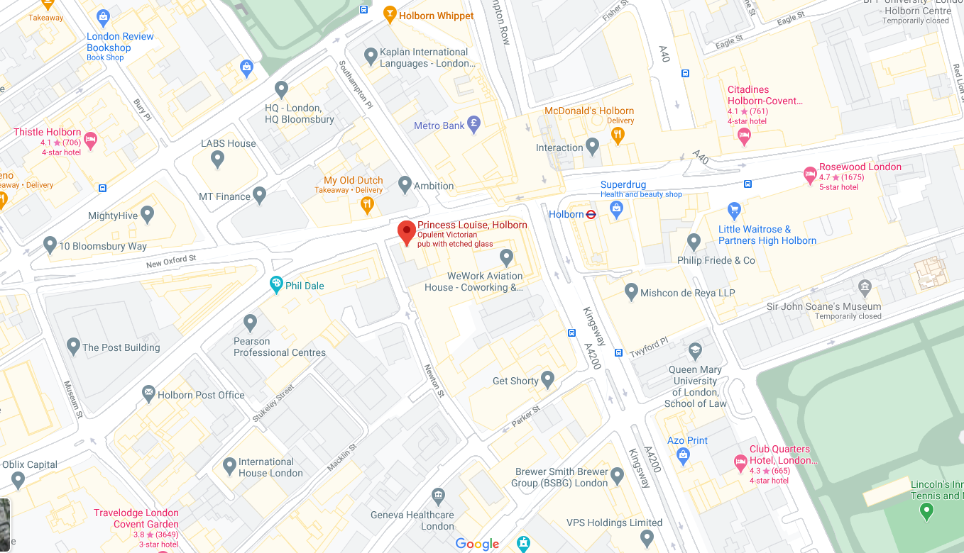

**Nearby Mainline Station:** London Charing Cross

**Station Distance:** 1050m

**Public Transport:** Near Railway Station (Charing Cross) and Bus Stop

**Nearby underground station:** Holborn

**Station Distance:** 100m