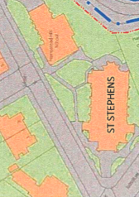

POND STREET

HAMPSTEAD HILL Gdns

POND STREET

Part of boundary wall where proposed works are to be undertaken

