36 Sumatra Road, London NW6 1PU
Design and Access Statement

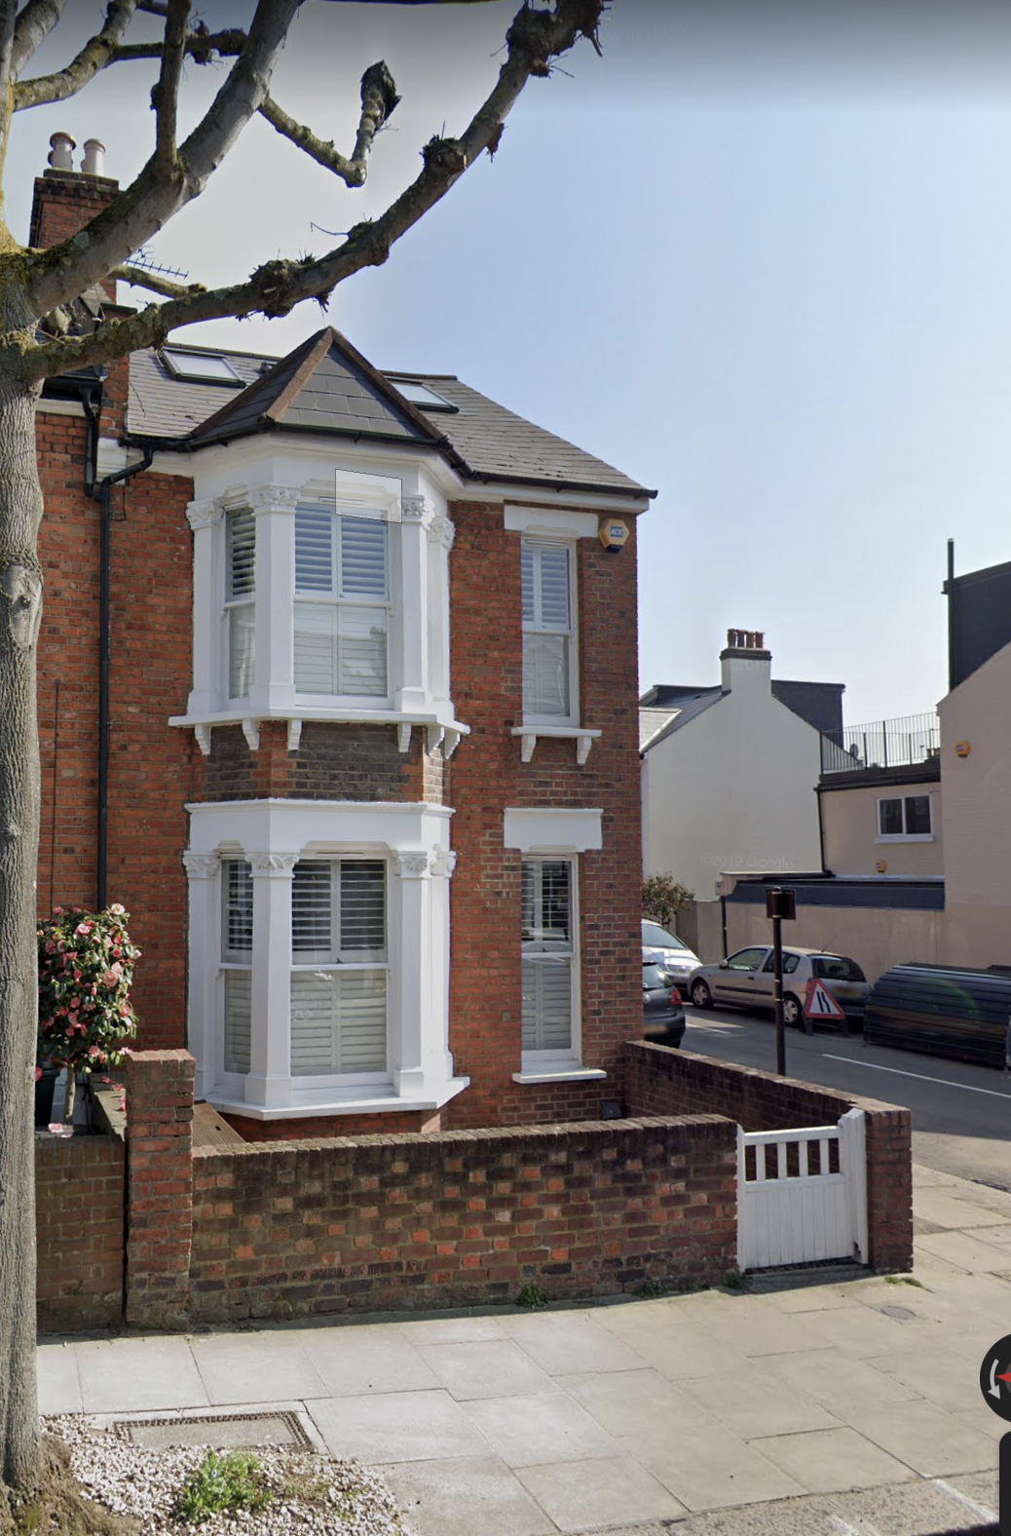

Site
The application site is located on the eastern side of Sumatra Road and is a mid-terrace two-storey with single storey side extension and terrace outrigger addition to a family dwelling house.

Proposal
The proposal is to add an inset entrance to the side of the property facing Glenbrook Road. Demolish the existing outrigger with terrace and build an extension in the existing footprint with terrace access at first floor level. The extension will provide an additional net area of 7m² to the property creating a kitchen and dining area opening onto the garden. It will be constructed from materials to match the host property.

Relevant Planning Policies

National Planning Policy Framework 2019
London Plan 2021

Camden Local Plan 2017:
A1 Managing the impact of development
D1 Design
D2 Heritage

Below states the means in which key issues are addressed from these policies following consideration.

Principle of Development

Recent planning applications for an asymmetrical apex roof and a terrace on the first floor in the area which are similar to the proposal that have been approved are respectively:

19 Solent Road 2019/1183/P
54 Sumatra Road 2017/3259/P

Side entrances in the area can be seen in the following properties.

40 Solent Road side access door to Glenbrook Road,
61 Hillfield Road side access door to Agamemnnon Road

Design

The new extension will match the footprint of the existing outrigger at the rear and be similar in massing to the existing rear additions along Sumatra Road. The property is already accessed from the side gate in the fence and the new internal access will improve the internal circulation and liveability for the residents.

The terrace is already visible from Glenbrook Road and the change will be visible in the same manner. However, the metal berries will be removed and replaced with glass berries and planters to maintain privacy fir the residents.

Layout
The layout will open out the existing corridor where the present side extension is and make a larger kitchen and dining area. The utility will be reorganised for the storage of bicycles.

Scale
The extension will be 1.9m in length, and a height of 2.6m at the highest eave facing the street.

Appearance
The details and appearance of the extension is to be subservient to the original building and respect the local area. The materials used will be white paint to match the existing building and GRP roofing which is inconspicuous and durable.

Amenity

The extension, being in line with the existing outrigger is unlikely to cause additional overshadowing to what is already present. The garden area is retained to ensure adequate outdoor amenity.

Access
Is not applicable to alter the access to enable a disabled access route to the property. The proposal does not, therefore change the disabled access.

