**Job Profile Information:**

**OD and L&D Data and Project Officer**

**Level 4, Zone 1**

**Role Purpose:**

This post plays a vital role in the OD and L&D service, ensuring stakeholders have access to high quality data and learning and development (L&D) reports. The post holder will also project manage bespoke L&D projects, understanding learning needs and ensuring the effectively delivery of interventions.

* Manage IT system developments, data analysis tasks and L&D projects
* Quality assure data, proactively considering and offering solutions where required and working with system specialists to resolve issues
* Produce standard, ad hoc and complex reports, templates, dashboards, metrics and other resources as required
* Identify and recommend system development to improve work process for the L&D team and to enhance end user experience
* To contribute to policy and process development within L&D
* To ensure compliance with Data Privacy and General Data Protection Regulation guidelines.

**Example outcomes or objectives that this role will deliver:**

1. Work in partnership with internal and external colleagues and stakeholders to ensure the functionality and design of the Learning Management System (LMS) is fit for purpose, ensuring issues are resolved efficiently.
2. Lead on the creation of complex statistical, formatted reports for presentation at management and project groups including SMT and CMT.
3. Work collaboratively with HR Analysts to develop a cohesive approach to data, metrics and other management information
4. Take a lead on the monitoring, management and quality assurance of eLearning, including designing and delivering training to colleagues’ to enable independent, service specific eLearning creation.
5. Coach and support colleagues to develop capability and increase confidence in data production, statistical reporting and the effective administration of the LMS
6. Manage and support L&D programmes and projects to ensure they are delivered within agreed timescales and meet specified requirements.

**People Management Responsibilities:**

*N/A*

**Relationships;**

The post holder will be expected to work in close cooperation with colleagues across the team, service and organisation without close supervision. They will be able to make decisions and command credibility.

The post holder must be able to understand the overall work of the service and how the learning and development provision contributes to it. The post holder must be able to relate well with a wide range of people at all levels.

**Work Environment:**

The OD and L&D Team is based at 5 Pancras Square and the Crowndale Centre. The ‘home base’ for this role is the Crowndale Centre.

Staff are also able to work either remotely or from home as part of Camden’s ‘agile’ way of working which supports our modern, dynamic and flexible working environment.

The post holder may occasionally be required to work at weekends or in the evening, particularly if projects require close working with teams who operate out of hours arrangements.

**Technical Knowledge and Experience:**

* Knowledge of working in a learning and development environment
* Knowledge of current priorities and trends in learning and development
* Confident working with raw data and able to re-format and/or cleanse it as required
* Awareness of and adherence to principles of data protection and confidentiality in handling sensitive data
* Advanced Excel skills (testing will form part of the assessment)
* Ability to present data clearly and in creative ways, using graphs, charts and other presentational techniques
* Ability to coach and train others
* Strong communication and presentation skills and comfortable working with people at different levels
* Ability to work under pressure and meet deadlines
* Good personal management skills, acting positively, flexibly and constructively, bringing energy and focus to the work.
* Significant experience of running reports, analysing data and formatting information for the purpose of presentation
* Significant experience of managing projects
* Experience of managing online systems, including learning management systems
* Proven experience of building good working relationships with colleagues, stakeholders and customers

**Camden Way Five Ways of Working**

*In order to continue delivering for the people of Camden in the face of ever increasing financial pressure, we need to transform the way we do things. We call this the Camden Way. The Camden Way is a key part of our transformation strategy often referred to as the transformation triangle which links the Camden Plan, the Camden Way and the Financial Strategy together.*

The Camden Way illustrates the approach that should underpin everything we do through five ways of working:

•Deliver for the people of Camden

•Work as one team

•Take pride in getting it right

•Find better ways

•Take personal responsibility

For further information on the Camden Way please visit:

<http://www.togetherwearecamden.com/pages/discover-jobs-and-careers-in-camden/working-for-camden/>

**Chart Struct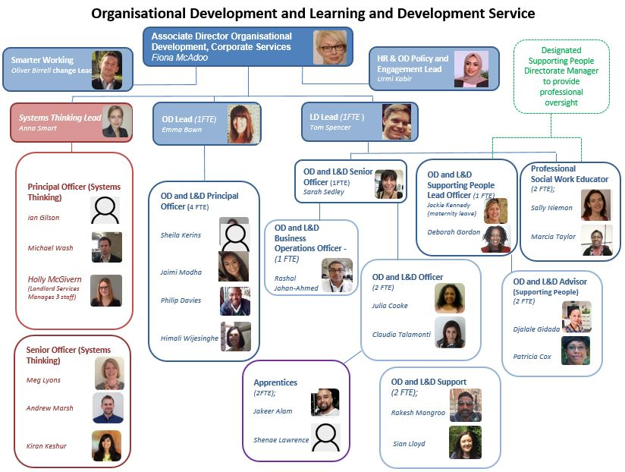ure**