4 Parsifal Road NW6 1UH

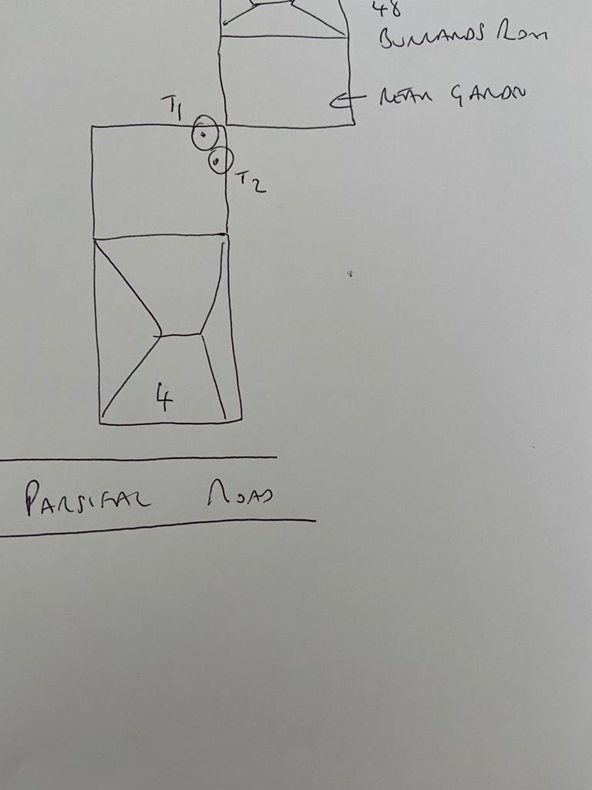

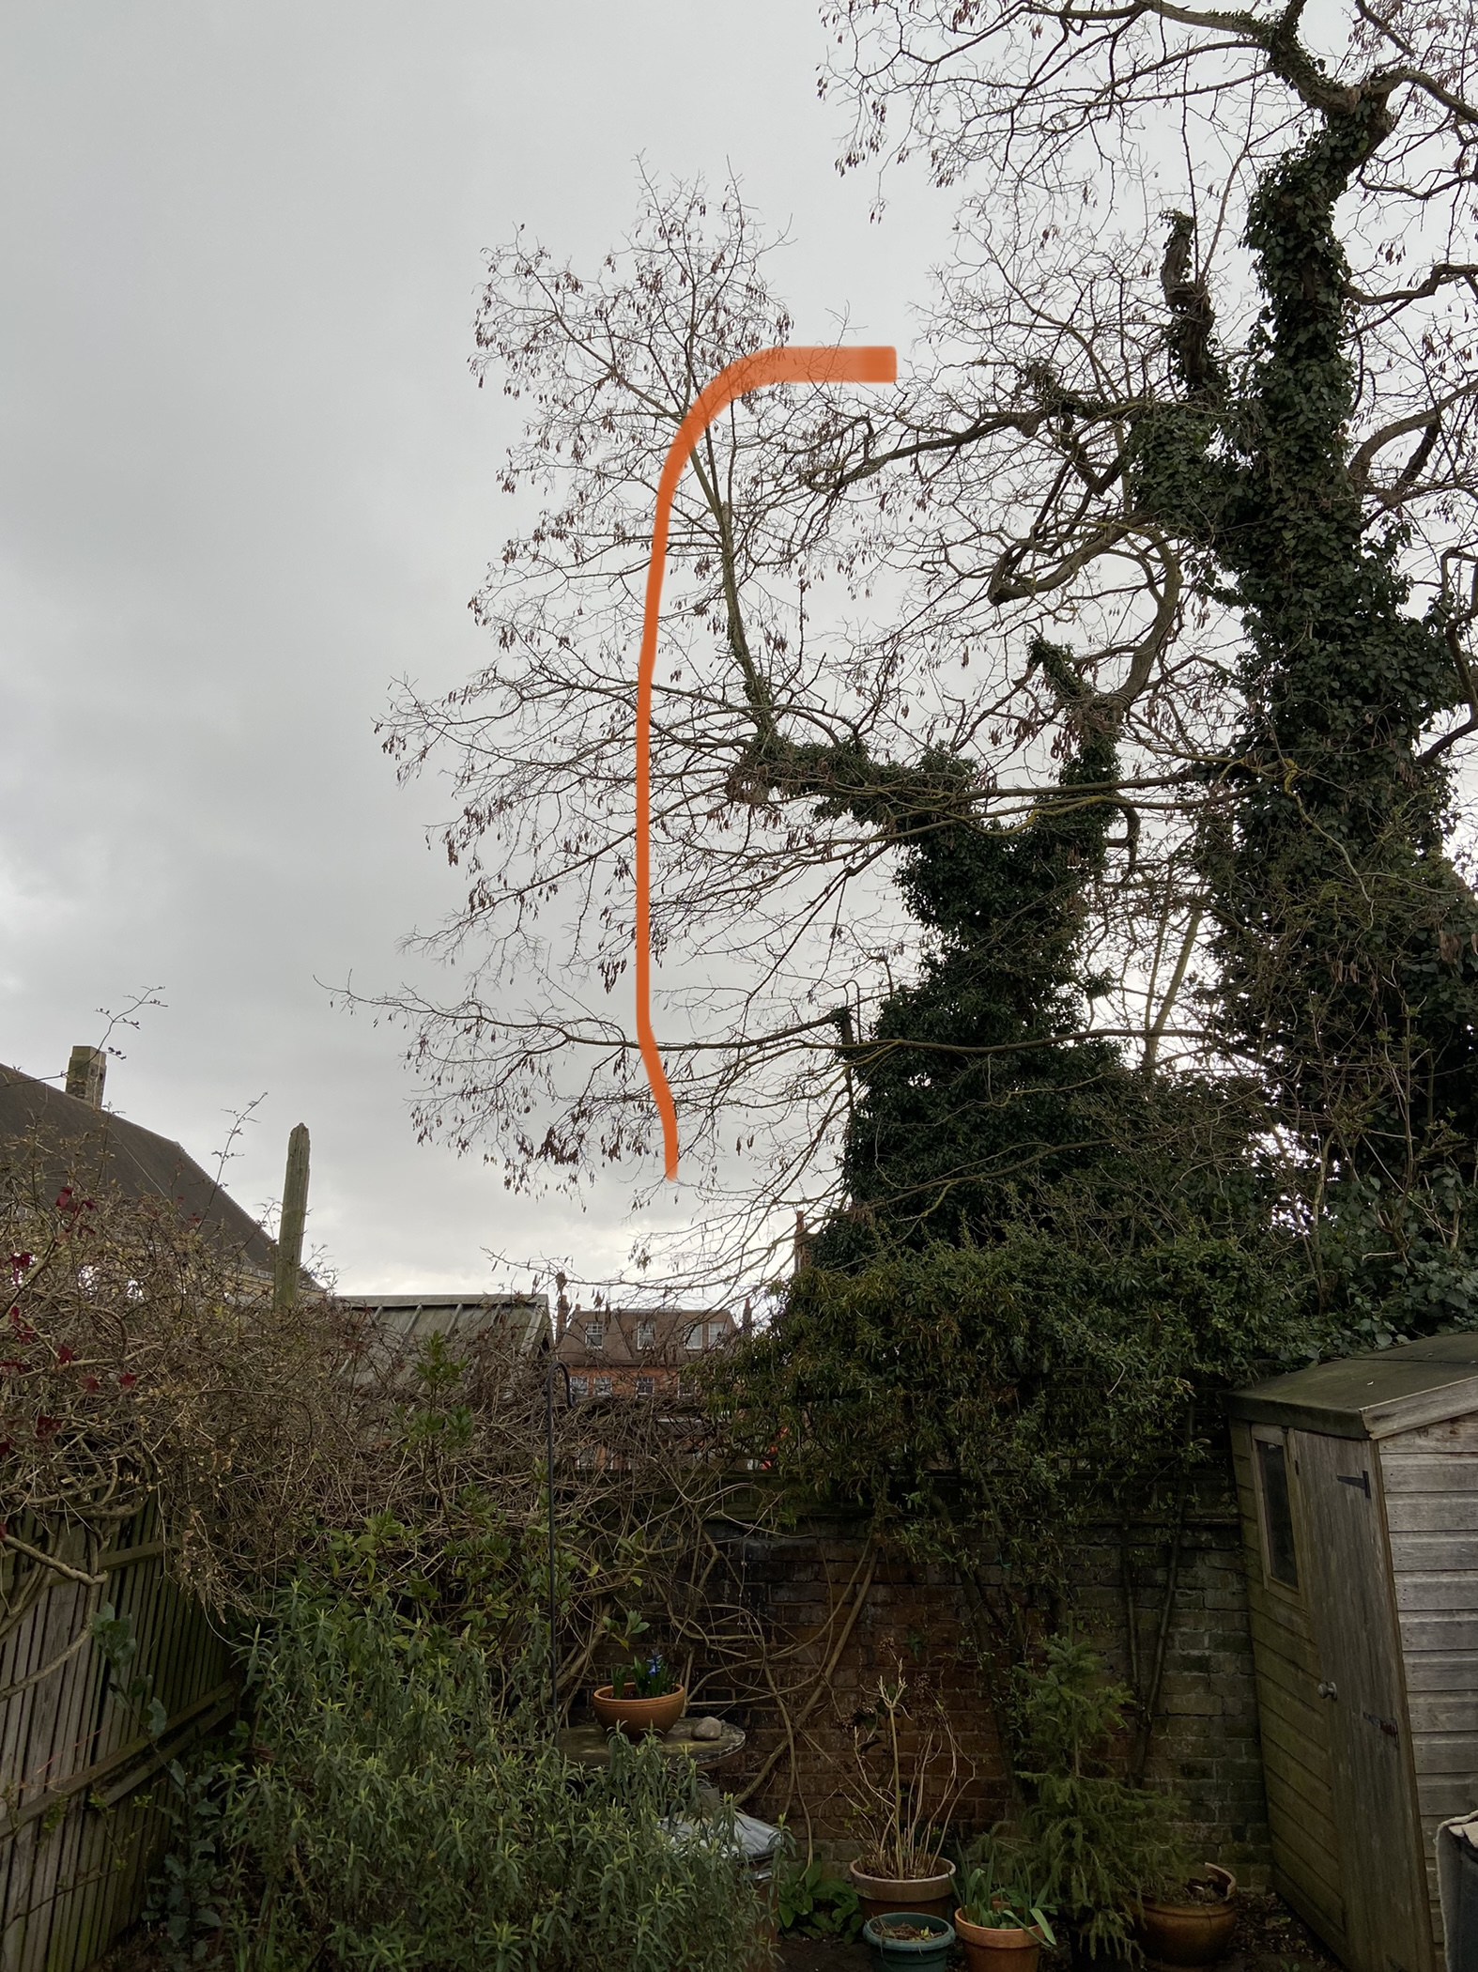 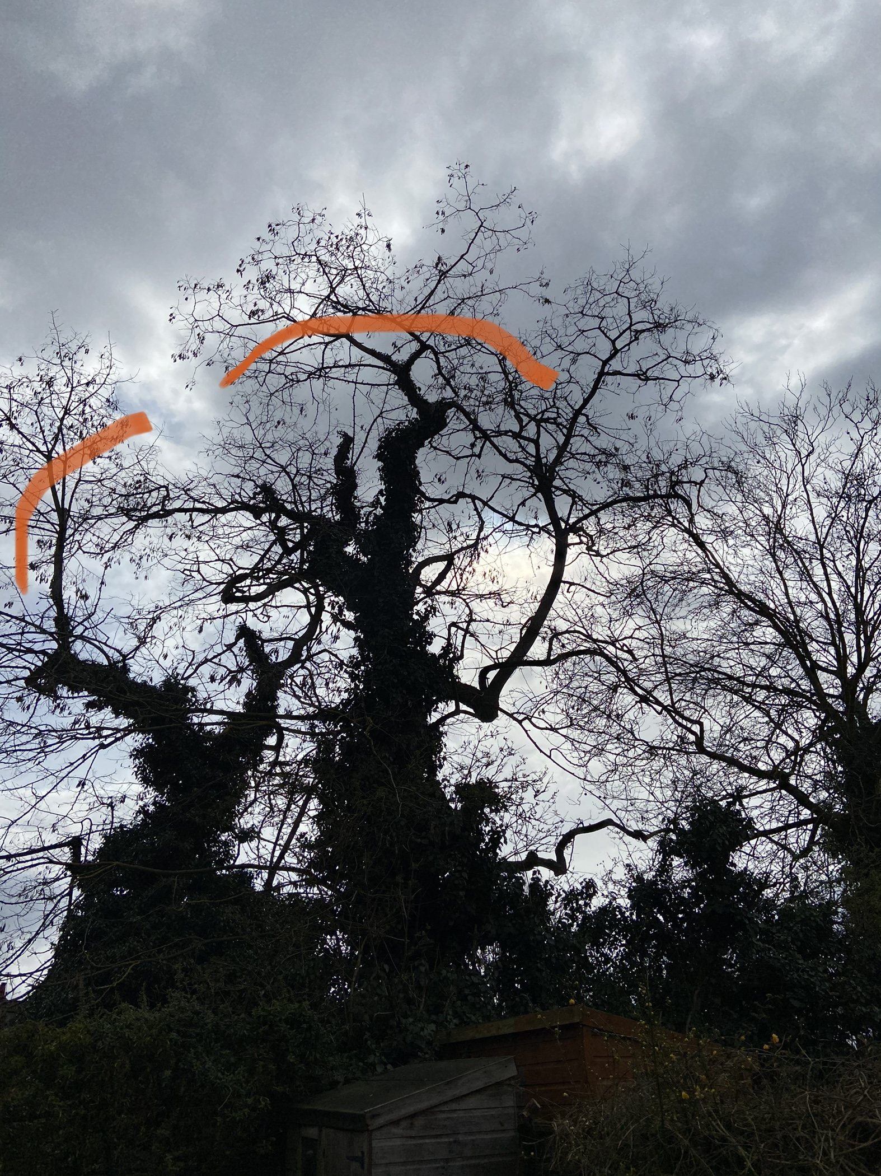

T2: Reduce one stem and reduce lateral branches T1: Reduce stem by 1.5m

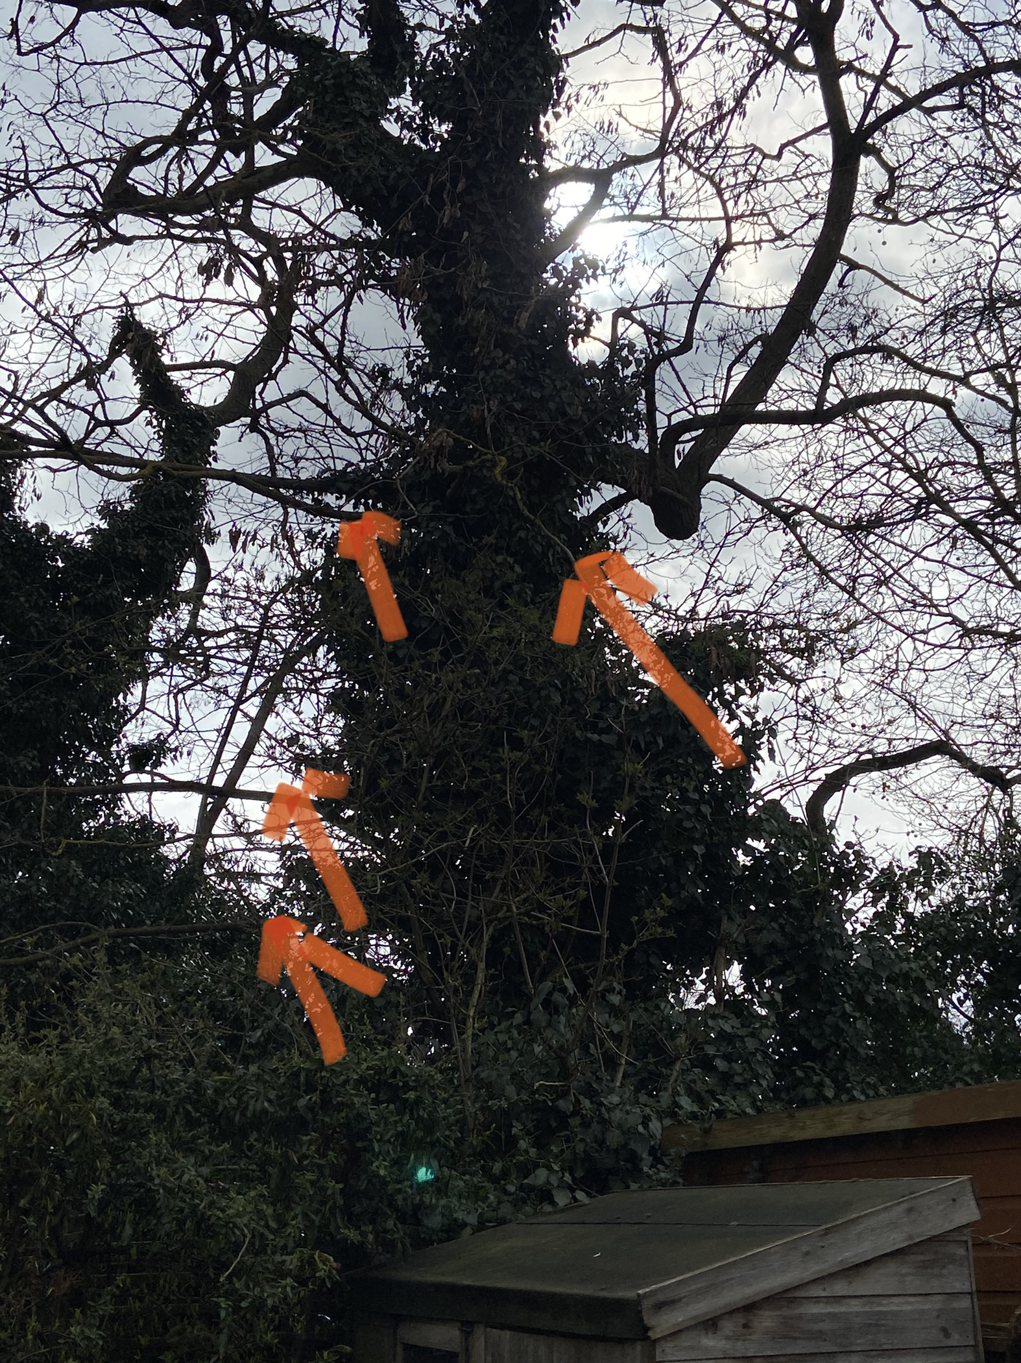

T1: Removing lower branches (up to 25mm in diameter) back to trunk