18/04/21

Our ref: 749/2021/notes

**70A Gaisford Street: notification of proposed works to trees in a Conservation Area**

**Section 4**

**Identification of tree(s) and description of works** (ref Figure 1)

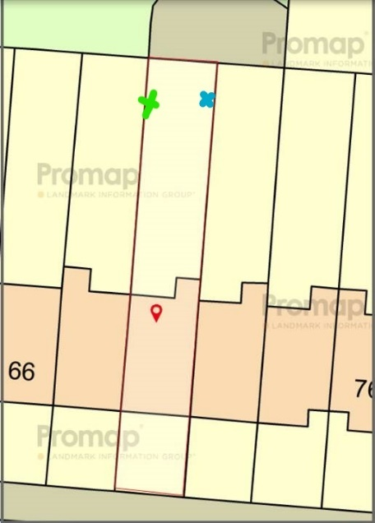

Figure 1:Location of trees in rear garden of 70 A green cross cedar, blue cross pittsosporum

*Cedrus deodara*

Location:

See Fig 1 green cross -rear of garden trunk within 0.1m of western garden boundary brick wall photo Note large ash tree in neighbouring garden

Description:

Early mature with girth 38cm dbh, and canopy spread average 5m, approx. height 12m.-photo

Reason for removal:

Wrong tree in the wrong place -too large for small garden and too close to boundary wall photo.

*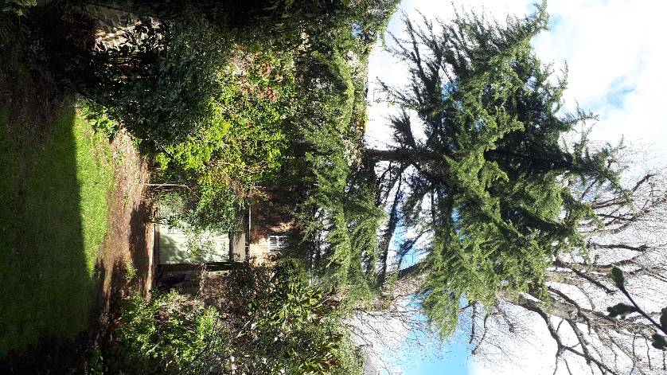Photo of cedar in rear of garden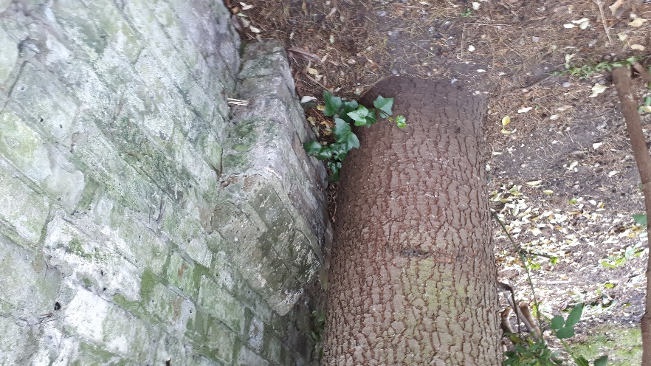Trunk of cedar close to boundary wall and showing raised ground*

*Pittosporum tenufolium*

Location:

See fig 1 blue cross -Rear of garden by eastern boundary wall

Description:

Immature tree Multi stemmed tree with dbh of 10,9,7cm, 5m in height some re growth from base stems

Tree works:

Coppice to create a bush form