**STATEMENT IN SUPPORT OF THE PLANNING APPLICATION**

**ROOF EXTENSION TO 17 FITZROY ROAD NW1 8TU**

**DESIGN**

17 Fitzroy Road is an end terrace house next to the Princess of Wales public house.

1) The design of the roof extension includes the roundels to the parapet wall to match the existing roundel detail to 7 Fitzroy Road, a house in the same terrace as No 17.

The roundels are similar to the roundels to the front parapet walls to 19 to 29 Fitzroy Road

(6 houses) and 26 to 36 Fitzroy Road (6 houses) **given full planning permission on 3 December 2009 (2009/5151/P)**

THE ROUNDELS WILL PARTLY HIDE THE ROOF EXTENSION AND COMPLY WITH PH23 with “the reinstatement of an architecturally interesting feature”.

2) Front & Rear Elevations

A slated mansard front elevation with dormer sash windows.

A slated mansard rear elevation with conservation style roof lights.

Designed to follow Planning Guidelines in the Conservation Area Statement.

3) Flank wall

Built up as for the following planning permissions :

19 Fitzroy Road (PP 2009/ 5151/P)

29 Fitzroy Road (PP 2009/ 5151/P)

26 Fitzroy Road (PP 2009/ 5151/P)

38 Chalcot Road (P 2014/5503/P)

The flank wall has been built up as part of the roof extension to 5 Fitzroy Road, at the other end of this terrace (see pic of flank wall attached).

The proposed extension to 17 Fitzroy Road balances the terrace.

**PRECEDENTS (All roof extensions including precedents outlined in blue on plan, page 5 below)**

1) 5 Fitzroy Road has a roof extension. (See pic attached.)

7 Fitzroy Road in this terrace retains the parapet roundel detail. (See pic attached.)

2) 37 and 38 Chalcot Road roof extensions.

37 Full planning permission dated 25 Oct 2011 (2011/5150/P)

38 Full planning permission dated 30 Sep 2014 (2014/5503/P)

These roof extensions are more prominent and have a greater impact on the street scene in Fitzroy Road and the longer views from and towards Primrose Hill Park than would the proposed roof extension to 17 Fitzroy Road.

3) 19 to 29 Fitzroy Road & 26 to 36 Fitzroy Road : roof extensions to two opposing terraces of six houses to each terrace

Full planning permission dated 3 December 2009 (2009/5151/P)

All the houses have similar external details including the decorative roundels on the parapet wall at roof level which partly hide the roof extensions.

These two terraces are closer to Primrose Hill Park and are more prominent than 17 Fitzroy Road.

4) 21 Chalcot Road roof extension.

Full planning permission dated 2 June 2015 (2015/2849/P)

The roof extension and the large front windows to the extension are highly visible from Chalcot Road.

21 Chalcot Road adjoins the Princess of Wales and the back of 21 Chalcot Road is close

to 17 Fitzroy Road

5) 6 Egbert Street roof extension

Full planning permission 2 November 2012 (2012/5508/P)

6 Egbert Street is directly behind 17 Fitzroy Road and overlooks the same garden area as No 17

6) 2 to 24 Fitzroy Road : the terrace of 11 houses

This terrace of houses is directly opposite Nos 5 to 17 Fitzroy Road

10 of the houses have roof extensions

6 houses with roof extensions have the roundel parapet detail (6 to 16 Fitzroy Road)

The only unextended house, No 2, is close to Gloucester Avenue

(NB No 8 is the entrance to a house on backland. There are 11 houses in the terrace)

**Summary**

**All these properties are close to 17 Fitzroy Road.**

The planning permissions referred to are recent, they cover the period 2009 to 2015.

**IMPACT ON THE STREET SCENE OF THE PROPOSED ROOF EXTENSION TO 17 FITZROY ROAD**

The back wall of the Princess of Wales has a number of ducts, air conditioning units etc and is unsightly (see pic attached). This wall is next to 17 Fitzroy Road. This back wall has a greater impact on the street scene than would the proposed roof extension.

The Princess of Wales is a more prominent building than 17 Fitzroy Road and the front wall is built on the pavement line. No 17 is set back from the pavement. The Princess of Wales hides No 17 from the viewer looking down the street from Primrose Hill Park.

The proposed roof extension will balance the parapet roundel detail on 7 Fitzroy Road and the roof extension to 5 Fitzroy Road at the other end of the same terrace.

The proposed extension to No 17 will be more attractive than the roof extensions to 18, 20, 22 and 24 Fitzroy Road which are directly opposite No 17.

The proposed roof extension to No 17 will be less intrusive than the roof extensions to 37 and 38 Chalcot Road which are highly intrusive when looking up Fitzroy Road towards the park.

The proposed roof extension will have less impact than the roof extension to 21 Chalcot Road with its highly visible glazed doors/windows.

The proposed roof extension to 17 Fitzroy Road will be partly hidden by the parapet roundels.

**Summary**

The proposed roof extension will not be prominent.

It will not be a significant intrusion on the street scene in this location where there are already many roof extensions as well as the Princess of Wales

**PH19**

All 15 houses in Fitzroy Road and Chalcot Road (listed under precedents above) which have been given planning permission for roof extensions are included in PH19 as being properties where roof extensions are restricted.

**PH18**

This policy lists the points to be taken into account where “where roof extensions are unlikely to be acceptable”

1) “It would be detrimental to the form and character of the existing building”

The roof extension at No 17 has been designed to comply with the Conservation Area

Statement.

Note the more detailed comments under Design above.

2) “The property forms part of a group or terrace which remains largely, but not necessarily

completely impaired”

The terrace is impaired by :

The roof extension to 5 Fitzroy Road, the other end terrace house.

One house in this terrace, 7 Fitzroy Road, has retained the roundels.

No 17 is next to the Princess of Wales and is impacted by the ducts, air conditioning

units and pipework on its back wall.

3) “The property forms part of a symmetrical composition, the balance of which would be

upset”

The property is not part of a symmetrical composition.

There is a roof extension to 5 Fitzroy Road and the roundels to 7 Fitzroy Road

4) “The roof is prominent, particularly in long views from the park”

17 Fitzroy Road is hidden by the Princess of Wales.

Far more prominent than No 17 are :

37 & 38 Chalcot Road

The two terraces 26 to 36 Fitzroy Road and 29 to 39 Fitzroy Road

5) “ The building is higher than many of its surrounding neighbours. Any further roof

extensions are therefore likely to be unacceptably prominent”

17 Fitzroy Road is next to the more prominent Princess of Wales.

See Impact on the Street Scene above.

The proposed roof extension to 17 Fitzroy Road is not “unacceptably prominent”.

**PH23**

PH23 states : “the retention or reinstatement of any architecturally interesting features and characteristic decorative elements such as gables **parapets** cornices and chimney stacks and pots will be encouraged”.

The replacement of the roundels to 17 Fitzroy Road provides a benefit to the area and complies with this policy.

**CONCLUSION**

The roof extension will be partly hidden by the roundels and would be unobtrusive in its impact.

Granting Planning Permission for the Roof Extension to 17 Fitzroy Road to include the roundels to the front parapet **will set a precedent**. No 17 is at the opposite end of the terrace to 7 Fitzroy Road which retains the roundels.

The Planning Authority will be able to ensure any subsequent roof extensions to this terrace include the same roundel detail.

Charles Lumley-Ellis FRICS 5 April 2021

(NB All the houses referred to in this document are Mid Victorian Terraced Houses with parapet walls to the front elevation.)

**ROOF EXTENSIONS TO MID VICTORIAN TERRACED HOUSES OUTLINED IN BLUE**

**No 17 Fitzroy Road outlined in red**



**Flank wall to the Princess of Wales**

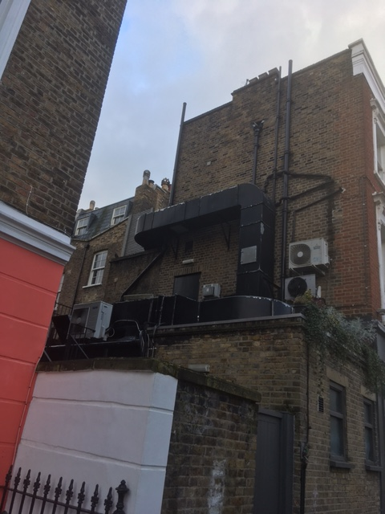

**5 Fitzroy Road roof extension & 7 Fitzroy Road roundels to parapet wall**

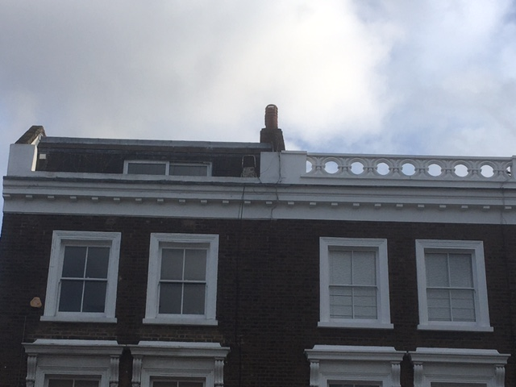

**17 Fitzroy Road. End terrace house**

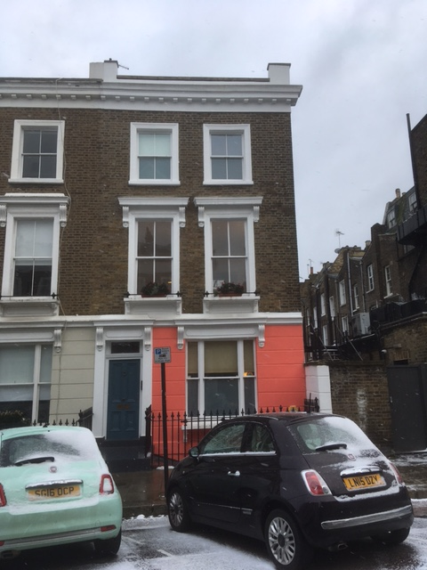

**5 Fitzroy Road, flank wall. The building has a roof extension.**

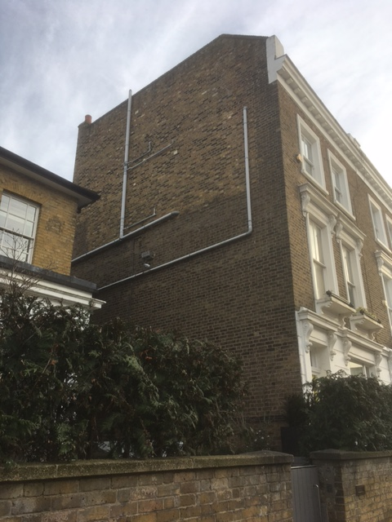

**37 & 38 Chalcot Road (continuous door numbers)**

**No 38 is the end terrace with the flank wall and roof extension**

**No 37 has a roof extension**

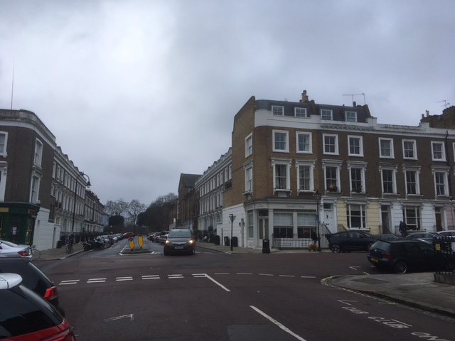

**21 Chalcot Road next to Princess of Wales. Roof extension with highly visible glazed doors.**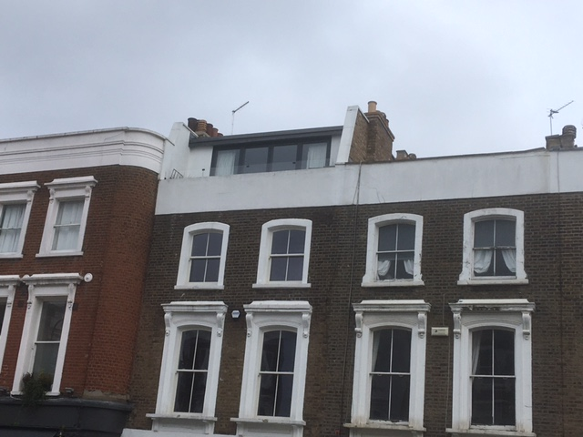

**26 Fitzroy Road. Roundels & roof extension.**

