**Design and Access Statement**

**For proposed alterations and repair work**

**At**

**33 Goldington Street, London NW1 1UE**

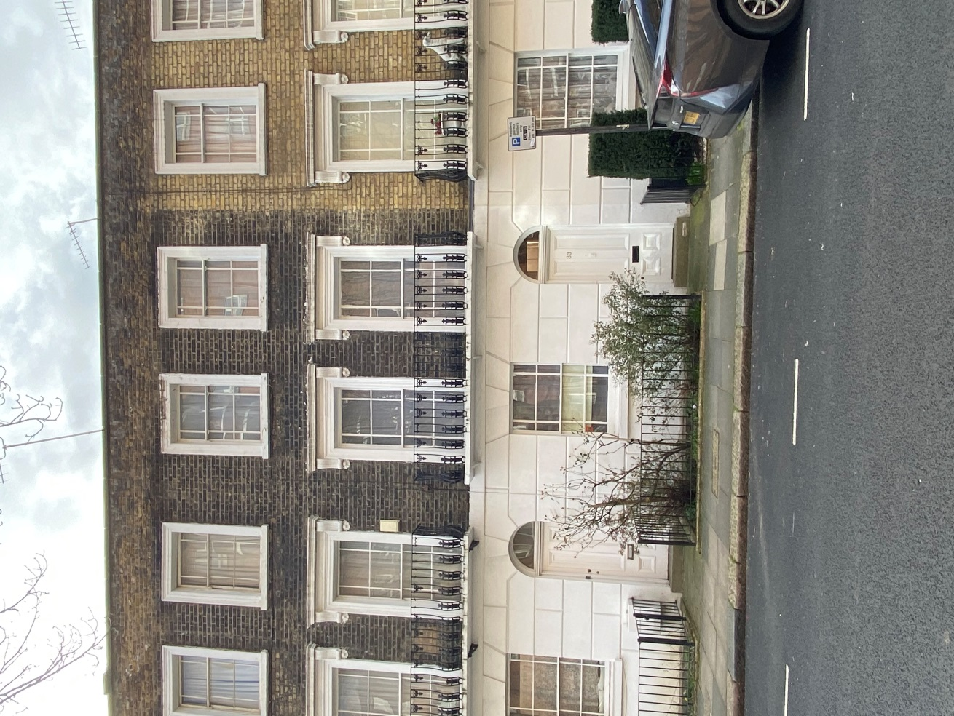

Photo 1 – View of front of 33 Goldington St

Prepared by Smiley Jim Ltd

12th March 2021

Page 1

1. **Introduction**

This design and access statement forms part of the planning and listed building applications for the proposed alterations and repair works to 33 Goldington St. It is to be read in conjunction with drawing numbers MP01 Existing Plans, MP02 Existing Sections, MP03 Existing Elevations, MP04 Proposed Plans, MP05A Proposed Elevations,MP05B Proposed Elevations (2), MP06A Proposed Sections, MP06B Proposed Sections (2), MP07 Door Schedule, MP08 Details Doors, MP10 Details Mouldings, MP11 Details Dining Room Window, and MP12 Details En-Suite Shower Room.

2. **The Site and Surrounding Area**

33 Goldington St is a modest Grade II Listed Building built c1850. It is one of a terrace of 14. The front of the property has a stuccoed rusticated ground floor exterior, with brick first and second floors. The windows on the first and second floors have stuccoed window embellishments. There is a balcony at first floor level with cast iron railings. The building has a simple three-cell layout, although this was been subjected to changes when owned and converted by the council. There are no comments in the listing with regards to the interior of the property, which has lost many of its original mouldings and detailing, while retaining some period features. It is considered to be a positive contributor to the Kings Cross St Pancras Conservation Area.

The front of the property faces onto Goldington Street. The rear faces onto communal garden land that is shared with the houses within this terrace and similar terraces along Medburn St and Penryn Street.

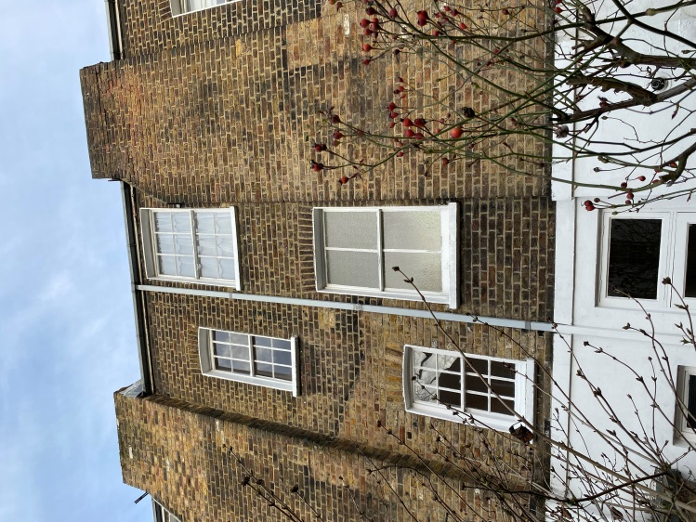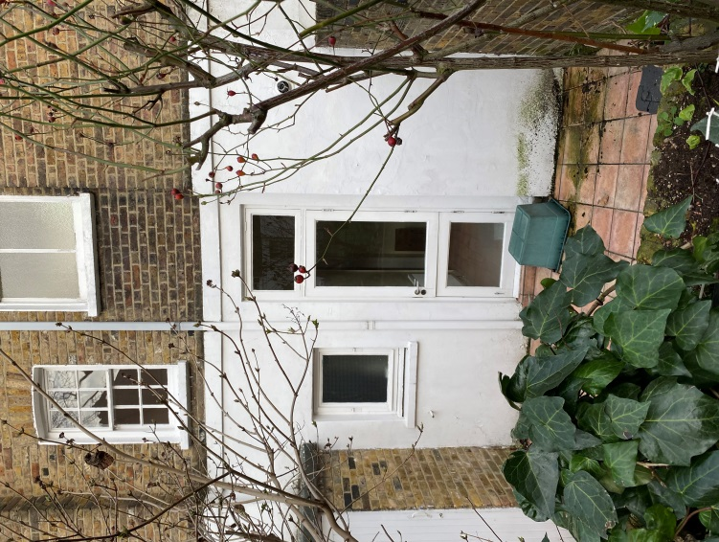

Photos 2 and 3 – Rear of 33 Goldington St

Page 2

There are some local shops along Pancras Road and Crowndale Road, and more extensive shopping facilities towards the centre of Camden.

There are bus routes along Pancras Road and Crowndale Road. The nearest train stations are locations are at Kings Cross and Mornington Crescent.

3. **Planning Context**

1. **Relevant History**

It is understood that the Street underwent some bomb damage during WW2, resulting in remedial work (ie with the roof structures in particular), which has consequently impacted on many of the original features.

The row of 14 terraced houses were remodelled in the late 20th Century as a London Borough of Camden Rehabilitation Scheme. We assume that many of the original features that have been lost were removed during this project. We are not aware of any material changes to the property since then.

1. **Relevant Policies**

National Planning Framework (2019)

The London Plan (2016) as amended

The Draft London Plan (with modifications) 2019

Camden Local Plan (2017)

* D1 Design
* D2 Heritage

Kings Cross/St Pancras Conservation Area Statement

1. **Pre-Planning Advice**

Pre-Planning advice was sought in 2020, ref 2020/5525/PRE for the proposed work. The case officer was Josh Lawler, with additional comments provided by Nick Baxter. The advice given has been taken into account in preparing this application, with additional supporting information being provided where requested.

4. **Proposed Work**

4.1 **Ground Floor**

a) It is proposed to form a new opening between the front and rear rooms. This will result in the loss of a non-period serving hatch. The new opening is to be 2020mm wide x 1980mm high, and will leave substantial nibs either side – there is precedent for similar openings in the street (eg ref 2013/7721/L). See drawing MP06A for details.

Page 3

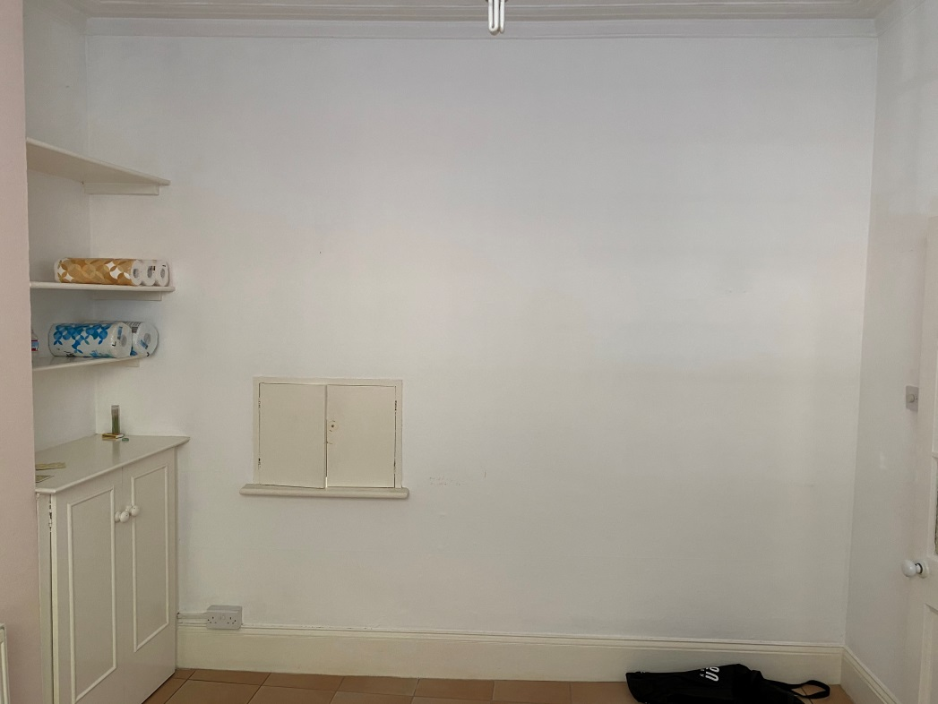

Photo 4 – Ground floor wall between front and rear rooms

b) Form new recess between existing rear room and wc to accommodate storage cupboard. Remove fanlight over existing wc door. (See drawing MP04)

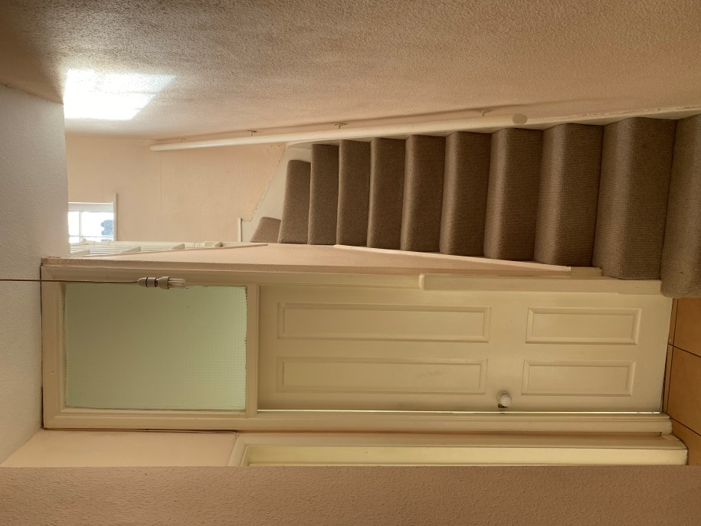

Photo 5 – WC door with fanlight over

Page 4

c) Replace existing rear door and fanlight with new timber door and fanlight (D5) in existing opening. (See drawing MP08).

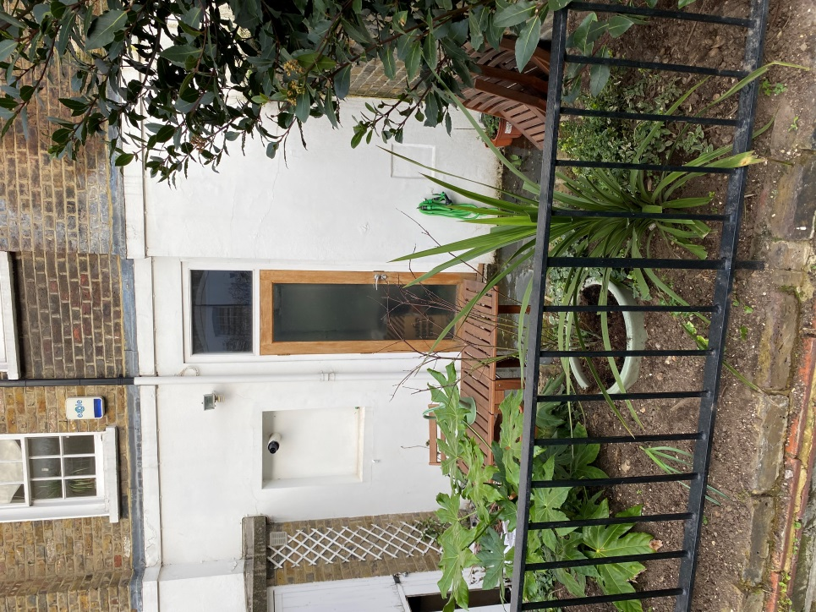

Photo 6 – No 29 Goldington St – approved rear door

1. Replace internal non-period door to front room with 4 panel Victorian style door (D2). Install 4 panel Victorian style door to rear room, where door is currently missing (D3).(Note: wc door(D4) is original and new doors will match this – see drawing MP08 for details of proposed doors).

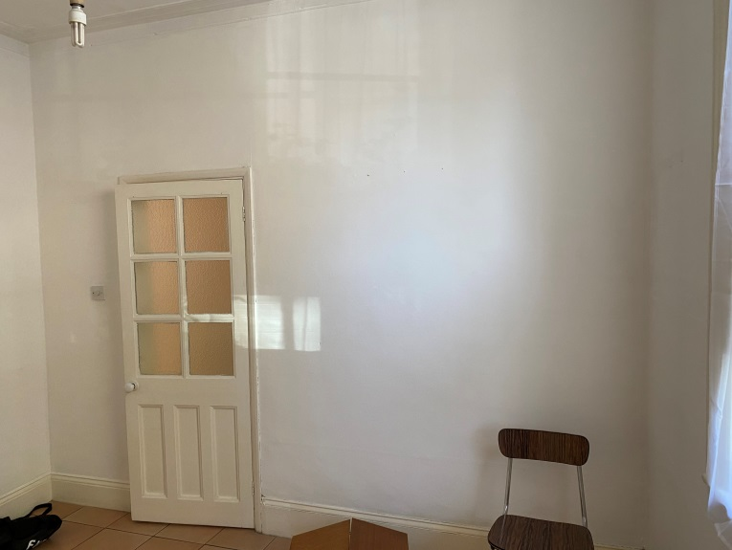

Photo 7 – Existing front room door to be replaced

Page 5

1. Re-instate Victorian style skirtings, architraves and mouldings. Existing cornice to front room and hall to be retained. Existing skirting to front room to be retained, although where this has been patched in due to later fitted cupboards, the non-period sections are to be removed and replaced with new to match. (see Drawing MP10 for details of proposed mouldings).

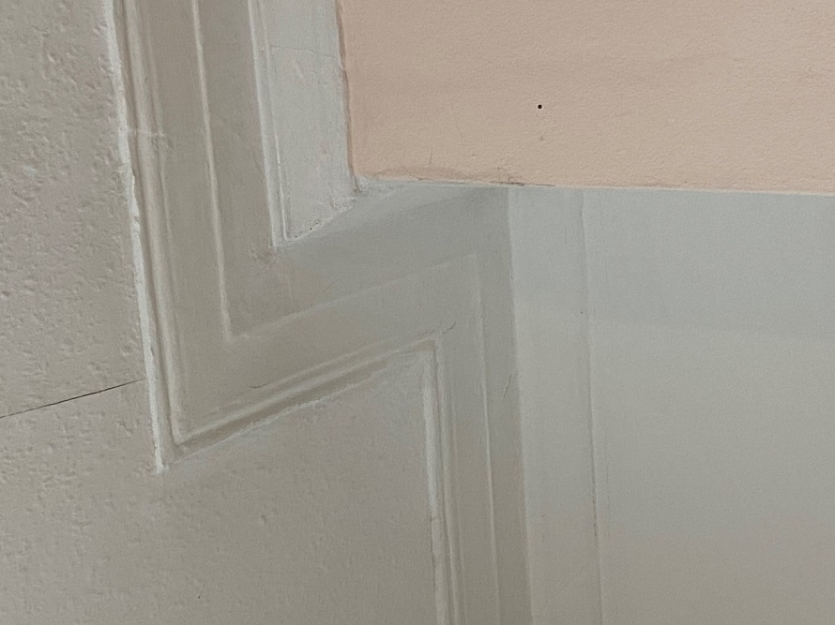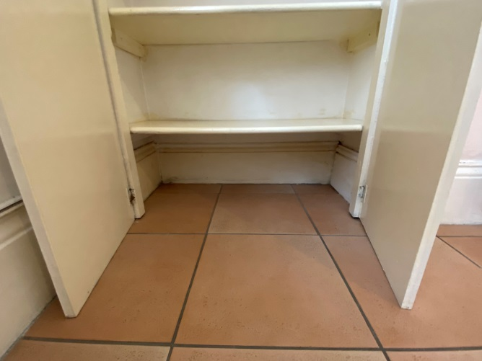

Photo 8 – Existing cornice in ground floor front room Photo 10 Existing skirtings in ground floor front room

1. Remove existing non-period fitted cabinets and shelving to front room.

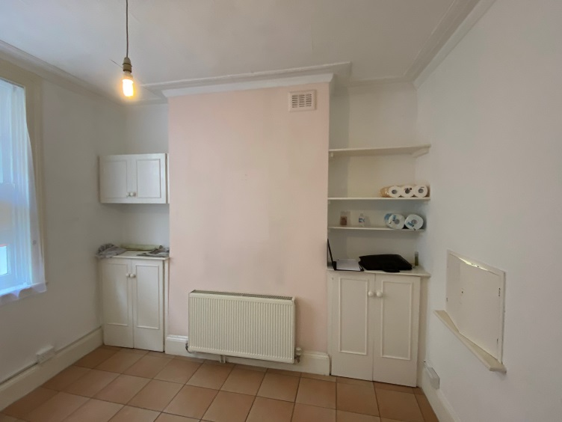

Photo 9 – Existing cupboards and shelving in ground floor front room

Page 6

1. Open up front room chimney to receive new kitchen cooker/range. Opening to be 950mm x 1850mm (see drawing MP06B).

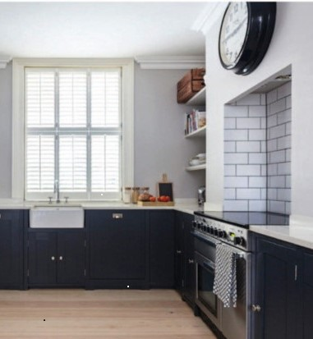

Photo 9A – Ground floor front room – example of chimney opened up at number 29 Goldington St

1. During the pre-planning consultation, it was proposed to install a window in the chimney of the rear room facing the courtyard garden. The advice given was that the window as designed at the time “would entail loss of fabric and the introduction of an inappropriate feature and is not acceptable.” This advice has been carefully considered and the proposed opening has been considerably reduced in size, and detailed such that the overall appearance of the internal and external wall surfaces would be retained. The proposal is to install a new opening in chimney to rear room. The opening is to have a hinged flush rendered panel externally with double-glazed unit behind in fineline metal framing, painted white to match the existing render. Internally, the opening is to be lined in timber with a hinged panel – the lining and panel to be painted to match the internal wall colour. When the panels are closed, externally you will see a flush rendered surface with the openable panel edged by a fine line of painted metal, 3mm wide. Internally, when the painted panel is closed, the flush openable area will be discernable by a thin 3mm shadow gap. The visual appearance of the existing building will thus be maintained. The opening can be filled in and rendered at a later date without affecting the integrity or appearance of the structure. Similar smaller panels exist in the street in this location.

Page 7

1. Remove electrical cupboard in hall. Relocate gas meter to under stairs.

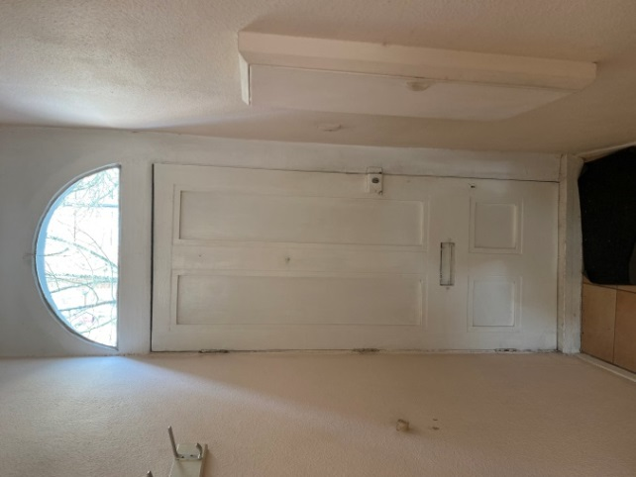

Photo 10 – Ground floor electric cupboard in hall

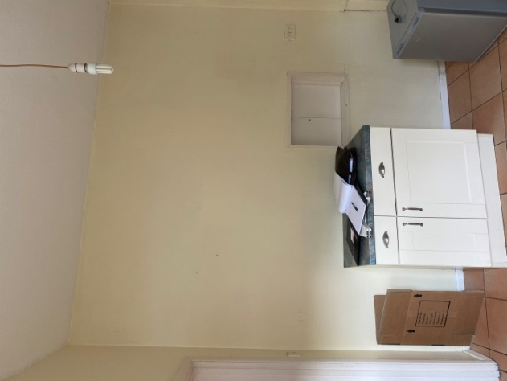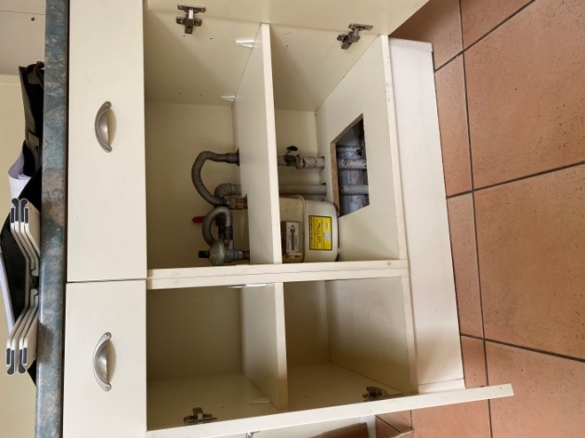

Photo 11 – Ground floor gas meter cupboard Photo 12 – Ground floor gas meter cupboard

1. Install water feature and planting bed in rear courtyard garden, using brickwork, bonded, pointed and selected to match existing, and new york stone paving to terrace and steps.

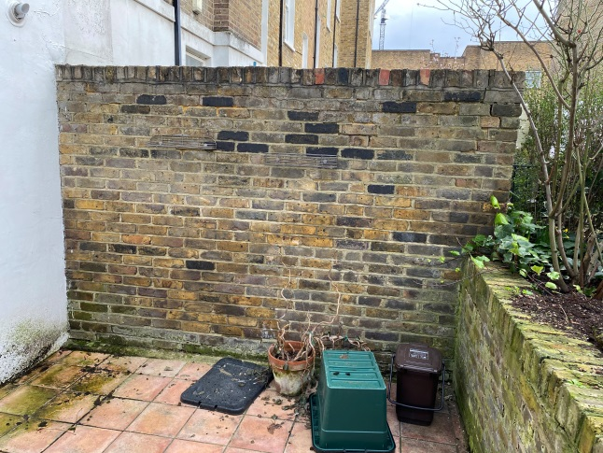 Photo 13 – Rear garden

Page 8

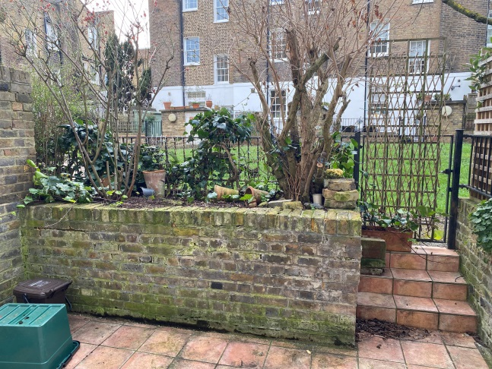

Photo 14 – Rear garden

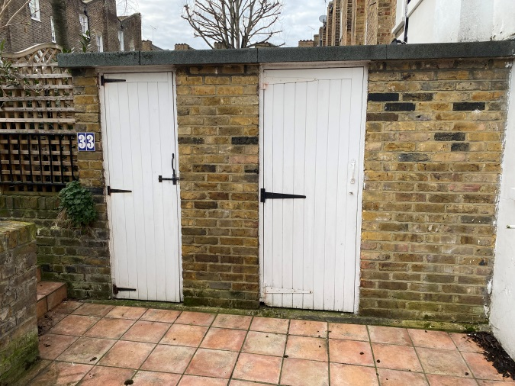

Photo 15 – Rear garden

4.2 **First Floor**

a) Remove existing bathroom, dressing room and cupboards (see drawing MP04).

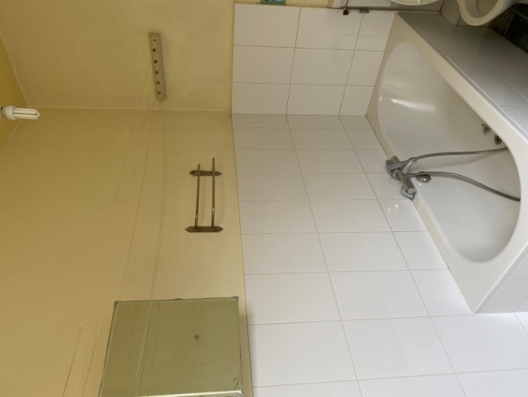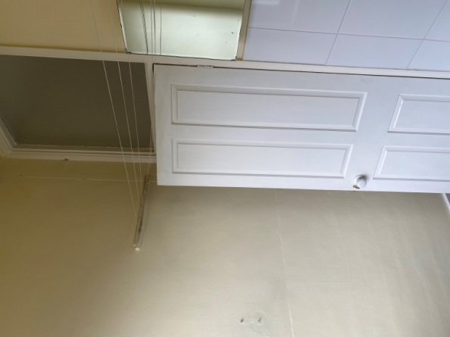

Photo 16 – First floor bathroom Photo 17 – First floor bathroom

Page 9

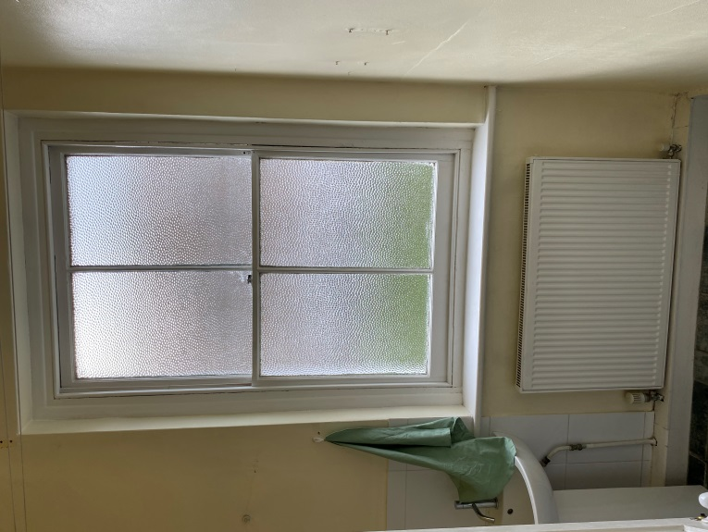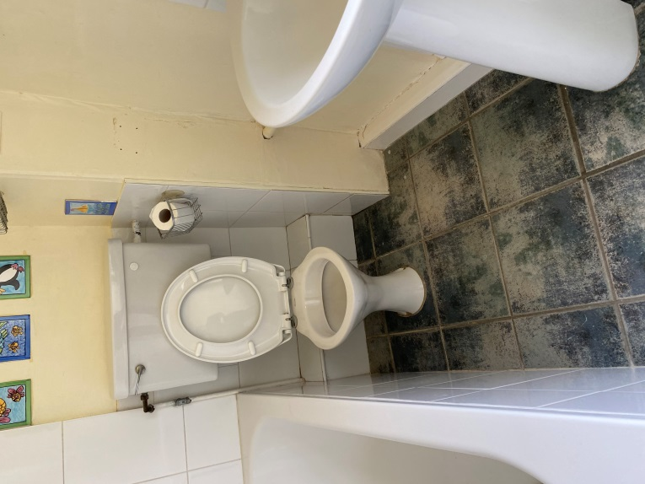

Photo 18 – First floor bathroom photo 19 – First floor bathroom

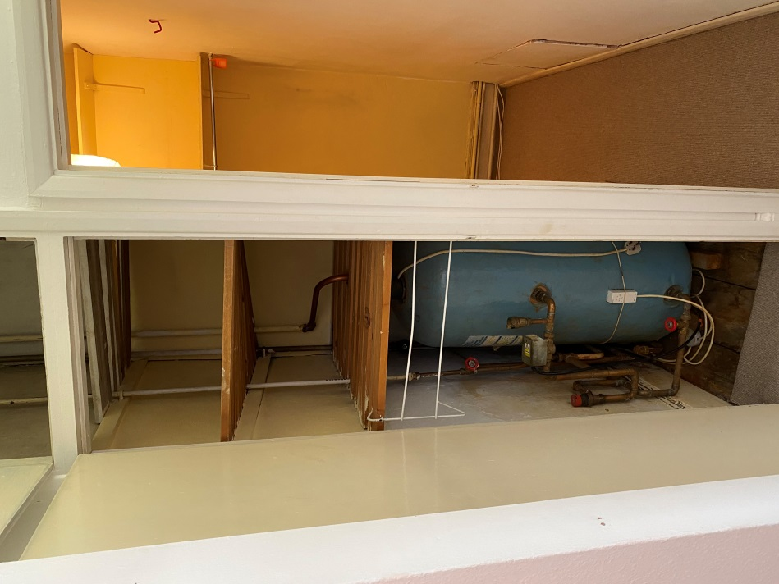

Photo 20 – 1st floor h/w cylinder cupboard & closet

Page 10

b) Reinstate working Victorian style fireplace to front room (see drawing MP06B).

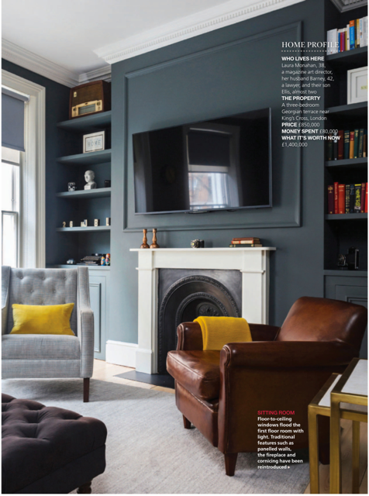

Photo 21 – Victorian style fireplace

c) Remove existing non-period doors. Install new 4 panel Victorian style doors (see drawing MP07). There is currently no door to the living room – a new 4 panel Victorian door is to be installed here.

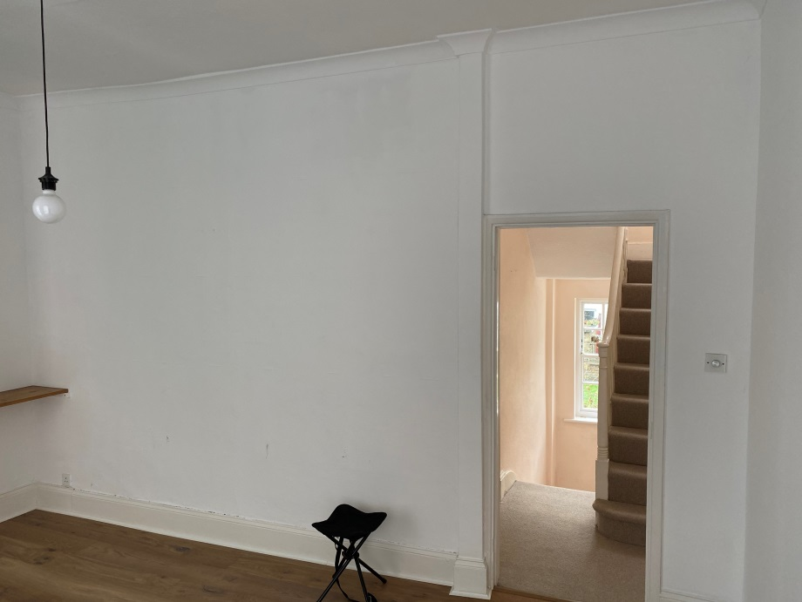

Photo 22 – 1st floor living room wall with no door and modern cornices and door architraves

Page 11

Remove existing non-period skirtings, architraves and cornices, and replace with new Victorian style mouldings (see drawing MP10).

In the pre-planning notes from Josh Lawler and Nick Baxter, they noted with regard to the proposed works to this level, that “these works are likely to be beneficial as they would reinstate the plan form at this level.”

4.3 **Second Floor**

a) Form new openings from master bedroom to hall (D9)and plasterboard over existing door opening (D8) (see drawings MP04 and MP06A).

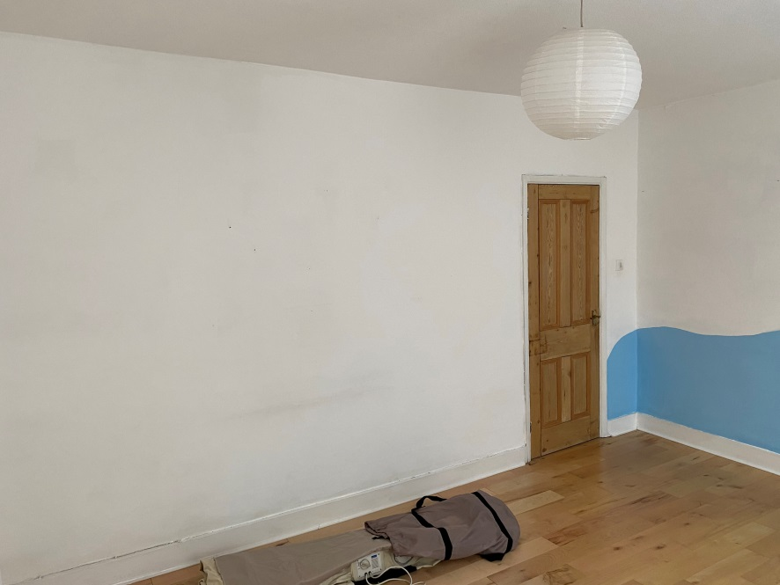

Photo 23 – 2nd floor front bedroom door

b) Form new en-suite shower room, with flush plain “secret” door (D10). Walls of shower room to stop 400mm down from ceiling. New ceiling of shower room to have waterproof plywood finish, painted(a similar arrangement was approved at 29 Goldington St (application ref 2013/7721/L). Install new plain “secret” door (D11) to bathroom. See drawings MP04 and MP12 for details.

In the pre-planning notes from Josh Lawler and Nick Baxter, they noted that “the provision of the bathroom at this floor is less harmful than having it on the first floor.”

The existing ductwork in the corner of the rear rooms at ground, first and second floors will be retained (although reduced in size where possible) and used for drainage pipework as presently exists. This will help to address concerns over exposed pipework.

Page 12

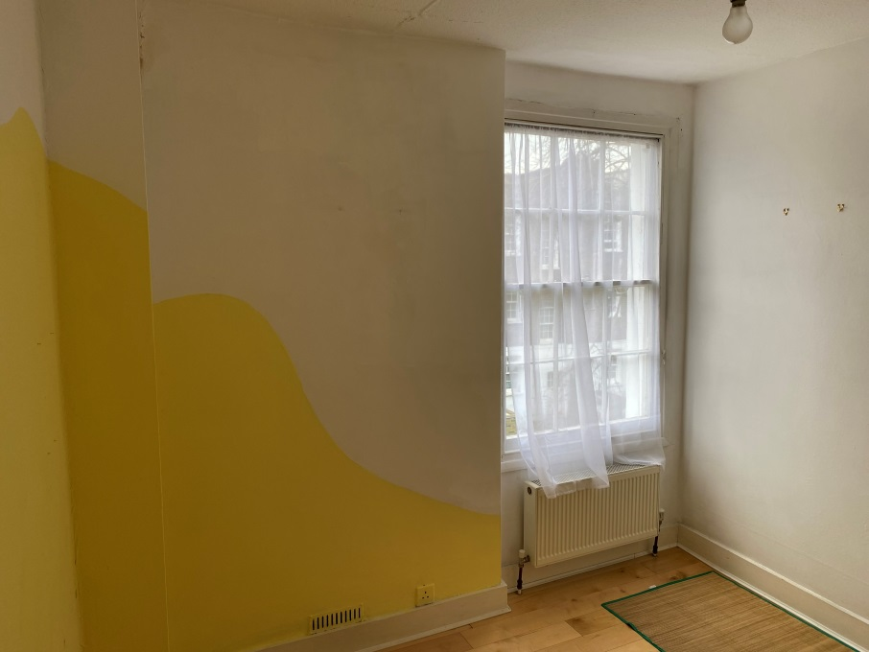

Photo 24 – 2nd floor existing rear room with ductwork in corner continuous to ground floor

c) It is proposed to change the access to the loft. During the pre-planning consultation, we were advised that “the insertion of a new loft staircase may harm historic features in the roof and is likely to compromise the understanding of the plan form. A more compact form of access, such as a spacesaver staircase might be less harmful”. This advice has been carefully considered, as have comments raised in relation to openings from the stair landing at this level. We have followed advice given, which has led to a layout which we believe “maintains the understanding of the plan form”.

Our preference is still to have a small but traditional staircase as opposed to a spacesaver staircase, which we believe would be more in keeping with the age of the property, and we would request that this is reconsidered in the light of the changes that have been made at this level of the house to retain the traditional cell layout. We do not believe that the proposed staircase will impact negatively on the roof structure.

The proposed work in relation to the staircase is to construct a new compact staircase from landing to loft, to replace existing loft hatch/stairs. There will be a toughened plain glass full height panel between the new and existing staircases as a safety barrier (see drawing MP04). The rectangular space of the existing stair and landing will be retained ensuring that the current cell arrangement of the existing property can be read.

4.4 **Loft**

During the pre-planning consultation, Josh Lawler and Nick Baxter noted that the “roof appears already to have been converted for habitable use and has a substantial hatch.” The proposed work to this area is mainly to improve access to the space, and to update it in line with building regulations. It is proposed to install new steels to sides of central loft space with stud partitions and new joists between steels, retaining existing joists, and adding new ones alongside the existing for strength (the existing ceiling below will be retained

Page 13

– the floor of the loft is not original).

New rafters will be added alongside the existing for strength, insulated and finished with new plasterboard (the internal finish of the space is not original).

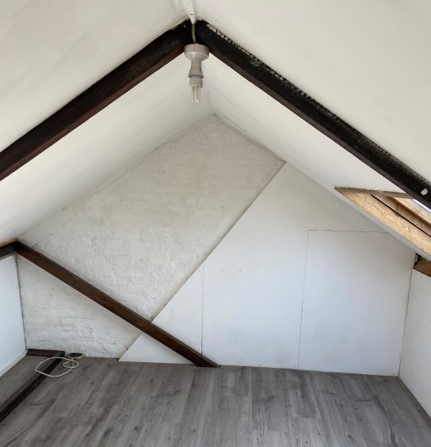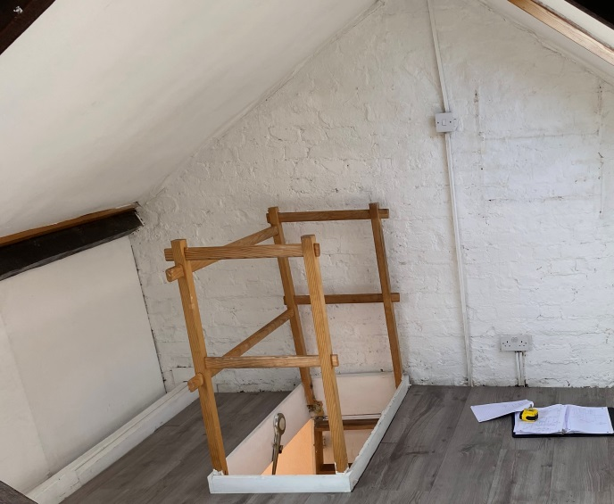

Photos 25 and 26– Existing loft with large loft access

Two braces are to be removed. Externally, the roof slate finish is to be cleaned of moss and made good with materials to match the existing, repairing pointing to brickwork and lead flashings as required, in materials to match.

The existing velux windows are to be retained. (please note: 29 Goldington St received permission for the inclusions of steels as proposed ref 2013/7721/L). See drawings MP04 and MP06B for details.

5. **Heritage**

It is not proposed to alter the external appearance of the property with regards to the front elevation, maintaining the architectural integrity of the street frontage. The replacement rear door and fanlight are in the existing opening, and in a simple style that matches the adjacent window, and which we believe to be acceptable. The plain rendered panel within the chimney is designed to have a minimal frame and to be flush with the face of the render, thus maintaining the plane of the façade at that point. It will allow much needed light into the adjacent room and provide more of a connection between the interior and exterior. The hinged panel on the interior will appear as a “secret” opening within the wall when closed. There is precident for openings within chimneys with flush panels (eg for cleaning chimneys).The simple water feature is in brickwork to match the existing The york stone paving and finish to the steps will enhance the existing courtyard garden.

Internally, the architectural layout of the main spaces will be maintained, with the exception of the second floor rear room, which will be sub-divided to provide a bathroom and en-suite shower room (this replaces an existing similar division on the first floor which has been removed).

Page 14

The ceiling of the en-suite shower room, being set down from the ceiling of the main space, will maintain the plan form of the original layout, and has been approved at 29 Goldington St ref 2013/7721/L.

In general, it is the owner’s intention to restore much of the character of the original Victorian building, while upgrading the structural and environmental performance in line with modern standards.

6. Access

There are no proposed changes to the access.

Page 15