Consent of premises licence holder to transfer

I/we | Dee Stuart Wilkinson
 | [full name of premises licence holder(s)]
the premises licence holder of premises licence number |  | PREM-LIC\2261
 |  | [insert premises licence number]
relating to
Sodexo, UCL Bloomsbury campus, Gower Street, London, WC1E 6BT

[name and address of premises to which the application relates]
hereby give my consent for the transfer of premises licence number
PREM-LIC\2261
[insert premises licence number]
to
CH&Co, UCL Bloomsbury campus, Gower Street, London, WC1E 6BT

[full name of transferee].

signed | 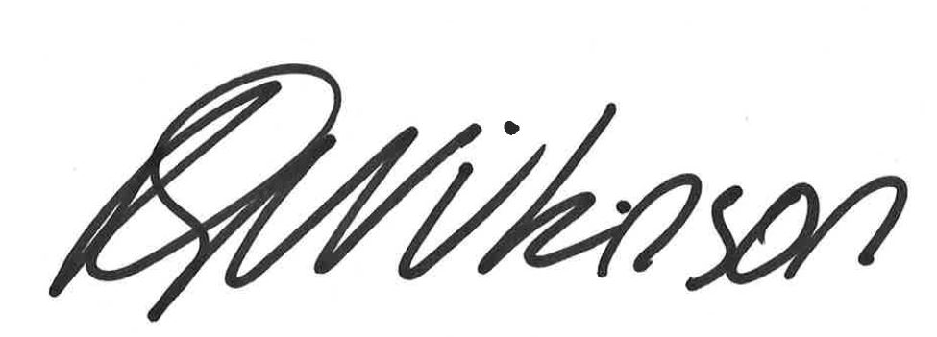
name  (please print) | Dee Wilkinson
dated | 25th March 2021

