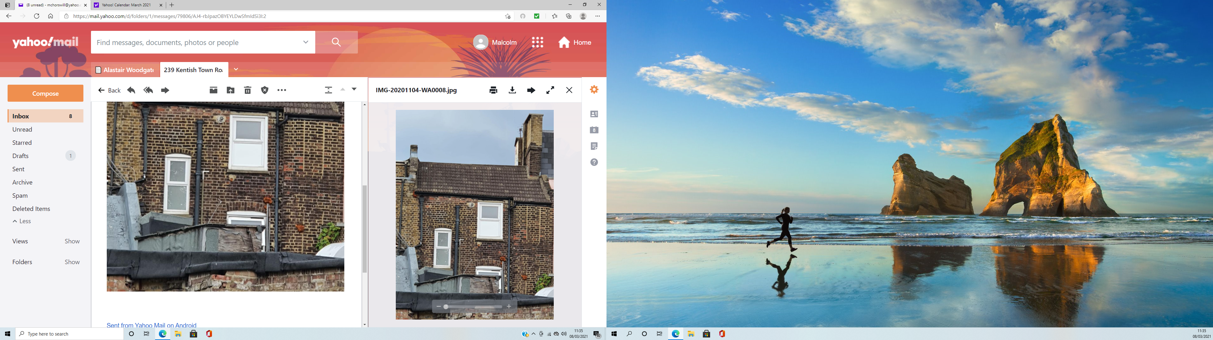

**PHOTOGRAPH 2 - 239 Kentish Town Road – Rear Elevation**