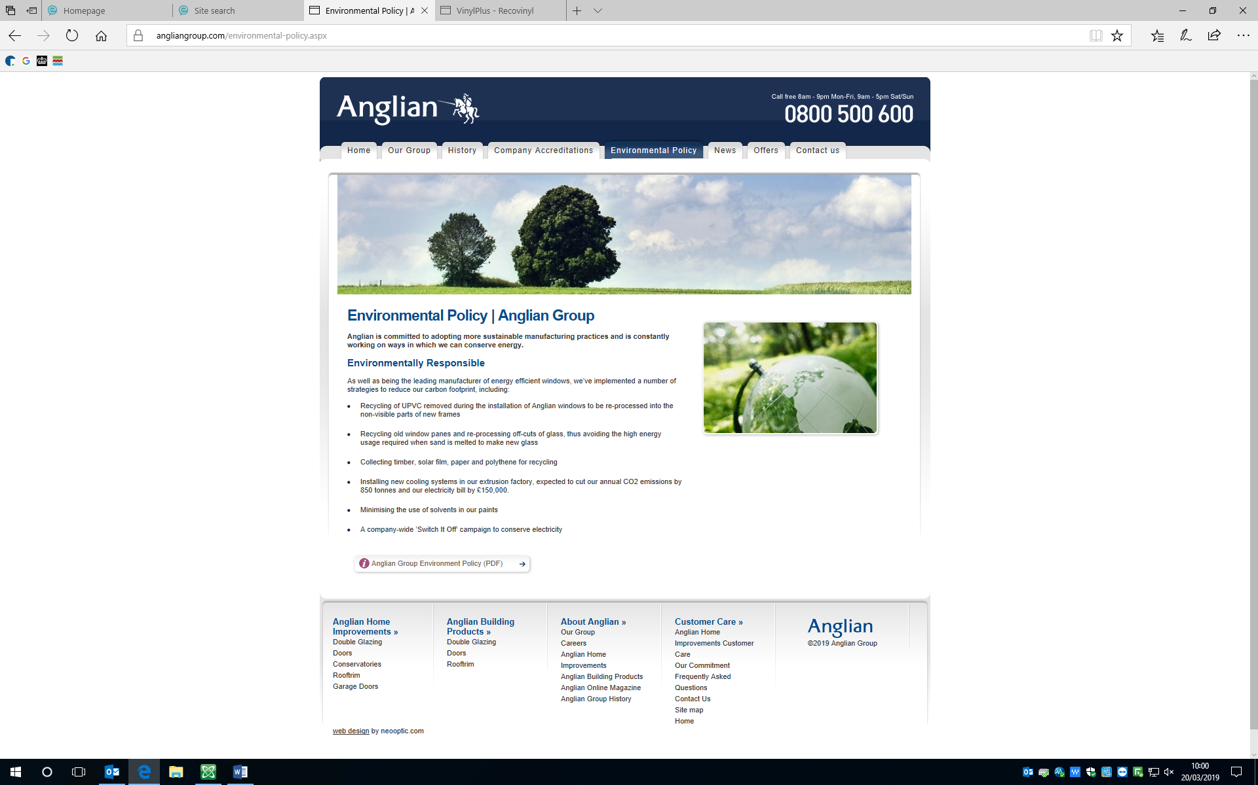 Anglian Home Improvement Environmental Contribution



Furthermore Anglian Home Improvements are also accreditated by Recovinyl Plus.

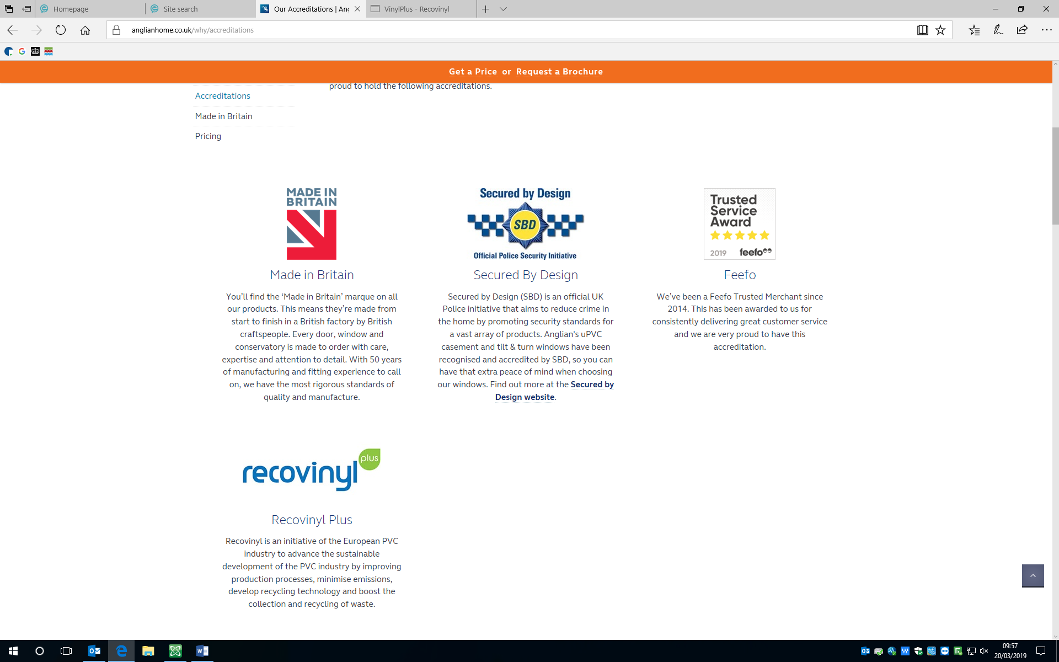

Vinyl applications can perform effectively for much longer than alternative materials. Their life-span can range from 30 to 100 years in the case of cables, pipes and window profiles. In addition, PVC products need minimal maintenance, and hence very limited additional consumption of energy, raw materials and chemicals is necessary to ensure their continued functionality. As a result, PVC has the advantage of remaining in use for a long period before it enters into the waste chain

When it reaches its end of life, PVC can be recycled. In fact, PVC has the longest history of recycling amongst plastics and the most advanced level of mechanical recycling.

Recovinyl registered and certified 633,127 tonnes of recycled PVC in 2017.