

DESIGN & ACCESS STATEMENT
Our Ref 303/09863
Location 57 HILLFIELD ROAD LONDON NW6 1QD
Proposal INSTALL REPLACEMENT WINDOWS

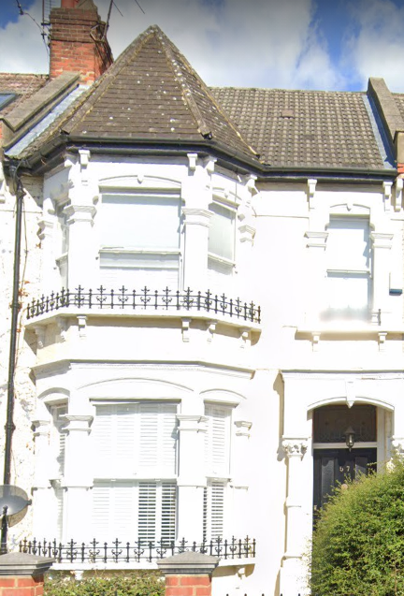

USE: Anglian Home Improvements have been contracted to replace the existing windows at the above named property.

AMOUNT: 6 windows

LAYOUT: Positioned to the rear and front elevations. There is no change to the footprint of the existing building.

SCALE: As existing. For sizes see CAD drawings.

LANDSCAPING: We will not be required to remove or cut back and hedges or trees on the site. Our proposal will not affect the amenities of the site or the surrounding area.

PROPERTY: We have been advised that the property does not fall within and conservation area and does not have an Article 4 but would require permission if any replacements are not like for like.

APPEARANCE/SPEC: We are proposing to replace the two existing windows to the front of the property with our Anglian Elite sash windows. The Anglian Elite Sash window albeit being constructed from PVCu due to the quality of design and build it is difficult to differentiate between our sash windows and the timber originals. Whilst other windows might only pay superficial attention to traditional details these windows have all the authentic detailing. These sash windows can preserve and enhance the appearance of Conservation areas. Specifics such as exclusive claw cam catch, original putty line details, traditional butt joints, continuous horns, deep bottom rail and white wood foil finish make the window appear most authentic.

The property, whilst near a conservation area, is not within a conservation area and therefore the same restrictions should not apply. The Elite sash window has been chosen to be sympathetic to the nearby conservation area.

The windows to the rear of the property are also to be white woodgrain PVCu with double glazing. The existing windows are deteriorating and are not energy and efficient. This elevation of the property is not visible from the public realm and therefore the changes will not have any negative impact.
The new windows will be low maintenance, provide better weather proofing and thermal efficiency and therefore will protect the internal and external fabric of the property.

The photographs below show the location of the windows to be replaced.

Front of property
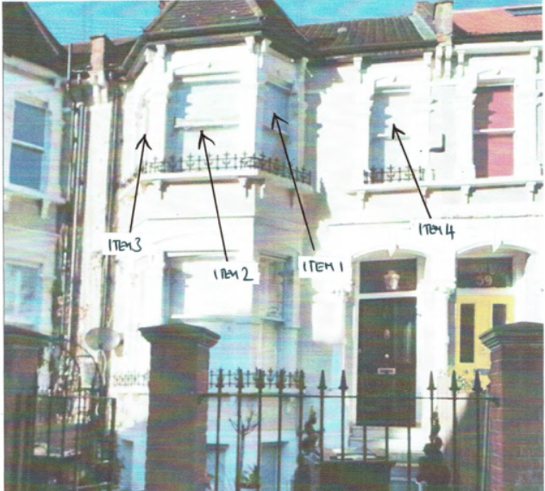

Rear of property
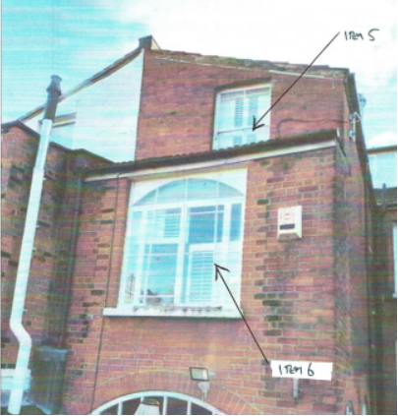

Our design is sympathetic to the existing building and will be constructed from high
quality materials and installation techniques. This improvement will therefore will
protect the internal and external fabric and integrity of the property.

The benefits to the homeowner to use Anglian’s PVCu windows are that they are low
maintenance and have increased longevity versus timber or aluminium and as such
the aesthetics of the property will be maintained without the reliance of future
upkeep. Our PVCu windows have a slimmer profile than timber and avoids the
increased risk of condensation associated with aluminium. Furthermore Anglian
have an environmental responsibility policy to ensure we help to protect and
maintain the environment where ever possible.

In addition draught proofing, sound insulation and security measures will all be
improved upon to the benefit of the quality of the life of the homeowners.

The Anglian Elite Window

Below are details of our Elite window highlighting all of the features and benefits
that are not normally seen on a PVCu sash window. This window has been approved
and endorsed by many local authorities for use in Conservation Areas.
The photographs below show some of the properties on Hillfield Road which have already replaced their windows with white PVCu
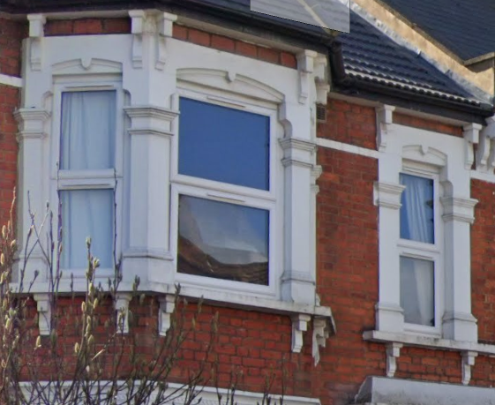

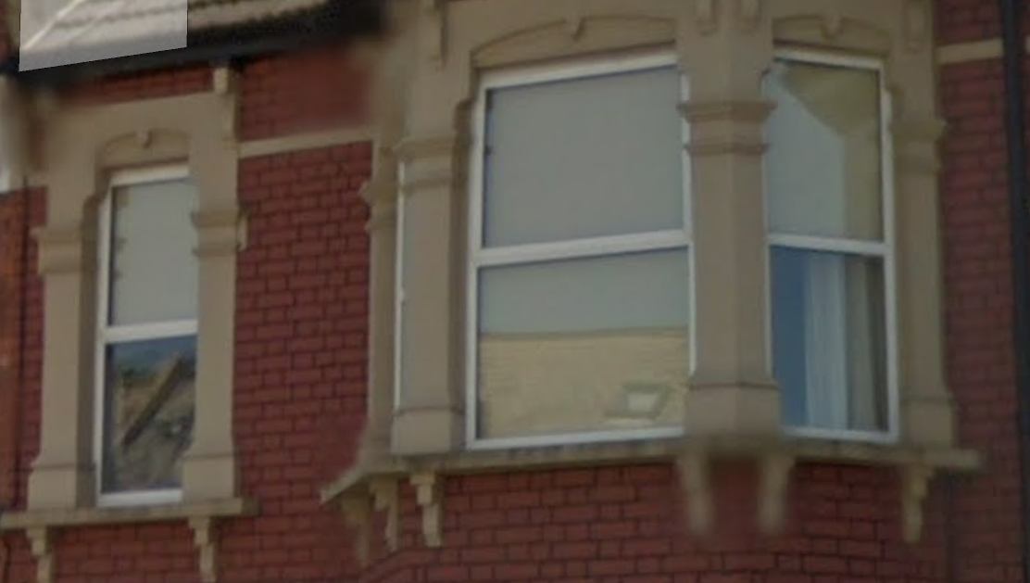

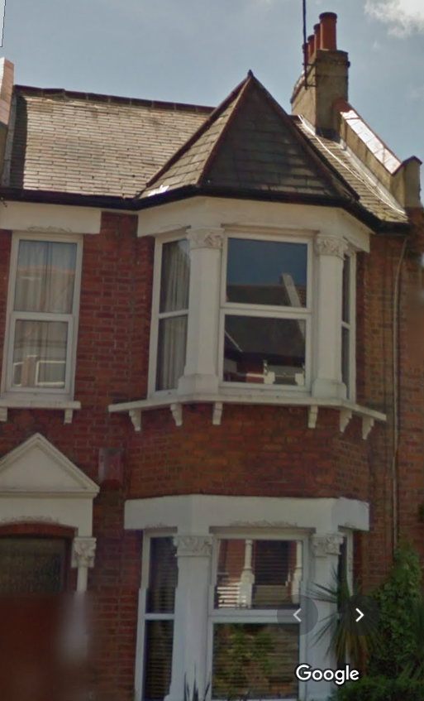

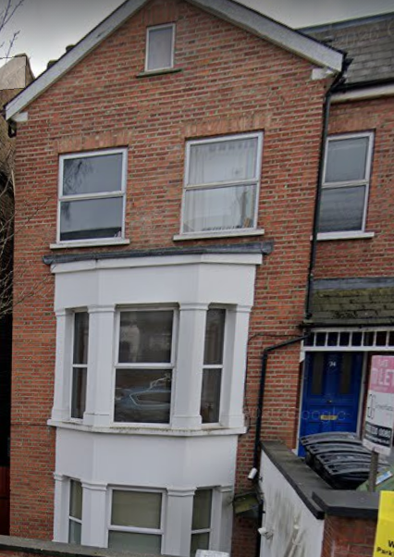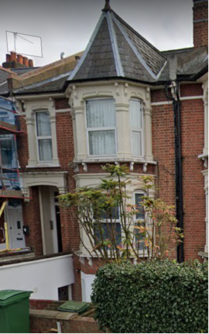

ACCESS: Access to the property for installation of any doors and/or windows shall be made through the existing access points. All materials shall be kept within the property boundary during installation.

