

**LINCOLN’S INN CHAPEL**

**Protective glazing**

DESIGN and HERITAGE STATEMENT

benjamin+beauchamp architects

the borough studios

the borough

wedmore

BS28 4EB

tel: 01934 713313

fax: 01934 713314

email: studio@b2architects.com

Project No 0685

Jan 2021

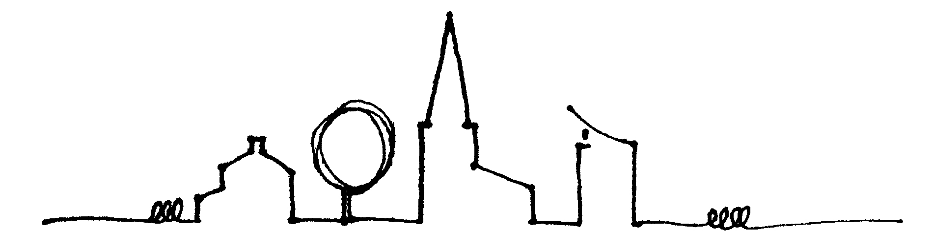

**CONTENTS**

1. **Introduction**

1. **The Site and Outline Historical Statement**
2. **The Proposals**
3. **Conclusion**
4. **INTRODUCTION**
   1. The following statement has been prepared in support of an application to re-remove the polycarbonate protective sheeting from three of the north side chapel windows.
   2. Two of the north windows (niii and niv) will additionally be subject to conservation and repair and when reinstalled, these windows will be brought inbound by approximately 30mm with Environmental Protective Glazing installed in the original position. The outcome will be both environmental protection of the early seventeenth century glass and the revealing of the ferramenta which is currently concealed by discoloured polycarbonate sheeting.
   3. Prior to this application being prepared, informal advice from the DAC has been sought and through this process, Historic England have been consulted. Alterations to the chapel are covered by Ecclesiastical Exemption and as such Listed Building Consent for the works is therefore not required.
   4. In parallel, the London Diocesan Advisory Committee have also been approached and a Faculty application is being applied for these same works.

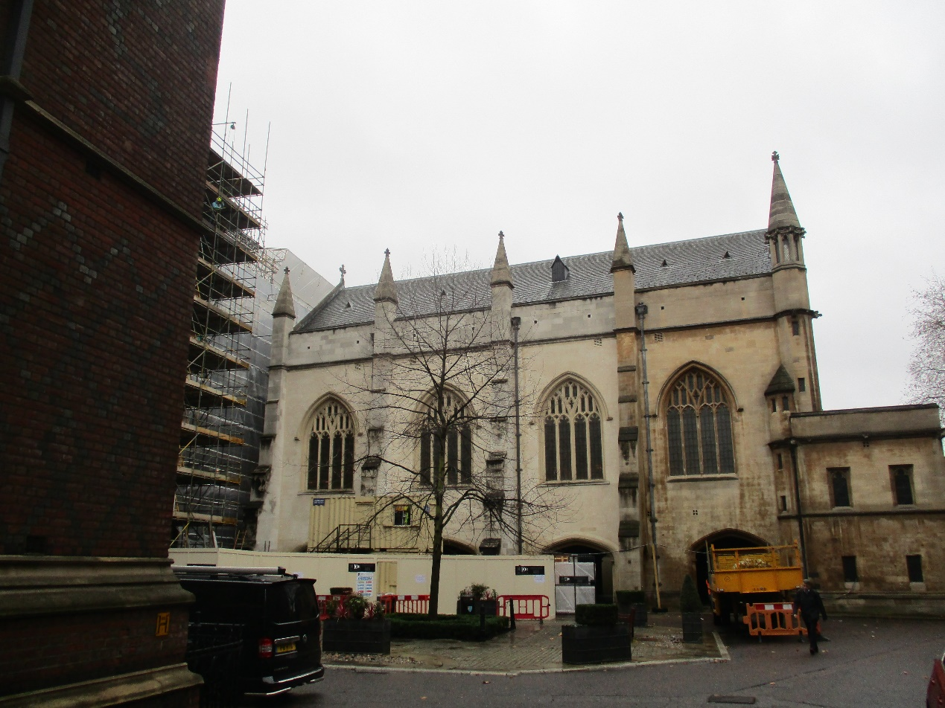

Above: Photo of the north side of the chapel during winter.

1. **THE SITE and OUTLINE HISTORICAL STATEMENT**
   1. The Honourable Society of Lincoln’s Inn is one of four Inns of Court in London. The site covers 11 acres and is believed to be named after Henry de Lacy, 3rd Earl of Lincoln.
   2. The Inn is located between Chancery Lane and Lincoln’s Inn Fields. The chapel is located in the centre of the Inn and is attached on the south side to the Grade I listed Old Hall. The chapel dedicated to St Richard, is Grade I listed and located within the Bloomsbury Conservation Area.
   3. The postcode is WC2A 3TL.
   4. The earliest mention of a chapel within the Inn dates to 1428 but this building became too small and a new 3-bay 2-storey chapel was built by John Clarke of Oxford in the early seventeenth century.

* 1. The foundation stone was laid by the Preacher John Donne in 1620 with the building consecrated on Ascension Day in 1623. Major repairs were undertaken in 1685 after consultation with Sir Christopher Wren. The chapel was extensively repaired in 1797 by James Wyatt whose work included the east window, a new copper roof, new plaster vaulting and re-facing in composition stucco. The gallery and organ were added in the 1820s and Hardwick remodelled the entrance in 1843. A major re-ordering was undertaken in 1883 by Stephen Salter when the building was extended westwards by one bay with the entrance vestibule and stairs constructed. The nave roof was also covered in slate at this time. A further repair programme was undertaken in 1915 after damage from a German Zeppelin raid. Further damage was sustained in the 2nd World War meanwhile recent works have included the installation of a disabled access lift and WC; the recovering of the roof and the installation of a new organ by Kenneth Tickell in 2010.
  2. The chapel is single wagon vaulted space with west end organ gallery all above a fan-vaulted Undercroft. The main volume measures 88ft x 40ft. The building is built of a combination of rendered brickwork and stone under a green slate roof laid in diminishing courses. The chapel is entered via one of two staircases at the west end of the building. There are two vestries. Burials on Benchers took place in the Undercroft until 1852. There is no churchyard. Inside, the collegiate feel is characterised by its windows and box pews.
  3. Within the chapel there are four stained glass windows. Until 1915, all of the original seventeenth century glass survived in-situ. The southwest window is by Abraham Van Linge, the northwest by Bernard Van Linge. The two easterly windows are by Richard Butler and all are contemporary with the original construction although much repaired by C E Kempe & Co Ltd following the air raid when the glass from the other windows was lost. These four windows are of national significance. The east window includes the crests of the 228 Treasurers from 1680 to 1908 with later Treasurers recorded in the northeast and southwest windows. At the west end of the Chapel are the colours of the Inns of Court Regiment.
  4. The box pews date from the construction of the chapel, with the communion rail late seventeenth century. The pulpit and tester are early eighteenth century meanwhile adjacent, a piece of alabaster on the east side of the pulpit is understood to be part of the altar from the original chapel. The chapel bell was cast in 1615.
  5. A Historic Building Assessment was prepared by Donald Insall Associated in March 2012 and this 223 page document should be cross-referred if more detailed information is required.
  6. The listing description is as follows:

*Chapel over open undercroft. 1619-23 by John Clark to replace a ruined chapel on a different site; with later alterations. Stone and rendered brickwork; green slate roof. EXTERIOR: 2 storeys. Originally of 3 bays, the 4th western bay and forebuilding 1882-3 by Stephen Salter, who also re-roofed the chapel. Western facade with central Tudor style entrance of pointed moulded arch having hoodmould with label stops and quatrefoil enrichment in spandrels; flanked by single light traceried windows and full height buttresses. At 1st floor level, central 2-light traceried window flanked by armorial shields and then 3-light traceried windows. Above the corbel table a 7-light traceried window with rose. East window similar, renewed by James Wyatt, 1795-6. North and south elevations buttressed (flying at ground storey) at bays with four 4-light Perpendicular windows each. Parapet and buttress pinnacles added by Stephen Salter. Undercroft with Gothic 4-centred arches, lierne-vaults and Tuscan demi-columns attached to the piers. INTERIOR: features of interest include original carved pew ends, early C18 pulpit with tester, late C17 communion rail with twisted balusters and original stained glass depicting Apostles by Bernard van Linge and Richard Butler. The south windows are much restored, the north largely reconstructed after an air-raid in 1915. HISTORICAL NOTE: the foundation stone was laid in 1620 by John Donne, who was Preacher to the Honourable Society of Lincoln's Inn from 1616 to 1622.*

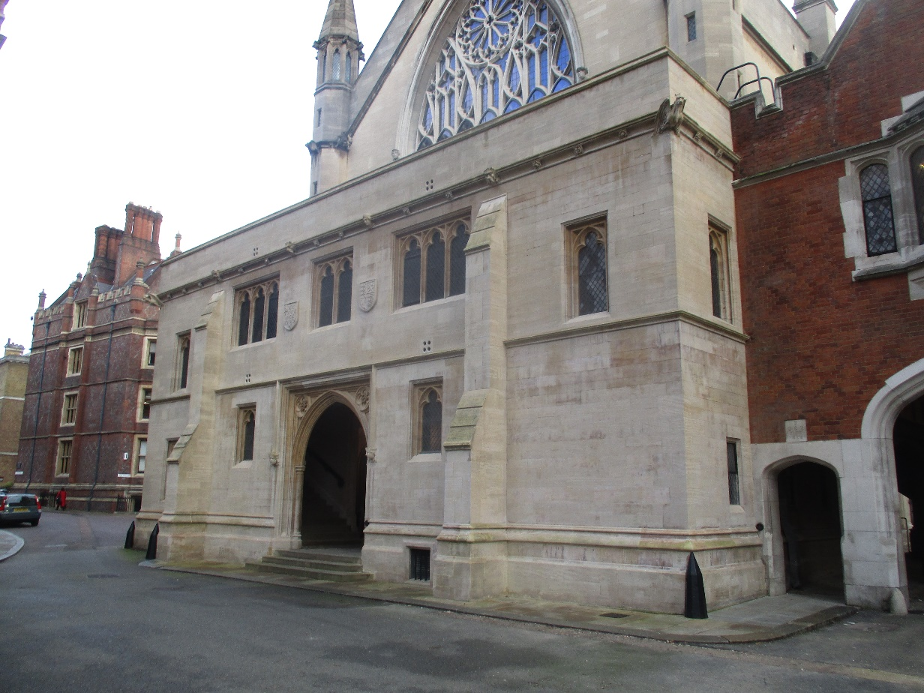

Above: The front elevation of the chapel

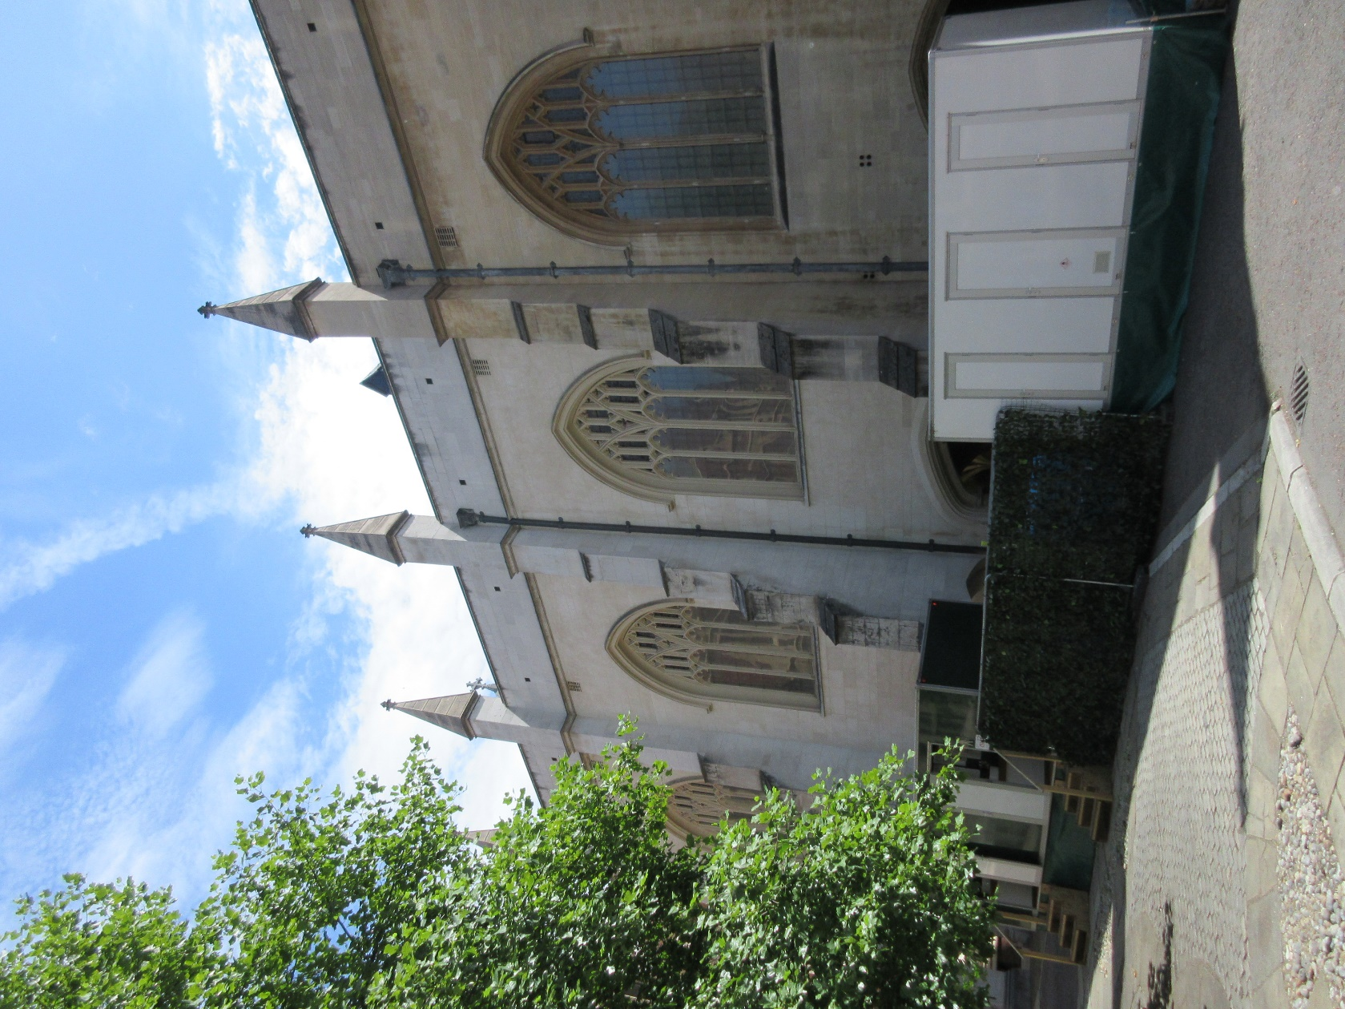

Above: Photo taken during the summer showing the three windows which are subject totto this planning application.

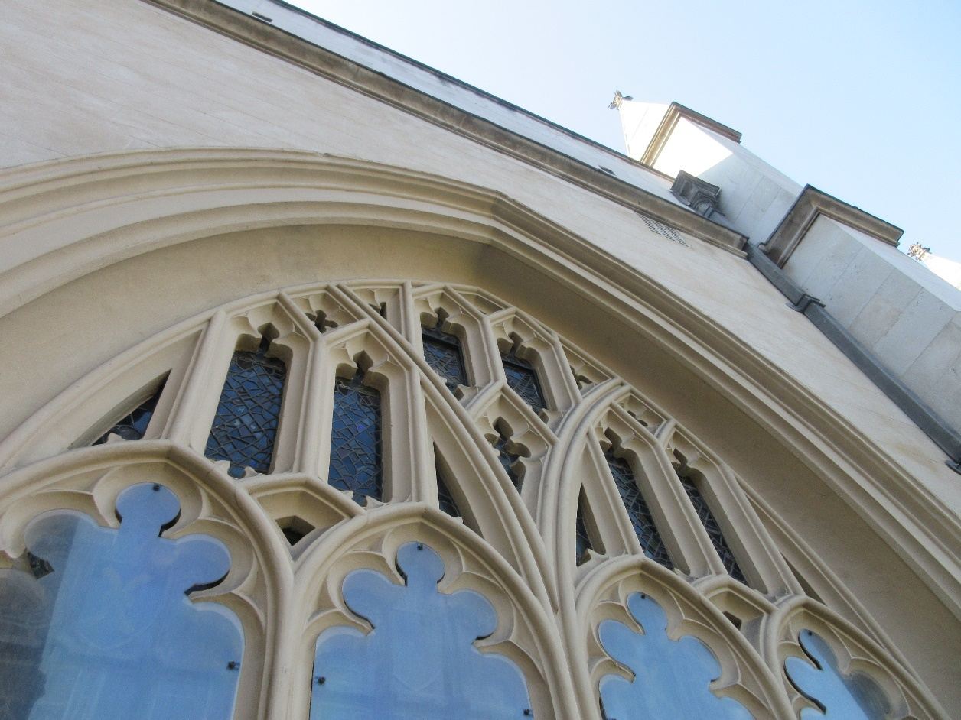

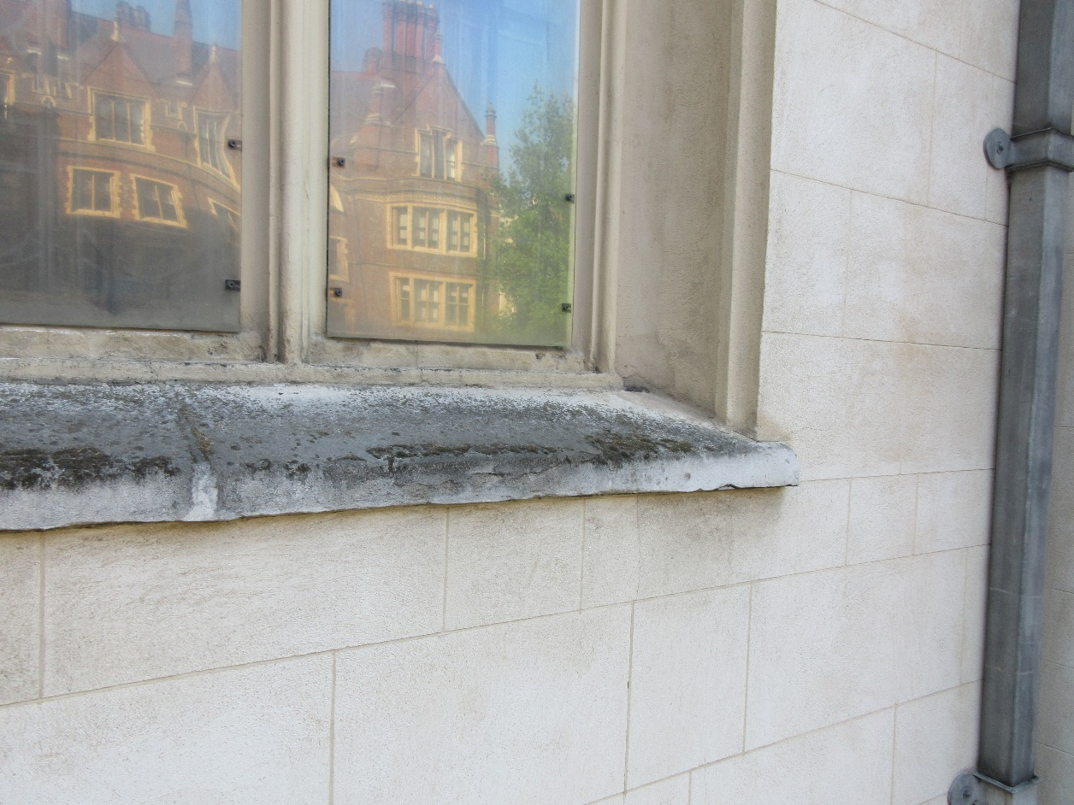

Above: Photos showing the existing polycarbonate installed immediately in front of the ferrementa.

1. **THE PROPOSAL** – Cross reference should be made to Drg Nos 0685.SK001 and SK002.
   1. The proposal is to remove and dispose of the yellowing polycarbonate protective sheeting installed in front of windows niii, niv and nv on the north side of the chapel thereby allowing the ferramenta to be viewed in relation to the stonework and glass behind.
   2. To windows niii and niv, where early seventeenth century glass is present, the glass will be conserved and repaired by The York Glazier’s Trust in line with their proposals as outlined in their report ‘Proposals for the Conservation and Environmental Protection of Window nIII’ dated August 2020 – copy attached. The same strategy will be adopted for window niv but for both windows, it needs to be recorded that consent is not being sought for this conservation and repair work as this work is covered by Ecclesiastical Exemption and subject to Faculty Jurisdiction.
   3. As part of the conservation works to windows niii and niv, the original glass will be moved inwards by approximately 40mm and mounted in a new 9mm bronze channel. Into the original grooves, new glass will be installed within a lead matrix with the existing ferramenta used to support the new glazing. The new glass panes sizes will mirror the subdivision created by the ferramenta and the glass will be 3mm mouth blown clear glass to give a more traditional aesthetic appearance and to ensure reflectivity is disrupted. The new external glazing will offer a degree of physical protection to the seventeenth century glass meanwhile the ventilated cavity with provide the environmental buffer that allows a best practice conservation led approach to the care of the glass. Detail of the proposed approach can be seen in Figure 7 of YGT’s report.
   4. The current proposal is only to consider windows niii, iv and nv but to improve the visual presentation in the short-term to medium term, the yellowing polycarbonate sheeting to window nii will be renewed on a like-for-like basis.
   5. No works are currently proposed to the south windows although it is hoped that the same strategy will be adopted to all the north and south aisle windows within the next few years.
2. **CONCLUSION**
   1. In summary, the introduction of External Protective Glazing will assist with the conservation and protection of the nationally importance seventeenth century windows and as a consequence of this, the proposed removal of polycarbonate sheeting from three of the windows will dramatically improve the visual appearance of the north side of the chapel and allow the ferramenta to once again revealed as part of the window and building.