Corkscrew willow   
  
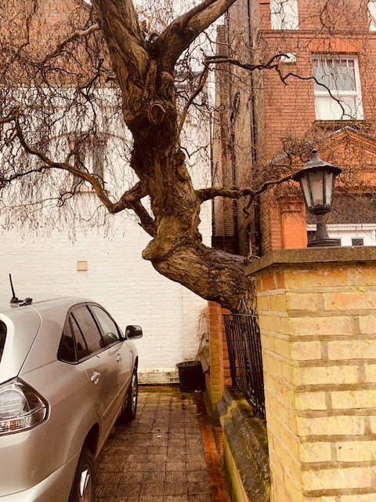

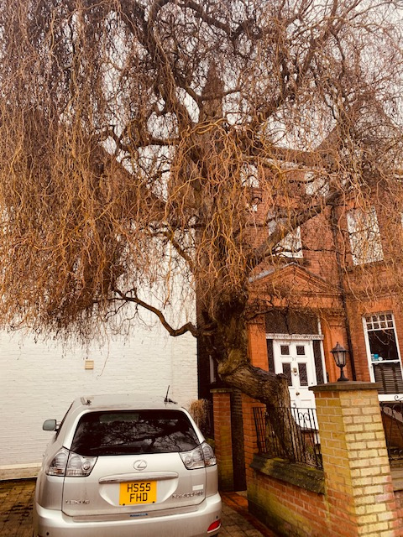

Leaning over wall railings towards car parking are

Fell and replant   
Had wall re built twice as it’s moving   
