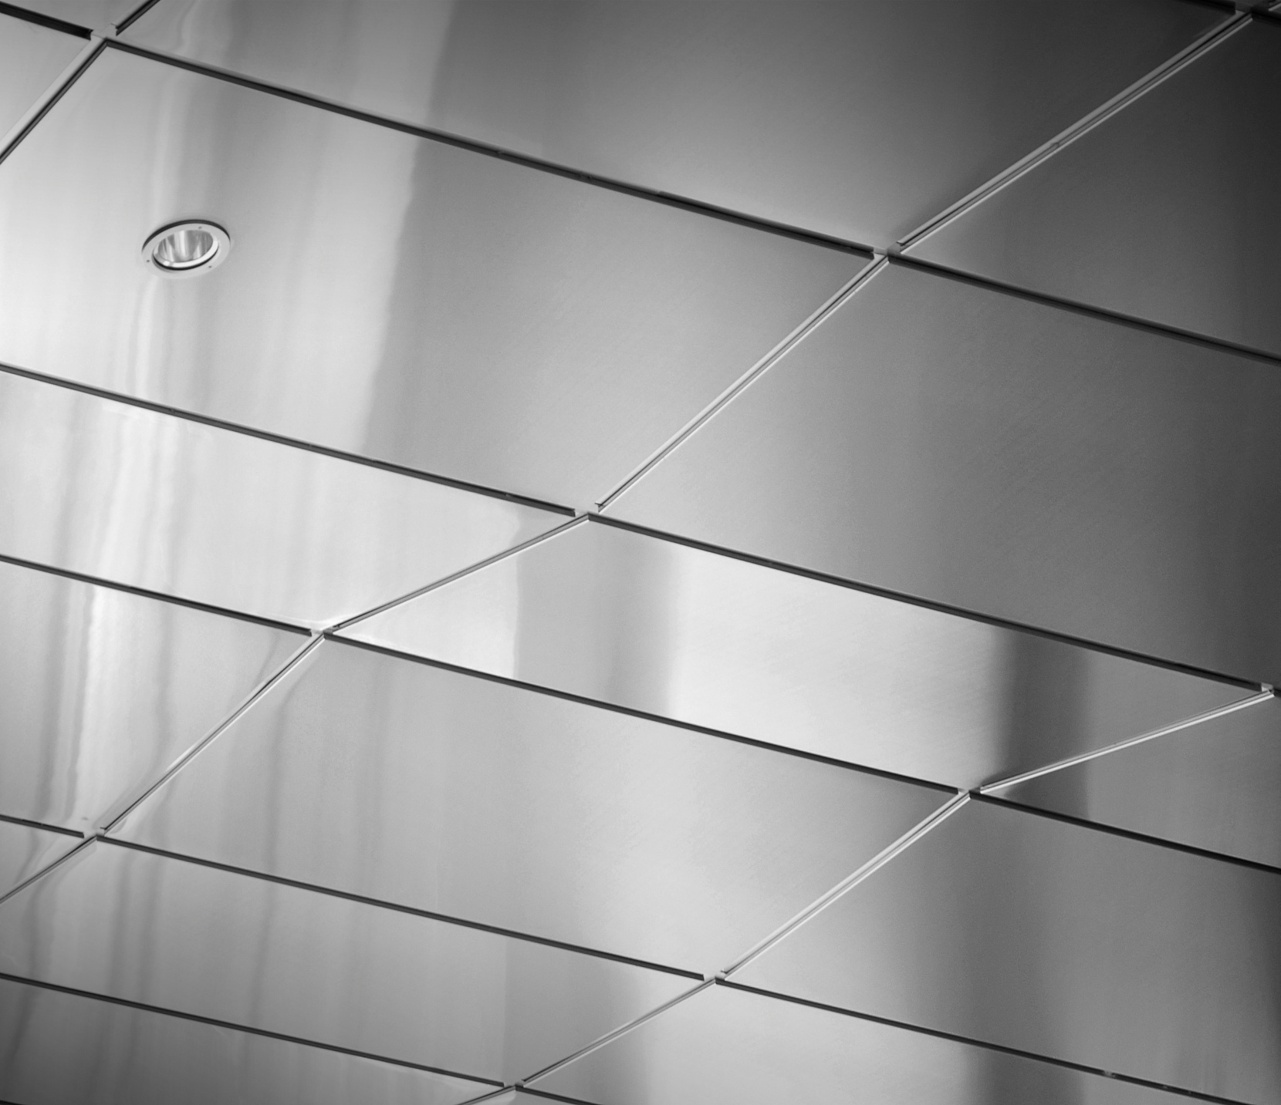

Section H92

NBS specification clauses

Jan 2019 – Issue V1.7

Proteus HR**®**

The below NBS format specification clauses are for a typical Proteus HR**®** Honeycomb Metal Rainscreen. The NBS format specification clauses can be tailored to suit individual projects and performance requirements. Please consult with the Proteus Sales department.

**Proteus HR® Honeycomb Metal Rainscreen**

|  |  |
| --- | --- |
| **H92** | **RAINSCREEN CLADDING** |
|  | To be read with Preliminaries/General conditions |
|  |  |
|  | **TENDERING** |
|  |  |
| 010 | INFORMATION TO BE PROVIDED WITH TENDER |
|  | Submit the following cladding particulars: |
| - | Proposal for primary support structure additional to that shown on preliminary design drawings |
| - | Schedule of builder’s work, special provisions and attendances by others |
|  |  |
|  | **TYPES OF RAINSCREEN CLADDING** |
|  |  |
| 110 | RAINSCREEN CLADDING |
|  | Primary support structure*…(SFS with sheathing, blockwork, reinforced concrete, etc.)* |
|  | Rainscreen cladding system: |
| - | Type: Proteus HR*®*, Honeycomb Metal Rainscreen  Manufacturer: *Proteus Façades Limited*, 1 Gerrard Place, Skelmersdale, Lancashire, WN8 9SU , +44 (0) 151 545 5075  Email: [info@proteusfacades.com](mailto:info@proteusfacades.com); Web : [www.proteusfacades.com](http://www.proteusfacades.com) |
| - | Requirement: Include all interfaces necessary for the completion of the installation. Include all mullions, bracketry, fixings, infill strips, perimeter flashings and closers. |
|  | Rainscreen panels: |
| - | Type: Proteus HR*®*, Honeycomb Metal Rainscreen Panel |
| - | Thickness: Nominal 27mm (*Panel range generally 22-50mm* to be d*etermined by spans and load requirements as advised by Proteus Façades Limited)* |
| - | Material and thickness: 1.5mm Weathering Steel |
| - | External finish: COR-TEN A |
| - | External colour: Natural Corten |
| - | Internal skin Colour: Neutral |
| - | Core: Aluminium honeycomb bonded to external and internal facings. |
| - | Panel tolerances:  +/- 1.5mm permitted deviation for panels up to 2400mm long  +/-2mm permitted deviation for panels over 2400mm long  +/-1mm maximum permitted deviation in two opposite sides of panels  Squareness of panels +/- 1.5mm (when the longest of two adjacent sides is taken as the base line)  Honeycomb infill tolerance +/-0.2mm  Maximum deviation under a straight edge 1mm, when measured at factory at ambient temperatures and humidity  Tolerances on curved panels subject to Radii, please contact *Proteus Façades Limited* |
| - | Fixing system, secondary support and fasteners: Proteus HR*®* panels fixed to Proteus extruded aluminium rail system, set out to suit project specific loads and spans. Standard Proteus HR*®* system secret fix hook brackets or direct fixings to rear of cladding panels, number and locations to suit project specific loads and spans. Purpose made high grade aluminium rail support brackets to suit loads and cladding zone depth. Provide continuous mullion section around all openings to support panel edges.  *Contact Proteus Façades Limited for standard drawings or request meeting with architectural advisor.* |
| - | Joint width: Nominal 15mm between panel edges, with recessed infill strip. |
| - | Joint type: Black PVC  *Other joint widths/types are possible, please consult Proteus Façades Limited*. |
|  | Air gap: Not less than 38mm between rear of panel and substrate/insulation |
|  | Backing wall/substrate: *…(SFS with sheathing, blockwork, reinforced concrete, etc)* |
| - | Thermal insulation: …*to suit u-value requirements* |
| - | Breather membrane: …*if required by insulation manufacturer.* |
|  |  |
|  | Accessories: Continuous closer panels at openings, where reveal are less than 175mm deep.  *Contact Proteus Façades Limited for further information* |
|  | Other requirements: Louvres, louvred doors, secret doors, perforated screens, mesh screens etc: *contact Proteus Façades Limited or visit* [www.proteusfacades.com](http://www.proteusfacades.com) |
|  |  |
|  | **GENERAL REQUIREMENTS/PREPARATORY WORK** |
|  |  |
| 210 | DESIGN |
|  | Rainscreen cladding system and associated features: |
| - | Complete detailed design in accordance with this specification and preliminary design drawings. |
| - | Submit detailed drawings prior to fabrication |
|  | Related works: Co-ordinate detailed design with other trades wherever interfaces occur |
|  |  |
| 220 | SPECIFICATION |
|  | Performance Testing: |
| - | System testing to CWCT standards for water tightness & wind resistance.  System testing for wind resistance, 2400pa Serviceability & 3600pa Safety.  (Proteus HR*®* Test no N956/02/13029 by Taywood Engineering) |
| - | System testing to BRE Digest 346, November 1989 – Part 7: Wind speeds for serviceability and fatigue assessments. Peak test pressure requirement of 2400Pa which covers a maximum design wind load in the UK, the test relates to a 50 year life cycle as explained in BRE Digest 346.  (Proteus HR*®* Test no R2790 by Wintech Engineering) |
|  |  |
| 221 | SPECIFICATION |
|  | Fire Testing: |
| - | Panels certified by Exova Warringtonfire to EN 13501-1:2007+A1:2009  External Face Material and Finish: Weathering Steel, Classification: A2-s2,d0 (Report No: WF 401084) |
|  |  |
| 230 | INFORMATION TO BE PROVIDED DURING DETAILED DESIGN |
|  | Submit the following cladding particulars: |
| - | A schedule of detailed design drawings and dates for submission for comment |
| - | A schedule of dead loads that will be transmitted from the rainscreen cladding to the primary support structure |
| - | Proposed fixing details |
| - | Details of fixings to allow removal of individual panels if required |
| - | A detailed fabrication and installation programme in compliance with the main contract master programme. |
| - | Proposals to support outstanding applications for building regulations approval |
|  |  |
| 232 | QUALITY PLAN |
|  | Requirement: Submit during detailed design |
|  | Content: In accordance with BS EN ISO 9001 and including the following: |
| - | Confirm status as *Proteus Façades Limited* Approved installer and attendance at training courses for installers and supervisors |
| - | Name of quality manager |
| - | Quality assessment procedures |
| - | Inspection procedures to be adopted in checking the work |
| - | Stages at which checklists will be used and samples of the lists |
| - | List of work procedures on the correct use of materials or components, both on and off site |
| - | List of *Proteus Façades Limited* product information with latest revisions |
| - | Storage, transport and handling procedures in accordance with *Proteus Façades Limited* standard procedures |
| - | Procedure for registering and reporting non-compliances |
| - | Maintenance procedures in accordance with *Proteus Façades Limited* standard maintenance guidelines |
| - | Certification that completed works complies with specification |
| - | Checklist register to ensure all items have been inspected and non-compliances discharged |
| 235 | INFORMATION TO BE PROVIDED BEFORE COMMENCEMENT OF MANUFACTURE OF PROTEUS HR*®* RAINSCREEN CLADDING SYSTEM |
|  | Submit the following cladding particulars: |
| - | Detailed drawings to fully describe the installation of the rainscreen cladding system |
| - | Project specific fabrication, handling and installation method statements |
| - | Certification for incorporated components manufactured by others confirming their suitability for proposed locations in the rainscreen cladding |
| - | Recommendations for spare parts for future repairs or replacements |
| - | Recommendations for safe dismantling, recycling or disposal of products |
|  |  |
| 240 | PRODUCT SAMPLES |
|  | General: Before commencing detailed design, submit labelled samples of…… (*panels, external facings, fixings, etc)* |
|  |  |
| 270 | MOCK-UP |
|  | General: Construct during detailed design work in an agreed location. Satisfy purpose and obtain approval of appearance before proceeding. Retain mock-up undisturbed until completion of cladding works or until otherwise agreed.  *Use clause if system requirements not fully explored and agreed prior to specifying. Identify scale and purpose of mock-up, e.g. to agree interface details with other trades, etc* |
|  |  |
|  | **DESIGN/PERFORMANCE REQUIREMENTS** |
|  |  |
| 310 | CWCT ‘STANDARD FOR SYSTEMISED BUILDING ENVELOPES’ |
|  | General: Comply with: |
|  | Part 2 – loads, fixings, movement |
|  | Part 3 – Air, water and wind resistance |
|  | Part 4 – Operable components, additional elements & means of access |
|  | Part 5 – Thermal, moisture & acoustic performance |
|  | Part 6 – Fire performance |
|  | Part 7 – Robustness, durability, tolerances and workmanship |
|  | *State any other requirements that may be required….* |
|  |  |
| 320 | HORIZONTAL ZONING OF WIND PRESSURE |
|  | Reference heights: *structural engineer to provide requirements and data. Delete clause if horizontal zoning is not applicable* |
|  |  |
| 340 | INTEGRITY OF VENTILATED RAINSCREEN CLAD WALLS |
|  | Requirement: Panel thickness, support spacings and fixing spacing to be confirmed by *Proteus Façades Limited* based upon the below loading information. |
| - | Panel dead load *Proteus Façades Limited to provide deadloads for particular external facing type and thickness* |
|  | Minimum design wind pressures:…. *To be advised by the structural engineer* |
|  | Design wind pressures:………………. *To be advised by the structural engineer* |
|  | External pressure coefficient (Cpe):…..*To be advised by the structural engineer* |
|  | Internal pressure coefficient (Cpi):……*To be advised by the structural engineer* |
|  | Hard body impact loads to CWCT TN75 (BS EN 14019) |
| - | Location and category:……. |
|  | Soft body impact loads to CWCT TN75 (BS EN 14019) |
| - | Location and category:……. |
|  | Temporary imposed loads:…*delete if none* |
|  |  |
| 350 | DEFLECTION UNDER WIND LOAD |
|  | Requirement: For listed components, at positive pressure & negative applications of the design wind pressure, normal deflections are not to exceed: |
| - | Framing Members: L/200 |
| - | Panels: L/90 |
|  |  |
| 370 | APPEARANCE AND FIT |
|  | Requirement: For rainscreen cladding wall: |
| - | To ensure the position and alignment of all parts and features as shown on the preliminary design drawings. |
| - | To accommodate deviations in the primary support structure, provided always that the latter is within stated design tolerances for the element of structure |
|  | Primary support structure: Before commencing installation of the rainscreen cladding system, carry out survey sufficient to verify that required accuracy of erection can be achieved. |
| - | Give notice: If the structure will not allow the required accuracy or security of erection. |
| - | Design tolerances:…..*to include allowance for panel manufacturing tolerances of +/- 2mm on panels over 2.4m long; system joints allow +/- 2mm of adjustment, cladding zone on majority of constructions allow +/- 10mm adjustment* |
|  |  |
| 380 | GENERAL MOVEMENT |
|  | Requirement: rainscreen cladding must accommodate anticipated building movements as follows:….*to be calculated by the structural engineer* |
|  |  |
| 430 | THERMAL PROPERTIES |
|  | Method for calculating the thermal transmittance (U-value) of the rainscreen wall: Weighted U-value |
|  | Average U-value of the rainscreen wall to be:….*state overall U-value requirement for compliance with Part L1A, L1B, L2A or L2B of England and Wales building regulations (or Scotland’s or Northern Ireland’s equivalents, as applicable)* |
|  |  |
| 450 | VAPOUR CONTROL LAYER |
|  | A vapour control layer if required, to the method described in BS5250, annex D, may be provided as part of the whole wall construction on the warm side of insulation |
|  |  |
| 490 | CAVITY BARRIERS TO BS 476-20 |
|  | Requirement: To resist the passage of flame and smoke for not less than…. *Insert periods and criteria, if required by Approved Document B of building regulations or by fire consultant* |
|  |  |
| 530 | TESTING AUTHORITIES |
|  | Requirement: Project testing must be carried out by a United Kingdom Accreditation  Service (UKAS) approved independent laboratory. |
|  |  |
|  | **PRODUCTS** |
|  |  |
| 710 | ALUMINIUM ALLOY FRAMING SECTIONS |
|  | Standards: To BS EN 755 alloy 6063-T6 |
|  |  |
| 712 | ALUMINIUM ALLOY SHEET |
|  | Standards: To BS EN 485, BS EN 515 and BS EN 573 |
|  | Alloy, temper and thickness to suit application and specified finish |
|  |  |
| 717 | CARBON STEEL SHEET |
|  | Standards: 0.7mm Galvatite substrate, hot dipped zinc coated steel to BS EN 10147. |
|  | Colour: Standard white |
|  |  |
| 720 | STAINLESS STEEL SHEET |
|  | Standards: To relevant parts of BS EN 10029, BS EN 10048, BS EN 10095 and BS EN ISO 9445 |
|  | Grade: To BS EN 10088-2 generally, 1,4301 (316) |
|  | Thickness: minimum 0.8mm, or as specified for impact resistance, etc |
|  |  |
| 730 | MECHANICAL FIXINGS – MATERIAL REQUIREMENTS |
|  | Stainless steel: to BS EN ISO 3506 grade A2 generally, grade A4 when used in severely corrosive environments. |
|  | Carbon steel: To BS 4190; galvanised to BS EN ISO 1461, sheradised to BS 4291, class 1 coating thickness and passivated or alternative coating suitable for corrosion protection |
|  | Aluminium: To BS EN 755 |
|  |  |
| 735 | FIXINGS AND FASTENERS |
|  | Type and use: As part of *Proteus Façades Limited* Proteus HR*®* standard system |
|  |  |
| 755 | THERMAL INSULATION & BREATHER MEMBRANE |
|  | Material: As drawings and Facade Engineers' specification. |
| - | Properties: Durable, rot and vermin proof and not degradable by moisture or water vapour. |
|  | Recycled content: Submit proposals. |
|  | Fixing: Attached to the outer face or supported within the backing wall so as not to bulge, |
|  |  |
| 830 | POLYESTER POWDER COATING |
|  | Requirement: As section Z31 |
|  |  |
| 840 | ANODIZING |
|  | Requirement: As section Z33 |
|  |  |
| 850 | POLYVINYLIDENE FLUORIDE (PVDF) COATING |
|  | Standards: To BS 4842, AAMA 2604-05 or AAMA 2605-05, subject to minimum coating thickness recommended by the sheet supplier |
|  |  |
|  | **FABRICATION AND INSTALLATION** |
|  |  |
| 910 | GENERALLY |
|  | Electrolytic corrosion: take necessary steps to avoid |
|  |  |
| 912 | METALWORK |
|  | Requirement: As section Z11 |
|  |  |
| 930 | ASSEMBLY |
|  | Pre-assembly of fixings generally carried out in storage areas to minimise disruption to installation areas |
|  |  |
| 960 | PRELIMINARY RAINSCREEN CLADING INSTALLATION |
|  | Requirement: Complete an agreed area of cladding for inspection and approval of appearance |
|  |  |
| 970 | RAINSCREEN CLADDING INSTALLATION |
|  | Commence rainscreen cladding panel fixing only when other trades have completed their work; e.g. electrical and mechanical first fix; insulation (if by others); to minimise damage to finished work |
|  | Tighten mechanical fixings to recommended torque figures, where stated |
|  | Protective coverings: Only remove when necessary to avoid scratches and abrasion damage |
|  | Agree locations of physical barriers to be erected by the main contractor for the protection of vulnerable works |
|  |  |
| 980 | INTERFACES |
|  | Installation: Locate flashings, closers, etc correctly and neatly overlap cladding to complete rainscreen. |
|  |  |
| 985 | DAMAGE |
|  | Repairs: Do not repair cladding without approval |
|  | Record of damage to cladding panels: Schedule damaged panels on record drawings |
|  | Record of repairs; Schedule repaired panels on record drawings |
|  |  |
| 995 | MAINTENANCE |
|  | Maintenance manual: Incorporate *Proteus Façades Limited* standard maintenance guidelines into Building Manual |
|  |