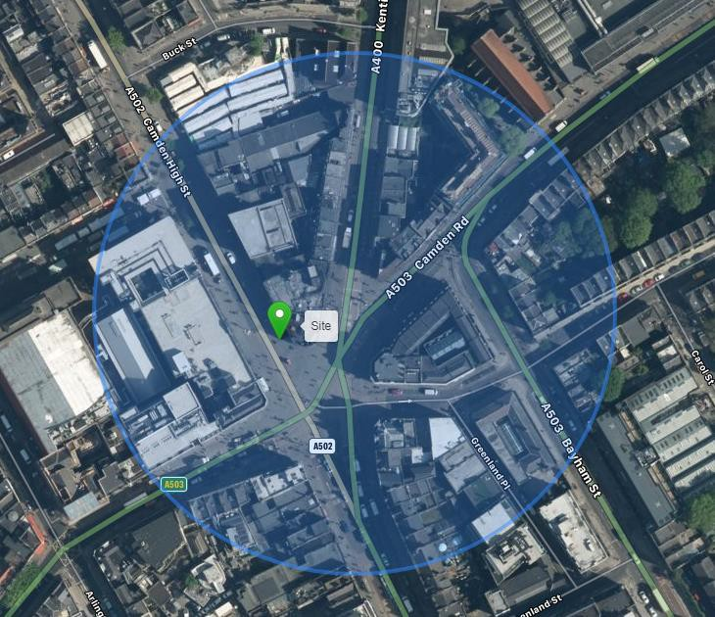
5G SITE SPECIFIC SUPPLEMENTARY INFORMATION AND PLANNING JUSTIFICATION STATEMENT PREPARED BY DOT SURVEYING

- Site Details

Site Name: | Junction of Camden High Street | Site Address: | Junction of Camden High Street, Camden, London  NW1 7BP
NGR: | E 528900, N 183889 | Site Address: | Junction of Camden High Street, Camden, London  NW1 7BP
Site Ref Number: | CMN13533 | Site Type: | Proposed 5G telecoms installation: 18m high Streetpole and 3no cabinets with ancillary works.

- Pre-Application Check List

Site Selection

Was Camden Council mast register used to check for suitable sites by the operator or the LPA? |  | No
If no explain why:

It was felt that the industry database was a more up to date source of information.
Was the industry site database checked for suitable sites by the operator: | Yes
If no explain why:

n/a

Pre-application consultation with Camden Council

Written offer of pre-application consultation: | n/a
Was there pre-application contact: |  | Yes
Date of pre-application contact: | 8 June 2020
Name of contact: | planning@camden.gov.uk
Summary of outcome/Main issues raised:

H3G (Three) is committed to providing improved network coverage and capacity, most notably in relation to 5G services. In these unprecedented times of Covid-19 pandemic, it is recognised that high-speed mobile connectivity is the lifeblood of a Community; facilitating educational benefits, providing access to vital services, improving communications with the associated commercial benefits for local businesses, enabling e-commerce and working from home as well as enjoying access to social, media and gaming for leisure time activities.

This is a planning resubmission further to the refusal in this location of a 18m proposal
on the below grounds:-
“The proposed monopole and cabinets, by virtue of their size and location, would
create unnecessary street clutter, would reduce the amount of useable footway,
would cause harm to highway safety and would hinder pedestrian movement,
contrary to policies A1 (Managing the impact of development), C6 (Access for all)
and T1 (Prioritising walking, cycling and public transport) of the London Borough of
Camden Local Plan 2017.)”

Our clients have taken this into consideration and managed to reduce the proposed size of the
proposal to 18m’s (the lowest it can go to from a capacity and coverage perspective in this
area and so we are resubmitting this application on that basis to work with the Council to
help attain 5G coverage for their population in this area.

Ten Commitments Consultation

Rating of Site under Traffic Light Model: | Amber
Prior to the submission of this application the applicant initiated pre-consultation with the local planning authority. This provides an opportunity to discuss development proposals and identify site specific issues.
Summary of outcome/Main issues raised:

Determination as to whether the prior approval of the authority will be required to the siting and appearance of the proposed installation is invited under Part 16, Schedule 2 to the Town and Country Planning (General Permitted Development) (England) Order 2015.

Proposed mast design has been reviewed in line with any pre and post application consultation feedback and measures taken to adopt 18m high H3G Phase 8 Streetpole with appropriate colour/finishes to reduce visual impact in the high street setting located within designated Conservation Area boundary (Primrose Hill).

H3G proposed ‘Streetworks’ installation located within the adopted Highway footpath is considered best suited to extend high-speed mobile coverage to the target community.

School/College

Location of site in relation to school/college:

There are no schools in close proximity to the site.
Outline of consultation carried out with school/college:

N/A
Summary of outcome/Main issues raised:

N/A

Civil Aviation Authority/Secretary of State for Defence/Aerodrome Operator consultation (only required for an application for prior approval)

Will the structure be within 3km of an aerodrome or airfield? |  | No
Has the Civil Aviation Authority/Secretary of State for  Defence/Aerodrome Operator been notified? |  | No
Details of response:

N/A

Developer’s Notice

Copy of Developer’s Notice enclosed? | Yes
Date served: | 16 March 2021

- Proposed Development

The proposed site:
H3G (Three) are in the process of building the UK’s fastest mobile network to provide improved coverage and capacity, most notably in relation to 5G services.

This proposal is for a new 18m high H3G Phase 8 Streetpole installation at Junction of Camden High Street, Camden, London NW1 7BP (NGR: E 528900, N 183889).

The technical details of this proposal are illustrated within enclosed application design drawings CMN13533_PLANNING_REV-A. It is recognised that the very nature of installing new 5G mast infrastructure within dense urban setting requires a highly-considered balance between the need to extend practical coverage reach with that of increasing risk of visual amenity intrusion.

In this location, existing mast sites are not capable of supporting additional equipment compliment to extend coverage reach across the target area and prospective ‘in-fill’ mast sites are extremely limited. Several options have been identified and subsequently discounted (Refer to Section 6, Figure 3). Notwithstanding this, there is an acute need for a new mast to deliver the required community coverage and detailed site evaluation together with review of pre-consultation comments in line with Camden LP Policy E1 : Economic development, have helped shape this application.

There is a practical need to ensure that mast antenna is within close proximity to shopping centre properties in order to provide effective service coverage and in this case, the proposed mast location within adopted Highway footpath; whilst visible from adjoining properties, has been very carefully set within the backdrop of HSBC branch outlet and identified as the single most appropriate site to support service delivery with Streetpole and equipment cabinets painted non-reflective colour Grey (RAL7035) to minimise visual impact.

Figure 1 - Site Photograph

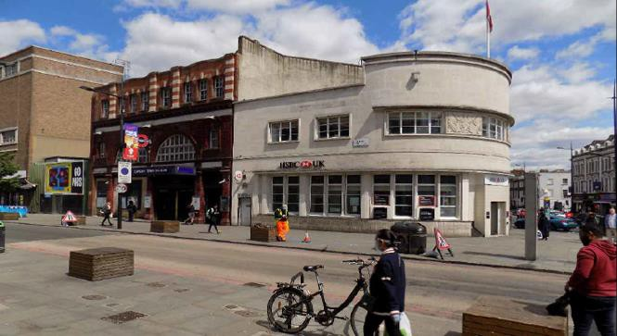

Proposed site option is considered the best available compromise between extending 5G service coverage across the target ‘coverage hole’ with the selected Streetworks mast height and associated antenna and ground-based cabinets restricted to the absolute minimum capable of providing the required essential coverage.

The site has been located within an adopted area of Public footpath in a position that will not impede pedestrian flow or the safety of passing motorists. The equipment cabinets are located at the base of the new pole and (unless the site is located in Article 2 (3) land), such installations are deemed Permitted Development without Prior Approval and therefore do not form part of the proposal from a planning consideration perspective as set out in the undernoted planning analysis:

Planning Policy Relevant to the Development Site:

Local Planning Authority: Camden Council
Development Plan: Camden Council LP Policy E1 : Economic development
The Adopted Roads Register shows that the proposed location falls within adopted Highway.

In this instance new 18m high H3G Phase 8 Streetpole with associated 3no. equipment cabinets (colour Grey RAL7035) are located within the adopted Public footpath to reduce visual impact in a main street retail setting located within designated Conservation Area boundary (Primrose Hill). Consequently, the proposed site location is not considered to pose an unduly onerous material consideration and favourable determination is invited.

The National Planning Policy Framework (NPPF) section of this Supporting Statement goes into detailed analysis of why this site is in compliance with the NPPF.

Policy Analysis:

Government attaches great importance to the design of the built environment and outlines this within Section 12 (para. 124) of the National Planning Policy Framework. It states:

“Good design is a key aspect of sustainable development, creates better places in which to live and work and helps make development acceptable to communities.”

In keeping with the National Planning Policy Framework (NPPF) guidelines of using: “high quality communications” (Section 10), the proposed design has been selected to minimise visual impact upon the streetscape by integrating with the existing built environment.

The design of the proposed antenna and ground-based cabinets is considered to be the least visually intrusive option available. Whilst it is accepted that there will be a localised visual increase through the installation of additional apparatus, it is considered that this will not overly detract from the character of the existing streetscape.

Enclosed map showing the cell centre and adjoining cells:
The optimum solution from a cell planning and radio coverage perspective has been put forward with the target Search Area (shown coloured pink dot) and existing H3G (Three) UK sites illustrated within Figure 2 below:
Figure 2 - Coverage Map: Proposed installation must be located close to the pink dot

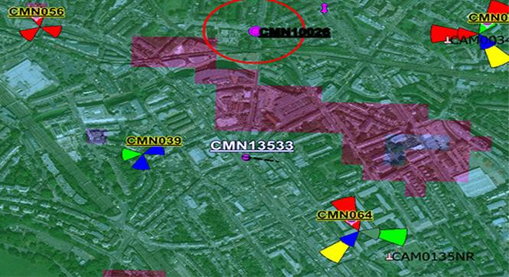

Type of Structure
Description:

Proposed Phase 8 Monopole c/w wrapround Cabinet at base.
Overall Height: |  | 18m AGL
Height of existing building |  | n/a
Equipment Housing:
Length: |  | See drawings
Width: |  | See drawings
Height: |  | See drawings
Materials
Tower/mast etc. - type of material and external colour: | Phase 8 Monopole, colour Grey RAL7035
Equipment housing - type of material and  external colour: | Profile steel cladding, colour Grey RAL7035

Reasons for choice of design:
The proposed installation is an H3G LTE (Three) Phase 8 Monopole which will facilitate educational benefits, providing access to vital services, improving communications with the associated commercial benefits for local businesses, enabling e-commerce and working from home as well as enjoying access to social, media and gaming for leisure time activities.

In accordance with the requirement set within National Planning Policy Framework (NPPF July 2018) guidelines; the proposed ‘Streetworks’ design has been selected to minimise visual impact upon the street scene by integrating with existing street furniture, having similar vertical emphasis and general overall appearance to street lighting columns in the urban setting.

- Technical Information

ICNIRP Declaration attached  ICNIRP (International Commission on Non-Ionizing Radiation Protection) aims to protect people and the environment against adverse effects of non-ionizing radiation (NIR). Public compliance is determined by mathematical calculation and implemented by careful location of antennas, access restrictions and/or barriers and signage as necessary. Members of the public cannot unknowingly enter areas close to the antennas where exposure may exceed the relevant guidelines. When determining compliance, the emissions from all mobile phone network operators on the site are taken into account. | Yes

- Technical Justification

Reason(s) why site required
The National Planning Policy Framework (NPPF) clearly states that authorities should NOT question the need for the service, nor seek to prevent competition between operators. Notwithstanding this, the Applicant considers it to be important to explain the positive technical justification for the site and how the facility fits into the overall network.

The site is required to provide new 5G coverage for H3G LTE in order to improve service in Camden. The cell search areas for 5G are extremely constrained with a typical cell radius of approximately 50m meaning that it would not be feasible to site the column outside of this target locale (Refer to Figure 3).

- Site Selection Process – alternative sites considered and not chosen

Discounted Options
In accordance with the sequential approach outlined in the NPPF, the following search criteria have been adopted. Firstly, consideration is always given to sharing any existing telecommunication structures in the immediate area, secondly; consideration is then given to utilising any suitable existing structures or buildings and thirdly, sites for freestanding ground- based installations are investigated.

This sequential approach is outlined below:

- Mast and Site Sharing
- Existing Buildings Structures
- Ground Bases Installations

In compliance with its licence and the sequential approach outlined in the NPPF, all attempts to utilise any existing telecommunication structures where they represent the optimum environmental solution have been employed. The Mast Data register is always examined prior to the submission of a planning application.

Discounted Options and National Planning Policy:

The National Planning Policy Framework (NPPF) is clear that LPAs should not question the need for the installation under Part 116:

“Local planning authorities must determine applications on planning grounds only. They should not seek to prevent competition between different operators, question the need for an electronic communications system, or set health safeguards different from the International Commission guidelines for public exposure”.

Typical to most 5G cell site deployment within the urban environment, this is an extremely constrained cell search area. It is recognised that the very nature of installing new 5G mast infrastructure within dense urban setting requires a highly-considered balance between the need to extend practical coverage reach with that of increasing risk of visual amenity intrusion and the only viable solution has been put forward. The DSA (Designated Search Area) is illustrated in Figure 3 together with site locations that were investigated and those subsequently discounted.

Discounted Options:
 |  | Land options within the target Search location are within close
D1 | E 528929, | proximity to retail properties with existing street furniture
Camden Town | N 183866 | affording little prospect of supporting mast development.
Search Area
 |  | Similarly, land options extending north east of the desired
D2 | E 528981, | Search Area are within close proximity to Grade II Listed
Camden Road | N 183964 | properties, St Michaels Church and War Memorial with
 |  | narrowing pavements affording little prospect of supporting
 |  | mast development.
 |  | Areas of adjoining roadway offer limited option to support
D3 | E 528893, | mast development but discounted due to location within close
189-191, | N 183864 | proximity to underground toilets and existing services limiting
Camden High |  | location of mast and equipment cabinet installation options.
Street
D3  Existing Mast infrastructure | n/a | Existing mast infrastructure is not capable of hosting additional equipment capable of extending signal reach across the area of coverage gap and discounted.
D4  Designated Areas | n/a | The vast majority of the desired Search Area falls within Camden Conservation Area which has favoured the identification of options towards the outer boundary of sensitive areas of land designation.
 |  | The recommended option falls just out within the Primrose Hill Conservation Area boundary with mast installation set against the backdrop of an established HSBC property which is considered best suited to extend high-speed mobile coverage to target areas of Camden and the needs of the local community.
Figure 3 - Proposed Site Location: 100m DSA (Desired Search Area) shown circled

D2

D4

D1
D3

D5

- Additional Relevant Information

Background to the Proposal
H3G supports Government ambition to be a global leader in the next generation of mobile technology set out within its March 2017 white paper, ‘Next Generation Mobile Technologies: A 5G strategy for the UK’ and expand its mobile network across Camden Council region and specifically in this instance to enhance 5G coverage levels within the High Street area.

Modern mobile phone base stations operate on a low power and accordingly, need to be located within close proximity to the areas they are required to serve. Increasingly, people are also using mobile devices in the home which requires the installation of base station infrastructure closer to such urban high street area.

The proposed scheme has been designed to ensure that fundamental principles of good siting and appearance are adhered to. The overall impact of the installation on the environment is therefore considered limited when viewed in the context that high-speed mobile connectivity is the lifeblood of a Community.
DEVELOPMENT PLAN POLICY:
Development plan considerations have a special significance in law. Section 54A of the Town and Country Planning Act 1990 (The Act), and re-iterated in Section 38 of the Planning and Compensation Act 2004, stated that:

“Where in making any determination under the Planning Acts regard is to be had to the Development Plan, determination shall be made in accordance with the Development Plan unless material considerations indicate otherwise.”

NATIONAL PLANNING POLICY:
The Government remain committed to promoting telecommunications and place emphasis on the importance of telecommunications to the wider economy. The National Planning Policy Framework (NPPF July 2018) sets out the Government’s planning policies for England and how these are expected to be applied at the Local level. It provides a framework within which local people and their representative Councils can shape distinctive local and neighbourhood plans, which reflect the needs and priorities of their own communities.

The purpose of the planning system is to contribute to the achievement of sustainable development. There are three dimensions of sustainable development, each of which give rise to the need for the planning systems to perform a number of roles including;

- Economic Role - contributing to building strong, responsive and competitive economy;
- Social Role - Supporting strong vibrant and healthy communities; and
- Environmental Role - Contributing to protecting and enhancing our natural, built and historic environment.
The NPPF contains at its core a presumption in favour of sustainable development which runs through both plan-making and decision-making processes. The NPPF recognises the vital importance of high-quality telecommunications and dedicates a whole chapter to this area. Chapter 10 of the NPPF outlines the Governments support for high quality communications. The paragraph extracts highlighted below, clearly outline the overarching support from Central Government for telecommunications and how Local Planning Authorities should embrace this vital infrastructure:

Paragraph 112 states:

“Advanced, high quality and reliable communications infrastructure is essential for economic growth and social well-being. Planning policies and decisions should support the expansion of electronic communications networks, including next generation mobile technology (such as 5G) and full fibre broadband connections. Policies should set out how high quality digital infrastructure, providing access to services from a range of providers, is expected to be delivered and upgraded over time; and should prioritise full fibre connections to existing and new developments (as these connections will, in almost all cases, provide the optimum solution).”

It continues in Paragraph 113

“The number of radio and electronic communications masts, and the sites for such installations, should be kept to a minimum consistent with the needs of consumers, the

efficient operation of the network and providing reasonable capacity for future expansion. Use of existing masts, buildings and other structures for new electronic communications capability (including wireless) should be encouraged. Where new sites are required (such as for new 5G networks, or for connected transport and smart city applications), equipment should be sympathetically designed and camouflaged where appropriate.”

Operators always follow the sequential site selection process. Where an existing site can be shared or upgraded this will always adhered to before a new proposal is put forward for consideration. In this instance there is no scope to upgrade existing mast or site share with the remaining practical solution to extend such coverage to Camden High Street being that of new infill Streetworks infrastructure located within the Public highway.

The support for telecoms and the need not to constrain Operators is laid out in Paragraph 116

“Local planning authorities must determine applications on planning grounds only. They should not seek to prevent competition between different operators, question the need for an electronic communications system, or set health safeguards different from the International Commission guidelines for public exposure.”
Conclusion
Government considers that high-speed mobile connectivity is the lifeblood of a Community. H3G (Three) is committed to providing improved network coverage and capacity, most notably in relation to 5G services.

Taking into account the site-specific factors and technical constraints, available options and planning constraints it is considered that the proposed site and design clearly represents the optimum environmental solution to extend coverage to the target Community.

The use of Public Highway adopted footpath complies with both central government and local planning policy guidance where the underlying aim is to provide an efficient and competitive telecommunication system for the benefit of the community while minimising visual impact.

In accordance with a recognised need to expand and promote telecommunications networks across the region, it is considered that the proposal fully accords with the National Planning Policy Framework and Council’s Local Plan Policies.

On this basis, favourable determination as to whether the prior approval of the authority will be required to the siting and appearance of the proposed installation is invited under Part 16, Schedule 2 to the Town and Country Planning (General Permitted Development) (England) Order 2015.

Contact Details

Name: (Agent) | Tom Gallivan FRICS | Telephone: | 07841104028
Operator: | H3G LTE | Fax no: | N/A
Address: |  | Email Address: | t.gallivan@dotsurveying.co.uk
Dot Surveying Ltd,
The Bonds (Suite 31),
2 Anderson Place, Edinburgh
EH6 5NP
Signed: | T Gallivan | Date: | 16 March 2021
Position: | Surveyor | Company:  (on behalf of above operator) | Dot Surveying Ltd

