37 PARKWAY NW1 7PN - HERITAGE STATEMENT
Prepared by Tim Godsmark BA (Hons) Arch, Dipl Arch, RIBA, WCCA

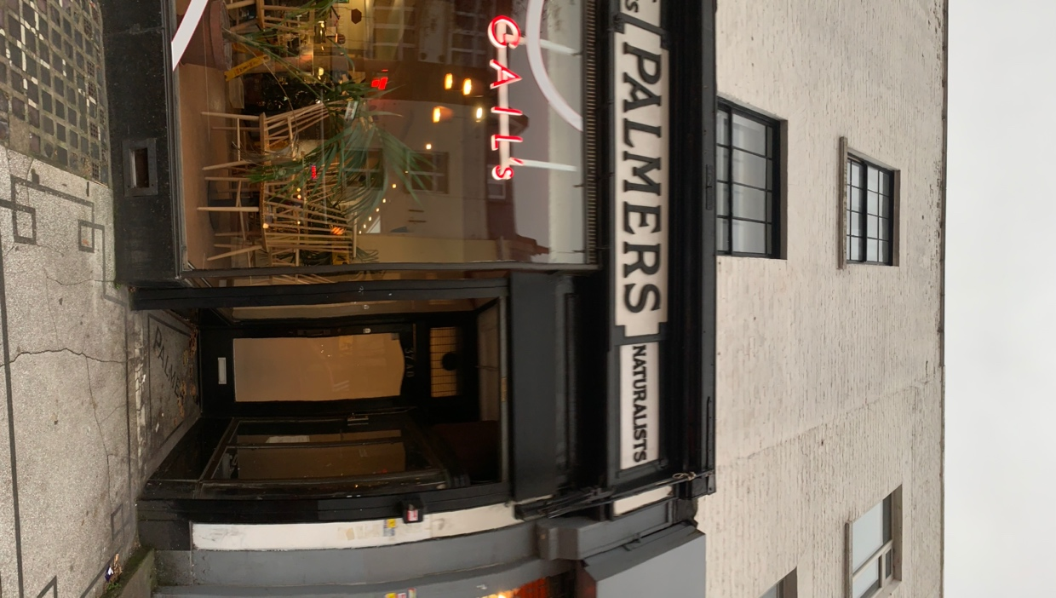

SITE

The site is a recessed entrance to flats above a shop in Parkway in Camden Town. The building and especially the shopfront are Grade 11 listed.

HISTORY

The building was constructed circa 1820. Records indicate the building was unoccupied in 1918 but by 1921 'Mrs Palmer (Florence), bird dealer' was trading from 83 Park Street, what is now 35 Parkway (the numbering and the street name changed during WWII). In 1924, the business was taken over by Mr George Palmer, presumably a nephew or son of Mrs Florence Palmer. Under George, the shop expanded one house westwards: in between 1937 and 1941 the shop began to be registered at Nos. 35 and 37 Parkway. It was at this time that the new shop front was designed and installed as a single composition, spanning the two premises owned by George Palmer. The panel which reads 'Regents Pet Stores' may have been added in 1954 or, more plausibly, it was included in the late 1930s makeover and only selected as the main trading name after 1954.

It would appear that the shop was served by the entrance at no. 35 and the accommodation above by the entrance at 37.

THE LISTING
The listing states that:

EXTERIOR: the shop front runs across the ground floor of a pair of three-storey 1820s houses, each of a single bay and part of a larger terrace. The shop front is symmetrical with three large display windows flanked by two doors which have smaller, curved display cabinets inside the porches. The shop front is of wood, painted black, with brass surrounds to the curved display windows in the corners. There is mosaic tiling along the pavement outside and in the porches, the latter spelling out 'PALMERS'. The upper horizontal elements of the window surrounds are scored with triglyph-style grooves and classical paterae adorn the four corners of the timber surrounds. Above this, the fascia has carved wood lettering on a white background. These announce 'PALMERS' in the centres of the two halves of the front, each flanked with smaller panels describing the shop and its wares in further detail. From the left they read 'MONKEYS' 'TALKING PARROTS' 'REGENT PET STORES' and 'NATURALISTS'. Above the shop, the single window openings retain their sash windows. Those to the first floor were once much larger and there is evidence that the longer sash windows were cut down to size when the openings were reduced in height, most probably when the shop front was inserted. The brickwork to the front is largely intact.

SUMMARY OF IMPORTANCE: 35-37 Parkway are a pair of early C19 terraced houses which in c1921 were converted to retail use by Palmers Pet Stores. The shop front, dating from around 1938, is of special historic interest as a rare survival of a pet shop advertising exotic pets in the distinctive sign panels which read 'MONKEYS' and 'TALKING PARROTS'. The shop front's significance is enhanced by its proximity to London Zoo, also articulated in the shop front lettering 'REGENT PET STORES'. The building is also of special architectural interest. Firstly, the elegant 1930s shop front has good points of detail including brass surrounds to the curved glass side windows and circular parterae marking each corner of the panels; secondly there is good survival of late Georgian features, including sash windows and door cases with fluted surrounds, which relate to the first phase of the building's development as a pair of terraced houses.

This indicates that the glazed side windows to the recessed entrances are viewed as being important. It should be noted that they currently have roller shutters with shutter boxes and fixed side guides positioned at the street frontage which contemporary planning applications indicate were in place before the listing in 2007. These have the effect of reducing the openness of the recess and negate it completely when closed, which the shutter at 35 is every night.

SUMMARY

The communal entrance to the flats is via a Grade 11 listed shopfront of circa 1938. The design must respect this and take into account the openness of the recess.

